SUMMARY OF JUDAISM
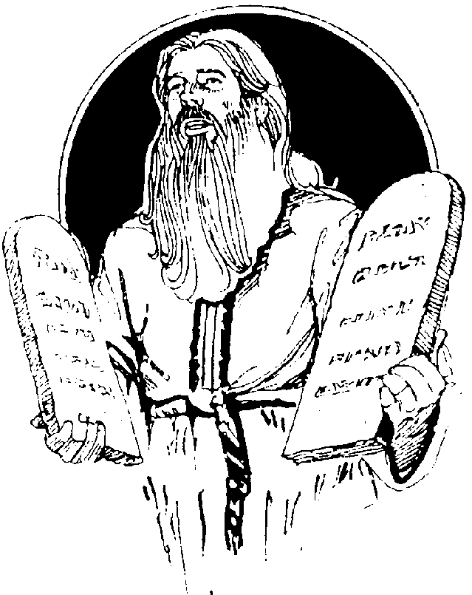
Moses

MAJOR RELIGIONS
Cultural Geography
Mr. Naumann

Judaism has both a "father" and a "founder." Abraham is called the father of Judaism because the Hebrew [Jewish] people believe they became the "Chosen People" when God established his covenant with Abraham. Moses is often referred to as the founder of the religion of Judaism because he is given credit for writing the Torah or the Law [the first five books of the Old Testament]. The religion took shape as Moses led the Hebrew people through the desert for forty years as they went from slavery in Egypt to freedom in the "Promised Land." This period is known as the Exodus, and ended around 1300 B.C. The Exodus ended with the Hebrew people settling in the area of modern Israel and Jordan in the Middle East. Today, Jews 17,822,000 live mostly in Israel (in Asia), Europe, and the Western Hemisphere, with 7,003,000 living in North America.

CONCEPT OF GOD: God is referred to as Yahweh and sometimes as Jehovah. The Jews are often called the first monotheists [believers in one god]. That is a debatable point, but it is true that Judaism did develop into a strongly monotheistic religion. Yahweh is a personal god who is concerned with the individuals as well as with the whole "Chosen People."

SACRED WRITINGS: The Torah contains the Law revealed by God. These are the first five books of what Christians call the Old Testament: Genesis, Exodus, Leviticus, Numbers, and Deuteronomy. All the books of the Old Testament are considered to be from God. Jewish scholars spend much time studying the Talmud which is made up of commentaries on the Torah. These commentaries were written by respected Rabbis [religious teachers], and are referred to as the "oral law."

IMPORTANT LEADERS: Moses, David, and the prophets of the Old Testament.

MAJOR SUBDIVISIONS: At the time of the Roman occupation of the Holy Land, there were several important subdivisions or sects in Judaism. The sect from which the modern branches of Judaism developed was the Pharisees. They believed in strictly following all the rules of Judaism. They had derived hundreds of laws from the laws written in the Torah. Custom, ritual, and following all the rules, even those handed down by oral tradition, were important to them. They considered themselves a separated people devoted to the study of the law. A group that strongly opposed the Pharisees was the Sadducees. These were mainly descendants of the priestly, aristocratic class of Jews. They rejected the idea of the resurrection of the dead, the belief in angels, and the parts of the law that had been handed down by oral tradition. The Samaritans were a group of people who were descendants of Jews who had married non-Jews. They did not practice their religion exactly as other Jews did and were not considered to be Jews by the rest of the Jewish people. The Jews had an intense dislike for the Samaritans. The Zealots were a Jewish sect that fanatically opposed the Roman rule of the Holy Land. They were waiting for a Messiah to com
e and lead them in battle to drive out the Romans. Finally, the Essenes lived in a monastic, ascetic community that shunned urban life.

When the Romans destroyed Jerusalem in 70 A.D., many Jews were driven out or fled from the Holy Land, Palestine. They lived in exile in many parts of the world, particularly in Europe and Asia. The Diaspora, the great dispersion, refers to this time of being in exile outside of the Holy Land. The major sect to survive this experience was the Pharisees. Out of the Pharisaic tradition developed most of the modern branches of Judaism.
The Britannica Book of the Year 1988 lists three groups of Jews: the Ashkenazim--84%, the Orientals--10%, and the Sephardim--4%. The Sephardim are the descendants of the Jews who lived in Spain and Portugal before the Inquisition conducted by the Catholic Church. The descendants of Jews who settled in middle and northern Europe after the Diaspora are known as the Ashkenazim. The Orientals are the descendants of Jews who settled in Asia after the Diaspora.
In the United States, most of the Jewish people are probably descendants of the Ashkenazim. In the United States today, there are three branches of Judaism: Orthodox, Conservative, and Reformed. The Orthodox Jews try to live strictly according to the Torah. They try to practice all of the rules of Judaism. Men and women sit separately in the synagogue and the services are all in Hebrew. Orthodox Jews still await the Messiah. The Conservative Jews try to remain true to the Torah, but they do make some concessions to living in a modern society. The Reformed Jews are the most liberal branch. They often use English for much of their religious services. They do not follow the dietary laws of the Torah as strictly as the Orthodox Jews. While they try to live the spirit of the Torah, they make more concessions to modern times. They also emphasize the more universal aspects of Judaism. They stressed the prophetic role of Judaism (ethical requirements of the faith), more than the rabbinic elements (the ritual requirements). The Orthodox and the Reform are the extremes in the U.S. and the Conservative Jews are somewhere in a middleground between them.
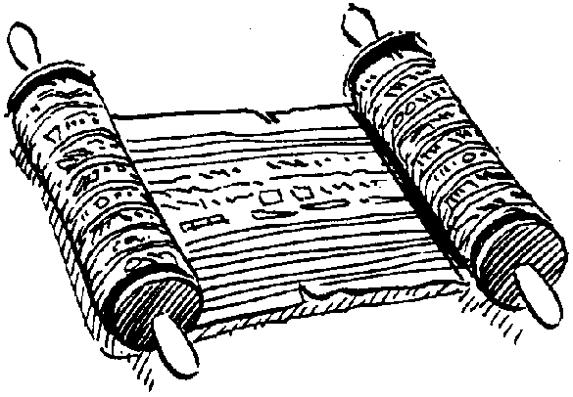

Torah

LEADERSHIP/CLERGY: There are no formal priests or clergy in Judaism. The Rabbi is a teacher. The Rabbi may play a greater role in the religious services, but, essentially, the Rabbi is a layman. A Jew may seek advice from a Rabbi, but the Rabbi has no special authority to tell another Jew what to do or not to do. In recent years, some women have become Rabbis and serve in Reformed synagogues [places of worship].

HOLY PLACES: Jerusalem is the most holy place for Jews. That is where King David ruled. That is where King Solomon built the temple and where it was rebuilt after the Babylonian Captivity. Today, only part of the foundation still exists and is called the Wailing Wall. Many Jews come to this wall to pray.

SPECIAL CUSTOMS: The Torah prohibits eating certain foods [particularly pork] and gives rules for preparing other foods. Food prepared according to the Torah is kosher. Orthodox Jews eat only kosher food; whereas, Reform Jews may not keep totally kosher homes.
Male Jewish babies are circumcised as a mark of the covenant with God that made them the Chosen people. When a Jewish male reaches the age of 13 [the age of religious responsibility], he becomes a man. This is celebrated in the ceremony known as bar mitzvah. Among Conservative and Reform congregations, there is a similar ceremony for females when they reach the age of religious responsibility. This is called bat mitzvah.
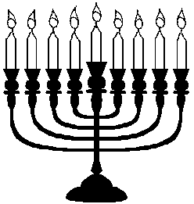

SPECIAL DAYS/SEASONS: The Sabbath is observed every week from sundown on Friday to sundown on Saturday. The home is central to Jewish life and worship. Religious rituals at home are important on most special days. The Ten Days of Penitence are observed in the month of Tishri in the Jewish calendar. They begin with Rosh Hashonah (the New Year) and end with Yom Kippur (the Day of Atonement). Passover (Pesach) is an eight-day festival which commemorates the Exodus and occurs in the spring. Other festivals are Hanukkah, Purim, Succos, Shebuot, etc. Students are invited to look up additional information about these religious festivals.

SYMBOLS: Two common symbols of Judaism are the Star of David [it has six points] and the menorah [a special candle holder that usually holds nine candles].

SHAPING EVENTS: During the Exodus from Egypt, the religion took shape and the monotheistic concept was clarified. Tradition states that this was a 40 year period.
The Golden Age of kings Saul, David, and Solomon were a highpoint of Jewish power and pride. After these times had passed, many Jews wished to return to a time like this.
The Babylonian Captivity involved the destruction of the Temple in Jerusalem and the removal of thousands of Jews to Babylon. Here the synagogue form of worship developed because it was impossible to worship at the Temple--they were hundreds of miles away from its ruins.
Under the Persian king Cyrus, the Jews were allowed to return to Jerusalem and rebuild their temple. The rededication of the Temple and of the Jewish people as God's Chosen People was an important event. It confirmed that God, in his own time, would help them out of every difficulty in which they found themselves.
The Revolt of the Maccabees to eliminate Greek influence on Judaism was another time of rededication. Idols were removed from the Temple and it was rededicated to Yahweh. Jews celebrate this event at Hanukkah.
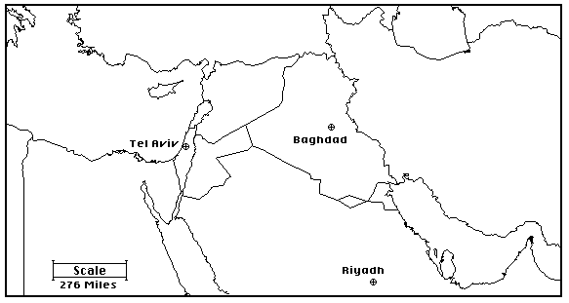

The final destruction of the Temple in 70 A.D. by the Romans began the time of the Diaspora.
The Holocaust in Germany in the 1930's and 1940's gave added life to the Zionist movement [a movement to recreate a Jewish homeland in the Middle East] which began around 1919. The restoration of the State of Israel in 1948, established that homeland. That precipitated a series of wars with the Muslims who lived in and around that area. This tense situation is still not completely resolved, but by late 1994, peace treaties had been signed between
Israel and Egypt, Israel and the Palestinian Liberation Front, and Israel and Jordan, and talks were taking place between Israel and Syria.

Syria

Egypt

Saudi Arabia

Jordan

Iraq

Iran

Turkey

Mediterranean Sea

Red
Sea
Persian
Gulf

Caspian
Sea

MAJOR BELIEFS AND GOALS: Judaism teaches that sin is the failure to do right and is a denial of one's own nature. In the Book of Genesis, God called everything he made "good," so human nature is considered fundamentally good.
Jews believe that they have a special relationship with God. This has given sense and purpose to history, to pain, and to all that happens. Belief in this special relationship has enabled the Jews to survive many difficult times of persecution. They believe that God is the source of justice and righteousness. When they stray from God's ways, it is only just that God punishes them with war and suffering. Their scriptures show them that whenever their ancestors acknowledged their wrongs and asked for forgiveness, God came to their rescue and renewed the covenant with them.
The following list summarizes much of the beliefs of the Jewish people. Since each congregation is autonomous, there is no "official" list that all Jews must accept:
1. There is only one God in the Universe - the God of the Hebrews [the God of Abraham].
2. Judaism's God is one of hope--He created the world for one noble purpose which is to prepare humanity for Heaven.
3. Life is not a burden to be escaped as soon as possible, but a gift to be lived according to God's will or desire.
4. Humans are dust but also have a spark of the divine in them in the form of a soul.
5. Humans are fashioned in the image of God -- that is above all, they have freedom.
6. Humans exercise this freedom when choosing between good and evil, which they face daily.
7. There is a belief in a Heaven and a Hell after death. One's destination depends on whether the person has chosen good or evil. God will be the judge.
8. Humans acquire wisdom and strength to make the right choices by loving and imitating God.
9. Judaism awaits a Messiah who will come from Yahweh, whose identity will not be known, but who will restore Jewish independence or lead them back to the promised land.
10. Judaism believes in the immortality of the soul.
11. The purpose of Judaism is to guide humans in their attempts to find God's will.

READINGS:

"Jews Assuming Social Responsibility"

St. Louis Post-Dispatch Sunday, November 8, 1970
by Edward B. Fiske

NEW YORK, Nov. 7--Ever since the destruction of the emple of Jerusalem in 70 A.D., Jews have prayed for a return to their Palestinian homeland. Their hope is rooted in the Lord's promise to "give the land of Canaan as your portion for an inheritance" (Psalm 105).
With the founding of the State of Israel in 1948, this hope was realized, and, in effect, centuries of diaspora existence were ended.
For obvious reasons, however, Jews found themselves preoccupied with the political and military aspects of the young state, rather than with its religious aspect.
Recently a group of Jewish and Christian theologians gathered at Seton Hall University to reflect on the religious meaning of Israel.

New Urgency
For many, even "secularized" Jews who after the Six Day War of 1967, discovered their emotional involvement with Israel, the religious dimension of the state is taking on new urgency for both faiths.
For Jews, the significance was summarized by Rabbi Irving Greenberg, a progressive young orthodox thinker from Yeshiva University. He noted that Jewish liturgy traditionally had focused on events from the distant past.
He went on to observe however, that present-day Jews have experienced within their own lifetimes two "overwhelming" events of major theological significance that are potentially capable of "supplanting the old orientation."
The first was the destruction of 6,000,000 Jews by the Nazis, an event that "has a major capacity to blot out the Emancipation [Exodus] as the orientating experience of the Jewish people."
The second has been the subsequent emergence of the State of Israel, which stands as a counter-affirmation that "God is faithful to His promises."
To Rabbi Greenberg, the two events, taken together, signify that God has continued to single out the Jewish people for a special "destiny and existence." More pragmatically, they mean that Jews must make a psychological shift from a condition of powerlessness to one of social responsibility.
The emergence of the State of Israel, he said, brings to an end the period of "exiled Judaism," when Jews had only marginal control over their own destiny and the lives of others and when "the task of religion was to give dignity to the powerless."
"Prophets can rely on spiritual power and make absolute demands for righteousness," he said. "Governments have obligations to protect people."
Rabbi Greenberg said that religious leaders must now learn to reconcile ethical absolutes with political realities. "In a sense," he continued, "what is being said in Israel to Judaism is: Put up or shut up. Don't just talk or preach ideals -- carry them out."

Problem for Christians
For Christians, the emergence of the State of Israel poses problems of equal magnitude. Orthodox Christianity has traditionally viewed the loss of the Holy Land as a sign that the Jews have fallen out of God's favor and that the truths of Judaism have been supplanted by the fuller revelations of Christianity.
The rebirth of the State of Israel, however, has now made this view untenable.
Charlotte Klein, a Roman Catholic nun who teaches at the University of Frankfurt, for instance, said that Christian theologians must begin to acknowledge that despite the unique role ascribed to Christ, Judaism continues to have "permanent validity" in the salvation process.
The Christians most eager to endorse this view have been Protestant Fundamentalists, such as evangelist Billy Graham, who regard events such as the reunification of Jerusalem as the fulfillment of biblical prophecy and signs that the Second Coming of Christ is fast approaching.
More Complex
For others the problem is a good deal more complex. The other-worldly nature of much of Christian orthodoxy makes it difficult for Christians to deal with something like the Jewish notion of the religious importance of land.
The Rev. Cornelius Rijk, director of the Vatican Office for Catholic Jewish Relations, told the assembled scholars at Seton Hall that recent developments had made the emergence of a Christian theology of Israel a possibility.
One is the growing interest among Catholics in the Bible, especially the Old Testament. Another is the increasingly open attitude among Christians toward other religions of all kinds.
Although the problem is far from solved, Father Rijk suggested that the answer could lie in the traditional Christian view that divine revelation did not end in ancient times but is a continuing reality. Despite current differences, he said, Jews and Christians stand side by side with partial truths awaiting God's final revelation and the initiation of the Kingdom of God.
Wherever the solution may lie, however, the fact is that Christian theologians already have a new attitude toward Judaism.
Rabbi Marc Tanenbaum of the American Jewish Committee summed it up. "The Jewish people," he said, "are being perceived in their own terms rather than as candidates for conversion."

