A SUMMARY OF ISLAM
Geography
Mr. Naumann

Islam was founded by a trader from Mecca, in what is now Saudi Arabia, named Muhammud who believed that he was receiving messages from God. Muhammud was unable to get enough people to follow him in Mecca, and he did make some powerful enemies there. Muhammud taught a strict monotheism and preached against the polytheism which was practiced in that area. At that time, a sacred place of pilgrimage in Mecca, the Ka'bah, was a place where many idols were kept and worshipped. Religious leader in Mecca feared that Muhammud and his followers might succeed in ending the practice of polytheism in Mecca so they conspired to kill him. The Hijra in 622 C.E. is considered the beginning of the Muslim era. The Hijra was the "flight"--when Muhammud fled from Mecca to the city of Medina to avoid being killed. He was welcomed in Medina and was made the ruler of the city. Islam spread there. Muhammud and his followers later returned and converted Mecca. For Muslims, Mecca is the most holy city on earth. Today, 971,328,700 Muslims are found mainly in Arabia, the Middle East, and North Africa, and it is the fastest growing religion in Africa. While Islam is associated with the Middle East where it originated, the country with the largest Muslim population in the world, Indonesia, is not in the Middle East. In recent years, the number of Muslims in North America has grown to 2,847,000.

CONCEPT OF GOD: Islam means submission to the will of Allah. Allah is the Arabic word that means "god"--it is not a name given to God. Islam is a strictly monotheistic religion. Muslims [believers of Islam] believe that their God, Allah, is the same as the God of Abraham, the father of Judaism. They do not believe that that God is a trinity like the Christians do. To Muslims, God is one and absolute, transcendent in power. God's will is arbitrary and he can change the direction of his will at any time. Allah is compassionate and merciful and hates oppression and injustice and requires kindness to orphans and to the poor.
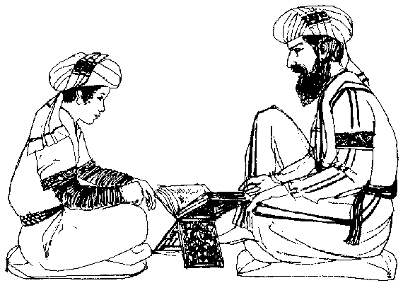

SACRED WRITINGS: It is believed that Allah gave a revelation to Muhammud through the angel Gabriel. It was written down and is called the Koran. The Koran contains many stories about people and events that are mentioned in the Jewish and Christian scriptures, but the details of the stories are not always the same. Muslims refer to Jews and Christians as "the people of the Book." Muslims recognize that Jews and Christians have had relationships with the same God; however, Muslims believe that only the Muslim revelation, the last one, is complete. The Koran also contains many other stories and teachings. It is believed to contain all that a person needs to know to live spiritually, economically, legally, socially, and politically. The Koran contains all these things because Islam is more than a religion; it is a complete way of life. There should be no separation between church and state under Islam.
Learning the Koran

The Koran is believed to be co-eternal with Allah and is written in rays of light on a tablet standing by the throne of Allah. The Angel Gabriel revealed to Muhammud from the co-eternal Koran. It contains the whole teaching of Islam. A traditional Muslim education is to learn the Koran. The Koran is only to be read in Arabic. Translations are available, but are not acceptable for the use of the faithful.

Next to the Koran, the most important book is the Hadith. It is a collection of the actions and sayings of Muhammud. Hadith means tradition.

IMPORTANT LEADERS: Among the important leaders is Muhammud Husein, Muhammud's grandson, whose assassination inspired the Shia sect. Abu Bakr was Muhammud's father-in-law and successor. Omar succeeded Abu Bakr and became the second Caliph [leader of Islam]. Zayd ibn Thabit was Muhammud's secretary who is credited with gathering together the revelations after Muhammud's death and organizing them into the Koran. Othman (Uthman) was the third Caliph under whose leadership the final, official version of the Koran was prepared. Ali was Muhammud's son-in-law whose followers claim was the first true Caliph. Ali's followers were called the Shia Ali and began the Shia sect of Islam.

MAJOR SUBDIVISIONS: The Britannica Book of the Year 1988 divides Islam into three groups: Sunnis -- 83%; Shia [Shiah or Shi'ah] -- 16%; and others (including Sufi) -- 1%.

The two main sects are the Shia [Shi'ite] and Sunni. They split over the question of the line of succession from Muhammud. The Shi'ite sect is sometimes referred to as the more liberal branch did not recognize the first three Caliphs as true successors to Muhammud because they were not related to Muhammud. They only recognize the fourth, Ali and his successors. They only recognize twelve Imams [religious leaders] since the death of Muhammud and believe that one more may appear at any time to conquer the world and usher in justice and righteousness. The Shia is the majority sect in Iran and a sizable one in India.

The Sunni sect is often referred to as the more orthodox sect in Islam, though there is no official leader to define what is or is not orthodox. The great majority of Muslims are of the Sunni Sect. The Sunni recognize the first four Caliphs as true successors to Muhammud.

An interesting, but small, sect in Islam is the Sufi sect. It is a mystical sect. Sufi means "undyed wool." A Sufi, then, is one who wears undyed wool because of its simplicity. Originally the movement was concerned with self-discipline, but later it changed its emphasis to the attainment of inner illumination and, especially, union with Allah.

LEADERSHIP/CLERGY: In Islam there is no ordained or unordained priesthood. There are no intermediaries between the believer and Allah. The ulema is a learned and respected teacher who explains the doctrines of Islam but has no official authority over anyone. The muezzin calls people to prayer from the minaret [tower] of the mosque [place of prayer]. Among the Shi'ite Muslims, the Imam is a respected leader.

HOLY PLACES: Mecca is the most holy city where Muhammud received his revelations. Within Mecca, the Ka'bah is the most sacred shrine. Muslims believe that Abraham built the Ka'bah. Jerusalem is also a holy place [it is holy to Jews and to Christians also]. The Dome of the Rock in Jerusalem is one of the earliest holy places in Islam.

SPECIAL CUSTOMS: Some of the diet restrictions of the Jews are followed by Muslims, particularly not eating pork. Alcoholic beverages are also forbidden.

Under the laws of Islam, men may have up to four wives. In many Muslim countries, women dress to be "covered." This practice is called purdah. The covering that covers the head and face is called a burka. The practice of purdah is not required by the Koran, but is really rooted in the pre-Islamic culture of those peoples.
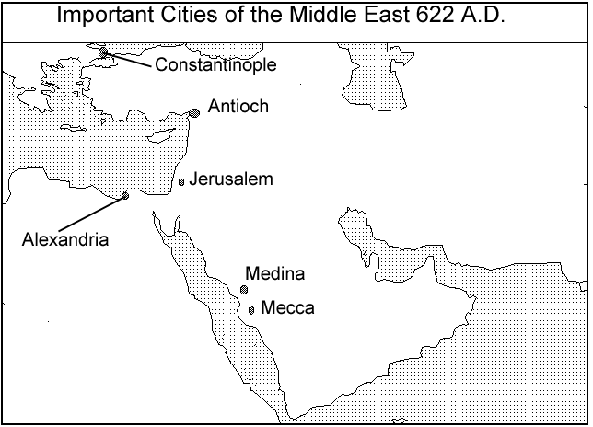

SPECIAL DAYS/SEASONS: The month of Ramadan is sacred and Muslims are expected to fast every day for the whole month. They take nothing by mouth [not even water] from sunrise to sunset. They may eat and drink at night.

SYMBOLS: The crescent, or new moon, often shown with a star as a symbol of Islam.

SHAPING EVENTS: The era of Islam began with Muhammud receiving the divine revelation. The calendar is dated from the Hijra, or "flight," which occurred in 622 A.D. This is when Muhammud had to flee from Mecca and find refuge in Medina, a city to the north of Mecca.

The 7th century was a period of theological disagreement about human will. Some Muslims taught that humans had free will. These were known as the Qadarites. This belief was considered to be a heresy at first, but it was later accepted. Opposed to them were those who believed in predestination, which left little room for free will. Some think that this controversy might have been instigated by contacts with Christians. The 10th century was the period in which the Muslim creed was crystallized.

During the 20th century, there has been a revival of fundamental Islam. It seems to be a reaction to the "corrupting influence" of Western culture. Faced with what some saw as a decline in vitality and power in Islam, some leaders promised that a return to orthodox Islam in an Islamic state would improve the situation in the Muslim world. One such leader was the Imam Ayatullah Ruhallah Khomeini in Iran. Under his leadership, an Islamic state has been imposed on Iran.

MAJOR BELIEFS AND GOALS: Islam, in essence, is a simple faith for the average person. It has great appeal to nomadic people because the requirements are not excessive and those commandments that do exist are clear and limited so that anyone can follow them. There are no formal leaders and clergy and no required places of worship. Islam is a faith that a believer can practice wherever he/she is. This is why it has been called a "portable religion." Islam includes the belief in one God, angels, revealed books [Koran], prophets, and a Day of Judgement.

There are five basic requirements of the faithful, often called the Five Pillars of Islam. The shahadah, or creed, is recited many times a day by the faithful. It is: La ilaha illa'llah muhammadun rasulu'llah. It means "There is no other God but Allah (and) Muhammud is the Prophet of Allah." When the muezzin calls the faithful to prayer five times a day, he uses a similar formula: Allah is most Great! Allah is most Great! I bear witness that there is no god by Allah! I bear witness that Muhammud is the prophet of Allah! Come to prayer! Come to prayer!

Then there is the pillar of daily prayer, or salat. Muslims are called to prayer five times a day. If they can go to a mosque, they should, but prayer can be said wherever the person is. Women generally pray at home, though separate space has been provided in mosques in recent times. Ideally, the head, hands, and feet should be washed before prayer. The prayers are said in Arabic, regardless of the daily language of the faithful. Prayer is said five times a day. Friday is set aside for public prayer. On Friday, all Muslims who can gather at and around the nearest mosque for prayer. During times of sickness or travelling, the Koran allows for a relaxation of this requirement. When a Muslim prays, he/she faces Mecca [in the earliest time of Islam, they faced Jerusalem].

Zakat, or almsgiving, is the requirement to provide for the needy. It is a voluntary gift to the needy. Some Muslims think of almsgiving as a loan to God, who will repay it in abundance.

The fourth pillar is sawm, or fasting. This is done during the month of Ramadan. Nothing may be consumed from sunrise to sunset, not even one's own saliva. This is done every day during that month.

The hajj, or pilgrimage is the fifth pillar. Before one dies, one should make a hajj to Mecca to the shrine known as the Ka'bah [Ka'aba]. This pilgrimage does much to unite Muslims and to create the sense of universal kinship [they would probably say "brotherhood"] of all people. One who has made the pilgrimage may take the title haji. Each year, during the special time for the hajj, hundreds of thousands of Muslims from many countries and continents experience the prescribed rituals together and leave with a deeper spiritual understanding of the kinship of all people that Allah desires.

Muhammud was opposed to cruelty, idolatry, gambling, infanticide, and unfairness to women. The word Islam means submission, here meaning submission to the will of Allah. In Islam, humans are seen as being created "good"; there is no dualism of a "sinful" body and a "good" soul in each person. Islam does allow men to have up to four wives.

Because its requirements are easy for anyone to meet, it might be called a portable religion because it can be practiced anywhere at anytime, Islam has been easily accepted by nomadic people. In Africa it has been the fastest growing religion in the 20th century, partly because it is not tainted with the association with racial discrimination.

READINGS:
EXCERPTS FROM THE HAJJ: AN APPRECIATION
written by Ismail Ibrahim Nawwab
Published in Aramco World Magazine,
Vol. 25 no. 6, Nov.-Dec. 1974

In response to God's injunction to mankind prescribing the Pilgrimage to Mecca (the Koran, Sura III, verse 97), countless followers of Islam, rising yearly from the global ocean of humanity, have sallied forth to make the Hajj for almost 14 centuries. Considering the uniqueness of this phenomenon, with its rich kaleidoscope of symbol and significance, appearance and reality, past and present, and the innate, almost universal barrier to empathy in religious matters, few non-Muslims can be expected to have any inkling of what the Pilgrimage really means to the believer.

What does the Hajj mean? Is it a sterile ritual? A formality, perhaps? Or, as one of the five pillars of Islam--that is, one of the requirements imposed on Muslims--is it merely an obligation to be discharged as quickly and perfunctorily as possible?

Nothing could be further from the truth. Indeed, it is no exaggeration to say that the Hajj, to the average Muslim, is the emotive goal and the climactic experience of his temporal existence. It is a form of spiritual fulfillment which he shares and simultaneously celebrates with the entire world of Islam. But to explain why--and to attain some understanding of the symbolism and function of the Hajj--one must go back to the historical and sociological highlights of the Islamic traditions in which its origins are embedded.

It all begins with Abraham. In Islam, Abraham--the same Old Testament Abraham familiar to Judaism and Christianity--plays an important role. He is regarded as a prophet and venerated as a zealous advocate of monotheism, as a relentless foe of idolatry and as builder of the Ka'bah, "the House of God," focal point for Muslim worship of the One God. With respect to the Hajj specifically, Abraham, his son Ishmael and his wife Hagar are central to some of its holiest rites.

But the Hajj only begins with Abraham; it is affirmed by Muhammud, the Prophet of Islam, who, in making the Pilgrimage begun by Abraham, found that it had degenerated into a soulless idolatrous ritual and purged it. To Muslims this continuous monotheistic strand holding together the time of Abraham and the era of Muhammud is a symbol of the unity of God which permeates Muslim religious thought. Thus the yearning to behold, at least once in their lifetime, the pivotal Ka'bah, the center of the cosmos and Qiblah or focus of all prayer, symbolizes to a Muslim humanity's movement toward unity in the quest for God.

The rites of the Hajj--which are precisely those followed or approved by Muhammud during his Pilgrimage--are few in number, simple in execution, but rich in meaning.

Quite apart from the historical and symbolic significance of the Hajj, the institution of the Pilgrimage serves two main functions for the Muslim, both as an individual and as a member of society.

The unassuming Ihram [seamless white garment] worn by the pilgrim serves a social purpose as well. For at least once in the believer's lifetime, the idea of equality among Muslims becomes a visible fact. Philosopher and fool, patrician and plebeian, millionaire and beggar alike wear this unsewn garment-and become indistinguishable.
The social status or privileged rank of the believer is of no consequence in the sight of God. During the Pilgrimage, as a result of this simple sartorial device, neither are they of consequence in the sight of man.

Also on the social plane, the major, unparalleled contribution of Islam is in the area of racial harmony and the brotherhood of the faithful. The Hajj is Islam's key instrument for creating and strengthening fraternal ties among millions of its followers. Pilgrims representing every conceivable color, country and tongue yearly converge upon Mecca. Here, they share common objectives and beliefs, and perform the same devotions. They also get acquainted with one another, and learn of, and grow to care for, the conditions of their brethren in other countries. The Hajj inspires in the believer an unrivalled sense of solidarity, a feeling of identification in a world of alienation. The believer feels himself a part of the whole system of the cosmos. Whether in Mina or Michigan, 'Arafat or Zululand, no man, no woman and no nation is an island. In this reunion, convened annually by God from the time of Abraham, ties of brotherhood and love are forged among people representing the nations of the earth.

The Unending Feud: Shi'ites vs. Sunnis
Time, August 17, 1987.
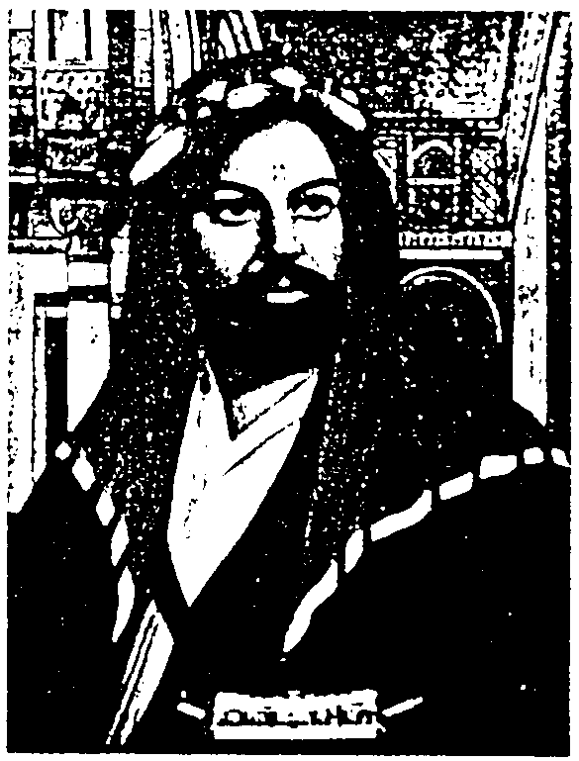

"There is no god but God, and Muhammad is the Messenger of God." That confession of faith, the shahada, is professed by all Muslims, be they the 700 million Sunnis who dominate the Islamic world from Morocco to Indonesia or the 90 million Shi'ites who rule Iran and form majorities in Lebanon, Bahrain and Iraq. To the shahada, however, the Shi'ites add, "And Ali is the Friend of God." Those additional words in praise of Ali, whom the Shi'ites passionately claim is Muhammad's true successor, epitomize the complex and often bloody feud between Islam's two branches.
Ali, the "Friend of God"

Among the close disciples of the Prophet, his son-in-law Ali was the most familiar with the teachings of Islam's founder. Yet when Muhammad died in A.D. 632, his followers bypassed Ali for the succession. However, the Shi'at Ali, the partisans of Ali, argued that the Prophet had designated Ali and his family the hereditary rulers of Islam. Persevering with his claim, Ali became Islam's leader in A.D. 656, only to be assassinated five years later. Hussein, Ali's son, eventually pressed his own claim to the leadership. But he and most of his family were killed in battle with rival forces at Karbala in Iraq. To the horror of all Islam, the Prophet's grandson was cruelly tortured before being beheaded.

To the Shi'at Ali, who later became known as Shi'ites, Hussein's tragic attempt to establish the Prophet's true succession was the supreme sacrifice for the faith. Martyrdom thus offers Shi'ites a chance to imitate their sainted hero. In Iran, which is more than 90% Shi'ite, passion plays depicting Hussein's last hours are performed regularly. Each year, on the date of Hussein's death, thousands of penitents march through Iranian streets whipping themselves with chains and branches, seeking purification through suffering.

Faithful Shi'ites admit only to the authority of Muhammad and the Twelve Imams, who comprise Ali, Hussein and certain of their direct descendants. The Shi'ites consider the Twelve to be mediators between God and man. Though the Twelfth and last Imam went into hiding in A.D. 940, Shi'ites believe that he will re-emerge to rule the world as the messianic Mahdi. Until that time, the Shi'ite clergy are responsible for interpreting Islam. The Ayatullah Khomeini, however, has gone one step further by establishing his government as a regency for the Mahdi. Khomeini, who claims descent from Muhammad through the Seventh Imam, has never claimed to be the Twelfth Imam, but he has done nothing to discourage his followers from hailing him as such. Some Shi'ites consider that zeal misplaced and heretical.

While they honor Ali, the Sunnis do not venerate their imams as divine intercessors. Sunni imams mainly conduct community prayers. Each Sunni (from sunna, "the tradition of the Prophet") believes he can have a direct relationship with God. While the Sunnis scorn emotional outbursts and engage in private, meditative piety, Shi'ites are more likely to indulge in displays of religious ardor. Indeed, the Sunnis, who consider themselves the orthodoxy, did not accept Shi'ism as a legitimate school of Islam until 1959.

Among some Arab states on the Persian Gulf, the relationship between Sunni rulers and Shi'ite subjects remains volatile. After all, in the eyes of the Shi'ites, any regime not under the rule of the Prophet's true heirs is an abomination. Indeed, Bahrain, which is more than 70% Shi'ite, defused a 1981 coup attempt allegedly inspired by Tehran. Kuwait, which is 25% Shi'ite, has been victimized by a wave of bombings believed to be the work of pro-Iranian terrorists.

In the war between Iraq and Iran, however, Iraqi Shi'ites, who make up almost 60% of their country's population, have chosen to be Iraqis first and Shi'ites second. The ancient animosity between Arabs and Persians apparently transcends religious sympathies. Nonetheless, the Iraqis receive constant reminders of Iranian Shi'ite fervor. Tehran's major offensives are named Karbala, after the place where Hussein died, and captured Iranian soldiers proudly show off the "keys to Heaven" issued to them when they enlisted. The celestial keys: dog tags. Observes an Iraqi official: "The Iranians are still fighting the Battle of Hussein."

