MAN THE CHOOSER AND MANKIND’S MOST IMPORTANT CHOICES
by Daniel Jacobson
From: The Journal of Geography Vol. LXIX No. 6, Sept. 1970

Simplified by J. Naumann

INTRODUCTION

East Africa -- One Million Years Ago

Perhaps a million years ago, early people set up temporary campsites on the shallow edges of small lakes. Armed with wooden spears and throwing stones, they hunted the small animals and the young of the larger animals. Using crude stone tools, the hunters cut up the animal meat and removed the marrow from the bones.

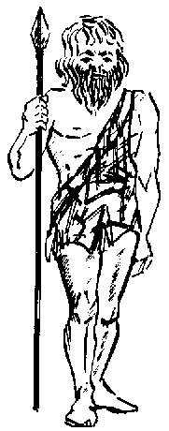
The ancestors of these hunters had not been hunters. They were plant eater, not meat eaters. They gathered fruits and nuts and dug for roots. They got along fairly well. As other animals that ate plants for food competed more with them for food, they were forced to make a choice. They could move to where there was less competition. They could fight the large animals that ate plants. But, the killing of small animals for their meat seemed to be the best choice for them.

When the choice was made, we do not know. but these people did make it. They began to search the earth for small animals. Over a long period of time, they learned to make their first tools. They created the first cultures to meet their needs.

THE POWER OF CHOICE

The people of today and all of their ancestors, even the earliest ones, have had the power of choice. Humans have used that power for both good and ill. They have grown in numbers and live all over the earth. By changing their ways of living [cultures], they have learned to live in many different environments. They have left their mark on the face of the land. They have cut down the forests; taken minerals from the earth; planted many kinds of crops; built tunnels, bridges, houses, and skyscrapers; and settled in small towns and large cities. They have built and destroyed. Many teachers have stressed the power of the environment over humans, but throughout time, humans really have been the choosers.

HUMAN’S MOST SIGNIFICANT CHOICES

Southwestern Asia -- 9000 to 7000 BCE

The descendants of the early hunters moved about and settled most of Africa and southern Eurasia from Great Britain to China. They learned to live in savanna grassland and forest environments. After they learned to use fire and make new kinds of clothes, they were even able to live in the colder climate regions. Neanderthal people even survived the climate changes that were part of the last ice age. As Homo Sapiens, or modern humans, they sent small bands of hunters across northern Asia and across the Bering Land Bridge to the New World.

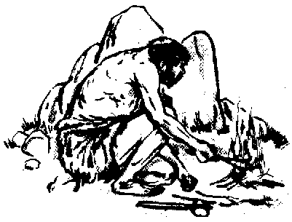As the ice age ended with the melting of the glaciers, humans kept on changing their ways as their environments changed. Around 9,000 to 11,000 years ago in southwestern Asia (not far from the modern countries of Turkey and Iraq), the environment changed very little. More moisture was available than there is today, but that is the only real difference. It was and is an area of rugged mountains and broad plains. The plant life ranged from forest to desert types. Rain came in winter and spring. On the upland slopes (1,000-3,000 feet above sea level), wild wheat and barley thrived. The animal life included wild dogs, goats, sheep, cattle, and pigs.

The upland habitat was a very good home for humans. They may have lived there for centuries hunting wild game and collecting seeds from wild grasses. They settled in caves or in the open near clear running water. In 8900 BCE, they had built a fairly permanent settlement in northeastern Iraq. Their homes were round stone huts topped with reed or mud and stick walls. They hunted game with finely chipped stone tools; ground acorns, berries, nuts, and wild seeds on millstones; and stored the crushed and ground product in pits. They made baskets, buried their dead in caves, traded over great distances for special kinds of stone, and wore ornaments made of stone beads and shells. There may have been other settlements like this in this hilly and mountainous area also.

At this time, there were other villages in Palestine along the coast of the Mediterranean Sea and in the Jordan Valley. Food collectors were also living and working in the southern part of the country we call Turkey today.

Domestication of Plants

All these early villages had good supplies and many kinds of food within reach. The arts of plant and animal domestication were born in many environments. They were born at different times and for varied reasons.

Having seen that wild grains were hard to harvest [the seeds fall off the stems easily], people in southwestern Asia may have picked those wheat and barley plants with seeds that were hard to knock off their stems. They planted some of these seeds near their upland homes or in new and different environments on lowlands near the edges of the hills. Over a large span of time, the plants changed to the domesticated plants we know today. Wheat lost its ability to scatter its seeds. It came to depend on people to scatter the seeds. Wild barley, which is well suited to the uplands, became a plant better suited to lowland country.

The Domestication of Animals

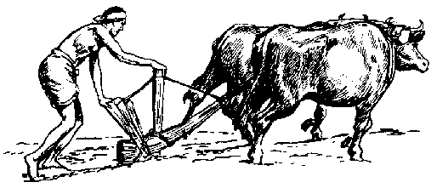Humans did not overlook the wild animals. Wild sheep and goats may have been tamed by village hunters or even by hunters who had not learned to live in villages yet. Sheep and goats were hunted, captured, and allowed to breed. The offspring became very tame. They were raised as pets and used for food. Clothes were made from the skins. People learned to use milk from the goat much later. Raising sheep for wool also came much later. Now it is known that the dog was not domesticated before sheep and goats were. For a long time, it was thought that the dog was the first one domesticated.

As people learned to plant crops in fields, plant eating animals began to gather near the villages. Wild cattle came to the villages as crop-robbers. They ended up as tamed beasts living in the pens and stables of the farmers.

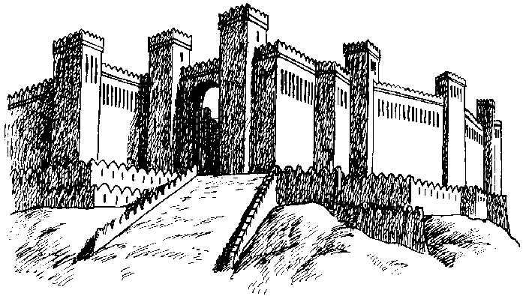
People had already made the most important choices they were to make during their lives on earth. They had chosen to plant the wild seeds and to raise the wild beasts in captivity. They had moved the plants and animals to places to which they were not by nature adapted. They had picked the varieties of breeds that they wanted to survive. People took their choices with them as they moved about and settled in Eurasia and Africa.

The Breakthrough to Civilization

Many social, economic, political, and intellectual changes took place as a result of people’s choice to be food producers. They developed the basics of civilization -- writing, refining metals, the wheel, organized religion, city life, and the state as apolitical unit. Population grew. Cultures changed and grew. Culture developed to the level of civilization in Mesopotamia -- a very different environment from the one where the domestication process began. Later, civilizations developed in other places like the Nile, Indus and Huang valleys. From these places civilization was spread far and wide. People had certainly made their choices. By making choices, they would change the face of the earth for all time.

CONCLUSIONS

Humans have always had the power of choice. In the earliest time periods, early people made their choices directly in terms of the natural environment. Their main interest from morning to night could only have been pure survival. There was time for little else.

A million years later, in the hill country of Southwestern Asia (9000-7000 BCE), man continued to cooperate with his environment. But his total knowledge had grown greatly, and he was to use that knowledge well. He would domesticate plants and animals. This was the basis on which civilizations were built and from which they soared.

Much later in England, fifty centuries after the development of agriculture and the breakthrough to civilization, humans would make other choices in regard to their environment. They would change sharply their view of the English resource base. They could then create an industrial revolution. These ideas also spread to many parts of the world.

Plant and animal domestication and the process of industrialization may well be the most important choices that humans have made on the planet to date. But in this decade, and those of the future, there are equally important choices that must be made if we are to survive as a world civilization

The times cry for foresight, vision, and visionary imaginings. They cry for an understanding of environment. They may well be crying for humans, the choosers, to make the most important choices they have ever made so far.

INVENTION PROGRESS AND INNOVATION FROM THE EARLIEST TIMES AND ANCIENT TIMES

The achievements listed under each civilization below are only some of the ones that it is remembered for having developed. It may not have been the only civilization to have developed that contribution. Civilizations also borrowed ideas from each other. More recent civilizations have been able to borrow good ideas from civilizations that came before them.

PRE-ANCIENT CIVILIZATIONS __________________________________________
Domestication of plants Domestication of animals
Use of fire Stone tools
Metal tools Clothing
Basket weaving Pottery
Boats

EGYPT_____________________________________________________________
Stone buildings Writing [hieroglyphics]
Solar calendar Geometry
Surgery and medicine

MESOPOTAMIA [Sumerians, Babylonians, Ssayrians, etc.] _____________________
Brick buildings Business records [cuneiform writing]
Astronomy Mathematics
The Plow Written laws

PHOENICIANS______________________________________________________
Improved ships and trade Simplified writing [alphabet]

ISRAELITES________________________________________________________
Idea of one God Old Testament literature

HITTITES___________________________________________________________
Iron Use of horses

PERSIANS__________________________________________________________
Highway system Religious toleration

LYDIANS___________________________________________________________
Standard metal coins as a medium of exchange

CREATANS_________________________________________________________
Foreign trade Plumbing

INDIANS______________________________________________________________
The Hindu religion The caste system
Metal working including iron Trade with Mesopotamia
Trade with China Spinning and weaving cotton
Created neatly laid out towns Decimal number system (including zero)

CHINESE_____________________________________________________________
Cultivation of wheat Cultivation of silk worms
Silk weaving and production Bronze weapons
Writing system Wheeled chariots used in warfare
Beginning of ancestor worship

