The “One PE Peak” test (arranged to drive the PM with a pulsed LED to give only about 10% of the time any light, and only 1% more than one photons) allows a measurement of the statistical fluctuations from the secondary emissions among the dynodes without the need to do mathematical calculations, because it is an average direct response of the Photomultiplier to a single incoming photon. A distribution including higher peaks would make the various PEs characteristics more complicated to discern.

The set up for the one PE peak involves driving an LED at a small frequency and covering the PM a surface with small openings such that the probability of more than one single electron entering the PM at the same time is really small. Supposing that the entire response is only a Poisson distribution where the number of counting trials becomes big while the probability of “success” becomes small, so that theoretically their deviation from the mean is just the square root of this number. (See Appendix). The Poisson distribution is defined as: P<x>(n) = e -<x> <x> ^{n} / n! , where n is the number of discrete counts in some definite time and <x> is the expected number of counts; it can be shown that n_{avg} = <x> after many trialsŦ. In a histogram a weighted average (<x>) of the number of events in the x-axis weighted by the frequency of such events in the y-axis, the probabilities for different multiples of 1 PE can be calculated, then the probability of 1 PE events (n=1) to no events (n=0): P<x>(1) / P<x>(0) = <x>; and 2 PE events (n=2) to 1PE events (n=1): P<x>(2) / P<x>(1) = ½ <x>. So by making the probability of 1 PE to no PE very small (= weighted average <x>), the probability of 2 PE to 1PE is half as small.

Because a histogram records the number of events vs. the amount of charge collected at each event (which is it self directly proportional to the gain), it gives the inherent gain fluctuations from a measurable mean following a Poisson distribution. However the distribution is not only due to Poisson but also involves a convolution of Gaussians for higher dynodes, as it will be shown.

The overall gain of the one PE peak is a spread of all the different gains when multiplied for each dynode stage. Then its shape is determined by the convolutions of all these functions, where the gain of the PM is proportional to the total number of electrons created, this in turn being the multiplications of all the different dynode gains (δ). The number of electrons produced by the first dynode will be approximated by a Poisson distribution since the average number of electrons produced are the least, whereas as the number of electrons produced for higher dynodes becomes large and their statistical fluctuation becomes more shaped like a Gaussian with standard deviation (σ) equal to the square root of the mean value. So if we approximate each of the higher gains by Gaussians (i.e. α e ^{(δ/2σ)^2}) and the first dynode by Poisson e ^{-Δ} Δ ^{n} / n! then their multiplication for n dynodes will be: β  e ^{−Δ} * e^{-n (δ/2σ) ^2}, where α  and β are different normalization constants. This expression can be rearranged look like:
β  e^{- (n δ^2+ 2 σ^2 Δ) / (2σ) ^2}, because the values in the exponents add. The fractional uncertainty (sigma / avg. number) of the peak then gives a quantifiable sense of the height of the peak to its spread; the lower this ratio the less the uncertainty. The fractional uncertainty then becomes: σ / ( n δ^2+ 2 σ^2 Δ)^{½} = 1/ (n δ+ 2 Δ)^{½}, since σ = δ^{½} . Thus the first dynode gain (Δ) has twice the effect that any other dynode would have, then having more weight on the narrowness of the peak.

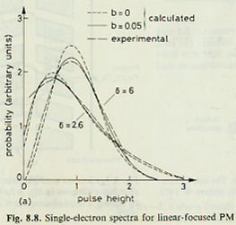
The Gaussians in reality have different spreads and depend on previous multiplicating distributions (something that was ignored in the treatment above). The probability for a cascading event is given by σ_{2Δ}² = δ₂² σ₂² + Δ σ_{Δ}² [Burle]◊, where Δ is the average initiating event and δ₂ is the sequential gain. However, it is gives a sense on why the fist dynode gain is important.

The parameter b shown in Fig 8.8 is the rms deviation from perfect uniformity of the secondary emission factor δ over the surface of the dynode.

First dynode gain derivation by Burle Tubes.

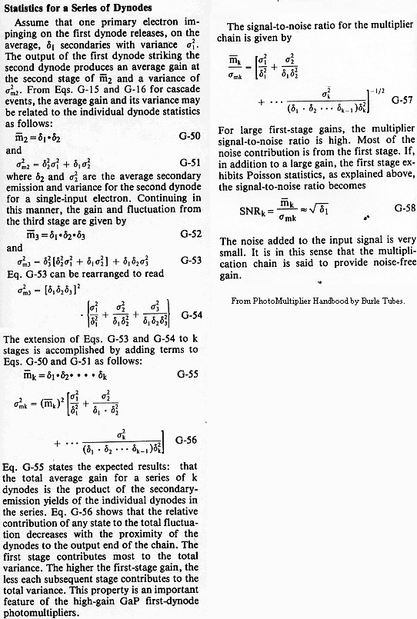

Ŧ See Appendix.
→ See Appendix for a derivation due to Burle PMs.

