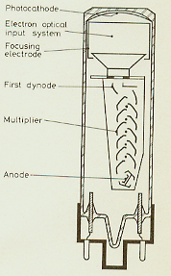
Photomultipliers work on the principle of the photoelectric effect in which the momentum of a photon, upon collision with a metal, can overcome the binding energy of an electron in this material, freeing it. Applying an electric field in this region can accelerate the electron away from the metal so that it can release more electrons when colliding with other surfaces, thus multiplying the number of electrons in each successive stage. By roughly releasing 10 electrons from the first dynode and 3-4 electrons in the successive 11 dynodes, gains in the order of 10 * (3-4)^11 = 10⁶-10⁷ are achieved. Thus utilizing the photoelectric effect to create a multiplying cascade of electrons is a great way to amplify the presence of a single incoming photon. This pulse of out coming electrons occurs in 5-10 ns, developing signals of 5 mV or greater produced from one incoming photon, 1 PE (Photoelectron). Signals of multiple PE’s as those produced by ionizing particles in the scintillating material, are analyzed with a logic arrangement to confirm or refute their presence.

The quantum efficiency, electrons released per incident photon, has a dependence on the wavelength of the photon and the target material, as shown in the figure below.
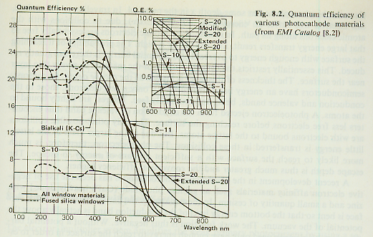

Metals have more valence electrons than do semi-conductors. Because these are essentially free, collisions by an electron from an ionized atom with the valence electrons results in transferring relatively large cumulative energies, as more collisions are encountered. Useful electrons in metals, then, are restricted to a thin layer in the surface known as escape depth. On the other hand, electrons in semiconductors have a better chance at eluding valence electrons, since there aren’t as many, so that an ionized electron can reach the surface with sufficient energy to escape. The end result is that the efficiency for semi-conductors is about 10-30 % and for metals is about 0.1%. A combination of both materials can be used to increase the performance; in our case the combination BeCu is used.
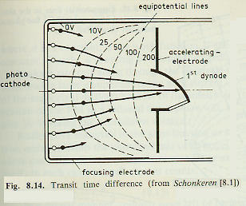
Electric and/or magnetic fields are arranged in the focusing electrode in order to collect all the electrons hitting at the same time regardless of their point of origin in the photocathode.

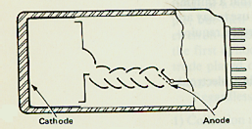
The gain of each subsequent stage in the multiplier chain (dynode) must be high and stable (i.e. low noise) in order to give stable gain. From the many designs in Photomultipliers, the Linear focused (shown on the left) currently used in our experiment, proves to give reasonable linearity over a modest current range since electrons are better focused and provides a gain of around 10^7 for 12 dynodes.

Gain is defined as the ratio of what you get out by what you get in
, where 50 ohms is the characteristic impedance of coaxial cables.

