Abstract:

A three week high school teacher’s workshop was held in June/July of 2004 at the University of Missouri St. Louis. Seven teachers from St. Louis area high schools and two teachers from surrounding states participated. Two undergraduates from a REU (research experience for undergraduates) program at the University of Pittsburg and a graduate student from UMSL also participated. The program was directed by Julia Thompson, Professor of Physics at the University of Pittsburgh, Adjunct Professor at the University of Missouri St. Louis, and Dave Kraus, Senior research associate. Several portable Cosmic Ray detectors were constructed by the group and taken to the teacher’s respective schools to be integrated into the school’s science curriculum. These detectors are intended as precursors to a more sophisticated GPS time stamping system which will provide a network of detectors capable of conducting research level work in addition to the pedagogical motivations already established.

Introduction:

High school physics education is currently in a state of reform. Topics from modern physics are beginning to find their place in the traditional curriculum of mechanics and electrostatics. Nuclear and particle physics are one example of such a reform. Cosmic ray detectors provide an ideal setting for introducing particle physics, experimental methods and an exposure to a professional research environment. These are the primary motivations for holding a teacher’s workshop. Our workshop involved nine teachers interested in bringing cosmic ray physics into their schools. Teachers were asked to focus on a specific project while aiding in the construction, testing and overall understanding of “LBL” detectors. Individual projects included “construction of the LBL electronics board”, “construction of a diffusion cloud chamber and an expansion cloud chamber” “testing two small counter arrays”, “effects of building materials on cosmic rays”, “film and video documentation of the workshop”, “use of GPS time stamped setups”, “evaluation of the CASA scintillator”. Four completed “LBL” setups were taken by teachers to integrate into their curriculum.
There are numerous other similar programs throughout the country [1]. Most of these programs are in conjunction with an established experimental particle physics group, which the St. Louis area lacks. Our CosRay HS project aims to introduce such a connection in the St. Louis area. Much of the support comes from an affiliation with the University of Pittsburgh which has ties to other universities and national labs. A strong effort was made to educate teachers on not just the construction, but also the use and testing of these detectors. A significant portion of the individual projects were dedicated to this.

Equipment:

The four detectors that were taken to area schools were modeled after a detector developed by Lawerence Berkeley National Lab [2]. The original LBL design consisted of two scintillators fixed inside a wooden box coupled to a simple coincidence logic device. Our detector also consisted of two plastic scintillators, each connected to a photomultiplier tube, but mounted in an acrylic frame that allowed for various orientations not permitted by the original LBL design. A coincidence logic unit was also modeled after the LBL setup. Individual teachers contacted LBL and requested printed circuit boards that were provided free of cost. A parts list found online was used to order the necessary components from an electronic distributor such as DIGI-KEY [5]. An updated parts list providing replacements for some discontinued parts was made by one of the workshop participants A smaller unit containing a microcontroller was used as an overflow counter since the original LBL board only contained three digits which limited the number of counts to be less than 1000 [6]. We intend to use these small microcontroller based counters as an eventual replacement of the LBL card, which will reduce cost and improve ease of operation. These microcontroller based counters come in an enhanced version which allows for higher counting rates. These LBL boards were tested by the group and found to have a threshold around 10mv, below which a count is not made. Measurements of the response to a dual pulse were also taken. It was found that two pulses must be separated by at least 800ns in order to be counted [appendix 1]. The output logic pulse from the comparator is also 800ns. Power supplies that provided the necessary 2000 volts to run the PMT’s were built in the 2004 winter semester by a high school physics class under the supervision of one of the workshop participants. These power supplies generated the high DC voltage by way of the Cockroft Walton principle [3].
Work on more sophisticated equipment was also begun throughout the workshop. Larger scintillators, .45m x .9m, were cleaned and prepared, attached to light guides, mounted into wooden frames, and tested with a CAMAC electronics setup. It is intended to place three scintillators of this size into a school with an electronics setup equipped with a GPS time stamp accurate to within 100ns. These units are provided at low cost by Fermi National Lab [4]. These larger setups could potentially be used to study high energy ( 10¹⁵ - 10²⁰ eV) showers which probe cosmic events beyond our galaxy. There are two reasons for which such a setup is necessary for these showers. First it is not clear over what distances an Ultra High Energy Cosmic Ray shower may extend. Second, primary particles could originate from the same cosmic event, but be separated by the time they reach the top of earth’s atmosphere. The subsequent showers from the two primaries would likely be separated by a distance that is greater than the collecting area of traditional large detectors, but could make nearly simultaneous signals in the proposed network of distributed detectors.

Continuing education:

In addition to the involvement of teachers in construction of detectors, an effort was made to provide teachers with some background information on modern physics, in particular particle physics, while doing so in a rewarding environment. This was done by dedicating the mornings and lunches of the first week to a more “academic” environment. This was accomplished with morning lectures by Professor Thompson and web searches, followed by presentations from guest speakers. Guest speakers and topics were as follows: UMSL professor Ta-Pei Cheng with “fundamental questions in particle physics”; University of Pennsylvania Professor Larry Gladney with “discussion of the SNAP (supernova acceleration probe) project”; UMSL professors Frank Moss and Sonya Bahar with “Stochastic Resonance in biological systems”; UMSL professor Ricardo Flores with “cosmology and gravitational lenses”; UMSL professor Phil Fraundorf and graduate student Amanda Hall with a tour of the UMSL microsopy lab; and a tour of the Washington University cosmic ray research program. The second week of the workshop consisted of a field trip to Fermi National Lab. Six of the teachers accompanied by an UMSL graduate student went on tours of the CDF (collider detector at Fermi lab), D-zero detector, magnet factory, and a discussion of educational issues with nobel laureate Ken Wilson.
Each teacher submitted some form of document that adds to a growing library on the construction, use, and operation of various detectors. This library will be used to familiarize teachers in future workshops with the project. These papers can be found on our website.

Future considerations:

Plans for a workshop in the summer of 2005 are already beginning to take shape. A one week workshop has been proposed with goals of further teacher recruitment and education. Use of some cosmic ray shower simulation programs such as Corsika, have also been implemented. It is planned to further involve simulations as the CosRay program evolves in order to learn more about estimation of energy and direction of cosmic rays from our detectors. Long term plans with similar programs have not yet begun to take place. We expect to join with these groups in the construction of a network of detectors across the United States and Canada that is connected through the internet and capable of detecting coincidences across great distances.
Much information on our program as well as links to sites of interest may be found on our website, [7] or by contacting Julia Thompson [jth@pitt.edu].

References:
1) ALTA Alberta Large Area Time Coincidence Array
http://csr.phys.ualberta.ca/~alta/Pages/Sitemap.html
CHICOS California High School Cosmic Ray Observatory
http://www.chicos.caltech.edu
CROP Cosmic Ray Observatory Project
http://physics.unl.edu/~gsnow/crop/crop.html
NALTA North American Large Area Time Coincidence Arrays
http://csr.phys.ualberta.ca/nalta/
NYSCPT New York Schools Cosmic Particle Telescope
http://www.physics.nyu.edu/NYSCPT
SALTA Snowmass-Area Large Time Coincidence Array
http://faculty.washington.edu/~wilkes/salta/salta-science.html
WALTA Washington Large Area Time Coincidence Array
http://www.phys.washington.edu/~walta
PITT-UMST the CosRay High School Project
http://www.phyast.pitt.edu/~jth/scied/quarknet/qnet.html
Preston College. A UK college, which has some detectors at a couple high schools
http://www.prestoncoll.ac.uk/cosmic
SEASA Stockholm Educational Air Shower Array
http://gluon.particle.kth.se/SEASA/
SCROD School Cosmic Ray Outreach Program
http://www.hep.physics.neu.edu/scrod
SKY VIEW University of Wuppertal (Germany)
http://skyview.uni-wuppertal.de
INDIANA UNIVERSITY QUARKNET
http://www.physics.indiana.edu/~quarknet

2) http://www.lbnl.gov
3) http://www.ultravolt .com (model A212-N4)
4) http://www.fnal.gov
5) http://www.digi-key.com
6) http://www.kitsrus.com/kits.html#k154 k129ND electronics123.com (Amazon
Electronics)
1-888-549-3749
7) http://www.umsl.edu/~thompsoj/quarknet/qnet2004.html

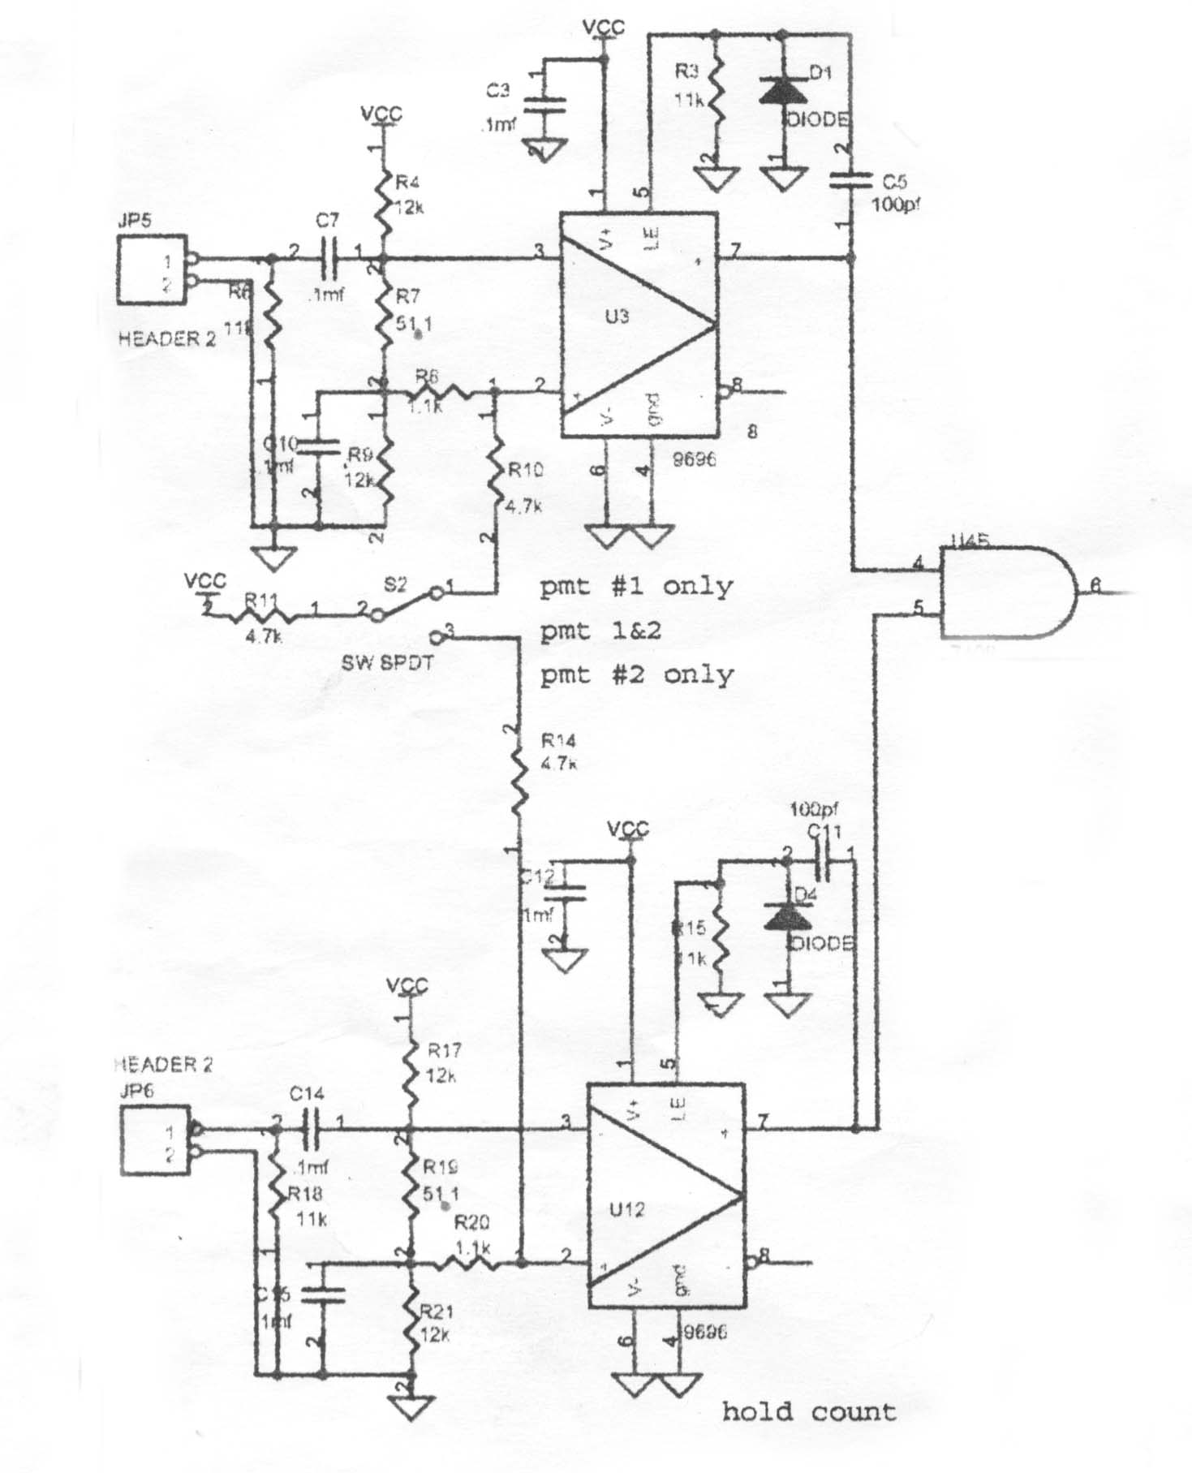
Portion of the LBL logic box
Circuit diagram available for download http://www.lbnl.gov/nuclear/abc
Appendix 1

The comparator threshold is determined by the voltage divider networks, R4, R7, R9 and R17, R19, R21. Vcc is 5V. The necessary difference is given by (51 / 24051)*(5) ~ 10mV.

This Threshold was tested using a CAMAC pulse generator and BNC cable attenuators.
The box counted a pulse 9mV high, but failed to count a 7mV pulse. These seem reasonable given that 5% resistors were used in the construction. The resistor/capacitor combinations C11, R15 and C5, R3 control the resolving time after a count pulse has been sent. The resolving time is the minimum amount of time that must pass before another count pulse can be sent. One can measure the resolving time by using a pulse generator to send a double pulse to the electronics unit. By adjusting the separation of the pulses one can find a point at which the double pulse is only seen as one. At this point the counting rate will get cut in half. This time can then be measured using an oscilloscope. On our first LBL board this time was set to 50ns, such a short time allows for fewer accidental counts, but this introduced a new problem. Since our signal is often much larger than the threshold, reflections from a slight cable impedance mismatch can get counted even though they are attenuated by a factor of approimately three on each reflection. The LBL counters constructed at the summer workshop were built with the resolving time at 800ns. This is large enough so that reflections are sufficiently attenuated below the threshold, but will increase the probability of accidental counts. In the future we may choose a resolving time somewhere between 50ns and 800ns.

