The Building and Testing of Two Scintillation Counters

By
Elisabeth Langford
with

Edwin Antillon

Table of Contents

Overview……………………………………….. 1
Construction of Scintillation Detectors………… 2
Testing of Light Leaks in MJ-EBL ……………. 3
Estimate of 1 PE using an Oscilloscope ……..... 4
Singles Counts of MJ-EBL Counters …………. 5
Testing Coincidence of MJ-EBL Counters …… 6
Testing of Building Materials on Cosmic Rays . 6
Appendix A ………………………...…………. 7
Appendix B ………………………...…………. 8
Appendix C ………………………...………... 10
Appendix D ………………………...………... 11
Appendix E ………………………...………... 12
Appendix F ………………………...………... 13
Appendix G ………………………...………... 14

Overview:
In order to have cosmic ray counters for use in the participating schools, teachers worked in pairs to build one set (two) of counters under the guidance of David Kraus, Senior Researcher Physicist. The characteristics of the photomultipliers were determined before the assembly of the counters. The resultant counters tested for light leaks, and other various characteristics, specifically the singles rate and the expected rate of cosmic rays; the pedestal, and the coincidence rate.

Construction of Scintillation Detectors:
Each counter is composed of scintillation material, a light guide, a photomultiplier tube, a base, and a silicon cookie.
Edwin Antillion tested each of the photomultiplier tubes (PMT) using the one photoelectron peak (PE) setup. This arrangement suppressed multiple photon events by limiting the amount of time allowed for counting cosmic ray events. The gain [i.e. for each photon reaching the photomultiplier, how many electrons were in the output signal]; and the noise [i.e. extraneous electrons produced by the electronic hardware] were also measured as was the bases’ voltage divider net works. For more information see Antillion’s paper on photomultiplier tubes.
After a PMT tube and a base joined, the combination was retested at 2100 volts using the QVT software and the one PE setup to find the pedestal energy peak (PED) and one PE. The PED is the constant “trickle” of charge that the Analog Digital Converter [ADC] always adds to each channel or bin as a calibration. It is used as the base line to which other measurement must be referred. For data on the counters made by Mike Johns and Elisabeth Langford see Appendix A.
To assemble the counters, first, a rectangular slab of scintillator material was glued to a light guide using optical glue. The scintillator and light guide were left undisturbed for 24 hours for the glue to harden. Meanwhile the PMT tube was attached to a base. The glass surface of the PMT and a soft, pliable silicone cookie were cleaned with absolute isopropanol to remove fingerprints, oils, and other dirt. After cleaning, the cookie was placed on the glass surface of the PMT.
A piece of PVC pipe, slightly over 12 inches long, had a thin ring of smaller PVC pipe glued to the inside edge of one end as a stop. A ring of bungee cord was placed against the stop to act as a cushion when the PMT was attached to the light guide, scintillator combination. Next, the PMT tube and base were inserted into the PVC sleeve. A sheet of magnetic shielding, cut to fit around the PMT, was inserted into the PVC pipe. Finally, a piece of Mylar was inserted between the magnetic shielding and the inside of the PVC pipe. The whole apparatus was wrapped in aluminum foil and then two layers of six mill [0.006 inches thick] black plastic. Photographic tape was used to seal the plastic. Black electrician’s tape was used to seal both edges of the photographic tape to the plastic. The counter was then tested for light leaks.
Lawrence Berkley National Laboratory boards (LBLs) were use for the electronics. These boards were designed by Howard Mathis at LBNL. The boards were modified by Rich Neiman, Mike Johns, Gene Bender, Danny Franke, and David Kraus.
The high voltage devices were made, based on the Cockcroft-Walton principle by students at Brentwood High School under the supervision of Rich Neiman and by Wayne Garver of the University of Missouri, St. Louis. The devices provide 0 to 2000 volts, controlled by a variable resistor with a screw adjustment and a pickoff voltage monitor.

Finding Light Leaks
The counter was connected to an oscilloscope and the trigger threshold was adjusted until a trace was found. The high voltage for the counters was increased until a noticeable signal was seen. The scales on the oscilloscope were adjusted until the voltage of one PE and the duration of the signal [about 5 to 10 ns] could be read.
The lights in the room were cycled off and on, while watching the scope for a change in the trace. The counter was then connected to the LBL board in order that counts could be taken both with the room lights off and with the room lights on. Next counts were taken while a flood lamp containing a 100 W bulb was used to shine light on various parts of the counter. The lamp was held far enough from the counter so that the heat from the lamp did not warp neither the plastic nor the tape, yet close enough to minimize the light shining on other areas of the counter. This lamp has been replaced by a fluorescent lamp that gives off less heat. If the counts varied widely during these trials, the counter was wrapped in another layer of black plastic. If the end to which the cables are connected had a light leak, short cables were attached to the base of the PMT. The cables were labeled, high voltage, anode, and dynode. This allowed the plastic to extend slightly beyond the PMT insuring a better seal. Appendix B for Data

Estimate of the 1 PE Signal
The oscilloscope have very low thresholds equal to or less than one mV [but of course at 1 mV the scope will see mostly noise]. The QVT threshold was higher, about 4 to 5 mV; the LBNL threshold is about 10 mV, and the discriminator threshold , which is, used in conjunction with the CAMAC [dtake] system, is 25 to 30 mV. The threshold voltage of the discriminator is greater than the 1 PE value. Therefore, it is not possible to trigger on the PMT itself to get the 1 PE and the cosmic ray rate is too large for the computer because the computer system has no hold off.
The rate must be approximately 10 or less per second. The current configuration reads in 8 channels of an Analog Digital Converter [ADC] and 8 channels of a Time Digital Converter [TDC]. These take approximately 50 to 100 PEs per event. At 10 counts per second [average one tenth (1/10) of a second between events], interference would arise for only one event in 1000.
The oscilloscope was used to find the one PE peak. The voltage supply was a Brentwood adjustable voltage supply box. One turn on the Brentwood equals 200 volts. The number of turns, the count taken from the LBNL board, and the 1 PE signal in millivolts was read from the oscilloscope. The one PE signal voltage versus the number of turns was plotted. This relationship is logarithmic. Figure 1 See Appendix C for Data

Figure 1

The same procedure was used for Rich Nieman and Allen Daniel’s counters. There was some concern about the measurement of counter STU as an exponential plot did not give a straight line. It is believed that the error was improper reading of the trace on the oscilloscope. This data needs to be rechecked. See Figures 2 and 3. See Appendix C for data.

Figure 2

Figure 3

Testing MJ_EBL Counters Single Rates.

The singles rates were determined for both MJ-EBL counters. The best voltages for the counters would be on a plateau. No plateau was found [this is believed to be from reflections caused by improper termination of LBNL logic board]. It was concluded that the best voltages would be between 8 and 9 turns or 1600 V to 1800 V. This insured that the voltage threshold (10mV) was equal to or greater than 2 PE but the pulse height was not so high that reflections from the cosmic ray events. [likely to be much larger than 1 PE] will trigger the counter.

See Figures 4 & 5. See Appendix C for Data.

Figure 4

Figure 5

Testing MJ-EBL Counters for Coincidence Rates
To find the best voltage for use with the LBNL board and a Brentwood adjustable voltage supply box, the voltage was increased in approximately 100-volt increments or 0.5 turns, starting at 1300 V. Each count was automatically timed for 1 minute by the LBNL board. A graph was made of counts versus turns. As figures 6 and 7 show, the relationship is logarithmic rather than linear. If there were no errors the best voltage would be found on a plateau. Although no plateau was found, the best voltage seemed to be about 1700 V to 1750 volts or 8.5 to 8.75 turns for the MJ-EBL counters. Figure 4. See Appendix C for Data

Figure 6

Figure 7

Appendix A: Basic Characteristics of PMTs with Bases

Basic Characteristics of the two counters
COUNTER | SIZE | AREA | EXPECTED CR COUNT
MJ-EBL-1 | (10.0 x 39.2 x 0.9525) cm³ | 3.92 X 10 ⁻² m² | ~5 counts /second
MJ-EBL-2 | (10.0 x 39.7 x 0.9525) cm³ | 3.97 x 10 ⁻² m² | ~5 counts /second

Testing of the two PMT with their bases

COUNTER | PMT # | BASE | PED | 1 PE | Photopk | sigma | sig/pp | resltn
MJ-EBL-1 | 61 | 91 | 16.00 | 23.52 | 7.50 | 6.56 | 0.87 | 2.86
MJ-EBL-2 | 34 | 96 | 16.00 | 36.07 | 20.00 | 8.27 | 0.41 | 0.98
MJ-EBL-2 | 34 | 96 | 16.00 | 26.84 | 10.00 | 13.45 | 1.30 | 3.17

17-Jun-04
Testing [PMT 34, base 96]
V = 2100V | 3 minute reading
Ped = | 16.00
1 PE = | 36.07
PE - Ped = | 20.07
sigma = | 8.27
sig/pp = | 0.41
resltn = | 0.98

Appendix B: Testing for Light Leaks

Testing for Light Leaks in Counter # 2 [PMT 34, base 96]
Slipping extra cover off from PMT end. PMT not covered
18-Jun-04
distance of lamp
from PMT in cm | counts/min
40 cm | 4991
54 cm | 5689
54 cm | 3821 | only this location uncovered
70 cm | 5462 | only this location uncovered
80 cm | 5819
80 cm | 2661
90 cm | 2610

V = 1600 | counts/min
Room lights off
no extra cover | 5403
Room lights on
no extra cover | 7865
Room lights on
PMT covered | 8178
Room lights on
scintillator covered | 3272
Room lights on
both covered | 3166
Room lights off
PMT uncovered | 2656

V = 1600 V |  | V = 2000
Room lights on |  | Room lights on
no extra cover | cover on PMT end | no extra cover
counts/min | counts/min | counts/min
2533 | 2503 | 357 255
2625 | 2382 | 369 796
2619 | 2412 | 330 981
2532

21-Jun-04
Added one more layer of plastic wrap.
1860 counts/min | 1 PE signal = 3 mV
The count did not change when a light was shone on it.
Testing for Light Leaks in Counter # 1 [PMT 61, base 91]
18-Jun-04
V = 2100V | 3 minute reading
Ped = | 16.00
1 PE = | 23.52
PE - Ped = | 7.52
sigma = | 6.56
sig/pp = | 0.87
resltn = | 2.86

21-Jun-04
 | Signal | 1 PE Signal
Turns | Counts/min | mV | Gain
8.0 | 1860 | 3 | 3.750E+06
8.5 | 16859 | 5 | 6.250E+06
9.0 | 101338 | 9 | 1.125E+07
9.5 | ---------- | 12 | 1.500E+07
10.0 | ---------- | 18 | 2.250E+07

The counter was divided into 4 parts and a flood lamp was shone on each section separately.
Section 1 was the farthest from the PMT
Section | count/min
1 | 188816 | 54315
2 | 80469 | 46195
3 | 91533 | 44712
4 | 138562 | 217248
PMT no lamp | 66809
PMT covered | 5201
light over strap | 5052
After an added layer of wrapping
ambient light | 6308 | 5489
Flood over PMT | 5595
Flood Light underneath counter
Section | count/min
1 | 7030 | 6936
2 | 8465 | 6844
3 | 6666
4 | 7101

Did not appear to have light leaks.

Appendix C:
Testing MJ-EBL Counters for 1PE Signal

 | MJ-EBL 1 | MJ-EBL 2
 | Counts / | Counts /
Turns | Minute | Minute
7.5 | 1.5 | 1.2
8.0 | 2 | 3
8.5 | 4 | 6
9.0 | 7 | 12
9.5 | 13 | 18
10.0 | 17 | 20

Testing Counters STU and PID for 1 PE Signal

 | STU | PID
 | 1 PE | 1 PE
Turns | mV | mV
7.5 | 5.0 | 3.5
8.0 | 5.5 | 4
8.5 | 19.0 | 5
9.0 | 20.0 | 6.5
9.5 |  | 9.5
10.0 |  | 9.5

Graph showing Cosmic Ray Distribution for Counter # 1 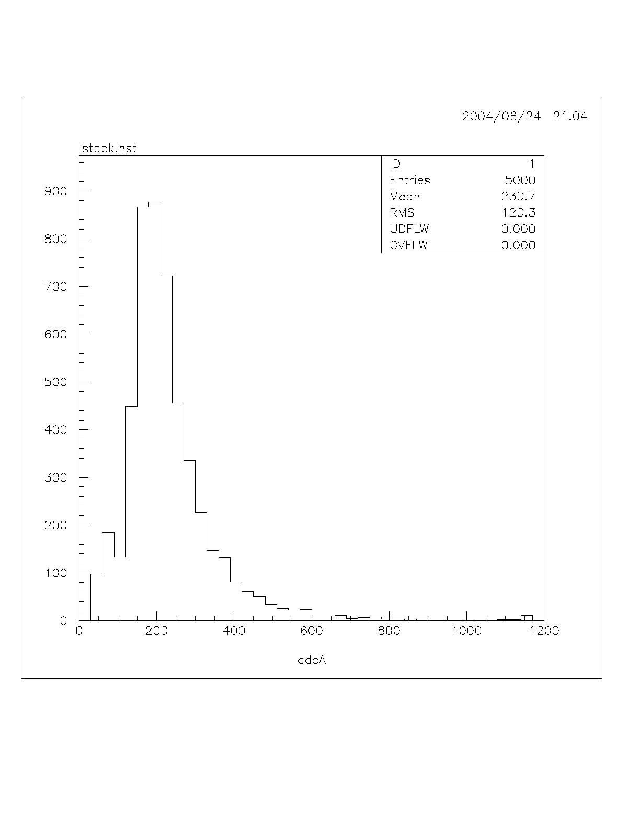
Graph showing Cosmic Ray Distribution for Counter # 2
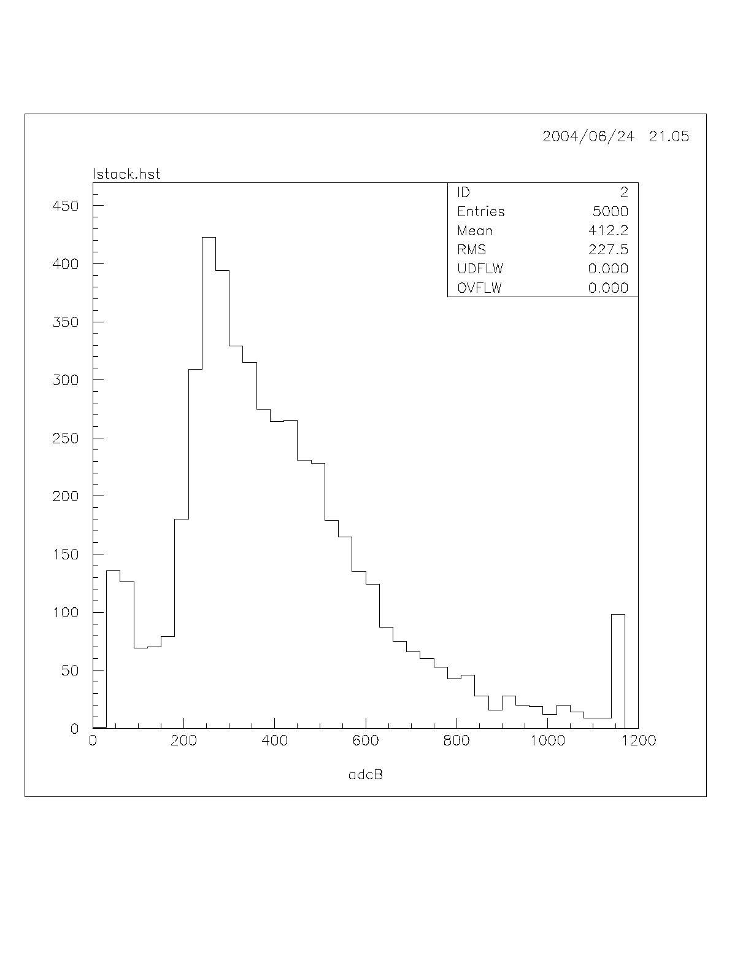
Appendix D
Singles Rate for MJ-EBL Counters
 | MJ-EBL # 1 | MJ-EBL # 2
 | Counts / | Counts /
Turns | Minute | Minute
6.0 | 0 | 1
6.5 | 13 | 13
7.0 | 307 | 363
7.5 | 923 | 1170
8.0 | 1743 | 2253
8.5 | 2842 | 4363
9.0 | 4588 | 7979
9.5 | 11673 | 28349
10.0 | 14959 | 32516

Appendix E
Testing MJ_EBL Counters for Coincidence

 | Counts
Turns | per minute
6.5 | 1
7 | 65
7.5 | 257
8 | 268 & 317
8.5 | 344
9 | 390
9.5 | 479
10 | 504
 | Counts
Turns | per minute
6.5 | 1
7 | 65
7.5 | 257
8 | 293
8.5 | 344
9 | 390
9.5 | 479
10 | 504

Testing Counters STU and PID for 1 PE Signal
 | STU | PID
 | 1 PE | 1 PE
Turns | mV | mV
7.5 | 5.0 | 3.5
8.0 | 5.5 | 4
8.5 | 19.0 | 5
9.0 | 20.0 | 6.5
9.5 |  | 9.5
10.0 |  | 9.5

Appendix F

Testing MJ-EBL Counters for Coincidence

 | Counts
Turns | per minute
6.5 | 1
7 | 65
7.5 | 257
8 | 268 & 317
8.5 | 344
9 | 390
9.5 | 479
10 | 504

Appendix G: Using the Oscilloscope and Calculating the Gain:
- Using the oscilloscope:
  - To find the 1 PE
    - Set the appropriate high voltage
      - On the power supply 1 turn = 200 V
  - Trigger on the appropriate channel.
  - Set both scales
    - Voltage
    - Time in μs
  - The voltage of the 1 PE peak is the most intense part of the trough, located somewhere in the middle
  - The threshold is the smallest voltage needed to trigger the PMT

1 PE

  - Take a series of readings reading the of the one PE signal at various voltages.

- To Calculate the gain:

  - Gain = # e⁻ / 1 PE
= q x (1 e⁻/1.6 x 10⁻¹⁹ C)
= (It) (1 e⁻/1.6 x 10⁻¹⁹ C)
= Vt/R x (1 e⁻/1.6 x 10⁻¹⁹ C)
  - Where:
    - q = charge in Coulombs
    - I = current in Amperes
    - t = time in seconds
    - R = resistance in Ohms

The papers referenced in this paper may be found at http://www.umsl.edu/~thompsoj/quarknet/qnet2004.html They are found toward the end of the website. Scroll to the paper wanted.
http://www.teknetelectronics.com/prodsearch.asp The LECROY website does not list QVT for sale, but if requested would send a quote.
http://www.lbl.gov
See footnote 1.
http://users.tm.net/lapointe/Cockcroft_Walton.htm has a wiring diagram and directions for making a Cockcroft-Walton device
see footnote 1
For more information on building and testing a counter see set of notes on making and testing scintillation counters in our setup by Kari van Brunt. For a detailed explanation of how to modify an LBNL board to use as the counter see: http://www.umsl.edu/~thompsoj/quarknet/2003/gene/2ctrs_mod.pdf
A computer program used in high-energy physics laboratories world wide.
A later measurement determined that the maximum voltage was 2150 V at 10 turns, giving 215 V per turn.

