Study Guide Geography 1002 Test 1
Mr. Naumann

1. Locate: Orinoco River, Colorado River, Rio Grande (River), Amazon River, Parana River, Caribbean Sea, Atlantic Ocean, Pacific Ocean
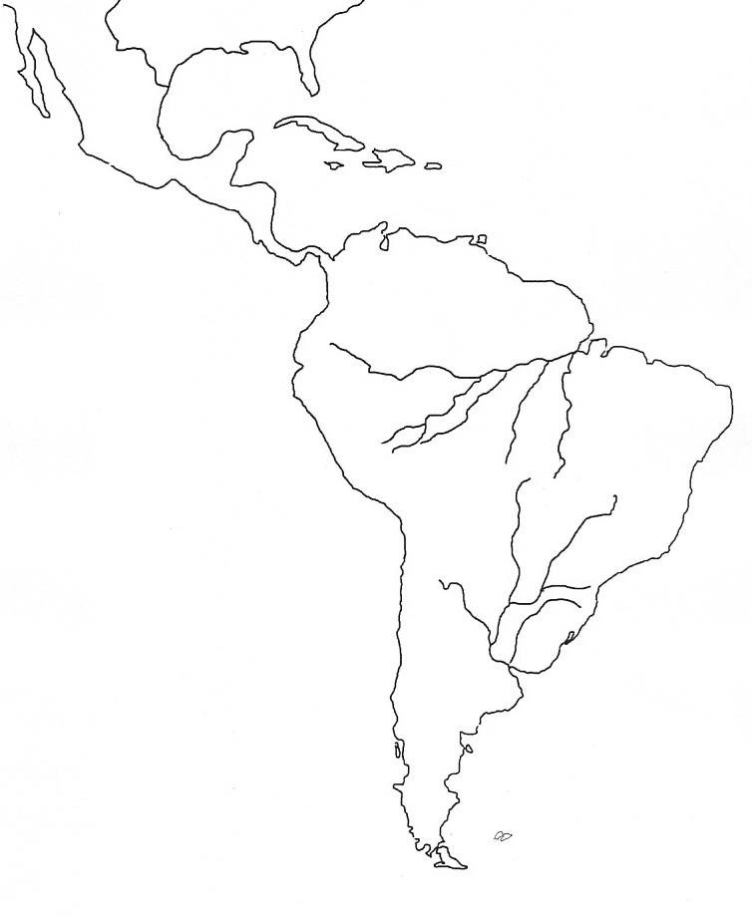
2. To what does the term lingua franca refer:.

3. What are examples of the physical landscapes that can be explained by the theory of plate tectonics? The Pacific Ring of Fire, Mount Pinatubo, Pangaea, the Mid Atlantic ridge, the Rift valleys of Africa, the Himalaya mountains, etc.
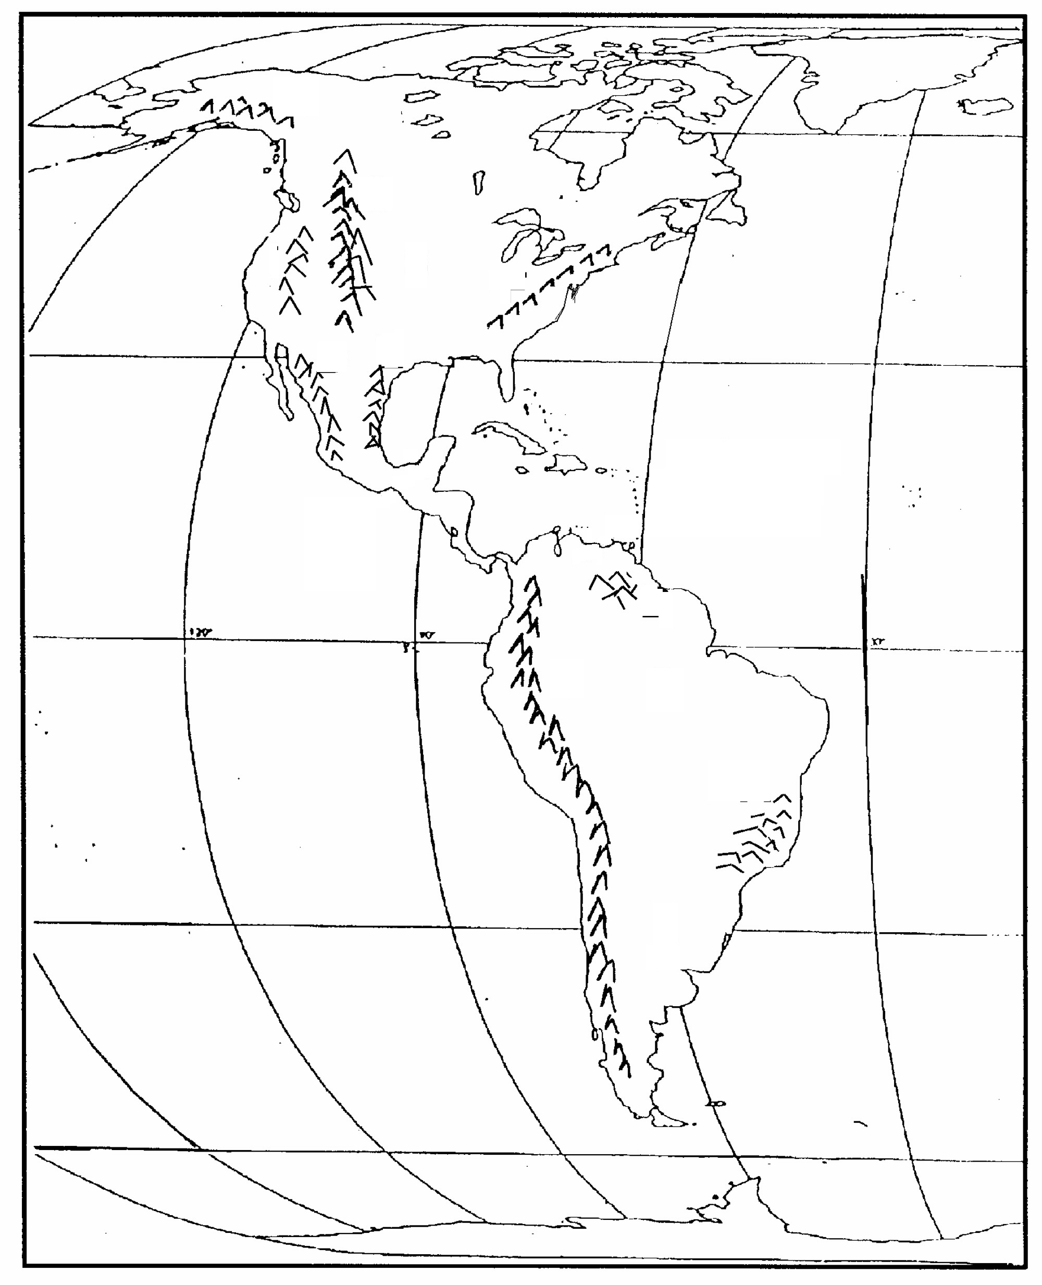
4. Locate the Rocky Mountains, the Appalachian Mountains, the Sierra Madre Occidental (Mountains), the Andes Mountains, Brazilian Highlands, the Llanos, the Pampas, the Yucatan Peninsula, the Amazon Basin, the Great Plains.
5. Which premise best supports or explains the theory of plate tectonics?
6. Through which process is rock broken down into smaller pieces?
7. . As climate is defined in the textbook, which of the measurable change reflects (is evidence of) a climatic change?
8. Given the differential heating and cooling rates of land and water, which kind of landmass is more likely to experience the most extreme change in temperature and air pressure over a year?
9. Explain process causing orographic rainfall.
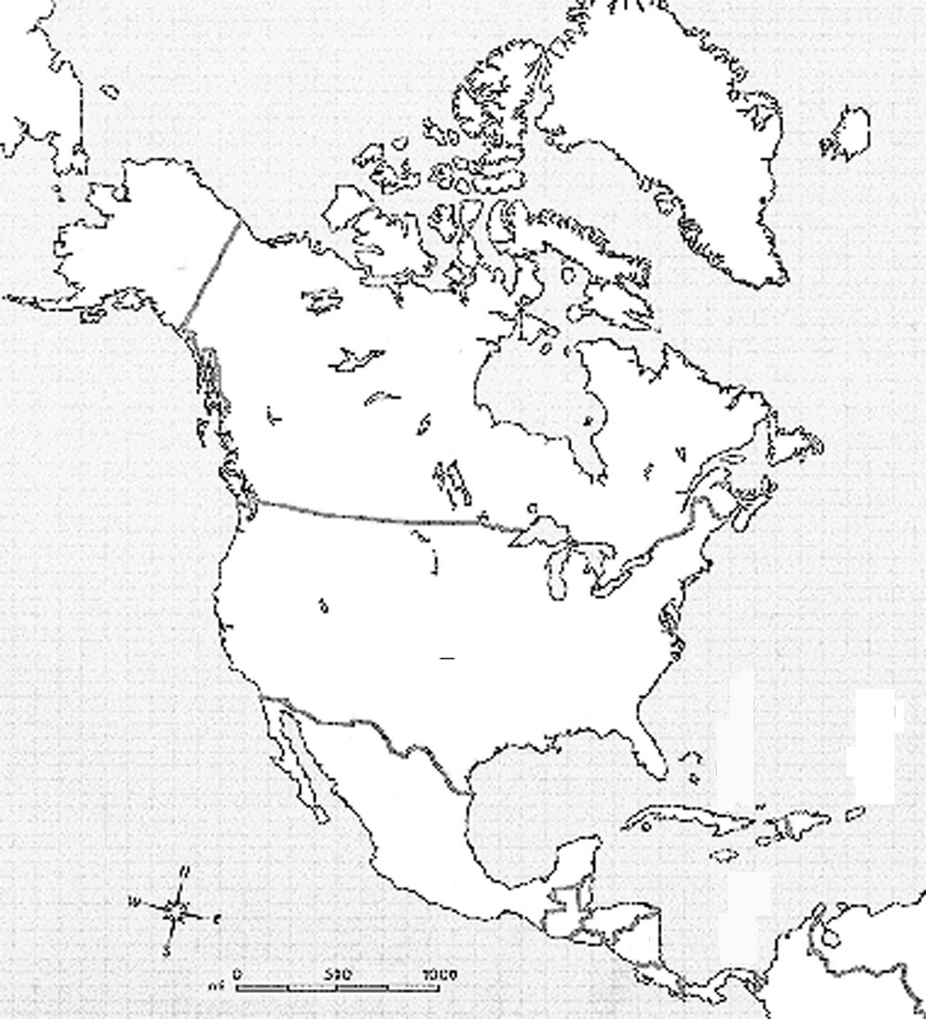
10. Locate these countries or political units: USA, Mexico, Cuba, Canada, Haiti, Belize, Panama, Colombia, Venezuela, Puerto Rico, Dominican Republic, Chile, Brazil, Argentina, Peru
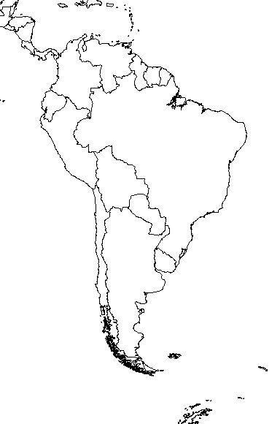
10. What are we fairly sure of concerning the early development of agriculture in the world?
11. In 2000, what was the world’s approximate human population?
12. What can be said of multinational corporations?
13. What are the problems that arise from the use of Gross Domestic Product (GDP) as a measure of societal and human well-being?
14. The relationship of which demographic factors gives us the rate of natural increase of a country’s population?
15. . What can be inferred about a population from a population pyramid that narrows towards the top and has a very broad base?
16. Explain the meaning of the term sustainable development?
17. What are mentioned in the textbook as a major causes of soil degradation?
18. At the global level, what best explains the fact that around one-fifth of the world’s human population subsists on insufficient and inadequate diet?
19. Approximately what percentage of the world’s resources does the wealthiest 20 percent of the world population consume today?
20. What seems to be the major cause of the current global warming?
21. What term is used in the book to describe a group of people who share a common culture, language, and political philosophy?
22. What is the term used in the chapter to describe most North Americans’ strong desire for personal success?
23. In Canada, what ethnic group is becoming assertively distinct from the other Canadians?
24. Which geographic phenomenon is most responsible for the constant threat of earthquakes in several parts of North America?
26. What process formed the North American central lowland that lies between the continent’s two major mountain ranges?
27. How is the story of how humans first came into North America is best summarized?
28. What processes or conditions are influential in determining the wide range of climate types found in North American?
30. What explains why the mid-Atlantic colonies (New York, New Jersey, and Pennsylvania) surpassed the colonies of New England and Southeastern Canada, both economically and in population?
31. The largest concentration of Canadians is located in what part of Canada?
32. What are the main forms of livelihood of many people along the North American Pacific coast?
33. In 2000, what was the approximate population of Canada?
34. According to the textbook, what represents asymmetries between the United States and Canada?
35. Approximately what percent of the North American population is employed in agriculture?
36. What factors have affected the high-tech industry in recent years?
37. The passage of the North American Free Trade Act (NAFTA) has had what effects?
38. Adherence to Roman Catholicism usually prevails in those areas that have received immigrants of which ethnic background?
39. What is the fastest growing type of household unit in North America?
40. Approximately what percentage of American (USA) children in 1999 lived in poverty?
41. The five percent of the world’s population that lives in North America produces approximately what share of the greenhouse gases released into the atmosphere?
42. By what means does the western United States support (make possible) farming?
43. What industry has helped “reinvent” the southern New England region?
44. What industry dominated the North American Economic Core when it was at its peak?
45. Despite much economic, political, and cultural diversity among the countries of Middle and South America, which characteristics do they have in common?
46. What is the name of the primary tectonic process that has created many of the mountains in Middle and South America?
47. How does El Niño affect the Peruvian fishing industry?
48. Describe the human landscape of Middle and South America just before its encounter with Europeans?
49. What factors best explain the rapid conquest of Middle & South America by Spain & Portugal?
50. What contributes, or has contributed, to the unstable business environment in many of the countries in Middle and South America?
51. What conditions represents the legacy of colonialism in Middle and South America?
52. What is the primary cause of contemporary population growth in the countries of Middle and South America?
53. Describe the principal migration trend in Middle and South America in the 20th century.
54. Describe a hacienda?
55. What typically has happened to profits generated by ranches and plantations in Middle and South America?
56. Explain the term import substitution?
57. What was the initial cause of the debt crisis suffered by many Latin American countries in the 1980's?
58. In what part of Mexico does most manufacturing occur in?
59. What has been the widespread responses of small-scale Latin American farmers who were displaced by large cash-crop enterprises?
60. What was the primary reason for U.S. involvement in the politics of Middle and South America after World War II?
61. What is a principal contributor to the decline of forests in the Amazon Basin?
62. What generalizations explain the social significance of race in Middle and South America?
63. What family type constitutes the basic social institution in Middle and South America?
64. What is the name given to the set of values that set the standard for ideal manhood in Middle and South America?
65. In what way did the Catholic Church change in the nineteenth century and particularly in the twentieth century in Middle and South America?
66. What is Puerto Rico’s official political status?
67. What is a major contributing factor to Costa Rica’s stable economy?
68. According to the textbook, what the characterizes the purpose behind many of the migrations people make from Mexico to the United States?
69. What is the modern assessment of the importance of the Panama Canal?
70. What was most responsible for creating the debt crisis in Venezuela?
71. What has been a major source of income for rural, poor farmers in addition to funding the ongoing civil war in Colombia?
72. What was a principal factor in selecting the location of Brasilia?
73. Why has dealing with hazardous (the primary reason) wastes in North America been such a controversial issue, particularly nuclear wastes?
74. How did the last period of glaciation affect North America and its landforms?
75. What conditions are related to the high level of income disparity that exists in the USA and in Latin America.
76. What are the four laws of ecology?
77. In Mexico, and many Latin American countries, the term mestizo refers to what?
78. What are problems associated with urban sprawl in the USA?

