Making the Best of Invasive Species

Garlic mustard and Asian carp can wreak havoc on their ecosystems, but do they have a future on your dinner plate?
- By Kristin Ohlson
- Smithsonian.com, May 25, 2011
This prolific invasive plant—cursed by home gardeners and park and wildlife managers alike—is routinely wrenched from the ground or spritzed with herbicide in an attempt to keep it from taking over. But on April 14 at Cleveland’s Shaker Lakes Nature Center, garlic mustard was the guest—or rather, pest—of honor. 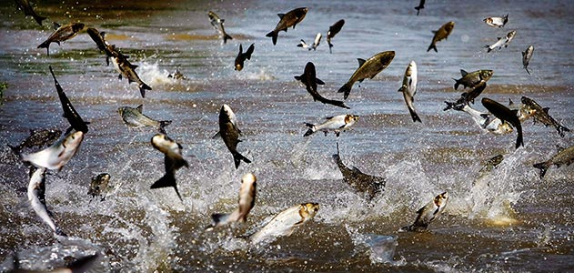
Figure 1 Asian carp, imported from China in 1973 to clean algae from Southern ponds, broke from their confines and infested the Mississippi River waterways.
“Pestival 2011” featured seven of Cleveland’s most notable chefs making garlic mustard a gourmet treat. They rose to the occasion deliciously: garlic mustard sauce over thin slices of roast beef, garlic mustard pesto on pork tenderloin crostinis, garlic mustard chutney on wonton-skin ravioli stuffed with tofu and paneer cheese, garlic mustard dip for thick-cut potato chips, and garlic mustard relish on chèvre cheesecake. The 125 attendees clustered around the chefs’ silvery platters, then carried artfully arranged portions of the garlic-mustard creations back to white-linen draped tables.
Would all this culinary artfulness persuade people to cook up some garlic mustard on their own, or at least recognize it when they see it along a path in a public park and yank it out?
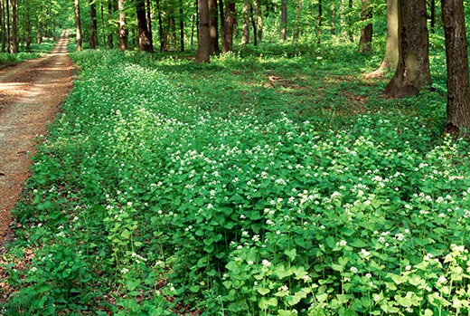
“We hope so!” says Terri Johnson, the nature center’s special events manager. “We look forward to the day when garlic mustard is eradicated. Then we’ll hold Pestival as a victory celebration.”
Figure 2 Garlic mustard is just one of 50,000 alien plant and animal species that have arrived in the United States. These invaders flourish in the absence of their native competitors and predators.
Garlic mustard is just one of 50,000 alien plant and animal species that have arrived in the United States. These invaders flourish in the absence of their native competitors and predators. European settlers brought garlic mustard here for their kitchen gardens. An attractive plant with heart-shaped leaves and tiny white flowers, it outcompetes native plants for light, moisture, nutrients, soil and space. It propagates at a fierce speed, producing thousands of seeds that spread by sticking to animals’ fur.
“If you don’t control it, woods filled with native species can be completely taken over by garlic mustard in five years,” says Sarah Cech, the nature center’s naturalist.
When the nature center first conceived Pestival six years ago—the first one was a simpler event in which the staff prepared a garlic-mustard pesto served with spaghetti for 80 guests—they didn’t realize they were part of a national trend. The United States spends around $120 billion each year to control invasive species, according to Cornell University ecologist David Pimentel. But in the past decade or so, a growing number of people have decided to view the crisis of surging alien populations as an opportunity to expand the American palate. If these species are out of control because they have no natural predators, then why not convince the fiercest predator of all—human beings—to eat them? The motto of these so-called invasivores is, “If you can’t beat ’em, eat ’em.”
Take the Asian carp (please!). Imported from China in 1973 to clean algae from Southern ponds, the carp soon broke from their confines and infested Mississippi River waterways. Gobbling up the phytoplankton that support native species, the carp can grow four feet long and weigh 100 pounds. They continue to swim north and could establish themselves in the Great Lakes, the world’s largest freshwater system, and decimate native fish populations there.
Figure 3 "Pestival 2011" featured seven of Cleveland's most notable chefs making garlic mustard a gourmet treat. Shown here is Chef Scott Kim and his assistant of SASA. They prepared wonton skin ravioli filled with garam masala seasoned tofu with paneer cheese served with garlic mustard chutney and cucumber salsa.
Wildlife managers have tried to prevent Asian carp and other invasive species from reaching the Great Lakes by installing electric underwater fences and, occasionally, poisoning the water. But chefs from New Orleans to Chicago have also tried to put a dent in the population by putting the fish on their menu. Now, a researcher at the Aquaculture Research Center at Kentucky State University is trying to figure out how to harvest and promote carp as a food source. Currently, a few processing plants are converting Asian carp into ingredients for fertilizer or pet food. “That’s a shame, because the meat quality is excellent,” says Siddhartha Disgupta, an associate professor at the center.
Disgupta argues that the carp has all the health benefits associated with eating fish and, since it eats low on the food chain, has few contaminants such as mercury that tend to be concentrated in the flesh of other fish species. He says he’s eaten Asian carp in various preparations and found it delicious. But even though this species of carp is prized as a tasty fish in China, Americans usually grimace at the idea of eating it.
“There’s a negative prejudice to the name,” Disgupta says. “People think they’re bottom feeders. They get them mixed up with suckers, which look similar but are from a different biological family.”
In Florida, George Cera has trained his fork on a different invasive creature: the spiny-tailed black iguana, which was imported as an exotic pet, then escaped and proliferated. Cera was hired by the town of Boca Grande on Gasparilla Island to hunt and kill the iguanas, which feast on endangered plants as well as the eggs of protected sea turtles, gopher tortoises and burrowing owls. “They grab and eat them like we’d eat a cherry tomato,” Cera says.
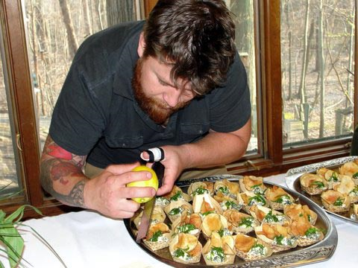
In two years, Cera bagged 12,000 iguanas, his conscience soothed as he found parts of protected species inside them. But it bothered him to kill an animal without eating it. Then, he met some Central and South American tourists who told him that iguanas are considered a delicacy back home, where they’re a native species. They gave Cera recipes. He tracked down more on his own and produced an iguana cookbook.
Figure 4 Jonathon Sawyer is the owner of the Greenhouse Tavern and was named Best New Chef of 2010 by Food and Wine magazine. He plans to include garlic mustard as a regular part of his menu.
“I thought it would be a fun way to educate the public,” Cera says. “Now, people come and ask me where they can get some of this meat.”
Perhaps no one tackles the issue of eating invasives with as much gusto as Jackson Landers, author of The Locavore Hunter blog. Over the past year, he’s traveled the country hunting invasives and gathering material for his new book, Eating Aliens. Landers has hunted and eaten feral pigs in Georgia, green iguanas in the Florida Keys, pigeons in New York City, Canada geese in Virginia and European green crabs in Massachusetts, among others.
“As a systematic approach to invasives, eating them should be a major component,” Landers says. “After all, human beings have eaten other species to extinction.”
Not everyone agrees with this approach, however. Sarah Simons, executive director of the Global Invasive Species Programme, echoes the thoughts of some wildlife managers, saying, “There is currently no evidence whatsoever to demonstrate a reduction in population size, or effective management, of invasive species by consuming them. More often, it is quite the reverse which occurs—promoting the consumption of an invasive species can actually create a market, which in turn increases the spread or introduction of invasive species.”
The organizers of Cleveland’s Pestival are well aware of the fine and dangerous line between educating people about garlic mustard—including its edibility—and inadvertently inspiring them to cultivate it in their backyards. But there seemed to be little cause for worry at the event. Most of the preparations offered an array of flavors, and it was hard for the diners to isolate the particular taste of garlic mustard. Some of the chefs only shrugged when asked if they planned to make the wayward green a regular part of their menu.
Figure 5 Chef Britt-Marie Culey of Coquette Patisserie made chevre cheescake with garlic mustard relish.
The exception was Jonathon Sawyer, owner of the Greenhouse Tavern and named a Best New Chef of 2010 by Food and Wine magazine. Sawyer loves to forage the ring of parks around Cleveland and has been carrying garlic mustard back to use in his restaurant and home for five years. In the springtime, he likes to eat the leaves raw, comparing their taste and bite to arugula. As the plants get older, he blanches and eats them like mustard greens.
“Dude, it’s the ultimate food!” Sawyer exclaimed as he passed out his artichoke and spinach dip with crème fraiche, garlic mustard and thick-cut potato chips. “It’s free, and nature wants us to get rid of it.”
Read more: http://www.smithsonianmag.com/science-nature/Making-the-Best-of-Invasive-Species.html#ixzz1O9uC6lav

Invasion of the Snakeheads

The voracious "Frankenfish" has turned up in the Potomac River, Lake Michigan and a California lake, sparking fears of an ecological Armageddon. But is the Asian import a monsteror the victim of monster hype?
- By Helen Fields
- Smithsonian magazine, February 2005
The scene is a sheriff’s office near a mountain lake, where a hunter and his dog have been found dead. The sheriff sets a bright orange hunting vest on his desk in front of an anxious woman. She nods, identifying it as her husband’s. “He loved that dog,” she says, crying.
“Listen, Norma,” the sheriff says. “If there’s anything at all that I can do, you tell me.”
“You can find the animal that did this and send it straight to hell. You can do that.”
The culprit in the Sci Fi Channel’s made-for-TV movie Snakehead Terror turns out to be a lakeful of monster fish. This star turn is fitting for the toothy “Frankenfish” that has generated many hair-raising newspaper and television news stories—the northern snakehead.
In addition to inspiring filmmakers, the snakehead’s appearance in North American waters in the past few years has worried wildlife biologists and commercial and sport fishermen. They fear that it will invade new rivers, multiply rampantly and edge out other species.
The northern snakehead is native to Asia and is one of 29 snakehead species. It made its national news debut in 2002, after an angler at a pond behind a strip mall in Crofton, Maryland, caught a long, skinny fish, about 18 inches from end to end, that neither he nor his fishing buddy recognized. They photographed the fish before throwing it back; a month later, one of them took the picture to the Maryland Department of Natural Resources (DNR). An agency biologist e-mailed the picture to fish experts, who told Maryland it had a snakehead on its hands.
It was after another angler caught a snakehead in the same pond and netted some babies that all hell broke loose. National newspaper and TV news reports described snakeheads as vicious predators that would eat every fish in a pond, then waddle across land to another body of water and clean it out. A reporter from the Baltimore Sun called it “a companion for the Creature from the Black Lagoon.” The scariest reports, fortunately, turned out to be mistaken. While some species of snakeheads can indeed wriggle long distances across the ground, the northern snakehead—the only species found in the Crofton pond—appears not to be one of them. But northern snakeheads do like to eat other fish, and a heavy rain could conceivably wash one or more from the pond into a nearby river that runs through a National Wildlife Refuge and into the Chesapeake Bay, the largest estuary in North America. To eliminate the snakehead menace, Maryland wildlife officials dumped the pesticide rotenone into the Crofton pond, killing all of its fish. Six adult snakeheads went belly up—as did more than 1,000 juveniles. Problem solved. Or so it appeared.
Two years later, northern snakeheads fulfilled biologists’ worst fear and showed up in the Potomac River. Experts worried that snakeheads in the Potomac, by eating other fish or out-competing them for food, could drive down numbers of more desirable species, such as shad or largemouth bass. You can dump poison in a little, enclosed pond, but you can’t poison the Potomac. It’s a wide, shallow river that originates in West Virginia and runs 380 miles before emptying into the Chesapeake. The bay fuels the region’s economy through recreation and fishing. Snakeheads couldn’t survive in the mildly salty water of the bay, but they could scarf down shad, fish that spawn in the Potomac and other freshwater tributaries. Millions of dollars have already been spent on fish stocking, dam modifications and other projects to help the shad, which used to be plentiful enough to support a commercial fishery in the bay.
Besides Crofton and the Potomac, the fish have popped up in several other places in the United States. In 1997, one was caught in a Southern California lake. A couple more appeared in Florida waters in 2000. In Massachusetts, one was caught in 2001 and a second in 2004. And in July 2004, an angler caught two in a lake in a Philadelphia park. Like the Crofton fish, the Philadelphia ones had settled in and started reproducing. But unlike the Crofton fish, they had access to a river—the Schuylkill, which feeds into the Delaware. Moreover, tidal gates that normally keep fish in the park had been stuck open for two years. Philadelphia fisheries managers decided that poisoning or draining the park’s interconnected ponds would cause more harm to resident fish than the snakeheads would, and have resigned themselves to snakeheads becoming a new member of the park’s ecosystem. The most recent surprise appearance was this past October when a northern snakehead was pulled out of Lake Michigan. The catch has raised fears that the voracious predator might take over the Great Lakes.
The northern snakehead, which is native to parts of China, far eastern Russia and the Korean peninsula, may seem plug-ugly to the undiscerning eye—it has big, pointy teeth and, given its particularly heavy mucus covering, a slime problem. It can grow up to five feet long. Like its reptilian namesake, it’s long and slender and can sport blotchy snakelike patterns on its skin. Unlike most fish, the northern snakehead has little sacs above its gills that function almost like lungs; the fish can surface and suck air into the sacs, then draw oxygen from the stored air as it swims. The air sacs are handy for surviving in waters that are low in oxygen, and even allow the fish to survive out of water for a couple of days, as long as it doesn’t dry out. A female lays thousands of eggs at a time, and both parents guard their offspring in a large nest they make in a clearing of aquatic plants.
Northern snakeheads are a popular food in their native range; they’re said to be good eating, particularly in watercress soup, if a bit bony. They’re fished commercially and raised in fish farms in Asia. They’ve also been sold live in markets in the United States. The Crofton snakeheads were eventually traced to a Maryland man who’d bought two of the fish in New York City for his sister to eat. When she demurred, he kept them in his aquarium and later released them. The U.S. Fish and Wildlife Service soon banned the importation and interstate transport of snakeheads, a plan that had already been in the works precisely because of fears that some snakehead species could thrive in parks, rivers and lakes if they got loose. The ban made it illegal to import all live snakehead species, including the colorful tropical species that populate the odd aquarium. Virginia has outlawed the possession of all snakeheads.
But the bans haven’t stopped everyone. A Los Angeles grocer was arrested this past May for allegedly smuggling live northern snakeheads into the country from Korea and selling them in his store; he pleaded guilty to importing an injurious species. U.S. fans of snakehead soup and other delicacies, however, may still legally obtain killed, frozen snakeheads, which are available in many of the Asian markets that once sold them live.
One day this past April, an angler caught a feisty northern snakehead in Pine Lake, in Wheaton, Maryland, outside Washington, D.C. Local officials drained the lake but found no more snakeheads. Then, like an ecological game of Whac-a-Mole, another northern snakehead reared its toothy head the very next week when a professional bass fisherman pulled a 12 1/2-incher from Little Hunting Creek, a Potomac tributary in Virginia about 15 miles south of the nation’s capital. Biologists tried using nets to capture snakeheads in the river, but eventually decided that a better way would be to let anglers go at the fish with plain old hooks and lines—which led to one of the odder fishing tournaments in recent memory.
On an overcast Friday morning in July, I joined a few dozen anglers at Columbia Island Marina in Arlington, Virginia, across a narrow channel from the Pentagon. The 2004 Snakehead Roundup was about to get under way. The roundup was sponsored by the Marina Operators Association of America to remind boat owners to take care not to transport unwanted species from one place to another—as hitchhikers on their boats or trailers, for example—and to let them know what northern snakeheads look like. Although 16 adult snakeheads had been caught in the Potomac by that time, no one knew whether they’d been born there or whether someone had just tossed them in—or even how common they were.
I tagged along in a 19-foot white-and-blue ski boat with three managers from a family-owned company whose boss didn’t seem to mind that the information technology division was running itself that day. “We’re conducting an offsite meeting,” software designer Brian Turnbull explained. Turnbull’s father-in-law, who is Vietnamese, asked him to bring a snakehead home. “He says if you catch one, you don’t have to hand it over to the state. It’s a delicacy.” Fortunately, Turnbull wasn’t required to choose between duty to family or to society because he didn’t catch a snakehead. Neither did anyone else on the boat, and neither, we found out when we later pulled up at the marina, did anyone else in the roundup.
A few weeks later, John Odenkirk, a biologist from the Virginia Department of Game and Inland Fisheries, seemed to be imitating the sheriff in Snakehead Terror, who kills his murderous lakeful of snakeheads by electrocuting them with a downed power line. Odenkirk, driving an aluminum boat through Dogue Creek, a Potomac tributary, was “electrofishing,” which involved running about 1,000 volts through a boom that protruded from the bow and trailed wires in the water like tentacles. “High voltage . . . The next best thing to explosives,” read the small print on the back of Odenkirk’s green “Snakehead Task Force” T-shirt, which he designed to sell to colleagues for $12 apiece.
Electrofishing, a common sampling method in fisheries research, isn’t meant to kill fish. But it may knock them out for a while. (It’s not considered sporting and requires a special permit.) Odenkirk nosed the boat in and out of the empty slips at the Mount Vernon Yacht Club a couple of miles downriver from Little Hunting Creek. Tiny fish leapt out of the water as others lolled gracelessly on their backs, stunned, just below the surface. Biologist Steve Owens and technician Scott Herrmann leaned over the bow clutching long-handled nets. Afish’s response to the electrical current depends on its skeletal structure, scales, size and how close it is to the wires. “Snakeheads are—they’re kind of bad-asses,” Odenkirk said. “They don’t like the juice and they try to avoid it.” Still, a snakehead that got close to the trailing wires would be stunned and surface, for Herrmann or Owens to snag. At least, that was the theory. We sped back up the Potomac past Mount Vernon to Little Hunting Creek, where the first Potomac snakehead was caught by a fisherman back in May. At the end of an hour and a half of electrofishing, the catch included many carp, several species of catfish, a bunch of goldfish, a long-nosed gar, a turtle— and zero snakeheads. Odenkirk said he’s always conflicted after an unsuccessful day of snakehead fishing. On the one hand, he said, he was disappointed he’d failed to catch one. On the other, “you’d be happy if you never saw one again.”
Though we didn’t see any snakeheads that day, Odenkirk says he’s sure the fish is established in the Potomac or soon will be. “It’s just not even an option that we’ve caught them all.” He says the fish probably nest in wide, shallow expanses of lily pads and wetlands. “We just can’t get back in those areas.”
But other officials say they’re not convinced the fish are here to stay. Steve Early, assistant director in the fisheries service at the DNR, worked on the Crofton pond in 2002 and has handled some of the Potomac snakeheads. He thinks the fish were only very recently dumped in the river, perhaps after Virginia’s 2002 ban on snakehead ownership. He points out that most of the snakeheads caught this year have been 2 to 6 years old, and that if they’d been living in the Potomac for years, surely someone would have caught one before. Early remained unpersuaded even after a baby snakehead was found in a Potomac tributary this past September. It was the 20th northern snakehead caught in the Potomac watershed, and the first juvenile. “Well, it’s not good news,” he says of the discovery, but points out that if some snakeheads do manage to reproduce, they may never thrive in the big river. Their future also depends on whether other fish in the Potomac develop a taste for snakehead fry.
For now, scientists are working on figuring out how the adults got there. It’s a critical question—if the fish were just recently dumped in the river, there’s a chance they’ll die without having generated a self-sustaining population—but it will require more than a rod and reel or a stun gun to answer.
Behind a door at the National Museum of Natural History in Washington, D.C. rest specimens from the world’s largest fish collection. Smithsonian ichthyologist Thomas Orrell walked down an aisle between rows of gray metal shelves containing jars with labels such as “China 1924.” Orrell held up a jar marked Channa argus, the northern snakehead. “They’re really beautiful fish,” he said.
Orrell is trying to learn if the northern snakeheads caught this past summer in the Potomac were born there. He’s analyzing DNA from 16 fish; if some of the Potomac specimens are closely related, it’s likely that the fish bred in the river. If they’re not kin, they were likely dumped in the river. Orrell is also comparing the DNA of Potomac fish with that of those caught in the Crofton pond, testing the idea that someone might have captured juveniles before the pond was poisoned and released them in the Potomac.
Orrell led me down a bare stairwell into the museum’s basement, past sandbags piled near an entrance in case of heavy rain and a walk-in freezer that smelled of long-dead fish, containing, among other things, an enormous tuna frozen since the 1960s. He lifted the top of a nearby freezer chest, rooted around and pulled out a long, black lump. “Watch out for flying debris,” he said, unwrapping a black garbage bag and scattering pieces of frozen blood. Inside was one of the most recent Potomac catches: a dark, diamond-patterned snakehead more than a foot long, now solid as a rock. After showing it off, Orrell shrugged, wrapped it up, laid it back in the freezer and washed his hands. He already knows whether the snakeheads are reproducing in the Potomac, but he isn’t telling; adhering to scientific protocol, Orrell declines to share his data until they’ve been reviewed by other experts and published in a scientific journal.
If northern snakeheads do have some ecological impact in the Potomac, largemouth bass are likely to suffer, says U.S. Geological Survey fishery biologist Walter Courtenay, who in 2002 wrote a snakehead risk assessment for the agency. The two species have similar habitats and would probably eat each other’s young. Capt. Steve Chaconas, one of only a few full-time fishing guides on the Potomac, does not like snakeheads one bit. “Of course, I’m worried about what potential it could have to impact the fishery,” he says. “Also because I’m a businessperson and my business relies entirely on people coming here to fish.” Even now, he says, customers ask how much the snakeheads have hurt fishing. It’s hard to estimate the extent of the snakehead’s impact on largemouth bass and other Potomac species. The northern snakehead was introduced to rivers in Japan in the early 20th century, but there has been little study of its ecological effects there. (The largemouth bass, native to North America, was introduced to Japanese waters in 1925 and is reportedly terrorizing native fish and snakeheads alike.)
In southern Florida, a close relative of the northern snakehead, the bullseye or cobra snakehead, has been living for a few years in the canals of BrowardCounty. The fish, which is native to rivers in South Asia and Southeast Asia, can grow to four feet or longer, but there are not yet enough data to know what effect the bullseye snakehead has had or will have on Florida ecology. Courtenay says the fish probably first got into Florida waters through ritual animal release, a common practice in East Asia that some immigrants have continued in their new land. (A study conducted in Taiwan in the 1990s, for instance, found that 30 percent of Taipei citizens— most of them Buddhists—had released animals as part of a prayer.)
Florida is home to dozens of introduced fish. Paul Shafland, a fisheries scientist with the Florida Fish and Wildlife Conservation Commission, has worked with invasive fish for 30 years, but he isn’t as troubled by them as most biologists. “We have philosophically, largely determined that exotics are inherently bad, and that’s fine,” he says. But, he adds, some introduced fish might fill up some part of the food web that was previously unoccupied.
In fact, introduced fish are just about everywhere. Rainbow trout, native to the western United States, have been transplanted into cold waters all over the Midwest and East. In the Great Smoky MountainsNational Park, on the border between Tennessee and North Carolina, rainbows have taken over at least 70 percent of the native brook trout’s territory since the 1930s. In the late 1960s, the walking catfish, an Asian species that really can move over land, escaped into the Florida wild. They’ve walked their way into warm waters throughout the southern half of the state, without causing major damage so far, Shafland says.
Lake Michigan, says Philip Willink, an ichthyologist at Chicago’s FieldMuseum, is also infested with nonnative fish. “Out of eight species of salmon here, six are introduced,” Willink says. But, as in the Potomac, some native fish still hang on in the lake, and he says it’s worth fighting new invasions. “We’re just trying to preserve what is left, because once it’s gone, it’s gone.” Since the Lake Michigan snakehead was found in a fairly deep harbor with little vegetation—an unlikely snakehead habitat—Willink surmises that the fish was probably just tossed into the water. Scientists did some electrofishing in the harbor to look for more snakeheads but didn’t turn up any.
The Potomac is not the river it was when George Washington looked upon it from Mount Vernon and made good money selling native shad. Goldfish, carp, channel catfish—none is native to the river. The now-widespread common carp, brought over from Europe, was put in the river in the late 1800s. Carp stir up a riverbed and make the water too cloudy for some other fish. The largemouth bass, native to other U.S. rivers, was introduced into the Potomac in the 1800s. And the blue catfish, a sharp-spined transplant from the Mississippi River basin that arrived in the Potomac late in the 20th century, is a headache for fishery managers now, who fear it could interfere with the commercial fishing of channel catfish—which were introduced from the Mississippi basin decades earlier. Descendants of released pet goldfish flourish in the Potomac, as they do virtually all over the world. But the other introduced species aren’t the point; the native fish are, says Dan Simberloff, an ecologist at the University of Tennessee, Knoxville. If the snakehead is different enough from the predators that natives have evolved with, it might drive some natives to extinction. It’s hard to predict what will happen, though. “Most invasive species don’t cause a huge amount of trouble, but some fraction of them do, and we haven’t been too good at predicting that,” he says. About the snakehead, he says, “I’m not optimistic.”
Cliff Magnus is a semiprofessional fisherman (he says he’s been sponsored for the past ten years by “Team Spouse,” a.k.a. his wife, a lawyer), but the attention he got from catching a snakehead last June in a Potomac tributary has brought him sponsors willing to pay his entry fees for bass tournaments. Magnus may have witnessed a seminal moment. He says he saw two northern snakeheads swimming around each other in Little Hunting Creek in late July. The fish were chasing and nipping at each other. The scene, which he described to some fisheries biologists, wasn’t exactly the makings of a Snakehead Terror sequel, but it was definitely ominous. The way the biologists see it, the fish were getting ready to spawn.
There Goes the Neighborhood
If the northern snakehead does establish itself in the United States, it’ll join a rogue’s gallery of introduced species that threaten native plants and animals in and around water. Clockwise from top: A denizen of the East, the bullfrog now inhabits the West, where it eats more delicate local frogs. Nutria, imported from South America as a source of fur, devour plant roots in marshes along the Gulf of Mexico and the Chesapeake. Asian zebra mussels, accidentally carried into U.S. waters aboard ships, have caused more than $1 billion in damage to pipes in the Great Lakes and Mississippi River basin since 1988. Amazonian water hyacinths clog Southern waterways. Aggressive mute swans from Eurasia take over native waterfowl’s feeding and nesting territories on the East Coast and Great Lakes.

Invasion of the Longhorn Beetles

In Worcester, Massachusetts, authorities are battling an invasive insect that is poised to devastate the forests of New England
- By Peter Alsop
- Photographs by Max Aguilera-Hellweg
- Smithsonian magazine, November 2009
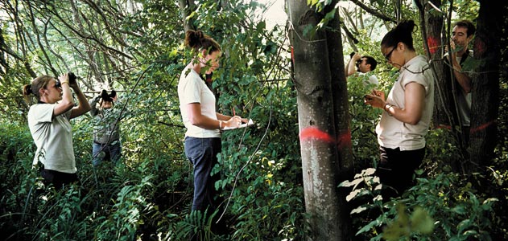
Figure 6 Researchers search for Asian longhorned beetles among Worcester's hardwoods.
On a pleasant july evening Donna Massie steered her car into her driveway at the bottom of Whitmarsh Avenue in Worcester, Massachusetts. Her husband, Kevin, and his friend Jesse were huddled beside Jesse's car, a gold Hyundai Sonata, and were peering closely at one of its doors. They were staring not at a dent but at a striking black-and-white beetle, about the width of Donna's pinkie and half as long, with bluish legs and two banded antennas that curved back over the length of its body like the whiskers of a catfish.
The beetle gently probed the surface of the car with its forelegs. None of the three was much of a bug person, and Donna was decidedly anti-bug, stipulating a death-to-insect policy in her house. Still, the beetle transfixed her. It was larger than any she'd ever encountered, and with its otherworldly colors it was almost beautiful. Before the creature whirled its wings and flew away, Massie and her husband decided that it must be a June bug, albeit a freakish sort.
The insect might have escaped further notice, and evaded authorities altogether, if the Massies had not hosted a cookout two days later in their backyard, where others began to notice the curious beetles. They were hard to miss, creeping along the trunks of the maple trees that fringed the Massies' yard. Their black wing casings stood out starkly against the silver bark. One beetle planted itself on Kevin's pant leg and had to be pried loose. Then Donna noticed something unnerving. Near the base of one maple, she found a beetle sprinkled with sawdust, its head submerged in a dime-size hole in the tree's trunk. It seemed to be eating its way inward.
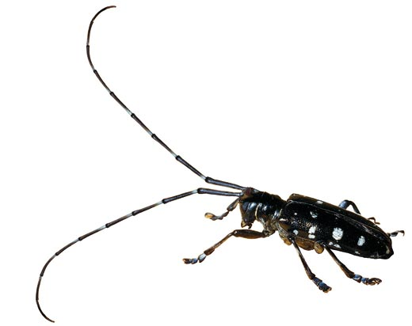
The following morning, Donna searched the Internet and identified her backyard visitor as an Asian longhorned beetle, also known by the abbreviation ALB. Her search also turned up a pest alert from the state of Florida that warned of the dangers posed by the insect. Donna began leaving messages with various agricultural authorities.
Figure 7 The Asian longhorned beetle is unique among invasive forest pests for attacking such a broad array of hosts, which is partly why it is so dangerous.
Patty Douglass, who works for the United States Department of Agriculture (USDA), was in her office in Wallingford, Connecticut, 75 miles south of Worcester, when Donna Massie's call came through. In her position as the plant health director for Connecticut, Massachusetts and Rhode Island, Douglass regularly fields phone calls from gardeners, landscapers and amateur entomologists who believe they've encountered one of the nonnative insects on the USDA's threat list. Nearly all of these calls prove to be in error, as the insect universe is almost incomprehensibly large and varied, and mistakes in identification are easily made. The beetle order alone contains some 350,000 known species; by comparison, the total number of bird species is roughly 10,000.
Massie took a photograph of the beetle with her cellphone and sent it in. The portrait was pixelated, but the beetle's speckled black-and-white abdomen and its telltale antennas were unmistakable. Within 24 hours of receiving the image, Douglass and Jennifer Forman Orth, an invasive species ecologist with the Massachusetts Department of Agricultural Resources, were standing beside Massie in her backyard, staring up at her trees. Douglass spotted one of the insects, confirming with her own eyes a scenario that she and others at the USDA had long feared—an ALB outbreak in New England. She grabbed Massie's arm. "Oh, God," she said. "They're really here."
For most of its history, the Asian longhorned beetle occupied a small, largely unremarkable niche in the forests of China, Korea and Japan. It was not known as a serious pest. In the 1960s and 1970s, however, the Chinese government began to plant enormous windbreaks of millions of trees in its northern provinces in response to erosion and deforestation. These windbreaks were composed almost entirely of poplar trees, which mature quickly and tolerate the arid, cold climate of northern China. As it happens, the poplar is a tree favored by the ALB, along with maple, birch, elm and several other hardwoods. The beetle is unique among invasive forest pests for attacking such a broad array of hosts, which is partly why it is so dangerous.
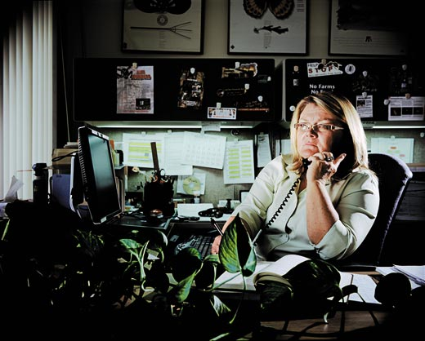
Adult beetles feed on leaves, twigs and young bark. Females deposit anywhere from 35 to 90 eggs, one at a time, in pits they dig in the bark. When the eggs hatch, ALB larvae bore into the cambium, the tissue that ferries the tree's nutrients, and then they move into the heartwood. Over several years, this tunneling chokes off a tree's supply of nutrients and kills it—a death by a thousand cuts.
Figure 8 Patty Douglass (in her USDA office) had long dreaded a beetle infestation in New England. "Oh, God," she said in Worcester. "They're really here."
In the 1980s, as China's poplar forests matured, the ALB population exploded. Within a few years, hundreds of millions of trees were infested, and the Chinese government had to cut tens of thousands of acres of forest to prevent the beetle's further trespass.
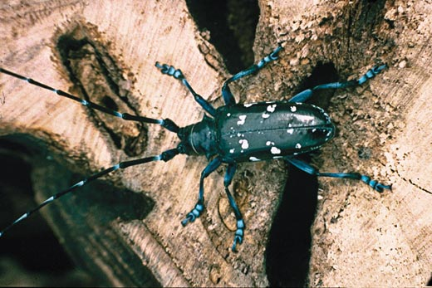
Meanwhile, China, along with the rest of the world, experienced a surge in foreign trade. Since 1970, global sea trade has tripled, and today more than 90 percent of the world's goods travel at least one leg of their journey by ship. The United States went from importing 8 million sea containers in 1980 to more than 30 million in 2000. And most of those products—diapers, televisions, umbrellas—are packed in crates or on pallets made of wood. In the 1980s, pallets of infested poplar began to leave Chinese ports, carrying Asian longhorned beetle larvae. A stowaway on the global shipping network, the insect came into nearly instant contact with warehouses across the world.
Figure 9 The inch-long beetle, with antennas about twice that long, lays eggs in bark. The inch-long beetle's larvae burrow deep into trees and eat the tissues called xylem and phloem that transport water and nutrients.
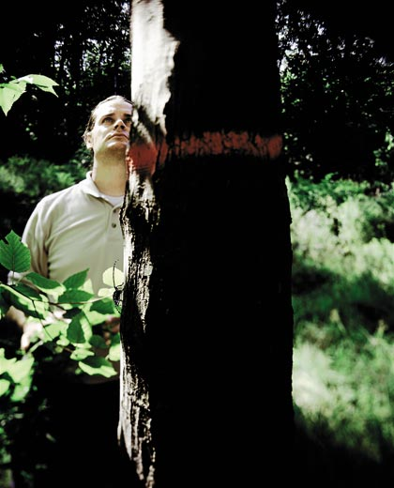
In August 1996, Ingram Carner, a landlord in Brooklyn, New York, noticed that the Norway maples on his property were full of strange perforations, each slightly thicker than a pencil and so perfectly spherical they looked as if they'd been drilled. When the culprit was identified, and the USDA realized the nature of the threat—a beetle with the capacity to destroy numerous native hardwoods—the agency began cutting down thousands of infested trees and chipping them. That's the best way to ensure the beetle's demise; insecticides don't reach it once it has burrowed past the cambium, although they might protect unafflicted trees. In addition, the USDA established a quarantine around much of New York City, prohibiting anyone from transporting wood that could host the beetle. The restriction is still in place. In the 13 years since the initial outbreak, authorities have documented the ALB in Queens, Staten Island, northern New Jersey and on Long Island. The work of eradicating the beetle from the New York City area continues.
Figure 10 "I think eradication is really possible," says Clint McFarland (in Worcester, with a beetle on a red maple). "And we don't have a choice, do we?"
Infestations have also been discovered in Chicago and Toronto. The beetles have been intercepted in dozens of ports and warehouses across the country, from Mobile, Alabama, to Bellingham, Washington. But the discovery of an ALB outbreak in Worcester marked an ominous turn. While previous infestations were confined to urban areas with relatively thin tree cover, Worcester—a city of 175,000 people 40 miles west of Boston—is full of trees, most of them hardwoods. More troubling, the city sits at the southern edge of the great Northern hardwood forest, millions of contiguous acres stretching to Canada and the Great Lakes. If the beetle escaped into such a forest, it could prove the most devastating arboreal pest we've ever known, occasioning more damage than Dutch elm disease, gypsy moths and chestnut blight combined. It could change the face of the New England woods.
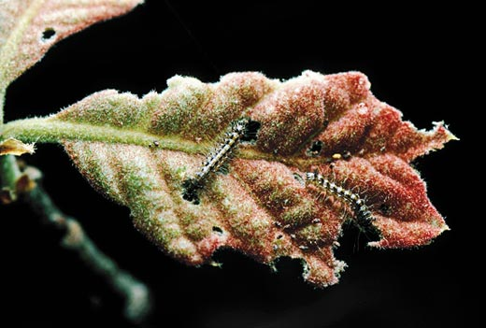
In the bowels of the Massachusetts National Guard Armory in Worcester, in a cramped conference room that serves as a makeshift headquarters, Clint McFarland is staring at a four-foot-wide city map tacked to the wall. The words "Regulated Area" are printed on it. McFarland traces the map with his fingers and reads the names of streets into a cellphone, which is never far from his hands and beeps and barks at him all day long. The room is covered with maps, each articulating a different set of beetle data. Along with the phones that are ringing constantly and the stream of uniformed personnel in and out of the room, the maps lend the impression of a command post hastily assembled on a battlefield.
Figure 11 Invasive species have disrupted American forests. European gypsy moths (caterpillars), released in the 1860s, attack oaks and other trees.
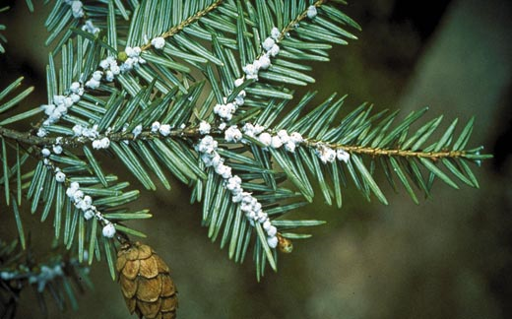
McFarland, 34, wears his hair in a ponytail, giving him a look that seems slightly at odds with the gold badge emblazoned on his jacket identifying him as an agricultural enforcement officer for the federal government. He has worked for the Animal and Plant Inspection Service (APHIS), the USDA division that deals with agricultural pests, for eight years, all of that time on the Asian longhorned beetle. In October 2008, his supervisors handed him the Worcester assignment. When I first met with him, he had been on the job a little over a month and even then showed signs of exhaustion, with red-rimmed eyes and a rasp in his voice. Stopping the beetle in Worcester was proving more difficult than he or anyone else had first imagined.
Figure 12 Hemlock woolly adelgids (egg sacs) eat hemlocks.
Within days of Donna Massie's telephone call, authorities from APHIS arrived in Worcester to orchestrate a containment plan with state and local officials. A state order was issued forbidding the transportation of all wood from host tree species and all firewood out of a 17-square-mile area in the heart of the city. APHIS assembled several ground survey teams to seek evidence of the beetle: exit holes, egg deposits, sawdust, and sap leaking from wounded trees. The service wanted to understand how wide the infestation was, and how serious. What they found alarmed them.
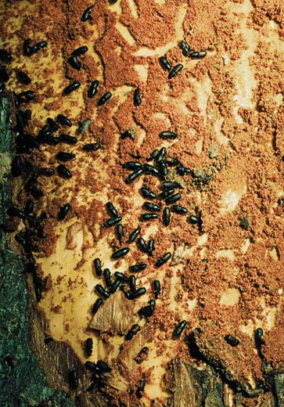
The life cycle of the ALB is roughly a year, nine months of which is spent buried in wood. While adult beetles are serviceable fliers, they tend not to move very fast. Beetles will often inhabit one tree for many generations until it is nearly dead. A quick way to gauge the length of an infestation is to look at the trees themselves: the more holes they have, the longer the beetles have been around. On street after street in Worcester, survey teams found trees riddled with holes, as if they'd been fired upon with a shotgun. In some cases, the trees were so weakened they'd begun to lose their limbs—victims of a long and sustained attack. It soon became clear that the beetle had found its way to the city a decade ago or longer.
Figure 13 Goldenhaired bark beetles infest pines.
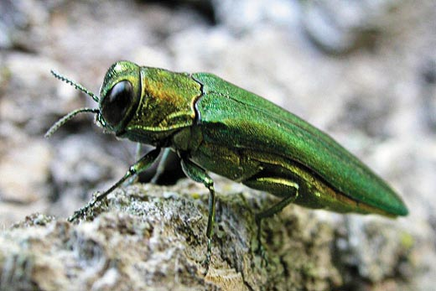
On the day I caught up with him, McFarland was organizing the deployment of more than 20 U.S. Forest Service smoke jumpers, forest firefighters from Western states, who had been brought in to climb through Worcester's trees to search for signs of infestation. Because the beetle first attacks a tree's crown, spotters on the ground may have difficulty detecting the insect; even the smoke jumpers, swinging from ropes and clambering over limbs, manage to identify only about 70 percent of infected trees. Complicating matters for McFarland, the quarantine had been expanded to 62 square miles, and this area encompassed more than 600,000 ALB-susceptible trees, each of which had to be inspected. Ten thousand trees had so far been examined, and more than a third showed evidence of beetles and would have to be destroyed before the summer, when the larvae would transform into voracious flying insects. Worcester was the worst ALB infestation the country had seen.
Figure 14 Emerald ash borers destroy ash.
After McFarland dispatched the smoke jumpers, he drove me to the site of the oldest infestation, located in a stretch of industrial land bordered by a highway on the west and a residential neighborhood on the east. We were accompanied by Ken Gooch of the Massachusetts Department of Conservation and Recreation. It was a bitterly cold day, one of the coldest on record in November in that part of the state, and the men tramped through the underbrush with their shoulders raised against the wind and their hands thrust in their jacket pockets. McFarland took occasional furious puffs on a cigarette. We walked 50 yards and then Gooch stopped suddenly and pointed at a tree stump. The exposed wood was raw, a pinkish yellow.
"When did that come down?" asked McFarland, raising his voice above the rush of passing highway traffic.
Figure 15 E. Richard Hoebeke (with invasive beetle specimens at Cornell) says as many as 600 other high-risk insect species could invade the United States.
Gooch shook his head. "I don't know."
The men walked around the stump. McFarland stared down at some sawdust and let out a sigh, as if to say, "What next?" The now missing tree had been identified as infested, as had almost all the maples in that part of town. But the cutting and chipping work was not supposed to have begun; whoever had removed the tree was not working for APHIS. The wood was, in effect, a ticking time bomb. Contaminated with beetle larvae, it could become a source for yet another outbreak elsewhere.
Standing beside the two men as they considered the whereabouts of a single tree in a city of trees, I began to grasp the immense challenge of trying to stop an insect from having its way in the world. I thought about all the years the beetle had been in Worcester before it was discovered, years in which wood was moved freely out of the city, in the back of a landscaper's truck, perhaps, or as firewood to be stacked beside someone's cabin in the forests of New Hampshire or Vermont or Maine. I remembered something I had read about the beetle: Chinese farmers, who had watched the insect march across the northern provinces, referred to it as the "forest fire without smoke."
It is no surprise that the beetle's escape from China came via trade. Invasive species have traveled undetected in the ballast of ships, in nursery plants, in crates of fruit, in old tires, even in the wheel wells of airplanes. Life likes to travel, and in the era of globalization it travels at a pace never before known, covering distances never before possible. Thousands of introduced species now prey upon or outcompete native species in the United States. The costs of this ecological upheaval, even in purely economic terms, is staggering—a 2005 Cornell University study put the damage from invasive species at $120 billion per year in the United States alone.
Not long after the Brooklyn infestation was discovered in 1996, the USDA began requiring that solid-wood packing material—the stuff used for shipping crates and pallets—be fumigated or heat-treated to kill the larvae of forest pests. These regulations were applied first in 1998 to Chinese imports and then in 2005 to those from all other nations. The regulations have reduced the entry of the ALB into the country, although, even today, dozens of the beetles are intercepted annually in ports nationwide, and other avenues of entry, such as live plant imports, remain. The protocols established by the government after the Brooklyn outbreak—quarantines, inspections and the destruction of infested trees—have largely succeeded, in part because the beetles disperse slowly on their own.
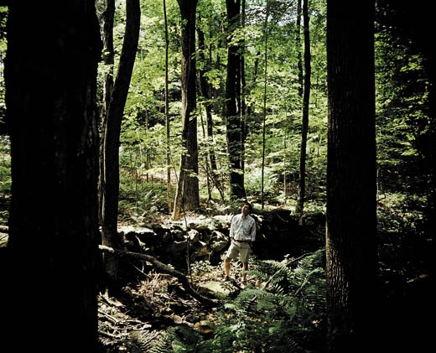
We have no choice but to fight the insect. The costs of not doing so are enormous—one USDA study puts the potential ALB damage in the United States at more than $650 billion, and that's accounting only for trees in municipalities, not on forested lands. The federal government has spent in excess of $250 million on ALB eradication efforts thus far, and more than $24 million in Worcester. Each known outbreak—in New York, New Jersey, Chicago and Worcester—was discovered in a densely populated area, by an alert citizen, after years of infestation. But what if other infestations are taking place out of sight—near a warehouse in a small town in New Hampshire, perhaps, or behind a lumberyard in upstate New York?
Figure 16 Compared with 1600, today's Northeastern forests have more trees the invaders like. David Foster (in the Harvard woods) calls them "beetle food."
I asked E. Richard Hoebeke, a Cornell University entomologist who has studied the Asian longhorned beetle as long as anyone in the United States, about possible undetected infestations. He talked about the many years the beetle had been invading before it came to our attention. He spoke of the overwhelming number of shipping containers pouring into the country.
"Are there other infestations?" he said. "I'm certain of it. Worcester won't be the last."
Concerned that the beetle might find its way into the Northern hardwoods, I visited the ecologist David Foster, director of the Harvard Forest, a 3,000-acre parcel in central Massachusetts that is the site of long-term ecological research. How might the beetle change the New England landscape? To ask that question, as it turns out, is to invite others—questions about what shaped the land in the first place. By way of explanation, Foster took me into the woods.
Much of the Harvard Forest, like more than half of New England, was cleared by farmers in the 18th and 19th centuries and later abandoned. Not far into our walk we passed a crumbling stone wall that cut a straight line through the woods. It was nearing dusk, and a skin of ice covered the snow. Foster, a tall man with dark hair and the ruddy complexion of someone who spends a lot of time outdoors, took big, crunching steps along the trail. We passed a stand of pines and ducked under some fallen snags, and then we came to level land populated by maples and birch. "Beetle food," said Foster, wryly.
It would seem to be our poor luck that so much of New England contains habitat so well suited to the ALB, but, as Foster pointed out, that is at least in part of our own making. In the mid-19th century, New England's settlers began to abandon their farms—lured by cities and by the opening of the West—and their fields returned to forest. Trees such as birch and maple and pine spread first and farthest, on land that once hosted more hemlock, beech and oak, which are not susceptible to the beetle. "Most people walk through these woods and don't see the human impact," Foster said. "But if we compare the vegetation of these forests in 1600 with the vegetation of today, we see huge changes. There's a tremendous increase in species like red maple, which is favored by the beetle."
We have shaped the forest in other ways, too. Chestnut trees once accounted for perhaps a quarter of the Eastern forest. But they were wiped out by the 1950s by an Asian fungus brought here on Japanese nursery stock. A shipment of logs from Europe in 1931 introduced Dutch elm disease, another fungal blight, which infected elms across the Northeast. The European gypsy moth, let loose in Massachusetts in the 1860s, has ravaged oaks and other trees, and the hemlock woolly adelgid, an Asian insect introduced to the East Coast in 1951, has caused widespread mortality in hemlocks. Another invasive Asian beetle, the emerald ash borer, is destroying millions of ash trees in the Midwest and Middle Atlantic. The cumulative effect of these and other pests and pathogens is a more homogenous forest, and one that is more vulnerable to invasion. "We're setting ourselves up for more catastrophe," Foster said.
Forests are becoming even more fragile as the climate warms and the range of native forest pests expands. In the Rocky Mountains, hundreds of thousands of acres of aspen have begun to succumb to the combined pressures of drought, disease, warmer weather and insect predation—a phenomenon termed "sudden aspen decline." Pine trees there are dying in even greater numbers: mountain pine beetles, aided by drought and mild winters, are laying waste to millions of acres.
As the evening grew dark, Foster and I turned back toward his office. We stopped at the edge of the forest, and we could see barns and a snow-covered field and the distant lights of a farmhouse. From where we stood, the Worcester outbreak was less than 40 miles away. I wondered what the beetle might do were it to make it here to the Harvard Forest, which harbors some of the oldest woods in all of Massachusetts.
"Even if it comes through here," Foster said, "there'll still be a forest. It may not be the same, but the forest will continue." He kicked at the snow with the toe of one boot and looked out over the field. "It is such a generalist, though," he said of the beetle. "It likes so many trees. I don't know. It really is one of the worst nightmares."
On the night of december 11, 2008, a freezing rain fell over Worcester, and in the hours before dawn Clint McFarland woke several times to the patter of sleet against his window. In the morning, when he stepped outside, he hardly recognized the city. Under a burden of ice, trees had fallen haphazardly onto cars and houses. Limbs littered the streets; nearly half the roads in Donna Massie's neighborhood were impassable. The ice storm, the worst in a decade, had blanketed much of the Northeast, leaving nearly a million homes and businesses without power, injecting an unforeseeable element of chaos into an already complicated beetle eradication effort.
Contractors up and down the East Coast, from as far south as Florida, began arriving in the city in pursuit of debris-removal work, many of them unaware of the ordinance against removing wood from a quarantined area. In the days after the storm, several trucks were seen carting tree limbs away, despite patrols by environmental police. "We know that wood has been moved out of the city," McFarland told me when I caught up with him the following week. "That's our paramount concern right now. It can't happen again."
Driving to a meeting of town officials, McFarland looked beleaguered. He'd been working nearly nonstop for days, and weighing upon him was the thought that he would have to tell his wife he was going to miss Christmas. The ice storm, meanwhile, had pushed back plans to begin cutting and chipping trees, and the tally of infested trees in the quarantine area had risen to nearly 6,000.
We passed streets lined with shoulder-high stacks of branches. On one block, nearly every tree along the road had been marked for ALB-related removal with an ominous red splotch. I asked McFarland if he thought much about what would happen if he failed in Worcester. He laughed and admitted that he did. "But it's in my nature. I have a fear of failure." He smiled. "Look, we can do this. I've been studying this beetle for years and I think eradication is really possible, and that's hard to say about most insects. And we don't have a choice, do we? There is so much at stake. If it hits the Northeastern hardwood forest, you're looking at the maple industry, timber, tourism. It's huge. We really can't fail."
A year later, there is reason for some optimism. The government's containment efforts have so far succeeded. More than 25,000 trees were felled within Worcester city limits in 2009. The area of quarantine around the city has expanded slightly, from 62 to 66 square miles. No new ALB infestations have been discovered outside the city center.
At the height of the crisis in the winter of 2008-2009, log loaders and bucket trucks were arriving by the hour from out of state, and chain saw crews were removing wood from backyards and rooftops and utility lines. Given the concentration of human effort marshaled against a single insect, it was tempting to think that this was the only battle against an invasive species. Yet in California, Virginia, Michigan and Florida—to name just a few affected states—the same drama was unfolding, if with different characters: the emerald ash borer and the hemlock woolly adelgid, sudden oak death and the citrus canker. Beyond our borders, more organisms are poised to invade. On average, we bring a major new agricultural pest into the country every three or four years. Cornell's Hoebeke told me that perhaps as many as 600 of the world's high-risk insect pests were not yet established in the United States, any one of which might prove as virulent as the ALB. He was particularly concerned about the Asian citrus longhorned beetle, which could devastate the country's citrus and apple orchards.
Sitting with McFarland in a car in Worcester listening to the thrum of logging activity, I was struck by what a strange confluence of events had brought the beetle to Worcester, an ocean away from its native range. People are largely to blame, of course. But there seemed an accidental ingenuity in the way the beetle had hitched itself, undetected, to the one species capable of taking it everywhere. I asked McFarland if he ever found something to admire in the Asian longhorned beetle, despite all the trouble it had caused.
"Oh, yes," he said. "I admire all insects. People say that insects will inherit the earth, but entomologists know better. The earth already belongs to the insects. They were here long before us and they've taken over every niche. They're in nearly every inch of soil, and they're in the atmosphere. We wouldn't be here without them—without pollination and decomposition. The earth is theirs. We're just trying to share it for a while."
Peter Alsop writes about science and the environment. Max Aguilera-Hellweg was the photographer for "Diamonds on Demand" in the June 2008 issue of Smithsonian.

