Iowa farmers ripped out prairie; now some hope it can save them
Figure 1 Black-eyed Susans intertwine with soybean plants. Most farmers say the Midwestern prairie chokes crops. But, according to Iowa State University researchers, the wild thicket protects soil from erosion. (Andrew Dickinson for The Washington Post)
By Darryl Fears August 7 – Washington Post
WRIGHT COUNTY, Iowa — There’s a wild presence in Tim Smith’s corn and soybean field that most farmers kill on sight.
Smith made his way toward it, hoisting his long legs over row after row of soybean plants under a baking mid-morning sun. “It’s right over there,” he said. He stopped at the edge of a Midwestern prairie, a thicket of tall flowers and grasses more frightening to farmers than any horror movie madman lurking in a barn with a chain saw.
Most growers say prairie is a nuisance that can choke crops. But not Smith. He is proud of the three acres he planted in the middle of one of the most productive farms in the county. He was there to show it off, not spray it.
This affection for prairie bucks a farming tradition that dates back to when settlers arrived in the Midwest to farm centuries ago and ripped out wild grasses to tame the earth. Over time, prairie was nearly eradicated. Farmers today are still destroying the little that is left.
It is a colossal mistake, according to recent studies by researchers at Iowa State University. Not only does prairie, with its deep-rooted plants, soak up farm wastewater that pollutes rivers, it also enriches soil.
“The reason why we have the best soil, making it possible to have the world’s best food production, is prairie,” said Lisa Schulte Moore, an Iowa State professor known around the state as the prairie guru. “And we’re killing it.”
Now Schulte Moore and a team of 50 researchers are pushing for a resurrection and spreading a message: Wild prairie could help the state’s agriculture industry. It could slow soil erosion that costs farmers more than a billion dollars per year in lost yield and lower water pollution from fertilizers and chemicals — pollution that triggered a lawsuit by Des Moines against three farm counties upstream.
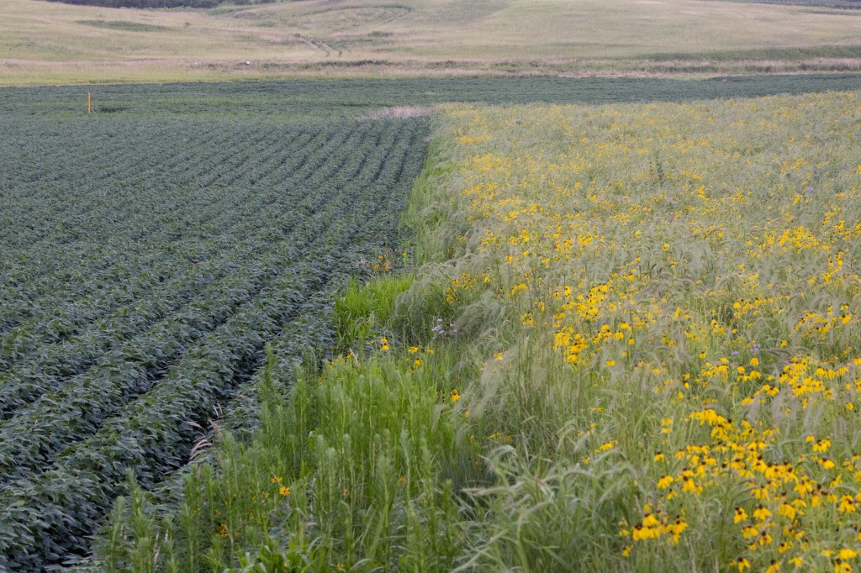
Prairie, together with other conservation practices already on farms, advocates claim, has the potential to reduce the massive runoff of nutrient pollution mostly from Midwestern farms that flows down the Mississippi River and forms a gigantic “dead zone” in the Gulf of Mexico every summer. In past years, this dead zone has suffocated marine life in an area the size of Connecticut and Rhode Island combined.
Some agriculture officials and city leaders believe lawsuits will not stop with Des Moines if gulf cities and states continue to lose fish harvests and tourist dollars to damage from the dead zone.
Iowa joined several Midwestern states in an effort to cut the region’s contribution to gulf pollution nearly in half, but participation is voluntary in Iowa, and conservation efforts are lagging.
Figure 2 A prairie strip filled with black-eyed Susans lies next to soybeans on Smith's farm. (Andrew Dickinson for The Washington Post)
A promising response, but hesitation lingers
When Smith stepped off the edge of a soybean field into his prairie strip, he literally took a walk on the wild side.

Bees landed and took flight from his sweaty forearms. A chorus of dickcissel birds sang as blackbirds dipped, dived and screeched at humans strolling dangerously close to their nests. Butterflies flapped technicolored wings as they darted between plants.
Prairie serves as habitat for hundreds of species. Its milkweed feeds monarch butterflies, which make an epic migration through the United States from Mexico to Canada every year. Monarch populations have dropped dramatically because of insecticides and loss of habitat.
Providing wildlife habitat for birds and animals on the decline is one of the driving forces behind a program called STRIPS — Science-based Trials of Rowcrops Integrated with Prairie Strips. Smith said he planted his prairie two years ago because he strongly believed in that philosophy.
He received funding from the Natural Resources Conservation Service (NRCS) to help pay for the seed, which is not always easy. Smith said other farmers told him agronomists at local NRCS offices fought them on the idea.
“I told [the NRCS] what I was doing . . . they said okay,” Smith recalled. “But you go to another county, and it might be a whole different discussion. They say, ‘Do this, and you don’t do that.’ You don’t get a consistent answer in every office.”
What STRIPS proposes is so new “and so innovative,” said Schulte Moore, one of the project’s leaders, that the entire conservation service is not on board. In Washington, officials are watching with interest. But in the counties, some farm advisers roll their eyes.
Schulte Moore is hopeful that this is changing. When STRIPS promoted the benefits of prairie to farmers a few years ago, “they looked at us like we were crazy,” she said. But when they produced research from an experimental chunk of prairie planted in a wildlife refuge, farmers such as Smith started to see that it could stop erosion and runoff.
In 2012, when the project was new, only one farmer signed up to plant prairie. Over the next three years, 26 planted it. Last year, 120 farmers who attended the project’s field presentations said in surveys that they intend to plant a total of 400 acres.
“We were like, ‘Wow, that’s a lot,’ ” Schulte Moore said. It was far too many acres to handle for a program struggling to survive on a paltry federal research grant. Schulte Moore spends most of her day asking for money.
But the response mattered. “People who don’t work with farmers view them as curmudgeons,” Schulte Moore said. “But they’re savvy and very data oriented. They get it.”
Schulte Moore said she understands why many farmers are hesitant. “Two hundred years ago, farmers plowed up the prairie because they didn’t consider it valuable . . . or couldn’t eat it. Now we’re asking them to plant it.”
Smith’s prairie acres were laid on a slope leading to Eagle Creek, which runs 90 miles to Des Moines. When rain soaks the field, the deep-rooted prairie “slows it down,” Smith said, and allows the earth to absorb it.
Tests show that the nitrate level in water from Smith’s farm is substantially lower than water in the creek, Schulte Moore said.
That has not swayed some reluctant farmers. Nearly 200 miles south of Smith’s farm, Steve Berger said over and over that he was excited about the idea of planting prairie on his 3,000 acres.
And yet, while mulling the idea for months, he has not planted a single acre.
Every other conservation method has a place on his farm: cover crops of oats or rye to soak up nitrogen, terraces that block water erosion and buffer strips that slow water running off the edge of farms.
But Berger, whose farming knowledge is respected throughout the Midwest, is hesitant about prairie strips. “It’s not easy to do this, and if you set a farmer up for failure, they won’t come back and do it again.”
Berger’s farm is an ocean of green soy and corn that undulate like waves when winds blow. Its profit margin is high. He said he needs more time to plan.
“My days and hours are scheduled right now, and when you talk about prairie strips, I’ve got to make time for it,” he said.
The clock is ticking
How much time do Iowa farmers have?
The state’s soil is eroding at an alarming rate. Topsoil was an average of 14 inches deep statewide in the mid-1800s; now it’s about six, Iowa State researcher Rick Cruse estimated in studies.
“Can we keep going this way for another 150 years? I don’t think so,” Smith said.
Iowa farmers lose about $40 per acre to soil erosion in a state where more than 85 percent of the land is covered by crops. “If you look at those figures and the amount of corn acres in Iowa, you quickly surpass a billion dollars of annual lost revenue,” Cruse said. Nearly a third of topsoil is lost in ephemeral gullies, swaths carved into farms by heavy rain. Since most prairie plants are perennial, they physically stabilize the soil most of the year.
Public opinion could turn against farmers long before the soil is gone.
Angered by nitrate pollution in two rivers that supply its drinking water, Des Moines Water Works sued three county boards of supervisors upstream for failing to regulate farm pollution that the agency pays $1 million per year to remove.
Des Moines Water Works is planning to build an $80 million facility within the next five years to manage an expected increase in nitrate pollution.
“We view it as a violation of the Clean Water Act,” Bill Stowe, the utility’s chief executive and general manager, said. Some experts estimate that nitrates in Des Moines’ water sources will spike substantially above what the Environmental Protection Agency allows.
The lawsuit has pitted Des Moines against a state that favors farmers and agriculture. Cedar Rapids Mayor Ron Corbett spoke out against it, saying, “When you file a lawsuit, that draws lines in the sand. The emotions make people harder and can develop resentment.”
Corbett said he worries that litigation could allow courts to decide how Iowans should farm or open the door to stronger federal regulation.
“If we don’t want judges deciding from the bench water policy for Iowa, and we really don’t want the EPA coming in and telling farmers what to do, the best way is to take the initiative on ourselves,” Corbett said.
For Cedar Rapids, the first step was to place several acres of prairie strip amid its corn and soy farm at the local airport, a demonstration project meant to show farmers that prairie can work. “Leading by example,” Corbett said.
Midwest states have to take responsibility for the pollution they produce, he said. “No one’s disputing that there is a dead zone in the Gulf of Mexico, and no one is disputing that years and years of phosphorous have made their way down the rivers of the Midwest,” he said.
Corbett admits he’s slightly biased. His city processes thousands of bushels of corn and is home to one of the world’s largest ethanol plants, creating hundreds of jobs and providing millions of tax dollars. He said he sympathizes with Des Moines Water Works, but the state needs to work together to solve pollution.
Stowe, the water agency manager, said outreach efforts failed. “We’re not looking for sympathy,” he said. “We’re looking for results.”

