Avocado trees are dying in South Dade. Here’s why

BY MONIQUE O. MADAN mmadan@miamiherald.com
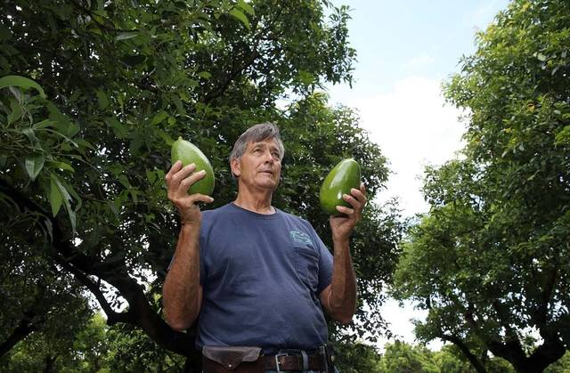
Your guacamole is in trouble.
What used to be lush, green fields of majestic avocado trees in South Miami-Dade are now acres of blighted groves occupied by withered, fungus-filled tree trunks.
Figure 1 Farmer Art Ballard displays a couple of Donnie avocados at his Ballard Groves farm from trees that have not been affected by the Laurel bay wilt, a fungal disease in plants that is wiping out avocado groves in South Dade. PEDRO PORTAL pportal@miamiheral
Sal Santelli, a local South Dade farmer, has hired workers to knock them down, chop them up and burn the wood. All that remains are giant piles of mulch alongside squashed avocado meat on the now-barren land.
Like other farmers of small groves, Santelli will not be replanting avocado, instead choosing to replace them with other tropical fruit. “These were all avocados and now they’re all gone. I’ve spent more than $10,000 so far to take out about 80 trees and it’s still not cleaned up yet.”
The culprit? Ambrosia beetle — a tiny bug the size of Abraham Lincoln’s nose on a penny. The beetle, which is spreading a fungal disease called laurel wilt, is responsible for killing more than 12,000 commercial avocado trees in South Florida since 2012. The avocado is Miami-Dade County’s leading crop, bringing in $54 million a year in revenue.
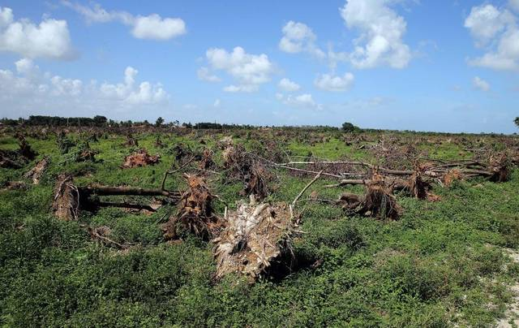
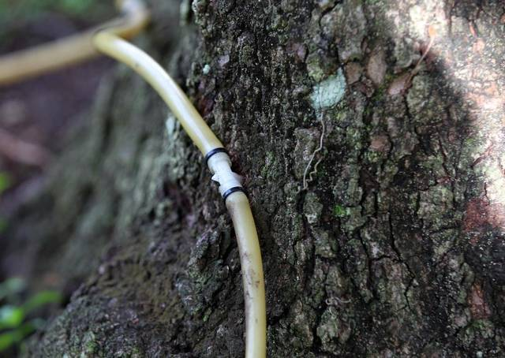
“The avocado industry is going to be devastated if they don’t solve the problem here,” said Santelli, owner of Health and Happiness Farms in Homestead. “We need to come up with a cure for this. Otherwise this industry will be something that we’ll talk about in the future and it will be gone.”
Figure 2 Detail of an avocado tree been treated with an injection at Ballard Groves farm to avoid the trees from been affected by the Laurel bay wilt, a fungal disease in plants that is wiping out avocado groves in South Dade. PEDRO PORTAL pportal@miamiherald.com
The tiny beetle carries the fungus in its mandibles. The fungus spreads to trees when the beetle drills through healthy tree trunks — avocado trees are a favorite. As the fungus rapidly spreads inside the wood, the tree starts turning a dark brown and then dies in as little as five weeks.
The fungus spreads to other trees because the roots of avocado trees connect underground over time. If one tree becomes infected, it can transmit the disease through the roots to the adjoining trees.
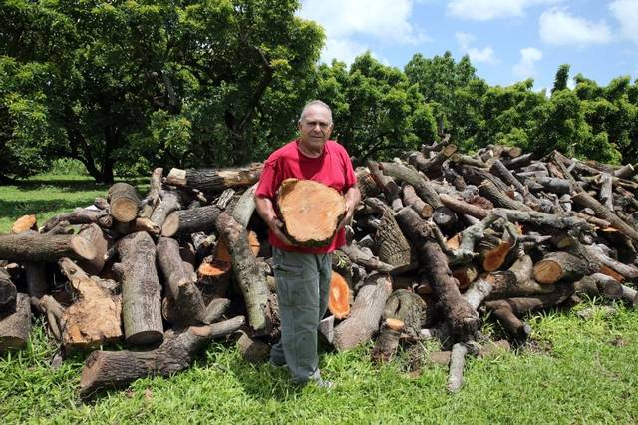
Scientists at the University of Florida Tropical Research and Education Center, along with officials at the Miami-Dade County Extension, have developed a recommended protocol for commercial growers and residents that may have a tree in their yard: Dig the tree up from the root, chop it down and throw it in the fire.
Figure 3 Farmer Sal Santelli, stands next to a pile of avocado trees at his Health & Happiness farms that have been affected by the Laurel bay wilt, a fungal disease in plants that is wiping out avocado groves in South Dade. All trees affected by the disease have to be cut down and removed
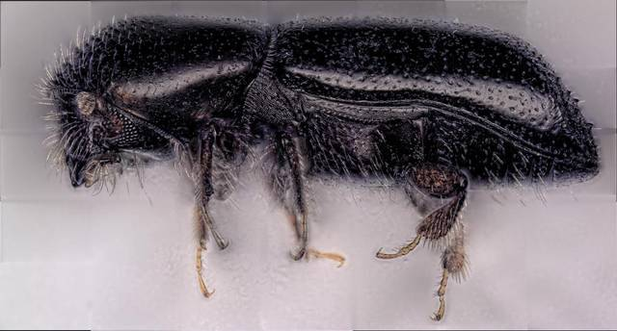
Edward Evans, UF’s agricultural economist, estimated that farmers have already spent around $4.8 million on tree removal and treatment and that it would cost anywhere between $206 million and $216 million to replace all commercial and residential avocado trees in Florida.
Figure 4 Image of the beetle
Jonathan Crane, a tropical fruit crop specialist at the University of Florida, said cutting down a tree as soon as symptoms arise is crucial to preventing the spread of laurel wilt, since there is still no cure.
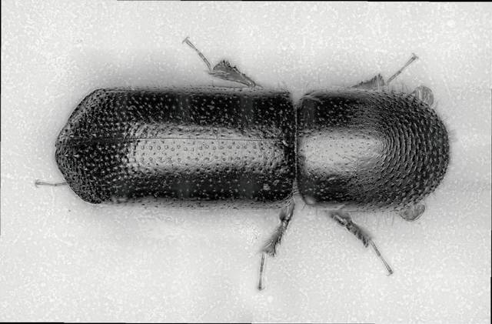
The ambrosia beetles “can fly from an infested tree where the owner is not trying to control the problem, and then they can fly into a grove that doesn’t have the problem,” Crane said.
Figure 5 top view of the bettle
Contributing to the problem: absentee farmers who don’t directly manage their crops. Charles LaPradd, the county’s agriculture manager, said less than 50 percent of farms in Miami-Dade County are actually owned by farmers, and the majority of them live elsewhere.
“So when an absentee farmer isn’t being proactive in treating or removing infected trees, the disease spreads even faster,” he said.
The disease first entered the U.S. from Asia in 2002 inside contaminated packing material. In 2004, the link between the ambrosia beetle and laurel wilt was established after cases had spread to South Carolina. It wasn’t until 2012 that laurel wilt was found in South Florida commercial avocado groves. Most recently the disease has spread quickly across Miami-Dade and is now in 22 other Florida counties.
Experts say the beetle infestations move from 15 to 34 miles per year. The insect does not like the avocado fruit itself, just the trunk. And although a tree may be infected, the fruit that was on that tree at the time is not.
Daniel Carrillo, an entomologist at UF’s Tropical Research & Education Center in Homestead, said in Asia the beetle is “not a problem because the beetle has many natural enemies and other organisms that control it. The beetle arrived here free of all those natural enemies and now it became a serious pest for us — it found paradise,” Carrillo said.
In mid-July, the Miami-Dade County Commission declared the disease a “nuisance,” saying any infected tree must be removed. This fiscal year, the county budgeted $150,000 for laurel wilt control and future budget allocations are planned, Miami-Dade Mayor Carlos Gimenez said. The state also allocated $150,000 this year.
In early June, Gimenez took a two-hour helicopter ride to take a look at the groves.
“What I saw was devastating,” he said. “The avocado crop feeds into the economy. People’s jobs and livelihood depends on these groves. Right now we are depending on research to see if there’s any way we can kill the beetle, or cure the tree, or find a way to stop the problem. It’s going to take some time.”
Read more here: http://www.miamiherald.com/living/food-drink/article92690152.html#storylink=cpy

