Are Recycling Programs Effective in Managing Damage to the Environment?
We Need Product Innovation, Not Happy Cup Fallacy
Jack Buffington 02/09/2016 EARTHTALK
If you take into account all throwaway containers used in the United States on a daily basis, there are one billion containers that flow through the supply chain — and perhaps only 400-500 million or so of these materials are collected for recycling. Of these 400-500 million containers collected for recycling, perhaps 15-25 percent are thrown away before they are even reused, and of the balance, maybe half are reused for the same or a better purpose. That translates into 180 million of today’s beverage containers being reused can for can, bottle for bottle, or cup for cup. The rest are either thrown away or used for a lessor purpose, having to be replaced tomorrow with new natural resources of fossil fuels, paper, silicon, and aluminum.
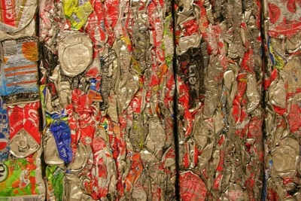
So what’s the plan to address this problem of massive packaging waste and its impact to the environment? Most people believe this issue can be addressed simply by consumers doing their part through participation in a recycling program, like exists in the zero waste nations in Europe (Sweden, Germany) — but is this really the case? From my role as a consumer products leader in the United States and an environmental science/supply chain researcher in Sweden, I have found the use of recycling programs to be more of a mitigation technique than a solution to this problem of waste and environmental impact. Why? Not because the consumer shouldn’t recycle, but rather due to the scientific and economic evidence that most of our beverage containers were never designed to be recycled, and therefore, are easier and cheaper to throw into a landfill or be downcycled than to be reused like for like, or for a higher purpose. In this model, the collection process of consumer recycling becomes an ineffective means with an end of low reuse, and therefore, high waste and environmental damage. Regardless of what is advertised on the side of your beverage container, the problem of economic waste and environmental damage cannot be resolved in this back-end solution to a front-end problem.
By some estimates, there is six times more plastic in our oceans than plankton, and every day, the situation only grows worse, with no real solution in sight. For a problem of this magnitude to be addressed, we must address this paradigm that our plastic mess can be solved alone through recycling programs, especially given consumer growth in developing areas of the world with business markets ramping up faster than environmental controls. Recycling programs can only mitigate the damage, and awareness must be raised regarding the need to design new beverage containers that can be safely and effectively recycled and reused, which will not only be good for the environment, but the economy as well. Today’s consumers are largely content that they are doing their part as long as they throw their container after use into a bucket with the three chasing arrows logo on it, but this is a lack of awareness of the real problem. Material scientists are on the verge of exciting and new materials that will not just mitigate environmental damage, but erase it. A greater focus must be placed on these innovations rather than happy cup fallacy marketing and environmental programs.
Recycling programs are not ineffective because we shouldn’t recycle, but rather because we should demand more from our consumer products industry and environmental associations in solving the problem. To save our oceans, we need transformation, not feel-good programs.
Jack Buffington, Ph.D. is a business leader at MillerCoors, the second largest beer manufacturer in the U.S., and a post-doctoral researcher in supply chain/biotechnology at the Royal Institute of Technology in Stockholm, Sweden. He is also the author of the book, “The Recycling Myth: Disruptive Innovation to Improve the Environment.”

Share this:

