Giant holes are bursting open in Siberia, and you can hear the explosions from 60 miles away
- By Sarah Kramer and Dave Mosher, Tech Insider – Business Insider
Giant holes are popping up all over the frigid tundra of northern Russia, and no one is quite certain where they come from.
However, the Siberian Times reports that witnesses are now describing explosive events that may be connected to the appearance of these mysterious craters.
Reindeer herders spotted one of the first huge holes in 2013, in the region's Taimyr Peninsula. It was about 13 feet wide, nearly 330 feet deep, and - as they stumbled across their find - the men "were almost swallowed up by the crater," the Siberian Times wrote.
The herders never saw what made the hole, which has since grown to a whopping 230 feet wide and filled with water.
But villagers who live dozens of miles away are finally coming forward to say they heard and saw something strange shortly before the crater was found, according to the Russian news outlet:
[R]espected scientist Dr Vladimir Epifanov, the sole leading expert to so far visit the site, said: 'There is verbal information that residents of nearby villages - at a distance of 70-100 km [43-62 mi] - heard a sound like an explosion, and one of them watched a clear glow in the sky.'
Since the crater appeared in winter 2013, more have shown up - including a 100-foot-wide crater on Siberia's Yamal Peninsula, which a pilot first spotted n 2014. Lacking a better explanation, aliens and underground missiles were floated as possible theories, according to the Washington Post.
But the truth - which the new eyewitness reports may help support - is that the holes might come from a threat not even Mulder and Scully are equipped to handle: climate change.
Scientific American reports that Arctic zones are warming at a breakneck pace, and the summer of 2014 was warmer than average by an alarming 9 degrees Fahrenheit, according to another story in Nature. As a result, scientists at NOAA think that permafrost, the permanently frozen ground that covers the tundra, is starting to thaw in these warmer temperatures.
So how does frozen methane blow a 100-foot-wide hole in the ground?
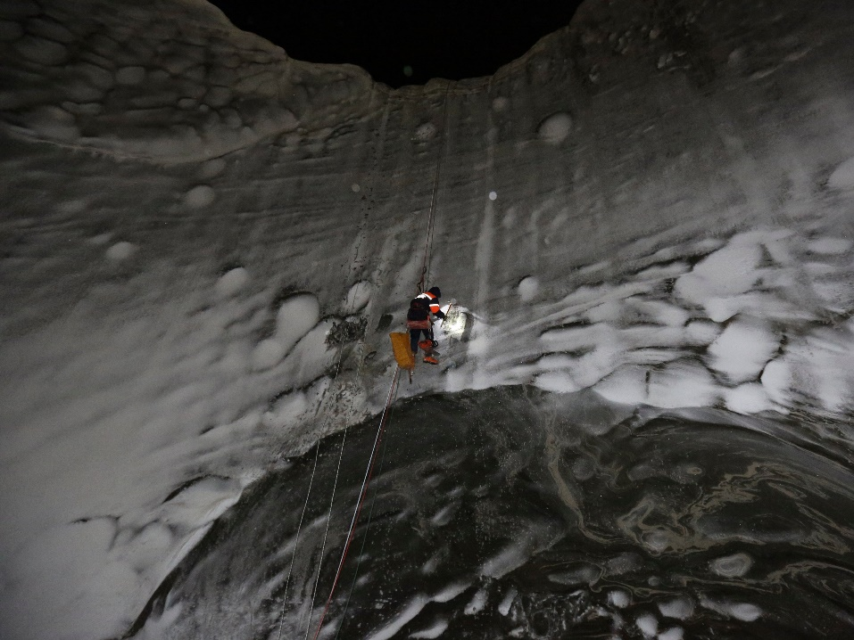
Given low enough temperatures and high enough pressure, methane and water can freeze together into what's called a "methane hydrate." Permafrost keeps everything bottled up but when it thaws, so does the hydrate. Methane is released as a gas, building up pressure - until the ground explodes.
Figure 1 A climber scales down a permafrost crater. Vladimir Pushkarev/Reuters
Scientists gained more evidence for this theory after an expedition to the bottom of the crater. It revealed the air had an extraordinarily high concentration of methane.
It's not just explosions and melting permafrost we should worry about, either. The EPA states that methane is a greenhouse gas that could have 25 times the impact of carbon dioxide over the next century.
A significant addition to methane emissions would likely have a disastrous impact on our already troubling atmospheric warming, since it's 21 times better at trapping heat, according to LiveScience.
Several outlets have even gone so far as to call this problem a "time bomb."
And it gets worse: One of the craters is just 6 miles from a natural gas field. The Siberian Times reported the combination of the two flammable materials in such close proximity is a huge safety concern for the area. (At least two of the craters have since turned into lakes.)
There may be an alternate explanation, though. Land can collapse without a burst of methane in something called a pingo, which form when ice is trapped between layers of earth and distorts the top layer into a sort of mound. Thawing can make those mounds suddenly collapse.
Even if the craters are the result of collapsing pingos, they're still likely the result of climate change (and still dangerous).
What's more, Slate reports, the same thing could happen in Alaska.
Pingo or exploding crater, it's clear that climate change is impacting the Arctic more rapidly than any other place on Earth, but researchers are only beginning to grasp how unprecedented warming will effect northern ecosystems.
During his visit to Alaska in September 2015, President Barack Obama echoed the common sentiment that the Arctic is "ground zero" for climate change.
These mysterious Siberian craters seem to be yet another warning sign that human-caused climate change is quickly spinning out of control, causing new and unpredictable changes along the way.
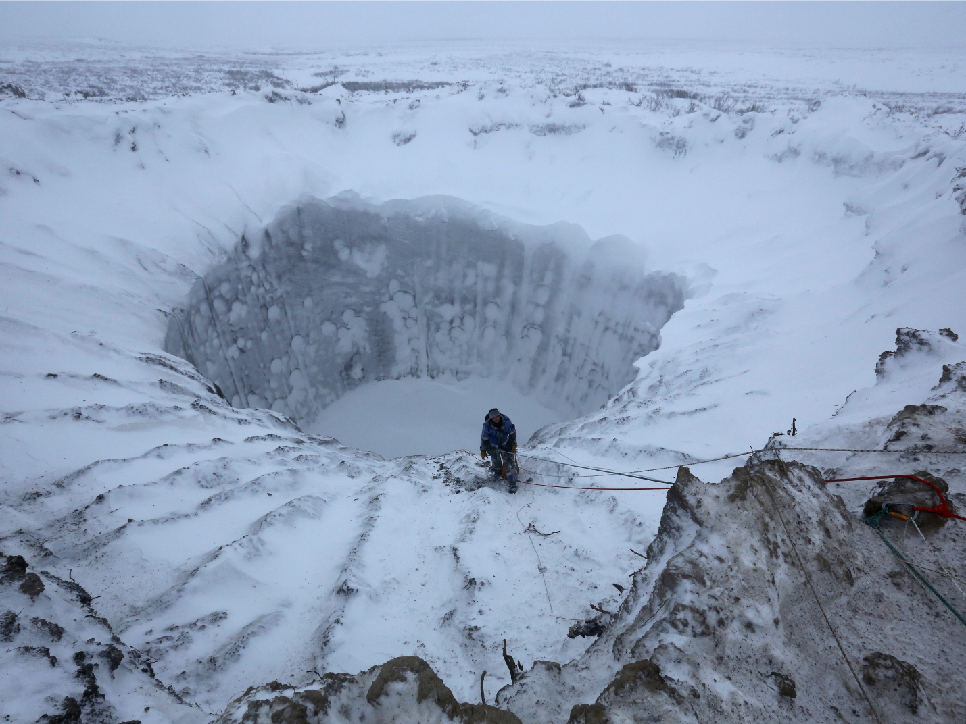
Figure 2 A 100-foot-wide permafrost crater in Siberia's Yamal Peninsula.
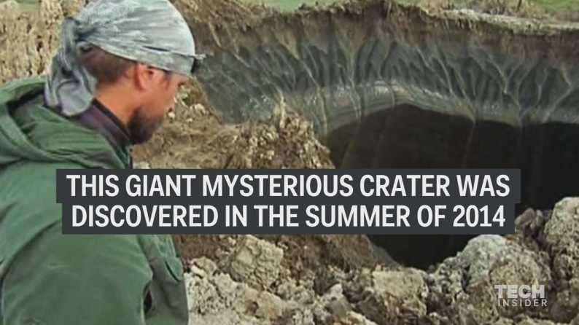
Read the original article on Tech Insider. Follow Tech Insider on Facebook and Twitter. Copyright 2016.

