These Plastic Bottles Full Of Bleach Light Up Homes Without Electricity

About 1.2 billion people worldwide don’t have access to electricity.
By Sarah Ruiz-Grossman 07/19/2017 HUFFPOST
In an effort to bring light to communities lacking electricity, one pioneering project is utilizing an unexpected tool: old plastic bottles.
Liter of Light, a project of the Philippines-based nonprofit MyShelter Foundation, provides light to poor households around the world with limited or no access to electricity ― by collecting plastic bottles, filling them with water and bleach, and sticking them into roofs. The bleach-filled bottles then refract the light from outdoors into the house, lighting up much like a lightbulb.
“Here the houses are so stuck together that they have no windows ― you have shantytowns that have a sea of iron over them,” MyShelter founder Illac Diaz, a Filipino native, told HuffPost, referring to poorer areas in the country. “It’s good for rain, but no light enters even during the day.”
But the bleach bottle lights ― which were originally thought up by Brazilian mechanic Alfredo Moser, who worked with MyShelter to bring them to people worldwide ― have a major downside: They only work when the sun is out.
To solve the problem, the group added a mechanism to have the bottles work at night as solar lamps. By slipping a test tube with a small LED lightbulb into the bottle, which in turn is hooked up to a mini-solar panel, the bottle can still refract outside light during the day, but then also be used as a lightbulb at night.
In addition to using the bleach bottle lamps and the nighttime solar bulbs, the group also converts kerosene lamps into solar lamps.
Since launching in 2012, Liter of Light has provided lights to 850,000 households across more than a dozen countries, including the Philippines, Egypt and Colombia. The plain bleach bottles represent about 5 percent of their lights, Diaz said, with the bulk being solar-converted bottles, kerosene lamps and streetlamps.
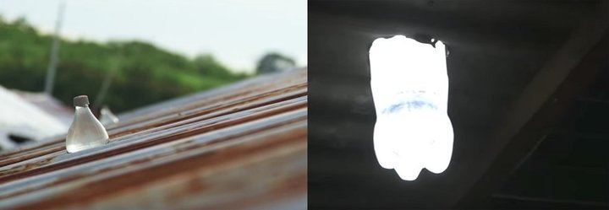
Figure 1 Liter of Light bleach bottles are shown inside a roof — one viewed from the outside (left) and the other from the inside at night.
With 1.2 billion people lacking electricity worldwide as of 2014, Liter of Light’s bleach bottles provide a cheap solution that is easy to make at home. They are also an alternative to kerosene lamps, which are often used by poor households around the world in lieu of electricity, but which pose a fire hazard and emit dangerous fumes detrimental to people’s health, according to the World Health Organization.
To make the bleach bottle lights, people simply have to mix 3 milliliters of bleach into a liter of water, according to Diaz. The concoction lasts for around five years, at which point one can simply switch out the water.
For the solar-converted lamps, the foundation trains women to build the circuits from scratch, Diaz said. The women then sell the lamps in villages for around $10 each, providing them with an income and ensuring people living locally know how to make and repair the lamps.
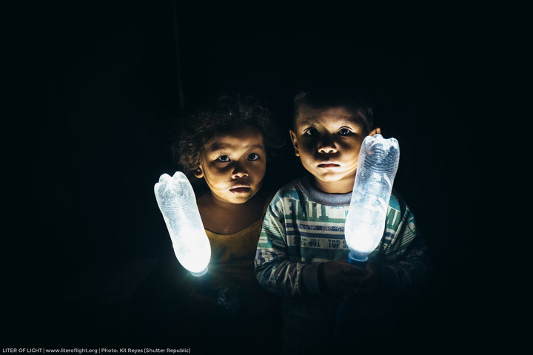
The group makes a point of ensuring all materials for its lights are sourced locally, and posts videos on YouTube to teach anyone how to make them.
For Diaz, it’s all about countering a common problem in poverty-fighting projects: sustainability.
Figure 2 Liter of Light - Two boys with LED bottles
He described how some well-meaning organizations ship items to poor countries, which can then cut into the sales of local vendors, and also create a new burden when objects break down and require expensive repairs.
“If you could not build it and repair it on the village level, there’s no way to be independent,” Diaz said. “These are simple pieces available in the market ― women would even get them from electronic junkyards. We want to create a solar revolution from the bottom up.”
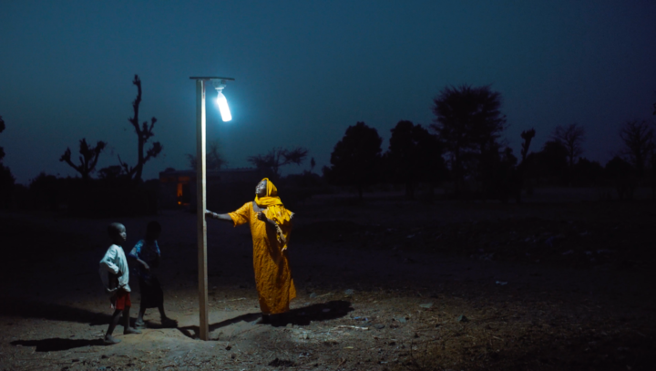
Liter of Light
A solar-powered street lamp from Liter of Light
Another problem Liter of Light seeks to address with its bottle lamps is plastic waste. By making use of discarded plastic bottles, the group aims to reduce garbage in communities where it works.
Diaz’s native Philippines is one of five countries that together contribute more than half of all plastic that enters the ocean worldwide, according to a 2015 Ocean Conservancy report.
“Plastic bottles are all over the place,” Diaz said. “We’re an island, and we’re one of the biggest countries in disposing plastics into the sea and contributing to ocean plastics.”
Around 8 million tons of plastic end up in the ocean each year, according to a 2016 report from the World Economic Forum. That’s like tossing a garbage truck’s worth of plastic into the ocean every minute.
Diaz estimates that through its lights, the foundation has recycled hundreds of thousands of plastic bottles. But the group still hasn’t reached as many people as it originally hoped, Diaz noted. In 2013, Liter of Light aimed to reach 1 million people by 2015. Now they’re hoping to achieve that goal by 2020.
Making the plastic bottle lamps is “something everybody can do,” Diaz said. “You have to understand the genius of the poor: People have spun off our ideas into their own backyard solar business. That’s what we want. A nation of backyard solar entrepreneurs, instead of them relying on our foundation.”
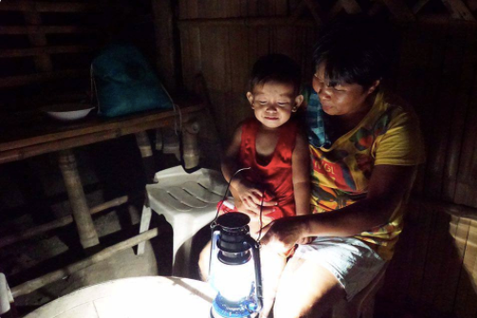
Liter of Light
A family sitting by a solar-converted kerosene lamp from Liter of Light.

