Why Religion Is More Durable Than Commonly Thought In Modern Society
%Tom Gjelten
April 28, 2017 NPR Morning Report

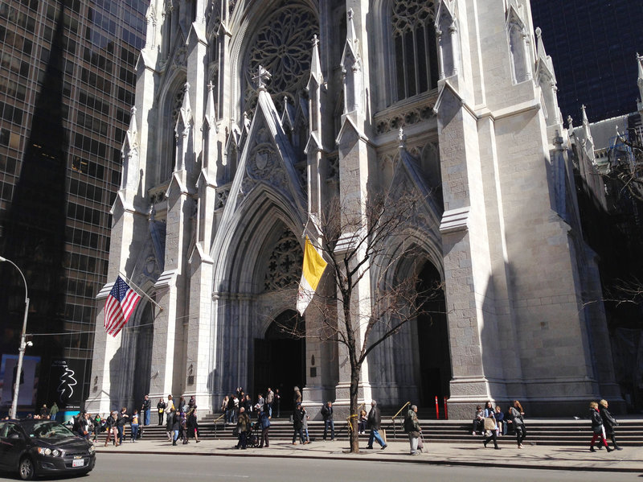
Figure 1 Pedestrians walk past St. Patrick’s Cathedral in New York City. The number of Americans who list their church affiliation as “none” has certainly increased, but more than 70%still identify generally as Christian.
Here is a proposition that may seem self-evident to many people: As societies become more modern, religion loses its grip. People separate their religion from their institutions and from parts of their lives.
Sociologists have a name for this idea. They call it the "secularization thesis." Now, research suggests the story is more complicated.
In 1822, Thomas Jefferson suggested an early version of it, predicting that Unitarianism "will, ere long, be the religion of the majority from north to south."
Some data from modern countries support the thesis. Fifty years ago, about 4 of 10 children in England attended Sunday school. Today, it's only about 10 percent. In the United States, just 5 percent of the population in 1972 reported no religious affiliation. By 2016, 1 out of 4 said they were unaffiliated.
Recent research, however, has suggested that religion is more durable than was previously thought. While church attendance has declined sharply in western Europe, secularization has been less evident in the United States. The number of Americans who list their church affiliation as "none" has certainly increased, but more than 70 percent still identify generally as Christian.
The new consensus of sociologists and demographers is that modernization and secularization are indeed related, but in complex ways.
A study released this week by the Pew Research Center on the relation in the United States between religiosity and educational attainment (one component of modernization, along with technological change and others) at first glance appears to support the secularization thesis: The more education people have, the less religious they are.
"College graduates are less likely to say they believe in God with absolute certainty," noted the lead Pew researcher, Gregory Smith. "They are less likely to say that religion is very important in their lives. They are less likely to say they pray regularly, and college graduates are more likely than others to identify themselves as atheists and agnostics."
A closer look at the data, however, offers a more nuanced picture. While highly educated Jews tend to be less observant than less educated Jews, the relation between education and religiosity is weaker among those Americans with a strong Christian identity.
"Highly educated [Christian] adherents are just as religious, in some cases more religious, than their fellow members who have might have less education," Smith said. Among mainline Protestants, for example, college graduates were actually found to be more likely than noncollege graduates to report weekly church attendance. Regardless of their educational attainment, these Christians find meaning in their church experience.
The sharp rise in the number of Americans who report no religious affiliation may also have an explanation that is unrelated to secularization. Research by Philip Schwadel at the University of Nebraska suggests it may simply be that it was less acceptable 50 years ago to identify as religiously unaffiliated than it is today.
Schwadel and others also argue there are significant differences between the United States and Europe when it comes to the process of secularization. In Europe, organized religion has generally been associated with governments to a far greater degree than in the United States. As a result, anti-government sentiment may have been more likely in Europe to produce antagonism toward the church. Government support for religion in many western European countries may also have weakened the vitality of those church communities.
"When a state creates a relationship with a religion, religious leaders no longer have the same impetus to go out and get people excited," said Schwadel. "They get money from the state through taxes, so they don't have to collect money from their congregants."
In the United States, by contrast, religious leaders have to "hustle" more, Schwadel said. "They need to get more congregants if their church is going to survive." Perhaps as a result, Americans are more committed than Europeans to their church congregations.
The notion that religious belief and practice have evolved with modernization does remain broadly accepted. As literacy has increased and scientific knowledge has advanced, supernatural explanations for developments in the natural world have become less important. Religion has nevertheless survived, Schwadel argues, because it plays a variety of roles.
"Religion provides people with a lot more than just explanations for the natural world," Schwadel said. "It provides community. It provides them with friends. It provides them with psychological support and economic support. It provides a lot more than simply an understanding of where they are in the world in relation to the afterlife."
A 2016 Pew study found that more Americans reported growing feelings of "spirituality," even while saying they were less attached to organized religion. To the extent that churches respond to that need, they will presumably have better prospects for survival.
The question that religious leaders and sociologists of religion face is whether modernization will eventually lead to secularization in the United States and other countries, just as it has in western Europe. Some argue that a diminished emphasis on traditional doctrine about the meaning of salvation, for example, or the existence of heaven and hell, is merely an early sign of growing secularism.
Among the pessimists about the future of religion is the writer Rod Dreher, whose new book The Benedict Option outlines a survival strategy for Christians "in a post-Christian nation."
"I've been going around to different colleges, Catholic and evangelical, giving speeches, and at every single one of these colleges, the professors tell me the same thing," Dreher said. "The kids are good kids, but they're coming out of families [and] local churches and youth ministries knowing almost nothing about the historic Christian faith."
Dreher is now convinced that the United States "is on the same downward path in terms of religious observance that Europe has been on for a long time."
"It's all about emotion," he said.

