Japanese family life is falling apart — and the reasons why go back to World War II
Chris Weller
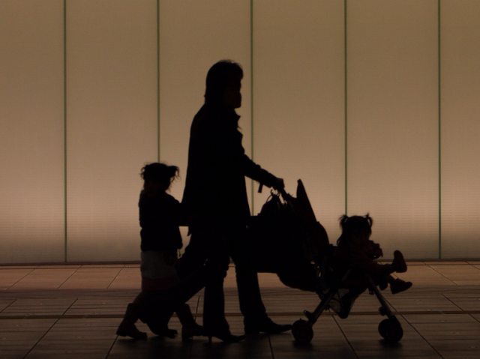
Japan is in the midst of a fertility crisis, and it's 65 years in the making.
Saddled with long work hours and rising expenses, young Japanese couples are opting not to have kids. Even if they have the energy to start a family, many simply don't have the time.
As a result, spending shrinks on the small scale and the Japanese economy contracts on the large scale. Japan has seen trillions in lost GDP over the past years, in combination with a population decline of 1 million people. Harvard sociologist Mary Brinton puts it bluntly: "This is death to the family," she tells Business Insider.
Japan's case isn't just extreme in scale; it's also extreme in how far the ripples of the past have extended into the present. Policies implemented in the early 1950s, in the aftermath of World War II, still shape the lives of many Japanese young people in 2017.
During the early 1950s, Prime Minister Shigeru Yoshida made it his top priority to rebuild Japan's economy. Much of the country had just been decimated in some form — if not by the two atomic bombs, then by the resulting effects on business and daily life.
Yoshida's plan involved a pact made between businesses and their employees. He called on companies to offer lifetime employment to their workers, asking that those workers devote the whole of their beings to those jobs.
The pact worked. Japan's economy emerged from the rubble as one of the strongest in the world. Japan became a manufacturing and technological hub, and almost none of the work came from outside the country's borders, save for trace populations of Chinese immigrants.
Ultimately, Japan's economy ended up becoming the third-strongest in the world. Its present-day GDP stands at $4.3 trillion.
But there was a high cost to that initial pact: Family life began to deteriorate. As more people began staying later at the office, and women began entering the workforce en masse, Japan's fertility rate started to plunge because its corporate structure wasn't built to accommodate both.
What started as a healthy 2.75 children per woman in the 1950s fell to 2.08 by 1960. Today, more than 50 years later, Japan's fertility rate sits at 1.41.
Yoshida's plan worked, and yet Japan still clings to its intense work culture. Frances Rosenbluth, a Yale University political scientist, says the early competition between firms to attract top talent for life has cemented Japan's corporate structure.
"You are promoted gradually with your class," she tells Business Insider. "You're sort of on this escalator of very steady, slow promotion. And if you leave your job you have to start over somewhere else. It's not a fluid labor market where you can pick up a job at another place with the assets you've accumulated in human capital."
This has led to many Japanese couples having almost no free time. Men work 16-hour days at times, while their wives may work similarly long hours. Some couples achieve a work-life balance by becoming entrepreneurs, allowing them to set their own schedules. But many fall victim to a system that dictates the roles men and women should play.
"Despite that there's an equal opportunity employment law, firms will find ways to avoid hiring and promoting women just for the economic reason," which is that women may leave to have kids, Rosenbluth says. "We call it statistical discrimination."
Rosenbluth says Japanese family life can't repair itself until companies make it easier to balance the demands of a job and home life. And since many firms don't see any incentive to do that, the government has a duty to offer tax breaks to those offer balance, Rosenbluth says.
Brinton takes a similar stance.
"No matter what you say, what you hear out of Prime Minister Abe's mouth, it's not about gender equality," she says. "It's about productivity of the economy and addressing the fact that Japan is one of the most rapidly aging societies in the world and they're going to run out of labor unless women have more babies."
Note: A Total Fertility Rate of 2.1 is the replacement rate: population size is stable. Below that number, the population size is shrinking.

