Eid al-Fitr: What you need to know
By Cristiana Moisescu, for CNN Updated Sun June 25, 2017
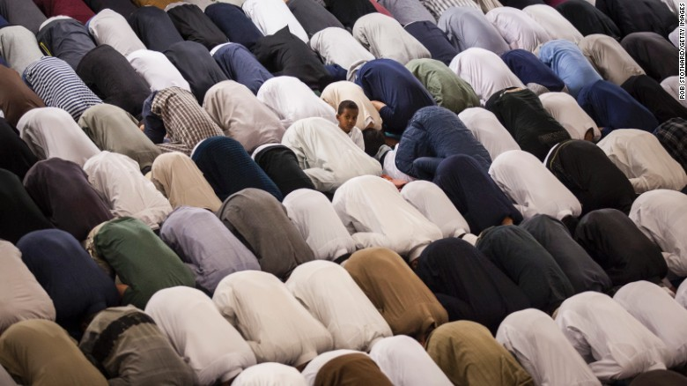
CNN)More than one billion Muslims around the world celebrated Eid al-Fitr on Sunday, as the month-long Ramadan fast ends and the festivities begin.
This year's Eid comes amid ongoing crises in the Middle East -- the civil war in Syria, the diplomatic crisis surrounding Qatar -- but the celebrations mark a time when communities within the Muslim world come together.

What is Eid al-Fitr?
One of the most important days for Muslims, this is the "festival of breaking the fast."
Families and friends gather to mark the end of Ramadan and show gratitude to Allah. Eid al-Fitr doesn't have any historical links; instead, the celebrations focus on the community and family, and a spirit of generosity is encouraged.

Ramadan is a month-long fast, which marks the month Muslims believe their Holy Book, the Quran, was revealed to the Prophet Mohammed. During this time, Muslims refrain from eating and drinking from sunrise to sunset. Ramadan is one of the five Pillars of Islam, requiring prayer five times a day and generally encouraging a more reflective behavior.

When is Eid al-Fitr?
On Saturday, Saudi Arabia's Supreme Court announced this year's Eid al-Fitr would begin on Sunday, June 25, according to state-run Saudi News Agency. Most of the Muslim world kicked off celebrations that day, but because the holiday is set by Islam's lunar calendar and depends on the sighting of the new moon, some countries celebrate it a day later. Ramadan and Eid do not fall on the same date each year for the same reason. Time-zones also impact when Eid begins.

Once Eid starts, the celebrations can last for up to three days in most countries. 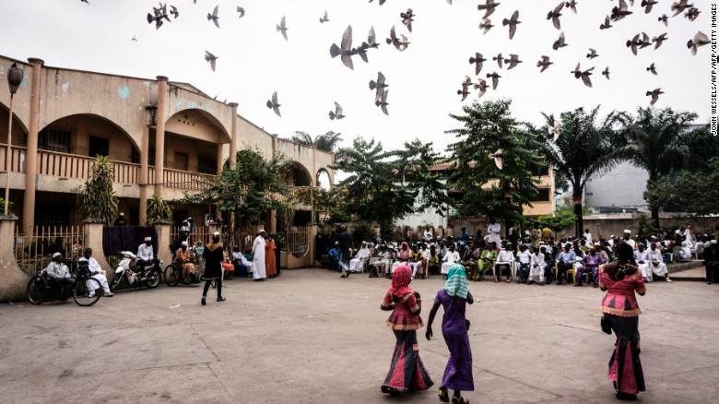
Muslims congregate in a square in Kinshasa, Democratic Republic of the Congo.

How to celebrate Eid?
During the day, Muslims gather in large open spaces or mosques for special prayers, called Salat al-Eid, usually followed by a small breakfast, their first daytime meal in a month.

Gifts are usually exchanged, and alms-giving is also a common practice. Another custom involves donning new clothes for the new day, which marks a spiritual renewal.

Food is an important part of Eid al-Fitr, as feasting takes the place of fasting. After a month of the latter, delicacies and heavy foods will reign at the lavish dinners being prepared.
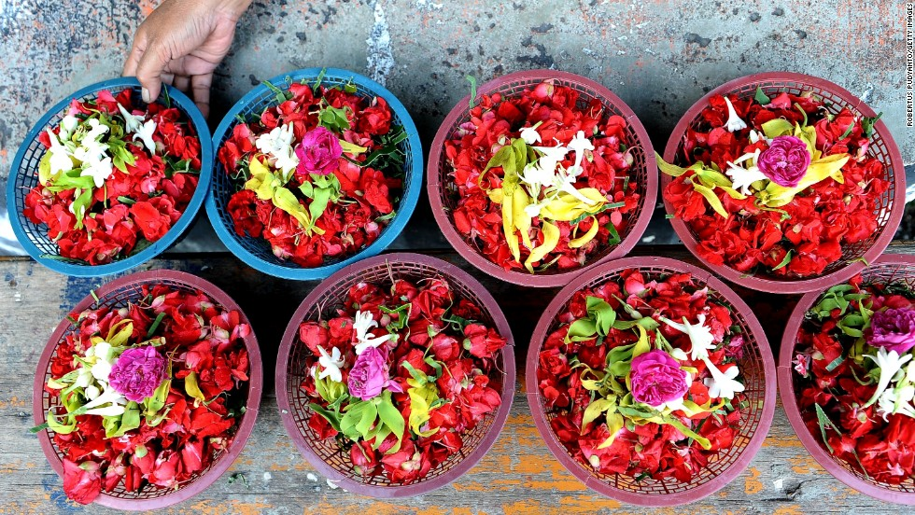

This week brings the end of the holy month of Ramadan, a 30-day fast practiced by many of the 1.6 billion Muslims living worldwide. The fasting period is celebrated with the feast day of Eid-al-fitr.
But after prolonged periods of fasting, some strategic eating may prove beneficial in order to enjoy the multitude of food on offer. CNN asked two top nutrition experts to share their health tips to help those celebrating make the most of the delicious feast.

A perfect feast to break the fast

Go slowly – In some places a typical Eid morning might begin with a plate of Shir Khurma --a vermicelli and milk pudding spiced with cardamom and cinnamon. Starting the day with a small breakfast is a good idea, says Courtney Ferreira, a Clinical Nutritionist at the University of Maryland Medical Center. The key is to go slowly no matter how tempting big plates of food may seem.

Eat little and often – Resistance may be a battle, but avoid indulging all at once."It's better to eat little portions at a time than fill yourself up all at once," says Ferreira. "Make sure you're listening to your body... being aware of what you're eating is almost more useful for people than what exact foods to eat."
The art of small portions – Gastrointestinal (GI) problems such as bloating can be avoided by sticking to small portions. "You can have some GI distress when you're eating that much, especially when you're not used to it," says Ferreira. "Eat a variety, but keep your quantities small. That will just help you prevent that uncomfortable fullness."

Easy on the sugar – While sweets such as baklava are an important (and delicious) part of the feast, be sure to go easy on them. "After doing a lot of fasting, if you're putting that much sugar into your body it can make you feel ill and nauseous from the high blood sugar ... it's just not the best for your body to have those crazy surges," says Ferreira.

Embrace diversity – Whether you eat baklava, Roti John or Lalmohan, diversifying your food intake is key for a balanced diet. Experts advise making sure to get enough protein, carbohydrates, fresh fruit and vegetables throughout the day to keep your body happy.

Remember your veg – "Fruits and vegetables, those are going to provide you with minerals you've missed out on," says Ferreira. She highlights that people don't need to take vitamins if they go back to eating a healthy diet in the weeks after the feast.

Get back to normal – Fasting during Ramadan also involves no drinking during daylight hours, so the body can have some hydration to catch up on during Eid celebrations. "As well as enjoying delicious dishes, remember to keep drinking fluids throughout the day to stay hydrated," says Ferreira.

Keep the good bacteria – Over the month of Ramadan, good bacteria have been growing in your gut, according to Tim Spector, author of The Diet Myth and professor at Kings College London, "A fast is a good way of regenerating your microbes, so that will increase certain beneficial species that you want to keep going through the times when you're not fasting," he says.

Bacterial cleansing – One type of microbe, akkermansia, is particularly helpful, "It comes out during fasting periods, and because it has no food to feed off, it actually nibbles away at your gut lining," says Spector. Fear not, this is a good thing. "It tidies it up," he says.

Energize your bacteria – During a feast, Spector recommends eating probiotics such as cheese and yogurt as well as polyphenol-rich foods including artichokes, leeks, onions, red berries and extra virgin olive oil, which provide energy for the now abundant levels of good bacteria in your gut.

Getting back to normal – After a month of fasting it will take some time for your body to adjust to a normal diet again. Ferreira explains that it's also best to get back to normal eating habits the day after the feast so nutrients can be replenished regularly over the following weeks.
"Most people return to their normal state within two to four weeks ... it depends on your age [and] your medical condition, how quickly your body will bounce back," she says.
While it's important to eat healthy, the main thing to remember on a celebration day like Eid al-Fitr is to have fun, "People should enjoy themselves! It's a tradition. They want to have a good time," says Ferreira.
You now have your tips -- go out and celebrate.
