5 things to know about Hanukkah, because Chrismukkah
By Yitzchak Carroll December 9, 2016
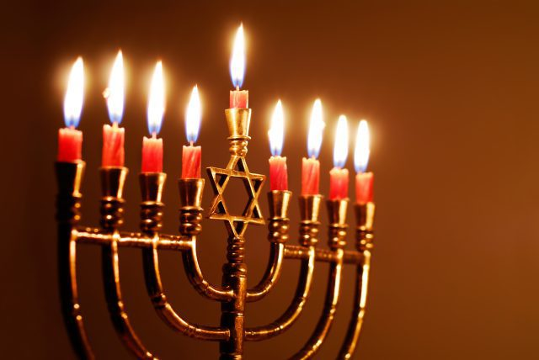
Candles lit for the eighth night of Hanukkah. (Getty Images)
What do candles, spinning tops and religious freedom have in common?
A lot — at least for Jews who celebrate Hanukkah.
This year, for the first time in nearly four decades, Hanukkah — which falls out based on the Hebrew lunisolar calendar — kicks off on Christmas Eve and ends on New Year’s Day. Some are dubbing this year’s confluence of festivities “Chrismukkah.”
So Jews around the world will begin their eight-day observance of Hanukkah on Saturday night, December 24 — the eve of the 24th day of the Jewish month of Kislev — just as Christians start celebrating Christmas Eve.
The Festival of Lights, as the holiday is also called, is a fun holiday, but it originates from a dire time in Jewish history. Hanukkah commemorates the rededication of the Holy Temple in Jerusalem during the second century B.C.E., after Syrian-Greeks took over the Land of Israel, defiled the Holy Temple and outlawed Judaism. A small group of Jews, known as the Maccabees, revolted against the Syrian-Greeks, and despite being heavily outnumbered, they won and took back the sacred Holy Temple. So that’s what we’re celebrating on Hanukkah.
Here are five things to know about this joyous holiday.

1. Light those candles
Tradition tells us that after winning back the Holy Temple in Jerusalem, the Jews wanted to light the sacred menorah (candelabrum), but lacked the special oil with the seal of the high priest to fuel the menorah. Miraculously, one jug of special oil was discovered, which lit the menorah for eight days and nights, until more oil was prepared.
To publicly observe the holiday and commemorate the miracle, Jews light their own menorahs, adding on another candle each night of the holiday. Eight of the branches represent the eight days of Hanukkah. The ninth branch holds the shamash, or servant candle, used to light the other candles.
Fun fact: Candles are placed in the menorah from right to left, but are lit from left to right.
Jews around the world say a prayer each night as they light their menorahs in the dark winter night. (But if you’re planning to light a menorah in your dorm, be extra careful or opt for an electric version.)

2. Savor the oil
The miracle of the remaining oil jug during the rededication of the Temple isn’t commemorated with lights alone. It’s also customary to eat foods prepared with oil on Hanukkah, including latkes (potato pancakes) and sufganiyot (doughnuts — often the jelly kind), adding a sweet — albeit unhealthy — taste to the festival. Just don’t eat too much!

3. Spin your tops
Before the Maccabees revolted, Judaism was outlawed in Israel. When Syrian-Greek officials came to check on the Jews, those studying the Torah and other religious texts would hide their scrolls and pull out four-sided spinning tops, called dreidels, and pretend to be playing games instead of practicing their religion, which was punishable by death.
Today, Jews play a variant of the game by spinning a dreidel and splitting chocolate coins based on which Hebrew letter the dreidel falls on. The one who ends up with all of the coins is declared the winner.

4. Did I hear presents?
Traditionally, parents gave children gelt — coins — in honor of Hanukkah, which has evolved into presents today, just as celebrants of Christmas — with help from Santa — give their children gifts in honor of the holiday.
Gelt still lives on, mostly in the form of chocolate coins, but modern Jewish children look forward to their Hanukkah presents for months. This year, Chrismukkah gift-giving could be a boon for retailers.

5. Coming together
Above all, the focal point of Hanukkah, as with other wintry holidays including Christmas and Kwanzaa, is coming together to celebrate good times with friends and families. Right before we head into the new year, these festivals give us the opportunity to connect with loved ones, appreciate the little miracles in our daily lives and charge up for a productive new year in 2017.
So do we, Seth Cohen, so do we. (Giphy)
Yitzchak Carroll is a student at Yeshiva University and is a member of the USA TODAY College contributor network.

