4 Maps That Explain Iran's Place In The Middle East
Opinions expressed by Forbes Contributors are their own.
Guest post written by George Friedman
As an expert in intelligence and international geopolitics, George Friedman is firmly focused on what he knows best—the future.
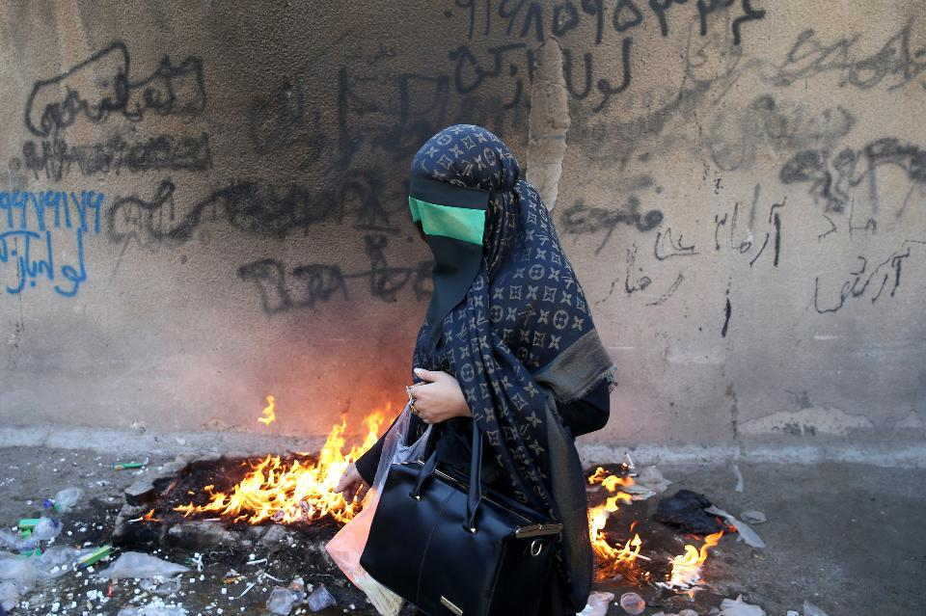
This picture taken on Tuesday, Oct. 11, 2016, shows an Iranian woman covering her face symbolically, as she takes part in a mourning ceremony in the city of Khorramabad, southwest of the capital Tehran, Iran. Shiites mark Ashoura, the tenth day of the Muslim month of Muharram, to commemorate the martyrdom of Imam Hussein, a grandson of Prophet Muhammad and one of Shiite Islam’s most beloved saints, during the 7th century Battle of Karbala in present-day Iraq. (AP Photo/Ebrahim Noroozi)
If you ranked the civilizations that have most affected the course of human development, Persia would be near the top of the list. We forget this because in recent centuries, the states that have ruled in Iran have been either weak or isolated from the rest of the world.
Since the 1979 Iranian Revolution, that has changed. There was even a short-lived moment when it seemed Iran was poised to predominate in the Middle East. This was right before the Syrian civil war broke out, as I explain below. That chance collapsed, and Iran has been consigned to a secondary regional power for the near future.
The four maps below explain why.
Geographical Limitations
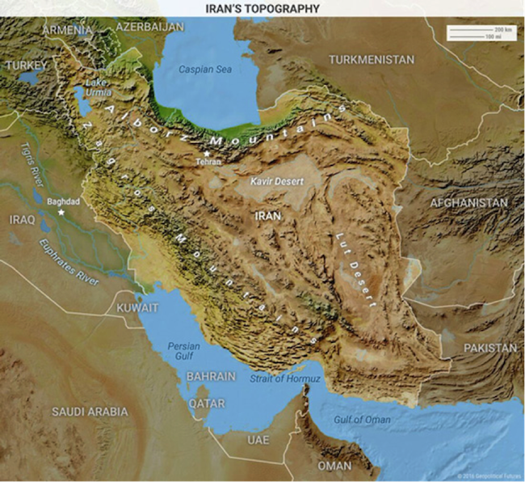
Geography has always been a two-edged sword for Iran. In terms of both area and population, Iran is the largest country in the Middle East. It is the 17th largest in the world.
Iran’s large cities are hemmed in by mountains and deserts. This fact defined ancient Persian strategy, and it defines Iran’s tactics today. Iran’s geography has made the country extremely hard to conquer. But it has also stopped Iran from easily expanding.
Recommended by Forbes
The best place for Iran to project power is to its west. All other directions are more difficult. Iran has strong influence in Afghanistan, but that country is even more mountainous—a tribal area with even less useful land.
Central Asia is another place Iran’s influence extends, but here too, the land isn’t worth what it would take to conquer it. The Caucasus is a non-starter. The terrain there makes it difficult for any military to invade.
Thus, Iran can expand only westward.
Iran sits on the Persian Gulf but never had a strong navy. The Strait of Hormuz is so narrow it blocks most of Iran. Whatever forces they came up with could be easily hemmed in.
Oil is important and has become a key resource recently. This makes the Strait of Hormuz more significant as a transport route. Iran has threatened to place naval mines in the strait. But that is a defensive move. And it would be fairly dangerous for Iran to try. Iran is a land power.
Ethnic and Religious Divisions
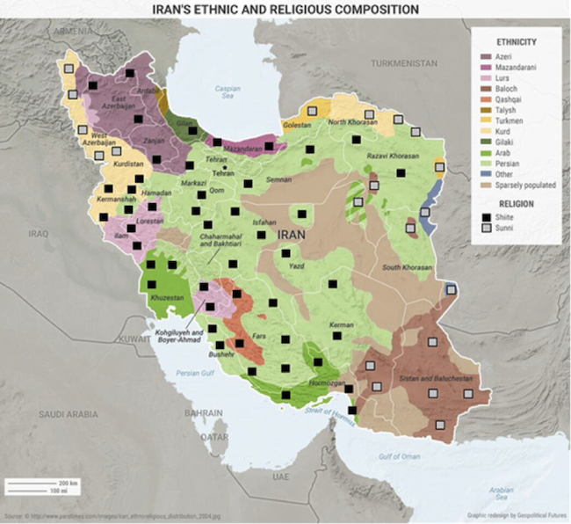
Many different ethnic groups have developed in Iran. This too is caused by Iran’s mountains. The mountains separate people and make movement hard. Isolated areas have their own cultures.
Iran is roughly 60% Persian. Farsi is the only official language for the nation, but at least seven other languages are recognized at the regional level. Dozens more are spoken throughout the country.
The map above shows how complex Iran’s ethnic, linguistic, and even religious makeup is. The Persian heartland is clearly visible. But there are sizable populations of Arabs, Kurds, Azeris, Turkmen, Balochs, and other groups spread throughout the country.
Iran is roughly 90% Shiite, but there are pockets of Sunnis as well. So, even in this sense, Iran is varied.
This means that whoever governs from Tehran must have some way to keep such a diverse population together in one state. That has historically meant central governments with strong coercive and institutional capabilities. These allow Iran to impose its writ over the people.
Constrained External Power
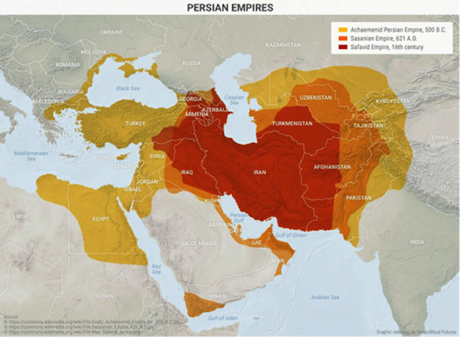
The Zagros Mountains protect Iran from would-be challengers. They also box in Iran. If Iran wants to project influence into Iraq, one of two conditions must exist. Either Iran must be incredibly wealthy and militarily strong, or it must be able to take advantage of weakness.
Persia was able to take advantage of weakness several times throughout history. But those times have always been when the area was weak and unable to resist Iran’s advances.
Take, for example, the period before 2011. Iraq was Iran’s biggest rival. Iraq was able to fight Iran to a draw in an incredibly bloody war from 1980 to 1988. This was despite having a population just one-fourth the size of Iran’s. But the US invasion of Iraq in 2003 removed that threat.
Since then, Iran has been building an arc of Shiite influence in the Middle East. Syrian President Bashar al-Assad’s Alawite regime was an ally of Iran. And Hezbollah’s dominance of Lebanon meant Iran could project power all the way to the Mediterranean.
The Syrian civil war dashed that dream. The rise of the Islamic State was a threat to Iran. And a strong Sunni Arab power in the heart of the Middle East could not be tolerated. This has driven the US and Iran into an uneasy but stable partnership.
Iran wants to influence Iraq. On the other hand, Iran funds various Shiite militias in Iraq. This is to ensure Iraq’s Sunni minority does not threaten the government in Baghdad.
The Assad regime has been weakened. Iran can no longer count on influence stretching through Syria to the Mediterranean.
The Arab world is in chaos. Israel is sitting pretty. And Turkey is a rising power. Turkey has almost the same number of people as Iran. It sits on more strategically advantageous territory, and it has a more advanced economy and military.
Turkey is going to be the dominant power in the Middle East. Iran will have to settle for being a regional power. It can influence countries in the region, but not push beyond.
Boundaries of Persian Expansion
Recommended by Forbes
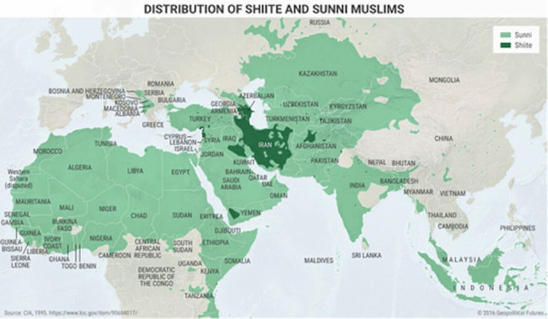
Despite its diverse population and its challenges in projecting power, great empires have risen from this part of the world and dominated most of the Middle East. The boundaries of these various empires, however, have always been fairly consistent.
Persia’s maximal level of expansion is from the Hindu Kush in the east, to Cairo in the south, to Istanbul in the north. Only the ancient Persian Achaemenid Empire was able to go farther. It spread to the coastal regions of the Black Sea.
This was because the rest of the Middle East was in tatters. There was no resistance to the Persian advance, either near Iran or in Europe. The only resistance Persia met was in present-day Greece. They had a bigger army than the Greeks but were beaten back by them. Persia never seriously threatened Europe again.
Iran’s influence outside its core territory has always been subtler than outright subjugation or control. It has too many geographic limitations. So, it had to cooperate with the locals it hoped to rule. This led to a blending of cultures and ideas. Before the rise of Islam, the dominant religion in Persia was Zoroastrianism—the principles of which survive today in both Judaism and Christianity.
Persia’s adoption of Islam shows how well it can blend elements of different cultures and religions. Very few outside powers have ever conquered Persia outright the way Islam did. Islam is an Arab movement in its origins. The fact that Farsi is written in Arabic script today is a sign of Islam’s impact on Persian culture.
But the Persians were still able to retain their own language. Farsi became the common language for the Turkic peoples of Central Asia, the Caucasus, Afghanistan, and South Asia. Farsi also influenced Urdu, Hindi, Bengali, and Ottoman Turkish.
Persia was able to adapt to Islam without losing major parts of its culture. To this day, Islam in Iran is uniquely blended in with society. Persia became a Shiite polity in 1501. As the map shows, Iran is the only formidable Shiite power in the Muslim world.
Conclusion
All four maps show that Iran is an influential power in its own right, with a proud history, culture, and way of doing things. But despite the impact it has had outside its borders, it is also fairly limited. Its cultural influence has been diffused throughout North Africa, the Middle East, and Central and South Asia.
Iran is a major regional power and the historical home of one of the world’s most influential civilizations. But Iran needs to meet certain conditions if it is to become more than a regional force. There is little indication this will happen any time soon.
Iran is and will remain a formidable geopolitical force. But its power is inherently limited by its geography.

