This 12,000-ton pile of orange peels is now a lush Costa Rican forest

Conservation experiment regrows pristine forest in a flash.
Bryan Nelson August 31, 2017,

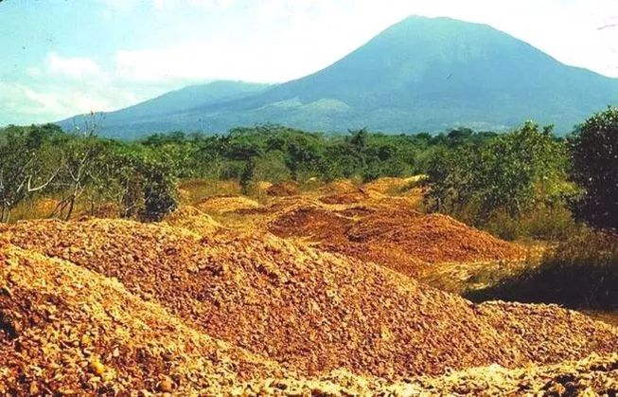
This orange peel dump is now a lush forest. (Photo: Daniel Janzen and Winnie Hallwachs, University of Pennsylvania)
Back in the late-1990s, 12,000 tons of orange peels from an orange juice manufacturing plant were dumped onto a highly degraded pasture in Costa Rica as part of an experimental conservation project. Then, just a year after the project was launched (and the orange peels were unloaded), the project was forced to close. Those piles of orange peels, however, were left there to rot.
Now, nearly two decades later, researchers have returned to the dump site to survey the results. To their amazement, no sign of the orange peels could be found. In fact, it took two expeditions just to locate the site; it was unrecognizable. What was once a degraded wasteland and depository for dunes of orange peels is now a lush, vine-laden jungle, according to a press release.
The orange peels had helped this land recover faster than anyone thought possible, and with almost no interference because of the project's early abandonment.

A collaboration between business, research and a park
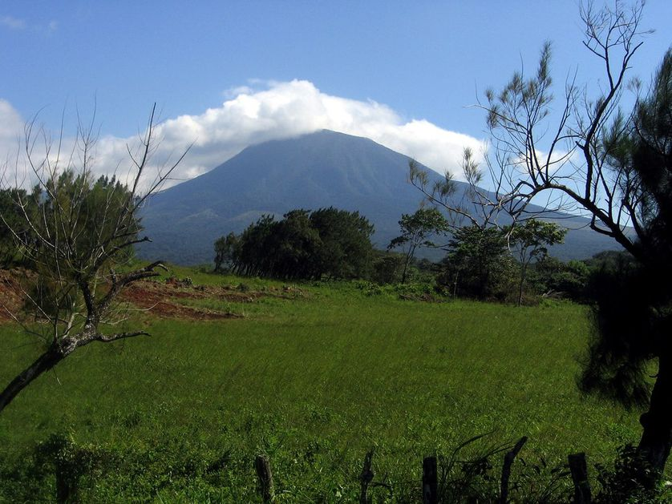Rincón de la Vieja Volcano in Costa Rica is part of the Guanacaste Conservation Area in the northern part of Costa Rica. The Del Or orange peels were dumped just outside the boundaries of the park. (Photo: Wikimedia Commons)
"The site was more impressive in person than I could’ve imagined," said Jonathan Choi, one of the researchers on the project. "While I would walk over exposed rock and dead grass in the nearby fields, I’d have to climb through undergrowth and cut paths through walls of vines in the orange peel site itself."
The original experiment was a collaboration between researchers, a nearby national park, and orange juice manufacturer Del Oro. The land was going to be included in a new expansion for the national park, but it was badly degraded. Del Oro would get to deposit its waste to the site for free on the hopes that the added biomass could eventually replenish the soils.
The results recorded before the project was cancelled were already impressive. Just six months after the peels were dumped, the piles had already been transformed — entirely naturally — into a thick, black sludge that was filled with fly larvae. Eventually it was broken down into the soil, but researchers had departed before any semblance of a forest had began to sprout.
Areas that were covered by orange peels were drastically healthier than other surrounding regions by several measures; they had richer soil, more tree biomass, greater tree-species richness and greater forest canopy closure. The project's area even contained a fig tree so huge it would take three people wrapping their arms around the trunk to cover the circumference.
Exactly how the area was able to recover so quickly is an open question, but researchers suspect it was due in part to the nutrients supplied by the orange peels combined with a suppression of invasive grasses that couldn't grow underneath the mammoth heaps.
"Plenty of environmental problems are produced by companies, which, to be fair, are simply producing the things people need or want," said study co-author David Wilcove. "But an awful lot of those problems can be alleviated if the private sector and the environmental community work together. I’m confident we’ll find many more opportunities to use the ‘leftovers’ from industrial food production to bring back tropical forests. That’s recycling at its best."
The findings were published in the journal Restoration Ecology.

