Muslims and Christians team up to help homeless
by Shafik Mandhai 21 Dec 2016
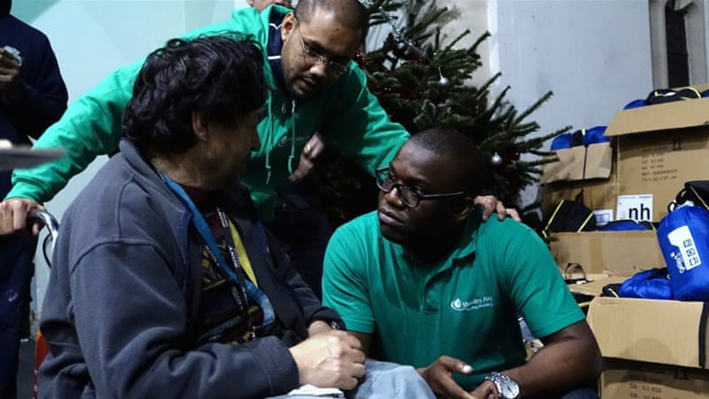
Muslim Aid charity workers hand out winter packs at a London church [Al Jazeera]
Muslim and Christian groups in Britain are joining forces to help the country’s homeless and other vulnerable groups during the Christmas period.
Organisations including Muslim Aid, the Al-Khair Foundation, Streetlytes, and churches across the English capital of London are expanding their efforts by providing meals and shelter packs to rough sleepers.
Their aim is to make sure those most in need are protected from cold weather and hunger during the holidays when many shops and services are closed or operating at reduced capacity.
More than 100 homeless people attended a Christmas dinner event organised by the groups at the Church of St Stephen and St Thomas in Shepherd’s Bush, west London.
Alongside the seasonal staple of Turkey, volunteers dished out servings of South Asian dishes such as biryani.
"As Muslims, Islam teaches us that we can't go to bed on a full stomach while our neighbour goes hungry," said the Al-Khair Foundation's Syed Hussain, as he managed a stall stacked with containers full of food.
"We’re working with people of all different backgrounds to show that Muslims care and we want to solve the problems facing everyone, not just our own."
Streetlytes volunteer Chris Hatch, a Presbyterian priest, explained that while many of those working to help the homeless were religious, the project was not "inherently faith-based".
We can have different belief systems but we can get along together and there can be unity in the way we serve our community, especially the poor
Chris Hatch, Presbyterian priest
"We've had Muslim and Jewish groups come help here, so it's not limited to one particular faith, but the main aim is just to serve those in need," Hatch said.
As volunteers rushed past with plates of food to hand out, Hatch, originally from the US city of St Louis, said the project showed how different faith groups could join hands to help those most in need.
"We can have different belief systems but we can get along together and there can be unity in the way we serve our community, especially the poor," he said.
"Everybody needs to eat and we all need a place to sleep ... so it’s important to serve, whatever your faith."
Providing warm meals is just one way in which the groups are helping.
The charity Muslim Aid was at the event handing out shelter packs to those that needed them.
The kit includes sleeping bags, multipurpose utensils, and phone numbers on which rough sleepers can contact the charity in emergencies.
Jehangir Malik, the charity's CEO, said he was shocked at the scale of homelessness in the UK.
"I've become accustomed to giving out these kits in different parts of the world and it's a reality check that I’m having to do this in the United Kingdom," Malik said.
"Doing the same here in London in the sixth richest country in the world, it’s touching."
Abu Akeem, also from Muslim Aid, said that the group was handing out more than 1,000 leeping acks during the winter period and planning to feed thousands more.
"We have nearly half a million people who don’t have proper homes in the UK and we want to work to address that vulnerability," Akeem said.
Last week, Muslim Aid and East London Mosque - one of the country’s largest - collected more than 10 tonnes of food to hand out to vulnerable families in the run-up to Christmas.
Malik stressed the importance of working with other faith groups to tackle issues such as rough sleeping.
"One segment of the community is not going to resolve issues like poverty, homelessness, and hunger ... as British citizens we have to come together," he said.
"It’s very symbolic that we’re doing this in the run-up to Christmas. It's a demonstration of our shared values, of our humanity, and our collective concern for the needy."
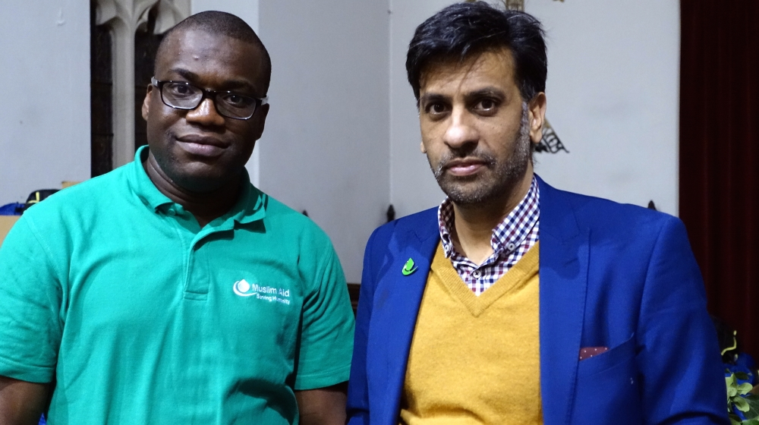
Akeem, left, and Malik plan to hand out more than 1,000 winter kits to the homeless [Al Jazeera]

