Rain is too much of a good thing for region's farmers after last year's drought

By Georgina Gustin ggustin@post-dispatch.com

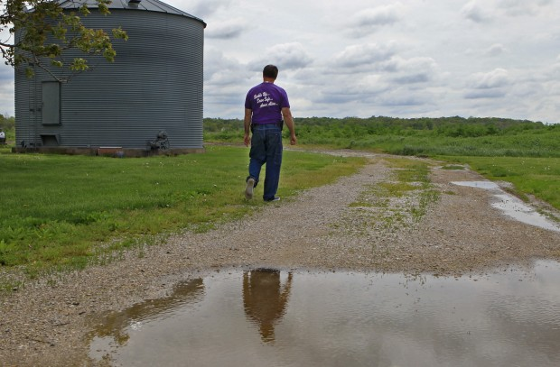

Figure 1 Farmer Greg Guenther, 59, surveys his farm east of Belleville on Monday, May 6, 2013. He said he should have his crops in the ground already, but it's been too wet to do anything. Photo by J.B. Forbes, [jforbes@post-dispatch.com](mailto:jforbes@post-dispatch.com)

Farmers had crossed their fingers and said their prayers. But then they got what they wanted.

A decimating drought last year ravaged the country’s corn crop and had farmers nervously hoping for a snowy winter or rainy spring to replenish parched farmland.

But now, after weeks of above-average rain, much of the nation’s corn belt is a muddy mess, leaving farmers frustrated and planting weeks behind schedule, potentially cutting into this year’s expected record crop.

“It’s just mud out there. There’s no chance, whatsoever, of getting anything done,” said Greg Guenther, who grows corn east of Belleville. “Everyone’s worried and annoyed, because it really should be in the ground, and we should be planting beans by now. Instead we’re just looking at muddy fields.”

Typically, growers in the St. Louis area have their corn crop planted by mid-April and are moving on to soybeans. But they’re already more than two weeks behind, and the forecast doesn’t look promising. 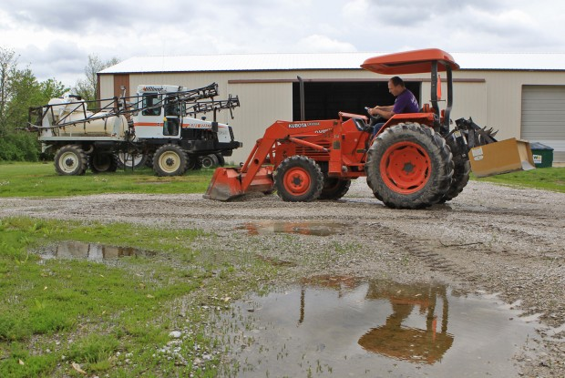

Figure 2 Farmer Greg Guenther, 59, fills watery potholes on his farm east of Belleville on Monday, May 6, 2013. He said he should have his crops in the ground already, but it's been too wet to do anything. His fertilizing tractors (left) stand ready to go to work when the fields finally dry out.

“We need some dry weather. I never thought I’d be saying that after last year,” said Pat Guinan, a climatologist and assistant professor with the University of Missouri. “And unfortunately, we have another system moving in later this week.”

For every day farmers are delayed getting their corn crop planted, yield potentially diminishes — which, after last year’s drought-decimated corn yield, is particularly worrisome.

“More than any time in recent years, we need a good crop,” said Rick Tolman, chief executive of the Chesterfield-based National Corn Growers Association. “We had such a bad year.”

Rain predicted for later this week could mean fields — even under optimal circumstances — aren’t dry enough to plant until next week, meaning farmers here would be nearly four weeks behind schedule.

“The whole corn belt is going to be way behind,” said Emerson Nafziger, a professor of crop sciences with the University of Illinois. “Whenever we shorten our season up with late planting, we tend to decrease yield potential — and we would not expect a record yield after a start like this.”

A U.S. Department of Agriculture report, released Monday, showed that the top corn-growing states had planted only 12 percent of their corn crop as of Sunday, whereas the historic average is closer to 50 percent for this time of year.

Farmers in Illinois, the country’s second biggest corn-producing state, had only planted 7 percent of the corn crop, compared to an average of 48 percent. In Missouri, farmers were faring slightly better: 22 percent of the state’s crop is in the ground; normally, it is above 50 percent.

“The rule of thumb for this area is that for every day after May 15, you’re losing a bushel of yield (per acre) for every day you wait,” explained Paul Bertels, a vice president with the National Corn Growers Association. “That’s almost here.”

This spring’s lower temperatures have also been a problem because corn needs soil temperature in the 50- to 52-degree range to germinate. So, last week, for example, when the weather was warm and dry, farmers held off, knowing the cold was coming back.

“They could have planted,” Bertels said. “But they knew it was going to get cold and wet again.”

A U.S. Department of Agriculture survey, released in March, found that American farmers intended to plant 97.3 million acres of corn this year, up for the fifth consecutive year, and the most corn acreage since the 1930s. Last year’s corn crop, predicted to be a record 14 billion bushels, instead came in around 11 billion, and yield was about 123 bushels an acre — 24 bushels below the previous year.

Conditions last year sent corn prices soaring, so this year farmers decided they would capitalize. In several states, farmers said they intended to plant more corn, particularly outside the corn belt. Within the corn belt, however, farmers appeared a little wary — in Illinois and Missouri, for example, farmers intended to plant less corn than last year.

“We were sitting here in January with producers asking us if they should plant any corn at all because there was no rainfall and the drought was very deep,” said Brent Myers, an agronomist with the University of Missouri Extension. “Now, here we are with the soil replete with moisture and no seed in the ground.”

Farmers now can only wait.

“I couldn’t even get across the field. I’d get stuck with the tractor, 6 to 12 inches deep,” said Garry Niemeyer, chairman of the corn growers association and a corn farmer from Auburn, Ill., in the center of the state. “Did I mention that patience is a good quality for farmers to have?”

When corn is planted late, problems can arise later in the season. Stalks tend to grow overly tall, making them vulnerable to high winds. Corn also likes milder temperatures to pollinate.

“The pollination period usually takes place around the Fourth of July,” Niemeyer said. “But if you plant in May, it usually happens later in July, and the hotter the temperature, the more potential for problems.”

If farmers don’t see better conditions in coming weeks some may decide to switch to soybeans, abandoning corn altogether, even though they’ve already invested in readying their fields for a corn crop. If they can’t get anything in the ground by June, insurance policies will kick in to cover some costs and make up for the losses.

Some may switch to different varieties of corn, such as hybrids that can tolerate a shorter growing season — if they can find them. Last year’s drought hit seed producers, too.

“The growing season isn’t long enough,” Tolman, said. “So they’ll switch to soybeans as the growing season slips away, or they’ll switch to a different corn variety. But the dilemma is that because of the drought, we don’t have a deep supply of seed.”

Still, farmers will scramble for that seed if they have to because the crop could be especially valuable this year.

Last year, growers did well because the drought forced prices up, and those farmers who didn’t bring a crop to market were covered by insurance. This year’s late start could mean prices are up again.

For farmers, that’s the only good news in the short term.

In this marketing year, which ends in August, the country expects to export 800 million bushels of corn, down from 1.5 billion last year and 1.8 billion the year before.

“We lost our export markets,” Niemeyer said. “Now we need to grow those markets back, and to do that we need to grow more corn. We’re trying really hard to do that.”

But farmers have seen extremes from year to year before, and they are used to adapting. Besides, the window for planting isn’t entirely closed — and growers have had good years even with late planting.

“We’re concerned,” Tolman said. “We’re not panicked.”