Jet stream shift could prompt harsher winters: scientists
By Jean-Louis Santini | AFP – Sun, Feb 16, 2014
Chicago (AFP) - A warmer Arctic could permanently affect the pattern of the high-altitude polar jet stream, resulting in longer and colder winters over North America and northern Europe, US scientists say. 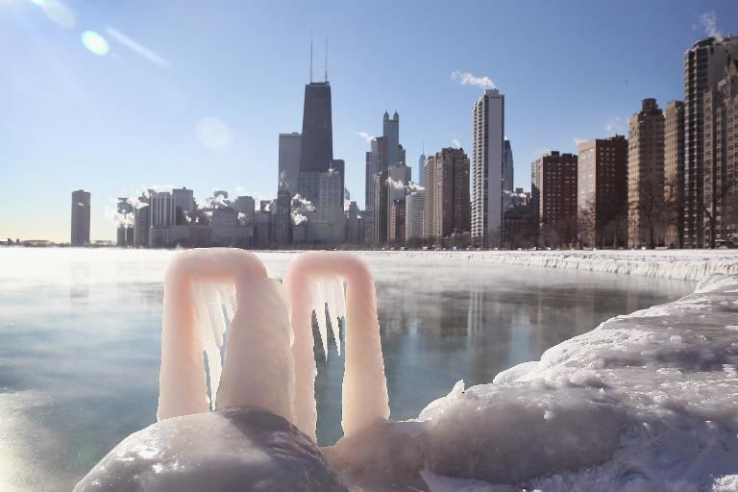
Figure 1 Ice forms along the shore of Lake Michigan in Chicago, Illinois as temperatures hovered around -10 degrees on January 28, 2014 (AFP Photo/Scott Olson)
The jet stream, a ribbon of high altitude, high-speed wind in northern latitudes that blows from west to east, is formed when the cold Arctic air clashes with warmer air from further south.
The greater the difference in temperature, the faster the jet stream moves.
According to Jennifer Francis, a climate expert at Rutgers University, the Arctic air has warmed in recent years as a result of melting polar ice caps, meaning there is now less of a difference in temperatures when it hits air from lower latitudes.
"The jet stream is a very fast moving river of air over our head," she said Saturday at a meeting of the American Association for the Advancement of Science.
"But over the past two decades the jet stream has weakened. This is something we can measure," she said. 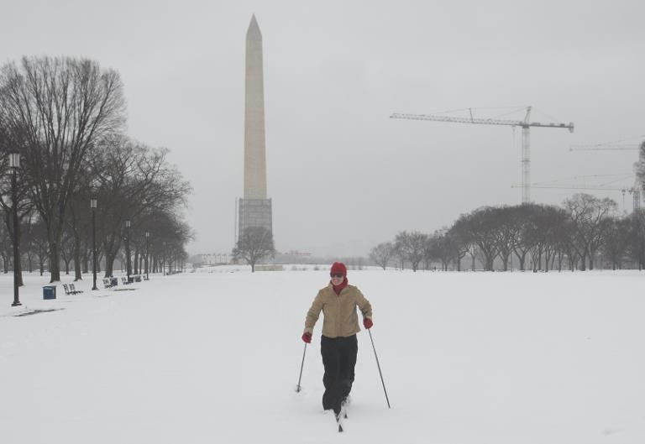
Figure 2 A woman skis cross-country across the snow-covered National Mall near the Washington Monument in Washington, DC on February 13, 2014 (AFP Photo/Saul Loeb)
As a result, instead of circling the earth in the far north, the jet stream has begun to meander, like a river heading off course.
This has brought chilly Arctic weather further south than normal, and warmer temperatures up north. Perhaps most disturbingly, it remains in place for longer periods of time.
The United States is currently enduring an especially bitter winter, with the midwestern and southern US states experiencing unusually low temperatures.
In contrast, far northern regions like Alaska are going through an unusually warm winter this year.
This suggests "that weather patterns are changing," Francis said. "We can expect more of the same and we can expect it to happen more frequently."
Temperatures in the Arctic have been rising "two to three times faster than the rest of the planet," said James Overland, a weather expert with the National Oceanic and Atmospheric Administration (NOAA).
Francis says it is premature to blame humans for these changes.
"Our data to look at this effect is very short and so it is hard to get very clear signal," she said.
"But as we have more data I do think we will start to see the influence of climate change," she said.

- Dire impact on agriculture -

The meandering jet steam phenomenon, sometimes called "Santa's Revenge", remains a controversial idea.
"There is evidence for and against it," said Mark Serreze, director of the National Snowland Ice Data Center in Boulder, Colorado.
But he said rising Arctic temperatures are directly linked to melting ice caps.
"The sea ice cover acts as a lid which separates the ocean from a colder atmosphere," Serreze told the conference.
But if the lid is removed, then warmth contained in the water rises into the atmosphere.
This warming trend and the shifting jet stream will have a dire impact on agriculture, especially in the farm-rich middle-latitudes in the United States.
"We are going to see changes in patterns of precipitation, of temperatures that might be linked to what is going on in the far north," said Serreze.
Jerry Hatfield, head of the National Laboratory for Agriculture and Environment in the midwestern state of Iowa, warned that this is not a phenomenon that affects only the United States.
"Look around the world -- we produce the bulk of our crops around this mid-latitude area," he said.
The main impact on agriculture and livestock will not come from small temperature changes, but rather from temperature extremes and the weather patterns that hold them in place for longer periods of time.
Droughts and freezes are already having "a major impact on animal productivity, it influences meat production, milk and eggs production," he said.

