Climate change linked to more pollen, allergies, asthma
MELROSE PARK, Ill. — From the roof of the Gottlieb Memorial Hospital in the Chicago suburbs, an 83-year-old retired doctor finds troubling evidence of why so many people are sneezing and itching their eyes.
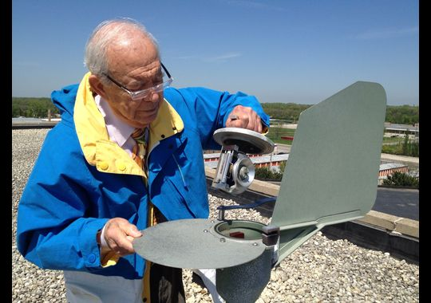
Joseph Leija counts the pollen and mold spores that collect on slides inside an air-sucking machine atop the six-story building. "There's been an increase, no doubt about it," he says of the 5 a.m. weekday counts that he's been doing as a volunteer for 24 years.
Figure 1 On May 13 in Melrose Park, Ill., retired allergist Joseph Leija shows the container holding a slide that records the mold and pollen of the past 24 hours. The air-sucking Burkard device sits atop the roof of the Gottlieb Memorial Hospital. Every weekday, Leija counts and identifies the spores from the slide using a microscope and reports his data to the public by 7 a.m.
"My allergies are much worse than they used to be," says Amanda Carwyle, a mom of three who lives 95 miles south in Pontiac, Ill. "I used to be able to take a Benadryl or Claritin and be fine." Now, despite three medications and allergy shots that make her feel a bit like a zombie, she says her eyes are watery and her head stuffy. "I'm so miserable."
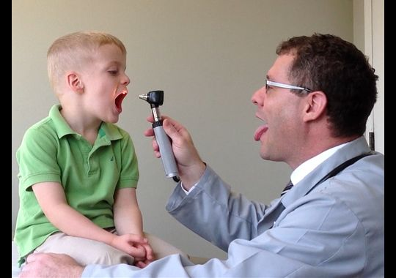
Climate change might be partly to blame. Scientists see a link to carbon dioxide, a heat-trapping greenhouse gas emitted by burning coal, oil and other fossil fuels. Tests show that the more CO2 in the atmosphere, the more plants generally grow and the more pollen they produce.
Figure 2 Brian Rotskoff, who runs Chicago's Clarity Allergy Center, examines Donovan Gill, 3, for allergy symptoms in his north Chicago office May 13.
Though some plants grow more food or flowers as a result, more pollen can spell trouble. Doctors say it's contributing to a rise in seasonal hay fever and allergic asthma in the USA, where the pollen season has lengthened up to 16 days since 1995. If carbon dioxide emissions continue to increase, they expect allergic conditions probably will worsen, adding to the discomfort of allergy suffers as well as swelling U.S. health care costs.
THE CARBON CONNECTION
"The link between rising carbon dioxide and pollen is pretty clear," says Lewis Ziska, a weed ecologist at the U.S. Department of Agriculture and a top researcher in the field.
His lab tests show that pollen production rises along with carbon dioxide. It doubled from 5 grams to 10 grams per plant when CO2 in the atmosphere rose from 280 parts per million (ppm) in 1900 to 370 ppm in 2000. He expects it could double again, to 20 grams, by 2075 if carbon emissions continue to climb. The world's CO2 concentration is about 400 ppm.
"I noticed something changing." says Leonard Bielory, an allergy and immunology expert at Rutgers University's Center for Environmental Prediction. He's been counting pollen in New Jersey for 27 years and initially wondered whether the spike was because of El Niño, a warm ocean current.
"I saw a trend as I did an analysis," he says, noting his counts in the past five years have been double that of any prior five-year period. In fact, this year's levels are the highest since he began. Bielory expects they could increase 20% to 30% by 2020.
He says last year's Superstorm Sandy exacerbated the problem by soaking the soil with so much water that even though April was dry, pollen has reached record local levels.
"There's clear evidence that pollen season is lengthening and total pollen is increasing," says George Luber, associate director for climate change at the Centers for Disease Control and Prevention. "It's one of the ways climate change is already affecting your community."
A 2011 study by Ziska and Bielory found that the ragweed season, which peaks in the fall (trees peak in spring and grass in summer), got longer the farther north you go where temperatures have risen more in recent decades. So in Oklahoma City, the season increased only one day from 1995 to 2009, but it jumped 16 days in Minneapolis and Fargo, N.D., and 27 days in Saskatoon, Canada.
Perhaps not surprisingly, more Americans are testing positive for allergies. Quest Diagnostics, which administers a blood test to detect allergies, found a 15% increase in ragweed sensitivity from 2005 to 2009. It says Chicago's rate was the sixth highest — after Phoenix, Las Vegas, Dallas, Kansas City and Riverside, Calif. — and one of every five Americans is allergic to ragweed in all U.S. regions except the Southeast and Pacific Northwest where fewer people are sensitive.
CDC allergy skin tests found increased sensitivity not only to ragweed but also to ryegrass, Bermuda grass and mold nationwide between two surveys that spanned an 18-year period, 1976 to 1994. The tests also showed more sensitivity to oak, except in the South. The study's authors say methodology changes might account for some, but not likely all, of the increase, which is consistent with that found in other countries.
A new CDC report suggests pediatric rates of hay fever, more common than drug or food allergies, remained stable from 1997 to 2011, based on interviews with parents. Co-author Lara Akinbami, a CDC pediatrician, says hay fever may still be increasing but, since its symptoms are similar to those of the common cold, parents may not recognize it as a seasonal allergy. They also might simply be treating it with over-the-counter medicines.
As for asthma, doctors say it's caused by many factors and exacerbated by pollen for the majority of asthmatics with allergic conditions. Federal data report a 17% increase in U.S. asthma prevalence from 2001 through mid-2012.
Asthma has become a "national epidemic" that affects one of every 12 people, or 56 million, the U.S. Environmental Protection Agency said this month. Most pediatric cases involve allergies, primarily hay fever.
Luber says many Americans don't suffer directly, but they all pay: "There are substantial costs to the health care system (from allergic conditions) that we all carry."
Scientists agree that rising pollen counts aren't all bad. In some cases, they boost the production of corn and other crops.
"It's true that some plants will be able to grow in new places they couldn't before," says Kim Knowlton, a Columbia University professor of public health who focuses on climate impacts. She says global warming could mean fewer people die of cold-related deaths.
"On balance, the negatives outweigh the positives," she says, citing other health problems that could ensue. More illness and deaths are likely from wildfires, flooding, heat-related strokes and infectious diseases such as cholera, according to the U.S. government's third National Climate Assessment, a draft of which was released in January.
Aside from pollen, the report says climate change could increase other factors that contribute to respiratory allergies and asthma. It points to higher summertime ozone concentrations, which make it more difficult to breathe, as well as more heavy downpours and rising air temperatures, which foster the growth of indoor fungi and molds.
SUFFERING THE IMPACT
For Carol Leopold and her 13-year-old twin sons, the pollen count is personal. She says their allergies have worsened in the past couple of years and they hit their peak in May, when spring comes alive.
"Anything that blooms enervates us. It wears us down," says Leopold, 43. She takes an antihistamine every day. When she goes on her 5:30 a.m. runs along Prairie Path in Elmhurst, Ill, a Chicago suburb where she lives, she takes her inhaler along.
Donovan Gill, 3, one of Rotskoff's patients, started showing symptoms two years ago. "We'd go to the playground, and if there was a honey locust tree and little yellow pieces of pollen fell from it, he'd blow up like a balloon," says Donovan's mom, Rachel, who lives in Chicago. "His eyes eyes would start to water and get red and swell."
She says his adenoids — glands in the back of the nasal cavity that can become swollen — were removed to help clear his airways. She's had to look extra hard for a preschool with clean, well-ventilated classrooms because, like many people with hay fever, Donovan reacts to mold.
Carwyle, 35, says she limits her exposure to pollen by staying mostly indoors during allergy season. "You try not to sleep with the window open," she says. Her 7-year-old son, who had only a few bad days last year, has just started allergy shots because of his sensitivity to — in her words — "anything that grows."
She says spring hit with a bang this year, as reflected in Leija's high counts of both tree and grass pollen. On a morning in mid-May, she recalls, "my whole car was coated with pollen."
CHALLENGES AHEAD
Researchers looking at how climate change will affect plants, pollen counts and health are the first to say there's a lot they don't know.
Bielory, for example, is doing EPA-funded research to try to figure out — based on historical data as well as multiple factors such as wind patterns, precipitation and population growth — how much pollen counts will probably rise. In lab chambers, he's growing different weeds and grasses at three different temperatures and CO2 concentrations.
He's also looking at whether food allergies, in addition to hay fever, are affected by rising carbon dioxide emissions. He suspects they are.
"There are so many pieces of the puzzle, and it's not a flat puzzle. It's a 3-D puzzle," says Bielory, who says too few scientists study the connections. He devotes two days each week to research and spends the other three treating patients.
The puzzle has non-climate pieces, too. Researchers are looking at why more people are becoming allergic and finding links to chemicals and, perhaps counterintuitively, cleanliness.
The "hygiene hypothesis," backed by some but not all studies, suggests people are more prone to allergies and asthma when they're not exposed to germs early in life. Why? Their immune systems haven't learned what's dangerous, such as bacteria, so they overreact to allergens, which are otherwise harmless.
"All of these things are likely affecting us," says the CDC's Akinbami, but it's unclear which factors — chemicals, hygiene, pollen — have the most impact or what their relationship is to each other. She says the first two sensitize people and the third triggers their sensitivity.
On the pollen front alone, there are large gaps in the data, says the CDC's Luber, noting pollen counts are not done on weekends and don't cover every state. There's not a single pollen-counting station in Alaska, Hawaii or 16 other U.S. states.
In fact, the 76 U.S. stations (plus one in Puerto Rico) are run by volunteers trained and certified by the National Allergy Bureau, part of the American Academy of Allergy, Asthma and Immunology (AAAAI), a private organization that promotes research and treatment.
"There's no federal funding," says Linda Ford, an allergist who volunteers to do the count for the Omaha area as a way to help her patients. "There is no automated service for this," she says, adding it can take as long as two or three hours.
"This is very important for patients, " says Leija, who does the only count in Illinois. He says if they know pollen season is coming, they can start medications in advance to help control their symptoms.
That's why, even though he retired last year after working 53 years at the hospital as a general practitioner and allergist, he continues to rise before the sun and climb the stairs from the sixth floor to the roof — rain or shine. When it's still dark outside, he wears a miner's head lamp.
"It's a hobby," Leija says as he removes a pollen and mold slide from the Burkard Spore Trap. The $5,000 device, which the AAAAI provides to counting stations, has a fan that draws air in at the same rate that people breathe.
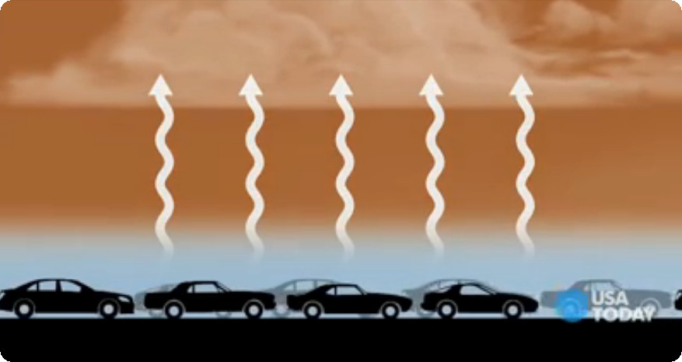
He starts early, so he can decipher the amount and types of pollen, using a microscope on the third floor, in time for the 7 a.m. TV news. He knows that someday he'll have to hand off his sunrise routine. His wife is ailing, so he's been working alongside a nurse who's getting certified to carry on the count.
A major component of the exhause is Carbon Dioxide.

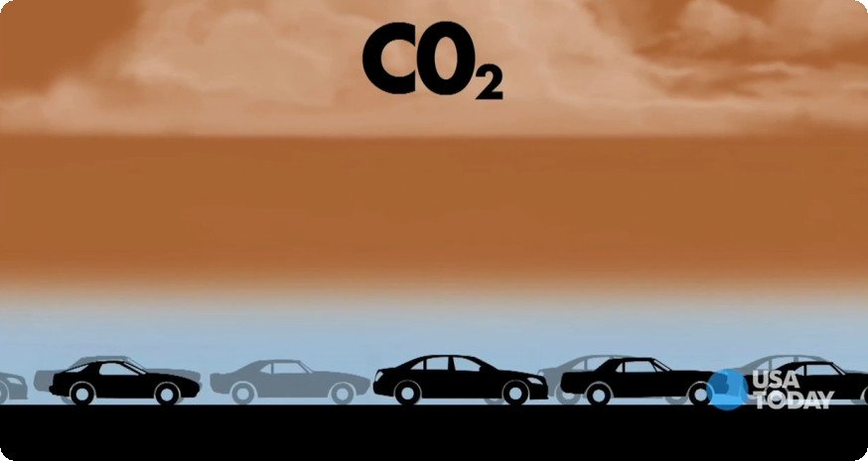
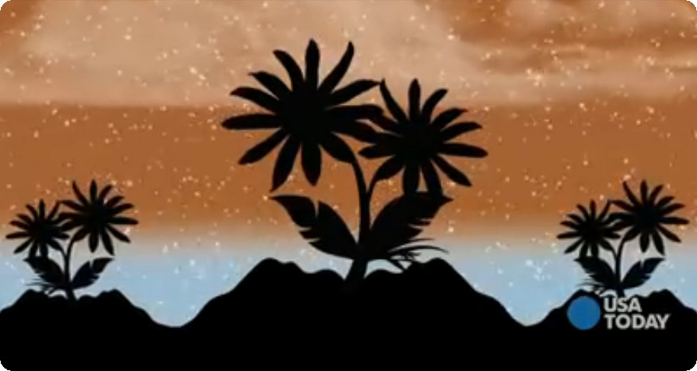
Figure 3 Increased CO2 encourages plant growth which produces more pollen in the atmosphere.

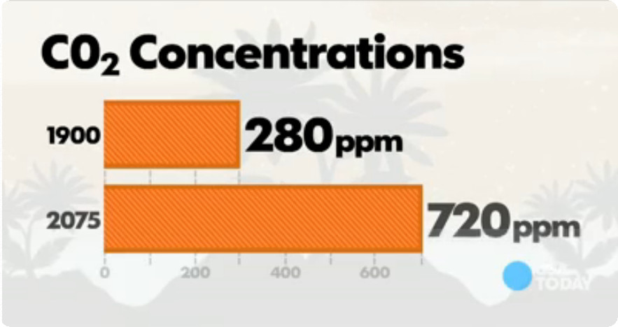
Figure 4 Unless we make some changes, the outlook doesn't look promising.

