Arctic sea ice in longest decline seen over past 1,450 years: study

Bob Weber - The Canadian Press - Published Wednesday, Nov. 23, 2011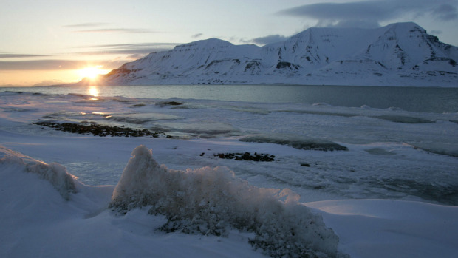
Figure 1 The sun shines low in the sky just after midnight over a frozen coastline near the Norwegian Arctic town of Longyearbyen in this April 26, 2007
Research published in a top scientific journal says Arctic sea ice has declined more in the last half-century than it has any time over the last 1,450 years.
The study, which gives the most detailed picture ever of the northern oceans over the previous millennium-and-a-half, also concludes the current decline has already lasted longer than any previous one in that period.
“When we look at our reconstruction, we can see that the decline that has occurred in the last 50 years or so seems to be unprecedented for the last 1,450 years,” Christian Zdanowicz of the Geological Survey of Canada said Wednesday.
“It's difficult not to come up with the conclusion that greenhouse gases must have something to do with this,” added Mr. Zdanowicz, one of the co-authors of the report in Nature.
“We cannot account for this decline by processes that are ‘natural.’”
Climate change is thought to be occurring faster in the Arctic than anywhere else on Earth and sea ice is considered one of the main indicators. The ice is crucial in northern ecosystems because it provides habitat for everything from plankton to polar bears.
Its gradual disappearance is also opening previously inaccessible areas to the possibility of resource development, as well as to commercial shipping.
Mr. Zdanowicz and his team combined 69 different data sources to determine the extent of sea ice for every decade going back about 1,000 years and every 25 years beyond that.
The team examined tree rings, ice cores from glaciers and lake and ocean sediments. To check the validity of their approach, scientists compared their calculations for the last couple of centuries with real-world observations from satellites, ship logs and other historical accounts.
They found that by the mid-1990s sea ice had fallen even further than in previous lows such as the so-called Medieval Warm Period between 800 and 1300.
Team members were also able to conclude that sea ice is influenced by more than just temperature. They discovered that ice actually shrank during what's known as the Little Ice Age, a period between 1450 and 1850, due to relatively warm ocean waters moving north.
That's what's happening now, said Mr. Zdanowicz.
“In the last 50 years what has really dominated the changes that we see in the Arctic Ocean is the rise in air temperatures and the rise in temperatures of the waters below.”
His study didn't look specifically at the impact of feedback loops in which open water absorbs more of the sun's heat than reflective ice. But Mr. Zdanowicz said indications are that that is starting to take effect.
“If you take this reconstruction and you put it in parallel with a number of studies that have emerged, the indications are pretty strong that the warming of the Arctic is accelerating.”
He acknowledged that although he has been able to get more detail on ice fluctuations than ever before, the time span considered in the paper isn't very long by geologic standards.
However, he points out he was involved with a previous paper that went back 10,000 years. That paper found sea ice was lower between 6,000 and 8,000 years ago — and also explained why.
“At the time, due to changes in the Earth's orbit, the northern hemisphere was receiving more solar energy than it does now,” Zdanowicz said.
“That process cannot account for what we are observing now. In fact, we should be heading into a gradual cooling trend right now if our climate was strictly controlled by orbital factors.”

