Chernobyl Zone Shows Decline In Biodiversity
...
http://www.bbc. co.uk/news/ science-environm ent-10819027
30 July 2010 Last updated at 11:00 ET
By Victoria Gill Science reporter, BBC News
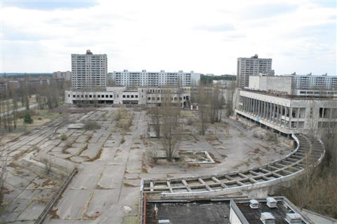
Figure 1 The ghost town of Pripyat, built to house workers of the Chernobyl nuclear power plant (Image: AP)
Scientists say contamination in the Chernobyl exclusion zone has affected biodiversity
The largest wildlife census of its kind conducted in Chernobyl has revealed that mammals are declining in the exclusion zone surrounding the nuclear power plant.
The study aimed to establish the most reliable way to measure the impact on wildlife of contamination in the zone.
It was based on almost four years of counting and studying animals there.
Continue reading the main story
The scientists say that birds provide the best "quantitative measure" of these impacts.
They report their findings in the journal Ecological Indicators.
The research team say that their census of species in the zone - which was carried out for more than three years - provides more evidence that contamination has a "significant impact" on biodiversity.
Professor Timothy Mousseau from the University of South Carolina, US, and Dr Anders Moller from the University of Paris-Sud, France, worked together on the project.
From 2006-2009, they counted and examined wildlife including insects, amphibians, reptiles, birds and mammals.
Their previously published work revealed some of the negative impacts on birds and on insects of the low-level radiation that still contaminated the exclusion zone surrounding the power plant.
The new data on mammals and reptiles shows what Professor Moussaeu described as a "strong signal" of reduced biodiversity in these groups too.
Swallows in Chernobyl (Image: Tim Mousseau) Migrating birds may be more sensitive to the effects of radiation
The research team compared the abundance of species in the exclusion zone with similar types of habitats in the area, which were not contaminated.
"The truth is that these radiation contamination effects were so large as to be overwhelming," Professor Mousseau told BBC News.
During their census work, he and Dr Moller have also examined the effects of radiation contamination on the animals. They say that these impacts are particularly obvious in birds.
In their studies on barn swallows, the team observed birds with tumours on their feet, necks and around their eyes.
"We think they may be more susceptible, after their long migrations, to additional environmental stress," explained Professor Mousseau.
Poison or haven?
Scientists in the Ukraine criticised the conclusions. Dr Sergii Gashchak, a researcher at the Chornobyl Center in Ukraine was not available for comment on this latest paper.
But he spoke to BBC News last year and dismissed the team's previous findings on insects and birds. He said that he drew "opposite conclusions".
"Wildlife really thrives in Chernobyl area - due to the low level of [human] influence," Dr Gashchak told BBC News.
"All life appeared and developed under the influence of radiation, so mechanisms of resistance and recovery evolved to survive in those conditions," he continued.
But Professor Mousseau said the evidence of an increase in biodiversity in the region is "purely anecdotal".
"This is the first paper that provides quantitative, rigorous data that the mammals really are significantly affected by contamination," he told BBC News.
"That said - it's not a bad idea to set this place up as a wildlife haven - it's a natural laboratory where we can study the long-term consequences of this kind of an accident."
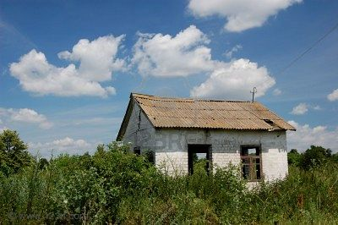
Figure 2 Chernobyl abandoned farm (Image: T Mousseau) Some reports suggested that the lack of humans was beneficial for wildlife
:
Chernobyl abandoned farm (Image: T Mousseau) Some reports suggested that the lack of humans was beneficial for wildlife
Dr Mousseau also criticised a recently made documentary film called Chernobyl, A Natural History, which has been promoted by a French production company as showing how nature has "recolonised" the exclusion zone in the absence of man.
Professor Mousseau said: "If society is ever to learn more about the long term environmental consequences of large scale accidents - and Chernobyl is just one of several - it is important that we all take our responsibilities seriously."
*** NOTICE: In accordance with Title 17 U.S.C. Section 107, this material is distributed, without profit, for research and educational purposes only. ***

