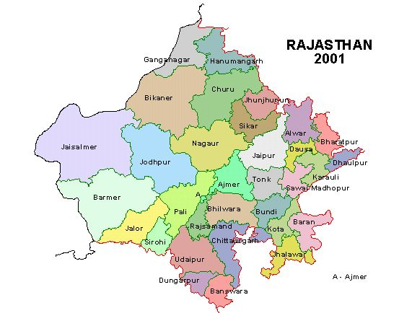
New York Times – December 2, 2002

India's Poor Starve as Wheat Rots
By AMY WALDMAN
HANNA, India — Surplus from this year's wheat harvest, bought by the government from farmers, sits moldering in muddy fields here in Punjab State. Some of the previous year's wheat surplus sits untouched, too, and the year's before that, and the year's before that.
To the south, in the neighboring state of Rajasthan, villagers ate boiled leaves or discs of bread made from grass seeds in late summer and autumn because they could not afford to buy wheat. One by one, children and adults — as many as 47 in all — wilted away from hunger-related causes, often clutching pained stomachs.
"Sometimes, we ate half a bread," said Phoolchand, a laborer whose 2-year-old daughter died during that period. "Sometimes, a whole bread."
More than two decades after a "green" revolution made India, the world's second-most-populous country, self-sufficient in grain production, half of India's children are malnourished. About 350 million Indians go to bed hungry every night. Pockets of starvation deaths, like those in the Baran district of Rajasthan, have surfaced regularly in recent years.
Yet the government is sitting on wheat surpluses — now at about 53 million metric tons — that would stretch to the moon and back at least twice if all the bags were lined up. Persistent scarcity surrounded by such bounty has become a source of shame for a nation that has taken pride in feeding itself.
Advocates for the poor and those pushing for economic reforms ask how a country can justify hoarding so much excess when so many of its people regularly go hungry.
"It's scandalous," said Jean Drèze, an economist who has been helping to document starvation deaths for a Supreme Court case brought by the People's Union for Civil Liberties, an advocacy group, to compel the government to use the surplus to relieve hunger.
The reason, experts and officials agree, is the economics — and particularly the politics — of food in India, a country that has modernized on many fronts but that remains desperately poor.
Critics say the central government, led for the last four years by the Hindu nationalist Bharatiya Janata Party, has catered to political allies and powerful farm lobbies in a few key states by buying more and more grain from farmers at higher and higher prices. At the same time, it has been responding to pressure from international lenders by curbing food subsidies to consumers.
One result has been huge stockpiles going to waste, while higher prices for food and inefficient distribution leave basic items like bread, a staple of the rural poor diet, out of reach for many. Even though the surplus is supposed to be distributed to the poor, politics and corruption often limit their access.
"It's not an economic issue anymore — it's a straightforward political issue," said Jairam Ramesh, the senior economic adviser to the Congress Party, the country's main opposition party.
Answering such criticism, Asok Kumar Mohapatra, who was until recently a joint secretary with the Department of Food and Public Distribution, said any system trying to feed a billion people was apt to have inefficiencies. "It's easy to find fault with this kind of organization," he said. But he, too, acknowledged the politics involved. "The simple thing is they have lobbies," he said of the farmers, "and lobbies work everywhere."
Both the glut in Punjab and the deprivation in Rajasthan reflect a government in transition between a quasi-socialist past and a free-market future, and one that at the local level especially seems deeply ambivalent about its obligations to its poorest citizens.
After a devastating famine in 1943 that killed three million people and humbling food scarcities in the 1960's, Indian central governments have been determined to ensure that the country could feed itself.
A nationwide system was set up to distribute subsidized food via a network of "ration shops" that today number 454,000. At the same time, India made great advances in increasing its productivity, by developing high-yield seeds and investing in infrastructure, like irrigation.
The green agricultural revolution quadrupled staple food production, from 50 million metric tons in 1950 to 209 million metric tons by 2000.
The fruits of those efforts can be witnessed nowhere more vividly than in Punjab. Today it is India's only state (along, perhaps, with neighboring Haryana, which was carved from Punjab), that derives more than 40 percent of its income from agriculture; until recently it had the highest per capita income in India. It has some of the country's best roads and, with only 2 percent of the country's land, grows 55 percent of its food.
While farmers in poorer states have either no grain surplus or no mechanism by which to sell it to the government, Punjab has 1,600 wholesale grain markets, including the one here in Khanna, the largest in Asia.
But the same system that has built up Punjab has also run into trouble on almost every front, and even the farmers here know it cannot last.
Over the past four years, even as advisory committees recommended stabilizing or lowering the support prices paid to farmers, prices instead went up, and up — to about $129 a metric ton, 2,200 pounds, for wheat this year from about $99 in 1997.
Punjab farmers, eager to cash in, are farming so much rice and wheat that they are depleting the state's water and soil, creating a long-term threat to the country's agricultural self-sufficiency.
"We know every year we take the water level down," said Bachittar Singh, 67, a farmer with 125 acres near here. "But what alternative do we have?"
Then there is the effect of such policies on the price of grain itself. The high prices paid to farmers by the government have inflated consumer prices, making it harder for the poor to buy grain. In some cases, the government, wanting to keep market prices in India high, has exported grain at lower prices than it was selling it to its citizens.
By the mid-1990's, India was spending close to 1 percent of its gross domestic product on food subsidies, with much of that lost to waste and theft. Under strong pressure from the World Bank and other international lenders to curb spending, the government decided in 1997 that only those below the poverty line would be able to buy heavily subsidized food. Everyone else would have to buy it only slightly below market price.
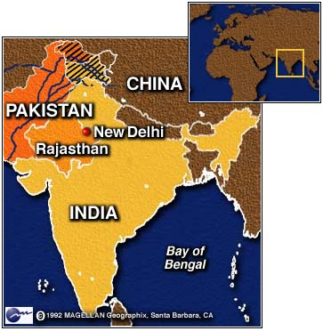
But with politics, indifference and corruption conspiring to limit the number of those identified as poor, the amount of food being bought from ration shops dropped significantly and stockpiles soared. The problem is compounded by the fact that even many of those classified as poor are unable to buy the subsidized grain because of inaccessible ration shops or dealers who steal the grain for sale on the black market.
Today the government has run out of warehouse space and has taken to storing the grain in fields rented from farmers. A recent report found that it was spending more on storage than on agriculture, rural development, irrigation and flood control combined.
Some of the wheat, often protected only by porous jute bags and black plastic tarpaulins, is rotten; even official estimates concede that 200,000 tons are "damaged," with the real total probably far higher. Inspectors have found worm-infested wheat at schools where the state is supposed to provide free lunch.
It is about 400 miles from the abundance here to the barren, scrubby landscape of Baran, in the southeast corner of Rajasthan. This year was the third year of drought, and the most brutal, with rainfall down by 70 percent.
In the village of Swaans, isolated by jolting dirt roads and dry riverbeds, one man, Gobrilal, lost an 8-year-old son to hunger this fall. He sat recently beneath the shade of a thatched shelter, surrounded by children who were all rib cages and swollen bellies, and recounted two months of agony.
On good days they ate once a day, but many days they ate nothing. Gobrilal's son began vomiting, even while asking for food, and died two days later. "If we had money," his father said listlessly, "we would have bought him wheat so he wouldn't have died."

Figure 1 Children await their parents, who, as part of a food-for-work program, are digging a pond in the village of Swaans, Rajasthan.
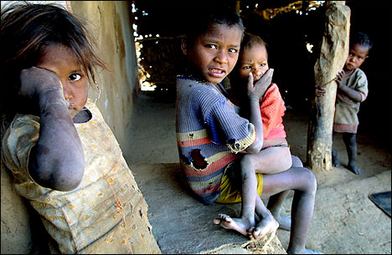

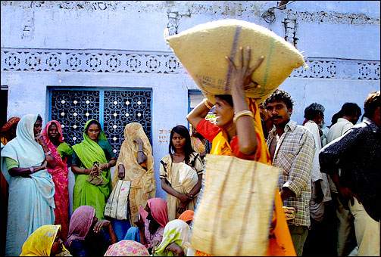

Figure 2 Women waiting for grain outside a ration shop in Rajasthan, India. Despite millions of tons of surplus wheat and rice, about 350 million Indians go to bed hungry every night.

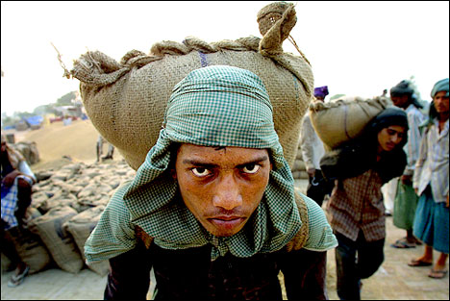

Figure 3 A worker loads a sack of grain into a truck in Khanna, Punjab. Tons of grain rot every year in India due to a poor distribution system.

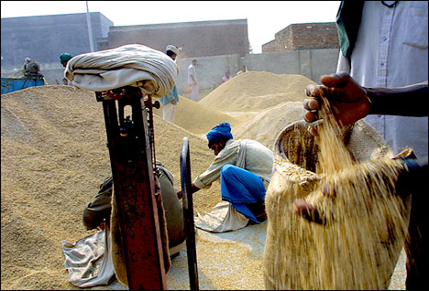
Figure 4 Grain is weighed in Khanna, Punjab. Persistent scarcity surrounded by such bounty has become a source of shame for a nation that has taken pride in feeding itself.

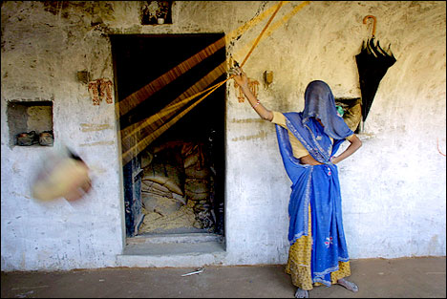

Figure 5 A woman swings her baby in a hammock outside a government shop in the village of Swaans, Rajasthan. While surplus food grain rots in some Indian states, residents of other states have very little food to feed on, leading to starvation and death.

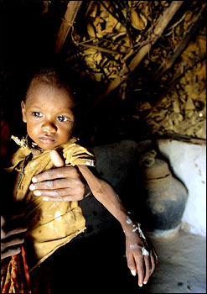

Figure 6 A malnourished child is held by his mother in the village of Doorg, Rajasthan. Half of India's children are malnourished.

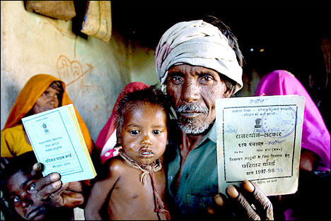
Figure 7 An elderly man displays his ration card. A nationwide system was set up to distribute subsidized food via a network of "ration shops" that today number 454,000.

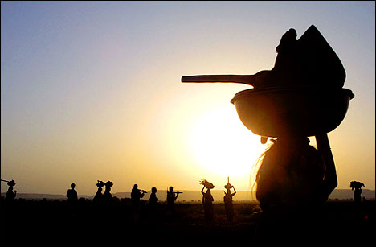
Figure 8 Workers return home after constructing a road, part of a food-for-work program in the village of Doorg, Rajasthan.

