Putin’s Grasp of Energy Drives Russian Agenda
By ANDREW E. KRAMER
Published: January 28, 2009

MOSCOW — The titans of Russia’s energy industry gathered around an enormous map showing the route of a proposed new pipeline in Siberia. It would cost billions and had been years in the planning. After listening to their presentation, President Vladimir V. Putin frowned, got up from his chair, whipped out a felt pen and redrew the map right in front of the embarrassed executives, who quickly agreed to his alternative.
The performance, which was carried on state television in 2006, was obviously stage managed, but there was nothing artificial about its point. It was a typical performance for a leader who has shown an uncanny mastery of the economics, politics and even technical details of the energy business that goes well beyond a politician taking an interest in an important national industry.
“I would describe it as very much his personal project,” said Clifford G. Gaddy, a senior fellow at the Brookings Institution in Washington and an expert in Russia’s energy policy. “It is the heart of what he has done from the very beginning.”
Indeed, from his earliest days in power in 2000, Mr. Putin, who left the presidency in 2008 and became prime minister, decided natural resource exports and energy in particular would not only finance the country’s economic rebirth but also help restore Russia’s lost greatness after the collapse of the Soviet Union.
Just this month, Mr. Putin’s personal immersion in the topic was on full display as he ordered natural gas shut off to Ukraine, in the process cutting supplies to Europe. It was portrayed by the Kremlin as a protracted commercial dispute with Ukraine. But the hundreds of thousands of shivering gas customers in the Balkans and Eastern Europe sent an unmistakable message about the Continent’s reliance on Russian supplies — and Mr. Putin’s willingness to wield energy as a political weapon.
When talking about energy, he often rattles off obscure statistics not often heard outside a Houston boardroom, like average daily production of fields and throughput capacity of pipelines.
Mr. Putin “clearly knows as much about BP’s business in Russia as I do,” Anthony B. Hayward, BP’s chief executive, once said after a meeting with him.
In fact, the standoff in Ukraine was just one part of a far larger Russian playbook on natural gas policy under Mr. Putin. In the past year, Russia has formed a cartel-like group with Middle Eastern nations with the goal of dampening global competition in natural gas, sewn up sources of supply in Central Asia and North Africa with long-term contracts to thwart competitors and used its military to occupy an important pipeline route in Georgia.
And this broader struggle extends over a dozen countries from Azerbaijan to Austria. In its sprawl and slow pace, it is often compared to the 19th-century struggle for colonial possession in Central Asia known as the Great Game. In the modern variant, Mr. Putin, a master strategist, has proved far more effective than his European counterparts.
“He has been thinking for some time, ‘What are the means and tools at Russia’s disposal, to make Russia great?’ ” said Lilia Shevtsova, a researcher at the Carnegie Moscow Center. In the post-Soviet world, she said, Mr. Putin concluded that “military power would no longer be sufficient.”
A spokesman for Mr. Putin, Dmitri S. Peskov, said that the energy market “was, is and will remain a strategic sphere for Russia” and that government leaders in Moscow should be versed in the topic. Mr. Peskov denied the Kremlin used exports for political purposes. Of Mr. Putin’s deep personal knowledge of the business, he said the prime minister showed a similar attention to detail in other matters, too.
In this contest, Russia’s overarching goal is to prevent the West from breaking a monopoly on natural gas pipelines from Asia to Europe. Boris E. Nemtsov, a former Russian first deputy prime minister who is now in the opposition, said: “It is the typical behavior of the monopolist. The monopolist fears competition.”
As they did two years ago after a similar supply disruption, European officials have promised in the wake of the Ukraine dispute to take steps to diversify the Continent’s sources of gas to end its reliance on Russia, which supplies nearly 30 percent of the total. European dependence is expected to grow as North Sea gas fields decline.
At a conference in Budapest on Tuesday, Prime Minister Mirek Topolanek of the Czech Republic called for a renewed effort to build the long-delayed Nabucco pipeline to bring Central Asian gas to Europe without passing through Russian territory.
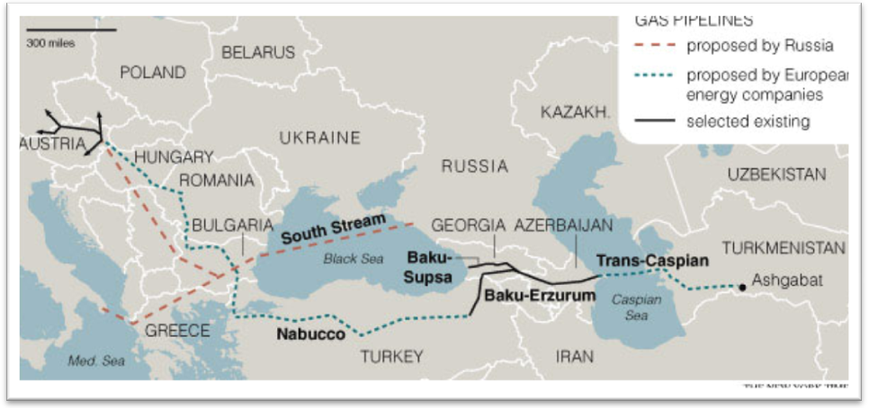
But there is a reason the project has never gotten off the ground: as determined as Europe is to end its reliance on Russian gas, Mr. Putin is equally adamant about extending it.
The Nabucco pipeline was proposed in 2002 by executives from European energy companies with the express intent of undercutting Russia’s gas monopoly. It would pass through Turkey and Georgia to the Caspian Sea.
Under the best of circumstances, building an international pipeline is an intricate and arduous process, technically, financially and politically. However, Nabucco’s planners rapidly discovered that their biggest obstacle was not a mountain chain or a corrupt local politician, but Mr. Putin himself. When OMV, the Austrian energy company, formally created a consortium for Nabucco in 2005, he responded with a competing idea: a pipeline called South Stream that would terminate at the same gas storage site in Austria, but originate in Russia and bypass Ukraine by traveling under the Black Sea.
In a contest often compared to chess, this Russian countermove, like all good chess moves, was both offensive and defensive.
To pay the hefty upfront construction costs, a pipeline needs both an assured source of supply and a market for the gas it transports. The South Stream pipeline would flood the gas market in southeastern Europe, locking up the customers the bankers behind Nabucco were counting on to finance the project.
At the same time it would undermine Ukraine’s domination of gas lines headed west, one of the biggest obstacles to Russian domination of the European gas market.
But Mr. Putin did not stop there. Leaving nothing to chance, he also took steps to choke off potential sources of upstream gas supplies deep in Central Asia.
The race to secure these rich sources of natural gas unexpectedly accelerated in 2006 with the death of the eccentric and isolationist dictator of Turkmenistan, Saparmurat Niyazov. While energy executives around the world rushed to Ashgabat, the Turkmen capital, to meet the new leader, Gurbanguly Berdymukhammedov, a former dentist, Mr. Putin was the first to cut a big deal.
Smiling and holding shovels at a televised ceremony to mark the start of construction, Mr. Putin and Mr. Berdymukhammedov agreed in 2007 to build a pipeline north, to Russia, depriving Nabucco of potential supply. It was not until 2008 that European Union officials got to Ashgabat with a memorandum of understanding for a trans-Caspian pipeline that could link to Nabucco. It has yet to be acted upon.
Farther west, it was the same story.
In February 2008, Mr. Putin signed an agreement with Bulgaria — over the objections of the United States and in spite of Bulgaria’s status as a new NATO member — making it a partner in the South Stream pipeline.
And in April 2008, Mr. Putin was in Athens, cutting a deal for a spur of South Stream. In this flurry of diplomacy he again beat his Western opponents. The United States State Department’s point man on Eurasian pipelines, Matthew J. Bryza, in Athens the next day, could only rue the signed deal. Mr. Bryza was left explaining to the Greeks: “If you have only one supplier of feta, you’re in a vulnerable position. The same for gas.”
The West still had an important pipeline partner in Georgia, a critical geographical link. But that all but evaporated in the brief war last summer.
By 2007, a pipeline section had been laid across Georgia, the Baku-Erzurum pipeline, which is now used for local distribution but will become a part of the Nabucco pipeline, if it is ever built. This brought the struggle for Nabucco to a pivotal stage, for it was now playing out along a storied trade route in the petroleum business, and one highly sensitive to the Russians.
In the 19th century the Rothschild banking family and the Nobel brothers of Sweden had built a railroad and pipeline across Georgia to sell Baku oil, undercutting the near monopoly in the business, Standard Oil of the United States, which was supplying Europe with kerosene produced in America.
After the breakup of the Soviet Union, the revival of this pre-Bolshevik energy corridor became a major foreign policy goal of the United States, intended to strengthen the economic independence of former Soviet states and diversify world oil supplies away from the Middle East. At a narrow point, the pipeline route passes just south of the Russian-controlled enclave of South Ossetia and north of another Russian ally, Armenia.
The August war sent a chill through boardrooms in the West when, for example, Russian tanks scurried back and forth over one of the buried pipelines and one crew occupied a pumping station. Russia, said Svante Cornell, a specialist on Central Asia and the Caucasus at the School for Advanced International Studies at Johns Hopkins University, sent a simple message: “We can blow this up at any time.”
While his track record is very strong, Mr. Putin is not infallible. Last summer he made a rare mistake by locking in long-term contracts for Central Asian gas at close to the height of the market — $340 for 1,000 cubic meters in 2009. While Mr. Putin achieved his goal of depriving Nabucco of more potential sources, Russia is now selling that gas in a down market to Ukraine for an average of less than $240 per 1,000 cubic meters — one possible reason, energy experts have said, that Mr. Putin tried to force Ukraine to pay more for gas this winter.
Despite its best intentions, Europe is likely to remain dependent on Russian energy supplies for the foreseeable future and, perhaps, indefinitely if Mr. Putin has his way. And that reflects his long-held beliefs.
As far back as 1997, while serving as deputy mayor of St. Petersburg, Mr. Putin earned a graduate degree in economics, writing his thesis on the economics of natural resources.
Later, when scholars at the Brookings Institution analyzed the text, they found 16 pages had been copied without attribution from a 1978 American business school textbook called “Strategic Planning and Policy,” by David I. Cleland and William R. King of the University of Pittsburgh. Mr. Putin has declined to comment on the allegation.
Tellingly, the passages they say were plagiarized relate to the indispensable role of a chief executive in planning within a corporation — the need for one man to have strategic vision and control.
New York Times, Jan. 29, 2009

