The day Burma was silenced
From Times Online
September 28, 2007

The junta showed a subtle and malignant cunning, and then moved against the monks

Kenneth Denby in Rangoon
Burma’s generals silenced the Buddhist monks yesterday morning.
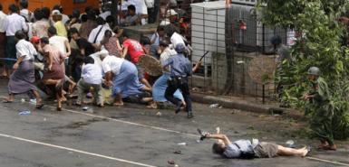
For a week and a half, the monks had been on the streets of Rangoon in their tens of thousands, and their angry calm gave courage to the people around them.
Figure 1 This is the moment that Kenji Nagai, 50, who was covering the Rangoon protests for the Japanese news agency APF News, was shot. He died later in hospital
But overnight, they were beaten, shot and arrested, and locked in their monasteries. Handfuls of them emerged yesterday – two or three brave individuals, a dozen at most – but nothing to approach the mass marches of the previous nine days. Everyone felt their absence.
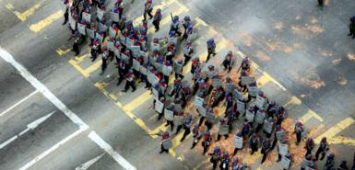
You could see it in the faces of the civilian demonstrators who took to the streets anyway, in defiance of the official warnings.
Figure 2 Security forces on the streets of Rangoon. It was their presence in monasteries today that has so angered Burmese
You could see it too in the swagger of the riot police, banging their batons menacingly on their shields as they advanced.
The monks were moral shields; without them the marchers had lost a lucky charm. They felt less like crusaders for justice and more like what they resembled – scared, angry kids in T-shirts facing well-drilled troops with automatic weapons.
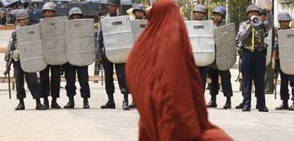
They stood their ground as long as they dared, too long for some of them. At least nine people were killed, according to patchy reports, and eleven others injured. The dead included a Japanese photographer.
Figure 3 The monks from yesterday were less in evidence after security forces blocked their movements
So far, though, this does not yet appear to be a repeat of the massacres of 1988, when 3,000 were mown down on the streets. The junta is showing patience and restraint, it is plotting its moves step by step, and it is displaying a subtle and malignant cunning.
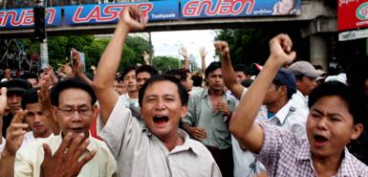
In the Mwe Kya Kan pagoda in the South Okkala district of Rangoon, it began at 2am, but seven hours later the evidence was plain to see – a dozen thick patches of congealing blood and human tissue splashed about the yard. The windows of the monks’ dormitories were smashed jaggedly by the impact of rubber bullets – hard, round spheres fired from green cartridges that the monks had carefully gathered up and put on display.
Figure 4 Pro-democracy protesters in Rangoon today. Many were too scared to venture out after dark.
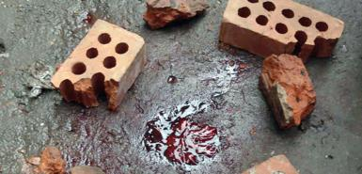
Inside everything had been smashed – the thin plywood walls, the monks’ plaster statues of the Buddha – and the thin mattresses were soaked with blood.
Figure 5 Blood on the floor of a Rangoon monastery raided by police last night in a bid to round up protest leaders.
“We had to flee for our lives into the neighbourhood,” said a small bespectacled young man named Ashin Thu, one of the few monks to have evaded arrest. “A family let me hide in one of their houses, I was so scared.”
The bullets may have been rubber, but at close range they can still do great damage. Seventy monks were driven away bleeding in 24 military vehicles and, to judge from the pools of blood in the yard, several of them were gravely injured.
Most outrageous of all, in the eyes of the survivors, was the theft that the soldiers had carried out. They took money from locked boxes and carried off a gold statue and a hoard of golden rings. And so it becomes clear why the Government has imposed an eight-hour overnight curfew. It was not to protect the city from “terrorists”, but to prevent its citizens bearing witness to its own crimes.
Similar raids – with beatings, terror and arrests – were reported in at least three other monasteries. Several senior members of the National League for Democracy (NLD), the political party of the Nobel Peace Prize laureate, Aung San Suu Kyi, were also rounded up overnight.
At 9am yesterday I had an appointment to meet U Myint Thein, the gracious and gentlemanly spokesman of the NLD. But U Myint Thein was otherwise engaged – in the headquarters of the police special branch, who took him away from his home in the middle of the night.
By the afternoon, there were troops stationed in monasteries all over the city. For Buddhists, there is an element of sacrilege in this, as well as simple bad manners. These were men of violence, fresh from acts of violence, who were imposing themselves on places dedicated to peace. At Moe Kaung Pagoda, the olive-uniformed troops wore red kerchiefs around their necks. It is the belief of many of the demonstrators that this is a sign that they are permitted to shoot to kill. But the killing was to take place elsewhere, on the road that leads south towards the Sule Pagoda, the second-most famous in Rangoon after the mighty golden Shwedagon. By noon, thousands of people had gathered at a crossroads which had been sealed off by soldiers, riot police and barbed wire barricades.
Around 1pm the police began moving forward, and the soldiers followed. Warnings were issued through loud-speakers on the roofs of vans.
Then, amid impenetrable confusion, shots were fired, as well as smoke grenades. It would be inconsistent with the behaviour of the security forces during the rest of the day if these had been live rounds, aimed to kill. But one man, apparently a photographer, was seen by witnesses to drop suddenly, as if shot. His limp body was lifted on to a military truck and carried away.
The crowd scattered and ran to reform a few hundred yards up the road. Banging their shields, the riot police advanced again with the loud-speaker van behind them.
The message was both crude and courteous. It included an honorific form of the Burmese word for “you”, and might be translated like this: “Good sirs, please leave the area or we will open fire in ten minutes time.”
No one had difficulty believing this and with oaths and screams of rage (one man lifted up his traditional longyi skirt to present a full moon to the forces of the junta), the protesters moved back, and back, and back again.
Late in the afternoon, shots were heard from the streets to the east of the pagoda. But by that stage none of the small corps of foreign diplomats, reporters and photographers following the demonstrations felt much like going out to have a look.
There are so many heartbreaking things about what is going in Burma, but for a foreigner one of the hardest to bear is the optimism. There are few foreign journalists here, but people treat them as saviours, encouraging them to get the story and the pictures out, with a touching faith that it will make a difference.
“Tell them to send foreign troops, UN troops,” said a young monk at the Mwe Kya Kan pagoda. “Please, fly them to our country to save our lives.”
An American in Rangoon told me yesterday about an opinion poll carried out on Burmese attitudes to US foreign policy.
“Like most people, they thought that it sucks,” he told me. “But not for the usual reason. Burmese wanted to know why George Bush hasn’t invaded their country yet.”
A boy named Raphael came up to practise his English, as the crowd screamed at the soldiers, and asked for my address so that he could visit me one day. A very small and old but irrepressibly vigorous white-haired man took my hand and led me to safety when he thought that I was too close to the trouble. “I am a teacher,” he said proudly. “PhD!”
Small, human encounters – and yet in these dark circumstances they become almost unbearably poignant. They are based on a very questionable assumption: that the people of Burma are going to be saved.
I wish that I could have told the monk, and the boy and the old man, that I believed everything would be well and that soon they could expect the basic decency from their Government that so many of us take for granted. Nothing is settled, of course, and the future is impossible to read – but on the basis of what I saw yesterday the Burmese junta is winning.

U.N. envoy heads into Myanmar maelstrom
By Aung Hla Tun Fri Sep 28, 10:57 PM ET
YANGON (Reuters) - United Nations envoy Ibrahim Gambari travels to Myanmar on Saturday carrying worldwide hopes he can persuade its ruling generals to use negotiations instead of guns to end mass protests against 45 years of military rule.
"He's the best hope we have. He is trusted on both sides," Singapore Foreign Minister George Yeo said. "If he fails, then the situation can become quite dreadful."
So far, the junta appears to have ignored the international clamor for a peaceful end to what blossomed from tiny protests against shock fuel price rises in August into a mass uprising led by monks, the moral core of the Buddhist nation.
Yangon was eerily quiet on Saturday morning after troops and riot police barricaded off the city centre from where the protests have reverberated around the world.
Authorities have told foreign diplomats based in Yangon that the trouble was being handled with restraint.
So far, that has meant raiding at least a dozen monasteries thought to be at the van of the protests, detaining perhaps hundreds of monks and sealing off city areas around two pagodas which marked the start and end of the daily mass protests.
So far, it appears to be working and the junta restored international Internet links early on Saturday after cutting them the previous day following a flood of pictures and video of soldiers chasing protesters traveling through it to the world.
On Friday, very few monks took part in the much smaller protests around the barricades. People in Yangon said many young monks were evading arrest by casting off their maroon robes and taking refuge in houses disguised as laymen.
"Peace and stability has been restored," state-run newspapers declared on Saturday, after security forces handled protests "with care, using the least possible force."
SCARED CITY BRACED
However, people in the neighborhood reported the Minnada monastery was raided on Friday and that shots were fired.
Monks have reported six of their brethren have been killed since the army started cracking down on Wednesday to end mass protests by columns of monks flanked by supporters who filled five city blocks.
Yeo said he did not think there would be much action on the streets while Gambari was in Myanmar, but people in Yangon were braced for more of the cat and mouse protests which had kept the city tense on Friday.
Crowds taunted and cursed security forces for hours on Friday around the barbed-wire barriers in a city terrified of a repeat of 1988, when the army killed an estimated 3,000 people in crushing an uprising in the country, then known as Burma.
When the troops charged, the protesters vanished into narrow side streets, only to emerge elsewhere to renew their abuse until an overnight curfew took effect.
State-run media admit nine people have been killed since the crackdown began, prompting international outrage.
"I am afraid we believe the loss of life is far greater than is being reported," British Prime Minister Gordon Brown said on Friday after talking to U.S. President George W. Bush.
Bush and Brown discussed the need to maintain international pressure on Myanmar's rulers and the White House condemned the crackdown as "barbaric."
INTERNATIONAL CLAMOUR
Bush authorized new U.S. sanctions on Thursday against the Myanmar government, which has been operating under similar restrictions for years.
The European Union summoned Myanmar's senior diplomat in Brussels and warned him of tighter sanctions.
EU experts looked into possible restrictions on exports from Myanmar of timber, precious metals and gems, but reached no decisions, one diplomat said. Investments by specific Europeans in the country were not raised, he said.
Activist Mark Farmaner of the Burma Campaign U.K., calling the EU sanctions "pathetic," said a freeze on assets had netted less than 7,000 euros in all 27 EU member states and many countries allowed their companies to do business in Myanmar.
Russian President Vladimir Putin said sanctions were premature but he was sorry to hear about civilian deaths. "As far as sanctions are concerned, this is a topic to be especially considered in the United Nations," he Putin.
Russia, like China, is a veto-wielding member of the U.N. Security Council and has shown growing interest in Myanmar's rich gas fields.
China, the junta's main ally, publicly called for restraint
for the first time on Thursday. But at the United Nations, China has ruled out supporting sanctions or a U.N. condemnation of the military government's use of force.
The Association of South East Asian Nations, which rarely criticizes a member directly, expressed "revulsion" at the crackdown.
There were protests across Asia on Friday, with many people wearing red to symbolize the blood spilled in Myanmar, and outside the United Nations building in New York.

