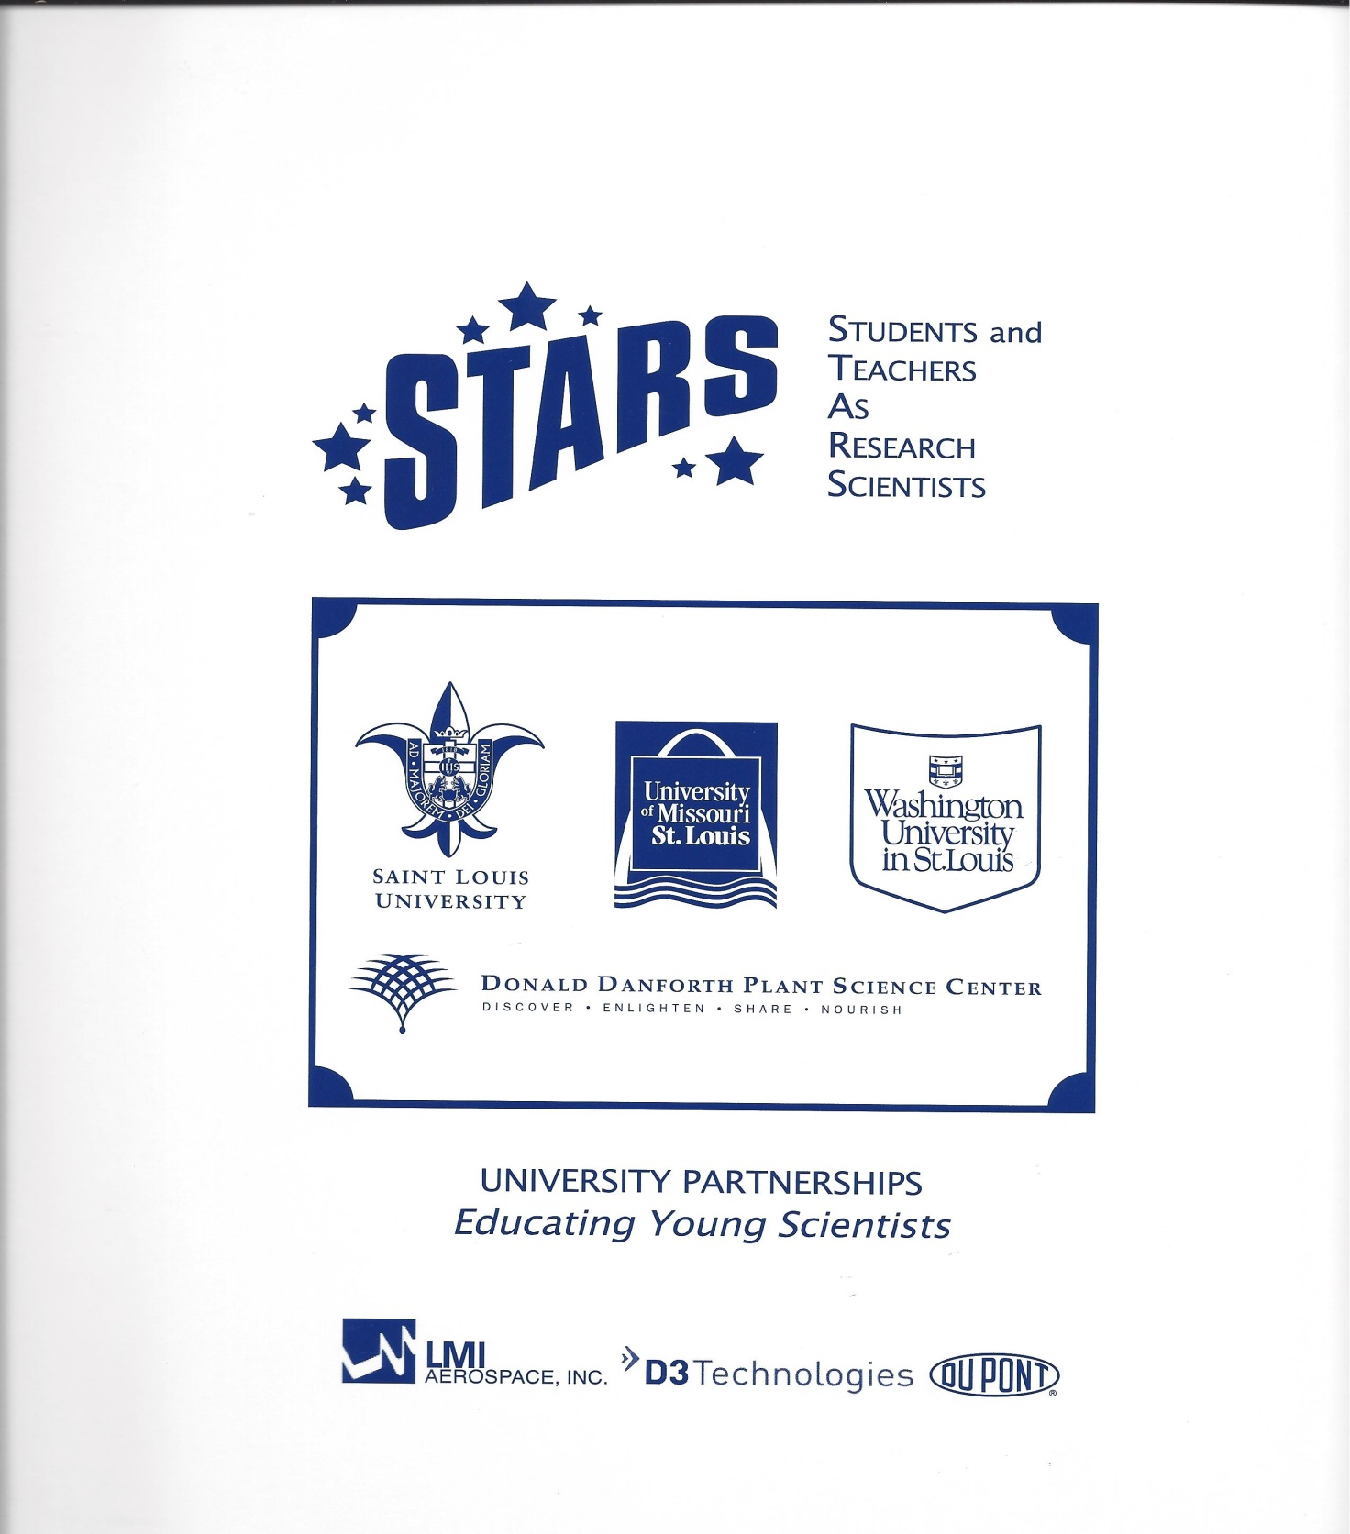

2015 SCHEDULE



*In Partnership with: Sponsored by:*

*Confluence Life Sciences LMI Aerospace Inc. /D3 Technologies, Office of the Chancellor-UMSL*

*Donald Danforth Plant Science Center Saint Louis University, Washington University in St. Louis, Boeing Company*

*Saint Louis University* *St. Louis Symphony, DuPont Nutrition and Health, Saint Louis Zoo Washington University in St. Louis Monsanto Company, Academy of Science of St. Louis, St. Joseph’s Institute for the Deaf*

*University of Missouri-St. Louis Easter Seals Midwest, St. Louis Children’s Hospital, UMKC, John Burroughs School*

***Mandatory UMSL Campus Activities are Shaded***

|  |  |  |  |  |
| --- | --- | --- | --- | --- |
| **MONDAY**  **JUNE 8** | **TUESDAY**  **JUNE 9** | **WEDNESDAY**  **JUNE 10** | **THURSDAY**  **JUNE 11** | **FRIDAY**  **JUNE 12** |
| *8:00 – 8:30*  ***REGISTRATION & CONTINENTAL BREAKFAST***  *121 Research Bldg., UMSL North*  *Park in Garage #52 on West Drive* | **RESEARCH**  Students  are to  meet  with  their  Research Mentors  at  their  respective  campus | *8:30 – 8:55*  *“****Student Introductions”***  *Continued from Monday*  *DR. KEN MARES*  *120 Research* | **RESEARCH**  Students  are to  meet  with  their  Research Mentors  at  their  respective  campus  http://www.forsythforfamilies.com/wp-content/uploads/2013/01/stars.jpg  ***5:30 -7:45***  ***SOCIAL EVENT***  ***Bowling & Pizza***  *Tropicana Lanes*  *7960 Clayton Rd.*  *(314) 781-0282* | YOU ARE  REQUIRED  TO E-MAIL THE TITLE AND A  1-2 SENTENCE DESCRIPTION  OF YOUR  RESEARCH  PAPER  TO YOUR  ADVISOR  BY  NOON  TODAY  **RESEARCH**  Your schedule  is based on  the discretion  of your  Research  Mentor |
| *8:30 – 10:20*  ***WELCOME and ORIENTATION***  *DR. KEN MARES*  *DR. CHARLES GRANGER*  *120 Research* | *9:00 – 9:55*  ***“Galapagos Islands and***  ***Avian Research Lecture”***  *DR. PATTY PARKER*  *Professor and Chair*  *Department of Biology, UMSL*  *pparker@umsl.edu*  *120 Research* |
| *10:30 – 11:30*  ***LABORATORY SAFETY and COMPLIANCE TRAINING***  *DDPSC and SLU – 120 Research*  *CLS and WUSTL – 115 Benton*  *UMSL – 116 Benton* |
| *10:00 – 11:20*  ***“Medical Ethics Lecture”***  *DR. IRA KODNER*  *Colorectal Surgeon*  *Director of the Washington Univ. Center for the Study of*  *Ethics and Human Values*  *kodner@wustl.edu*  *120 Research* |
| 11:45 – 12:30  BUFFET LUNCH  Millennium Student Ctr. (MSC)  Century C – Third Floor |
| 11:30 – 12:15  BUFFET LUNCH PROVIDED  MSC Century C |
| **RESEARCH**  Your schedule  is based on  the discretion  of your  Research  Mentor |
| *12:30 – 2:00*   1. ***STUDENT PHOTOS*** *Third Floor Rotunda* 2. ***LAB COAT FITTINGS***   *Third Floor Rotunda*   1. ***UMSL ID CARDS***   *You Must Bring Your Current Photo ID Rm 190*   1. *BUY $25* ***METRO PASS***   *Room 238 - Cashier* |



**WEEK TWO**

|  |  |  |  |  |
| --- | --- | --- | --- | --- |
| **MONDAY**  **JUNE 15** | **TUESDAY**  **JUNE 16** | **WEDNESDAY**  **JUNE 17** | **THURSDAY**  **JUNE 18** | **FRIDAY**  **JUNE 19** |
| *8:00 – 8:25*  ***Research Paper Update***  *DR. HEIDI HOPE*  *120 Research* | **RESEARCH**  Your schedule  is based on  the discretion  of your  Research  Mentor | *8:30 – 9:25*  ***“College Essay Writing Lecture”***  *MS. TORI NEASON*  *Admissions Officer*  *Undergraduate Admissions*  *Washington University*  *tneason@*wustl*.edu*  *120 Research* | **RESEARCH**  Your schedule  is based on  the discretion  of your  Research  Mentor | MANDATORY!  YOU ARE  REQUIRED  TO SEND AN  E-MAIL GIVING THE  INTRODUCTION START & REFERENCES  FOR YOUR  RESEARCH  PAPER  TO YOUR  ADVISOR  AND MENTOR  OR MENTOR DESIGNEE  BY  NOON  TODAY  **RESEARCH**  Your schedule  is based on  the discretion  of your  Research Mentor |
| *8:30 – 9:30*  ***“Overview - Selective College Admissions Lecture”***  *MS. CHRYSTAL OKONTA*  *Admissions Officer*  *Undergraduate Admissions*  *Washington University*  *cokonta@wustl.edu*  *120 Research* | *9:35 – 10:50*  ***“Protecting Wildlife through Conservation Medicine”***  *SHARON DEEM*  *DVM, PhD, DACZM*  *Institute for*  *Conservation Medicine*  *Saint Louis Zoo*  *deem@stlzoo.org*  *120 Research* |
| *9:35 – 10:30*  ***“Ecology of Invasive***  ***Species in Missouri:***  ***Who Does What to Whom”***  *DR. ROBERT MARQUIS*  *Professor – Dept. of Biology*  *Director – Whitney R. Harris World Ecology Center*  *University of Missouri-St. Louis*  *Robert_marquis@umsl.edu* |
| *10:30 – 11:25*  ***“Urban/Suburban Biodiversity”***  *SHEILA VOSS*  *Vice President, Education*  *Missouri Botanical Garden*  *Sheila.voss@mobot.org*  *120 Research* | *11:00 – 11:50*  ***“Curiosity Revealed the Cat: Domesticating the Cat Genome“***  *WESLEY WARREN, PH.D.*  *Asst. Director, The Genome Institute, Washington Univ. School of Medicine*  *wwarren@genome.wustl.edu*  *120 Research* |
| 11:35 - 12:00  BUFFET LUNCH PROVIDED  MSC Century C | 12:00 – 12:30  BUFFET LUNCH PROVIDED  MSC Century C |
| **RESEARCH**  Your schedule is  based on  the discretion  of your  Research Mentor | **RESEARCH**  Your schedule is  based on  the discretion  of your  Research Mentor |
| ***SOCIAL EVENT***  ***St. Louis Galleria Mall***  Movie and ice cream after!  http://us.cdn4.123rf.com/168nwm/cole123rf/cole123rf0810/cole123rf081000130/3712294-opened-movie-clapboard-used-by-movie-directors-with-bright-star-behind.jpgDetails TBD! |

**WEEK THREE**



|  |  |  |  |  |
| --- | --- | --- | --- | --- |
| **MONDAY**  **JUNE 22** | **TUESDAY**  **JUNE 23** | **WEDNESDAY**  **JUNE 24** | **THURSDAY**  **JUNE 25** | **FRIDAY**  **JUNE 26** |
| *8:00 – 8:25*  ***Research Paper Update***  *DR. HEIDI HOPE*  *120 Research* | **RESEARCH**  Your  schedule  is based  on  the  discretion  of your  Research Mentor | *8:30 - 9:50*  ***“Facts and Fiction -***  ***The Interviewing Process for College Admissions”***  *DR. DAN ORY*  *Professor of Medicine*  *WUSTL School of Medicine*  *dory@wustl.edu*  *120 Research* | **RESEARCH**  Your  schedule  is based  on  the  discretion  of your  Research Mentor | MANDATORY!  YOU ARE REQUIRED  TO E-MAIL TO YOUR  ADVISOR AND MENTOR OR MENTOR DESIGNEE BY  NOON TODAY -  ADDING MATERIALS AND METHODS WHILE CONTINUING TO WORK ON INTRO & REFERENCES.  **RESEARCH**  Your schedule is based  on the discretion of your  Research Mentor  **SOCIAL EVENT**  **“MUSIC OF U2”**  Music of U2**St. Louis Symphony**  **Powell Hall**  **7:30 p.m.**    *Channeling the global celebrity stardom of front man, Bono, and the musicians of U2, the STL Symphony and a rock band perform their greatest hits, including*  *“Beautiful Day,”*  *“One” and*  *“With Or Without You.”* |
| *8:30 – 9:45*  ***“St. Louis' Bioscience***  ***Innovation Ecosystem”***  *MR. DONN RUBIN*  *President and CEO*  *BioSTL*  *drubin@biostl.org*  *120 Research* |
| *9:50 – 11:05*  ***“Nerve Injury Lecture”***  *AMY MOORE, MD*  *Asst. Professor, Surgery*  *Plastic and Reconstructive Surgery Center*  *Department of Surgery*  *WUSTL School of Medicine*  *mooream@wudosis.wustl.edu*  *120 Research* | *10:00 - 11:30*  ***’The Soloist’***  ***“A Study of Paranoid Schizophrenia and Other***  ***Mental Health Issues”***  *HENRY NASRALLAH, M.D. Chair*  *Dept. of Neurology & Psychiatry*  *Saint Louis University*  *hnasral@slu.edu*  *MR. ADAM CRANE*  *Vice President*  *for External Affairs*  *St. Louis Symphony*  [*adamc@stlsymphony.org*](mailto:adamc@stlsymphony.org)  *MR. EDDIE SILVA*  *External Affairs and Publications Manager*  *St. Louis Symphony*  *120 Research* |
| *11:15 – 12:00*  ***Washington University***  ***Undergraduate Program***  *MS. ARIEL SAUL*  *Admissions Officer asaul@wustl.edu*  *MR. CHRIS KROEGER*  *Assoc. Dean, School of Eng.*  *ckroeger@wustl.edu*  *Washington University*  *120 Research* |
| 12:10 - 12:30  BUFFET LUNCH PROVIDED  MSC Century C | 11:45 - 12:15  BUFFET LUNCH PROVIDED  MSC Century C |
| **RESEARCH**  Your schedule is  based on  the discretion  of your  Research Mentor | **RESEARCH**  Your schedule is  based on  the discretion  of your  Research Mentor |



**WEEK FOUR**

|  |  |  |  |  |
| --- | --- | --- | --- | --- |
| **MONDAY**  **JUNE 29** | **TUESDAY**  **JUNE 30** | **WEDNESDAY**  **JULY 1** | **THURSDAY**  **JULY 2** | **FRIDAY**  **H O L I D A Y** |
| *8:00 – 8:25*  ***Paper Q & A With Your Advisor***  *201 Stadler /Hamper-Woerndle-Meisel*  *244 Stadler / Weinberg*  *245 Stadler / M. Hope-Berger*  *248 Stadler / Granok*  *301 Stadler / Burnette*  *304 Stadler / Howard*  *120 Research / H. Hope*  *121 Research / Krul* | **RESEARCH**  Your schedule  is based on  the discretion  of your  Research  Mentor | **RESEARCH**  Your schedule  is based on  the discretion  of your  Research  Mentor | MANDATORY!  YOU ARE REQUIRED  TO E-MAIL TO OUR  ADVISOR AND MENTOR OR MENTOR DESIGNEE BY NOON TODAY  ADDING THE START OF YOUR RESULTS AND DISCUSSION WHILE CONTINUING TO WORK ON OTHER SECTIONS.  **RESEARCH**  Your schedule is based on the discretion of your  Research Mentor  http://media-cache-ec0.pinimg.com/736x/d8/0a/12/d80a12b56f9025854fb26c0bcc266170.jpg  **BASEBALL**  **4:00** *Leave for Union Station for dinner there on your own.*  **5:45** *Meet at Union Station Metrolink Station (top of the stairs) to ride to the game as a group.*  **6:15 CARDINALS**  **vs.**  **San Diego Padres**  **Busch Stadium Sections 234 & 235**  *Fireworks display after the game! 25,000 fans, age 16+ receive 1982 Replica World Championship Ring!* | http://www.townofchapelhill.org/Modules/ShowImage.aspx?imageid=5728  **H**  **O**  **L**  **I**  **D**  **A**  **Y** |
| *8:30 – 10:45*  ***“Nanoscience and Medicine”***  *DR. TOM GEORGE*  *Chancellor and Professor, UMSL*  *tfgeorge@umsl.edu*  *DR. YOUNG-SHIN JUN*  ***“Nanoscience and the Environment”***  *Associate Professor*  *Energy, Environ. and Chem. Engineering*  *Washington University*  *ysjun@seas.wustl.edu*  *DR. GEORGE GOKEL*  *Distinguished Professor*  *Director, Ctr. for Nanoscience, UMSL*  [*gokelg@umsl.edu*](mailto:gokelg@umsl.edu)  *120 Research* |
| *11:00 – 11:50*  ***“University of Missouri - St. Louis Undergraduate Opportunities”***  *MR. DREW GRIFFIN*  *Director of Admissions – UMSL*  *askdrew@umsl.edu*  *MR. JOE SOUTHERLAND*  *Academic Advisor - UMSL*  [*southerlandj@umsl.edu*](mailto:southerlandj@umsl.edu)  *120 Research* |
| 12:00 - 12:30  BUFFET LUNCH PROVIDED  MSC Century C |
| **RESEARCH**  Your schedule is  based on  the discretion  of your  Research Mentor |

**WEEK FIVE**



|  |  |  |  |  |
| --- | --- | --- | --- | --- |
| **MONDAY**  **JULY 6** | **TUESDAY**  **JULY 7** | **WEDNESDAY**  **JULY 8** | **THURSDAY**  **JULY 9** | **FRIDAY**  **JULY 10** |
| *8:00 – 8:25*  ***Paper Q & A With Your Advisor***  *201 Stadler /Hamper-Woerndle-Meisel*  *244 Stadler / Weinberg*  *245 Stadler / M. Hope-Berger*  *248 Stadler / Granok*  *301 Stadler / Burnette*  *304 Stadler / Howard*  *120 Research / H. Hope*  *121 Research / Krul* | **RESEARCH**  Your  schedule is  based on  the  discretion  of your  Research  Mentor | 8:30 – 9:25  ***“Change and Reliability in the Evolution of Information Processing***  ***by Animals“***  *DR. AIMEE DUNLAP*  *Assistant Professor*  *Department of Biology, UMSL*  *Aimee.dunlap@umsl.edu*  *120 Research* | **RESEARCH**  Your  schedule is  based on  the  discretion  of your  Research  Mentor | MANDATORY!  **YOU ARE**  **REQUIRED**  **TO E-MAIL**  **YOUR**  **RESEARCH**  **PAPER INCLUDING ABSTRACT**  **TO YOUR**  **ADVISOR**  **AND MENTOR**  **OR MENTOR DESIGNEE**  **BY**  **NOON**  **TODAY**  **RESEARCH**  Your  schedule is  based on  the  discretion  of your  Research Mentor |
| *8:30 – 9:50*  ***“Subversive Science: Sustainability and Architecture”***  *MR. BRUCE LINDSEY*  *Dean and Des Lee Professor*  *College of Architecture*  *Washington University*  *lindsey@samfox.wustl.edu*  *120 Research*  *10:00 - 11:55*  ***“Autism: What is it?***  ***Who is affected?***  ***What is being done?”***  *MS. JEANNE MARSHALL*  *Vice President, Autism Services*  *Easter Seals Midwest*  *jeanne.marshall@esmw.org*  ***“Finding Kansas: Living and Decoding Asperger’s Syndrome”***  *MR. AARON LIKENS*  *Author*  *aaron.likens@esmw.org*  *120 Research* | *9:30 – 10:30*  ***“Living and Dying with Oxygen:***  ***Driving Forces Behind the Origin of Eukaryotes, Sex and Aging”***  *DR. JACK KENNELL*  *Associate Professor*  *Department of Biology*  *Saint Louis University*  *kennellj@slu.edu*  *120 Research* |
| *10:35 - 11:50*  ***“Saint Louis University***  ***Undergraduate Admissions”***  *MR. MICHAEL GRUZESKI*  *Assistant Director*  *Office of Admission*  *Saint Louis University*  *gruzeski@slu.edu*  *120 Research* |
| 12:10 - 12:45  BUFFET LUNCH PROVIDED  MSC Century C | 12:00 - 12:30  BUFFET LUNCH PROVIDED  MSC PILOT HOUSE – 1st floor |
| **RESEARCH**  Your schedule is based on  the discretion of your  Research Mentor | *12:30 – 1:30*  ***(FOR INTERESTED STUDENTS)***  ***“UMKC Six-Year Medical School”***  *Ms. Brandy Baze*  *Recruitment Coordinator*  *Admissions and Recruitment*  *UMKC School of Medicine*  *steelebr@umkc.edu*  *MSC Room 313* |
| **RESEARCH**  Your schedule is based on  the discretion of your  Research Mentor |



**WEEK SIX**

|  |  |  |  |  |
| --- | --- | --- | --- | --- |
| **MONDAY**  **JULY 13** | **TUESDAY**  **JULY 14** | **WEDNESDAY**  **JULY 15** | **THURSDAY**  **JULY 16** | **FRIDAY**  **JULY 17** |
| ***8:00 – 8:25***  ***Paper Q & A***  *201 Stadler /Hamper-Woerndle-Meisel*  *244 Stadler / Weinberg*  *245 Stadler / M. Hope-Berger*  *248 Stadler / Granok*  *301 Stadler / Burnette*  *304 Stadler / Howard*  *120 Research / H. Hope*  *121 Research / Krul* | MENTOR  PAPER  PRESENTATION  Your  schedule is  based on  the  discretion  of your  Research  Mentor | *8:00 – 9:15* ***CONFIRMATION***  ***CEREMONY***  ***REHEARSAL***  *104 Stadler* | **RESEARCH**  Your  schedule is  based on  the  discretion  of your  Research  Mentor | *8:00 - 11:55*  *RESEARCH PAPER*  *PRESENTATIONS*  *With Advisors*  ***TWO, STAPLED copies of your COMPLETE research paper must be given to your advisor this morning. MUST INCLUDE THE SIGNED***  ***MENTOR APPROVAL SHEET.***  *101 Benton / Hamper*  *104 Benton / Granok*  *116 Benton / Woerndle*  *225 Benton /*  *240 Benton / Krul*  *241 Benton / Meisel*  *242 Benton / H. Hope*  *243 Benton / Howard*  *120 Research / Weinberg*  *104 Stadler / M. Hope* |
| *9:30 – 9:55*  ***PHOTOGRAPHS***  *Total Group & By High School*  *Research Building Back Steps* |
| *8:30 – 9:45*  ***“How to Make a Good Presentation”***  *DR. DAN RUZICKA*  *Research Scientist*  *Monsanto Company*  *dan.ruzicka@monsanto.com*  *120 Research* | *10:00 – 11:30*  ***PRESENTATION***  ***PRACTICE***  *With Advisors*  *101 Benton / Hamper*  *104 Benton / Granok*  *116 Benton / Woerndle*  *225 Benton /*  *240 Benton / Krul*  *241 Benton / Meisel*  *242 Benton / H. Hope*  *243 Benton / Howard*  *120 Research / Weinberg*  *104 Stadler / M. Hope* |
| *10:00 – 11:30*  ***“Frontline of Hope”***  *NIHARIKA RATH, MD*  *MS. JAN ROGERS*  *SUSAN SCHUH*  *St. Louis Childrens’*  *Hospital Foundation*  *Rath_n@kids.wustl.edu*  *jbrogers@bjc.org*  *sms7841@bjc.org*  *120 Research* |
| LUNCH ON YOUR OWN | **12:00 – 12:45**  **BUFFET LUNCH PROVIDED**  MSC Century B and C |
| 11:45 – 12:15  BUFFET LUNCH PROVIDED  MSC Century C  *12:15 – 1:15*  *(FOR*  *INTERESTED STUDENTS)*  ***Science Fair Competitions***  *DR. BRUCE HAMPER*  *Honors Fair Chairman*  *Asst. Teaching Prof., UMSL*  *MS. PEGGY NACKE*  *Director*  *Special Projects/Events*  *Academy of Science STL*  *peggyn@academyofsciencestl.org*  *MSC Room 313*  *MENTOR*  *PAPER*  *PRESENTATION*  *Your schedule is based on the discretion of your*  *Research Mentor* | *12:15 – 3:30*  ***PRESENTATION***  ***PRACTICE (continued)***  *With Advisors*  *101 Benton*  *104 Benton*  *116 Benton*  *225 Benton*  *240 Benton*  *241 Benton*  *242 Benton*  *243 Benton*  *120 Research*  *104 Stadler*  *You may depart at the discretion of your Advisor* | ***1:00 – 2:15***  ***RESEARCH PAPER***  ***PRESENTATIONS (cont.)***  *101, 104, 116 Benton*  *225, 240, 241, 242, 243 Benton*  *120 Research, 104 Stadler*  ***2:25 - ALL students board bus***  ***2:30 - Bus departs for Touhill*** |
| *3:00 – 4:00*  ***CONFIRMATION CEREMONY***  ***(Reception follows***  ***in the lobby area)***  ***Touhill Performing Arts Center E. Desmond and Mary Ann***  ***Lee Theater – UMSL*** |