Attracting, Developing, and Retaining IT Professionals

December 4, 2006
University of Missouri-St. Louis

--Tammy Hawkins, Matt Wanninger and Ying Jing
Executive Summary
IT workers are valuable assets to any company as they are in high demand. As business needs grow and change with the capture and usage of electronic communications and data storage and reporting, IT needs continue to grow. IT workers are in strong demand in the US, with the IT worker pool decreasing due to a knowledgeable, retiring population combined with a lack of IT college graduates. IT jobs were reduced in the US in the late 1990s and early 2000s due to the dot com bust and post 9/11 terror attacks. IT hiring has increased in the recent past 2 years. This is due to many factors including the passage of Sarbanes-Oxley laws, the increase of data storage which also encourage the increase in purchase or development of software applications to use the data efficiently (ERP, CRM systems, etc.), as well as increased use of technology in all items of business in many industries. Software development is among one of the fastest US growing industries, and troops of skilled IT workers are being sought to aid in the development and customization of the various software.
Attracting well skilled IT workers can be truly challenging, in combination with the dwindling pool of workers available in an environment where demand exceeds the available supply. Employers must devise an attractive combination of compensation, bonuses, benefits packages, training programs, and healthy, fun work environments. Good word of mouth amongst IT workers is a very strong way to attract well qualified employees. Online job search sites used in combination with filtering criteria have also become a large source of well skilled applicants. A thorough job description must be prepared, listing all needed skills and abilities as well as detailing all job duties to be performed. Interviews should be prepared beforehand and applied uniformly to each applicant. Employers should be frank and honest about the position to be filled with the applicant. They should consider administering tests for IT skills to assure the applicants are truly knowledgeable in all software knowledge testable. They should perform a good reference and/or background check on the individual, and may decide to ask for work samples, a drug test, and/or criminal background check. To avoid the cost associated with searching, interviewing and hiring the correctly skilled IT worker that may only be needed temporarily, many companies are opting to hire a consulting firm to provide a well skilled worker. These workers come with an added cost per hour to cover the consulting firm’s costs of finding and supplying the skilled worker.
Attracting and hiring the correct employee is essential. The most in demand skills include: Windows administration, Wireless network management, SQL server management, Cisco network administration, and CheckPoint firewall administration. Additionally, companies are seeking to hire individuals that also possess soft skills such as team skills, communication skills, critical thinking skills, personal motivation, and creative thinking skills. Industries most seeking IT workers currently include: Financial services, Insurance, Telecommunications, IT, and Banking. These industries are dealing with a lot of data and software for which they need well experienced, high skilled IT workers. Workers can be recruited via online job search sites, consulting firms, or employee referral (word of mouth), amongst other sources. Salaries are very dependent on the job role fulfilled, region, and experience. Salary ranges can be anywhere from $40,000 for beginners to $300,000+ for high level IT executives. These salaries have continued to increase in the US along with demand.
Creating training and skills development programs for the IT workers that the company wishes to retain is vital for many reasons. Developing IT workers not only encourages IT workers to remain in their position, it also helps by bringing new skills and abilities to the company’s IT team. Development can empower workers, by having only one or two workers attend training and then allowing them to train other employees. Training can be conducted a variety of ways including e-learning, formal training, self-study, exam certification, coaching, study leave, and on-the-job training. Training can be costly but the benefit is well worth the investment.
Motivating employees is a key for IT organizations. Motivation can be achieved through monetary rewards, intrinsic benefits, a fun work environment, challenging job duties with well earned rewards given upon completion, etc. While money is a well liked and easy to dispense motivation, it is also very short lasting. Companies that truly invest in motivating employees through creative methods have received wonderful returns. These returns come in the form of improved employee retention, good word of mouth externally and internally (good press, helps recruiting), and happier, better satisfied employees. Most important is praise and recognition of good employees. Motivation often helps employees to be more creative and focused on work. Top methods that encourage employee retention include: providing training or professional development, offering flexible schedules, and increasing base compensation.
Quicken is a superb example of a company that understands the importance of motivation, development, and retention of employees. They are a home loan mortgage provider that operates via website portals. When Quicken began they faced fierce competition in a market that was aggressively growing. Quicken attempted to hire and retain high skill IT employees to design a break through website portal at which customers could easily apply and purchase home mortgage loans. They have won countless awards for their pleasant work environment as well as for their creative website design and massive home loan success. Innovation has included free amenities (slurpies, cappuccino, popcorn, etc), having an in-house band play at every team meeting, providing incentive bonuses, and other bonuses and recognitions). Quicken’s IT team performs like a well oiled machine. They constantly receive development training and are constantly assigned challenging but doable projects in which every employee is empowered to suggest innovation. They are a great company in which to study for how to attract, develop, and retain IT workers.
IT Attracting

"You attract people by challenging them and empowering them. People like/want the opportunity to be successful and achieving difficult assignments their way...you don't tell them what to do, you help them be successful. Good people will step up and deliver as long as you don't let them drown.”
- Project Manager for an IT department within an Insurance firm (Tremaine)

In the 90’s employment of IT was increasing
The United States’ supply of IT workers is drastically reducing. Warnings of shortages of engineers, scientists, and now information technology specialists have appeared regularly since the 1950’s. On the one hand, technological strength is a crucial ingredient of American economic prosperity. On the other hand, the continual pressure to maximize the country’s supply of technical talent also requires attracting more high tech workers. Workers need to know the IT work is stable and can be prosperous, as IT confidence was shaken in the dot command post 9/11 haze.
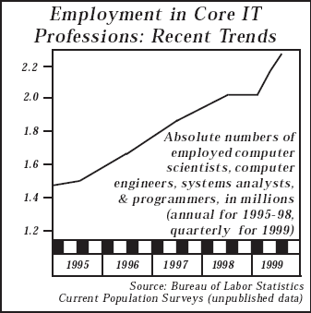
According to the survey about the trends of IT employment from 1995 to 1999 in U.S. from Bureau of LaborStatistics, we could see the trends of employments in core IT professionals was increasing during this period. The report of IT Workforce Data Project showed that the higher-level core IT occupations —computer scientists, computer engineers, and systems analysts—grew from less than 300,000 workers in 1983 to over 1.5 million workers by the end of 1998. Growth for programmers was less rapid, but the numbers of those workers also increased during this 15-year period, from about 450,000 to over 600,000 (http://www.cpst.org/IT-4.pdf). From this chart we could see the trend of growth had continued in the first three quarters of 1999. The increases in employment suggest increases in demand. This was a time when the internet was becoming a new household item and there was really computer communication revolution occurring in the US. The increase is only predicted to continue in the future, as demand continues to exceed the supply of workers available each year.

But at the beginning of 20th century hiring decreased
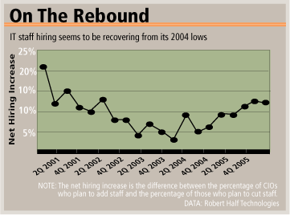
The trend of IT hiring declined at the beginning of the 21st century. This is partly due to many companies slump in hiring post dot com and 9/11 phases in the US. There is also more re-investment for IT, as IT investment tends to be cyclical, often with a 5-year trend. In this chart we use the net hiring increase/decrease numbers from 2001 to 2005 which is calculated by subtracting the percentage of CIOs who plan to cut staff from the percentage who plan to add staff (Spencer Lee). Although this is a far cry from the level of activity during the late 1990s, it still represents a significant improvement: we could see IT staff hiring seems to be recovering from its 2004 lows.

Fast growing industry
The trend of IT salary is incrementally growing currently. According to the survey from Bureau of Labor Statistics, among the top 10 fastest growing industries in U.S. there are two kinds of IT industries: software publishers and computer systems design and related services. These industries have increased in number of jobs by 5.3% and 3.4%, respectively (US Bureau of Labor Statistics).
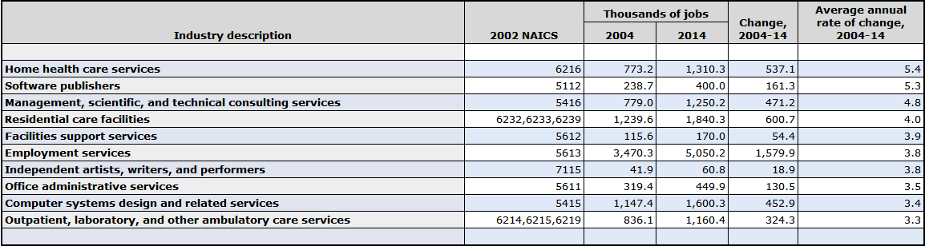
In addition, research conducted in September 2005 for 2006 Salary Guide finds that most businesses expect to increase IT hiring this year. It also shows that starting salaries for many IT positions are rising. For example, they expect 2006 starting salaries for IT auditors and lead application developers to increase by 11.2% and 5.3%, respectively, over 2004 (Bureau of Labor Statistics). So we could draw a conclusion that the IT industry is awakening.
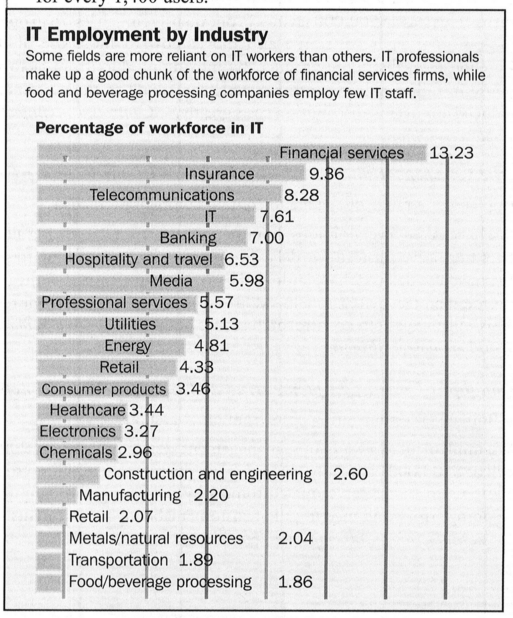
Also, those companies employing IT workers per industry are of importance. Certain industries have a large focus on hiring IT workers at this time as they update their legacy data systems into ERP and CRM systems, as technology changes rapidly for their industries, and as they are trying to learn how to manage and report upon the massive amounts of data their companies now store. The top five industries that are hiring a large amount for IT workers includes: Financial services, Insurance, Telecommunications, IT, and Banking (“Technology Staffing”). It can be noticed that all five of these industries are known for having massive amounts of customer and industry data with which they must work and track. Also, these industries have been largely impacted by Sarbanes-Oxley which has impacted how they store consumer data and for what length of time. Therefore, IT workers that have knowledge in these industries may have a good advantage in the current IT hiring market.
Additionally, it should be noted that there is currently a shortage of IT workers available to companies. The graph below shows the variance in workers available against predictions of workers needed (Murphy).
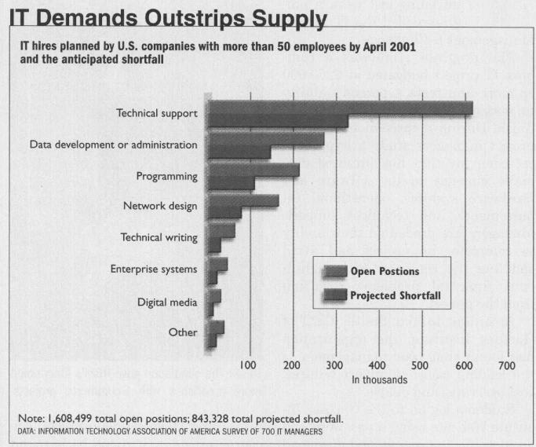
There are many reasons for these shortages, including the retirement of baby boomers and the lack of IT related college graduates in the US. Other reasons for this IT worker shortage within companies can be found below.

Demand/supply of IT staffs: Reasons of shortage:
- Turnover is the no.1 – IT workers are known to be job hoppers, often seeking new skills, challenges, experience, and higher pay.
- Money is one of the biggest reasons – Switching jobs and building a resume of experience can allow the IT worker to request more compensation.
- Demand of skills – When a worker becomes a subject matter expert within an IT area or field, they become in high demand to competitors in the industry.
- Business growth – The growth of business can shift employees around and cause a need for different skills for which people must be hired to fulfill. (McGee)

Shortages can be handled by perhaps using consulting firms to fill IT gaps until the company can identify the correct job description to hire a permanent employee (if needed).
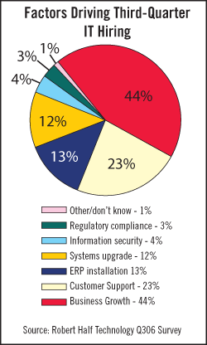
Since these are main reasons for shortage, they also are some of the main reasons as to why companies are seeking more IT employees. Overall, hiring is expected to increase over the 3 quarters (end of 2006 into beginning of 2007). The top three factors driving third quarter hiring in 2006 according to a survey of more than 1,400 CIOs include: business growth (44%), customer support (23%), and ERP installation (13%). Systems upgrade, security and overall systems maintenance are all rapidly growing factors that also can be driving reasons for more IT hiring within companies (DM Review Editorial Staff). Paying attention to the trends for the type of hiring that will occur can help IT employees now focus on studying the correct subject matters so they possess valuable knowledge upon graduation (not outdated knowledge for a position which is no longer being aggressively hired). These statistics are also important for an employer to know, so they know how to better focus their hiring and employee training to meet these growing future needs.
Essentially, with the IT industry growing, it is important now for companies to identify how they can attract the best quality IT workers for their money in an ever dwindling pool of applicants. There are many different ways that companies can attempt to attract IT workers. This can be through offering exciting job roles/duties which helps create well planned job descriptions, encouraging development and training, offering good benefits/compensation and an enjoyable work environment, and making the employee feel valuable. Understanding how to best approach each of these items to truly make an employee feel valuable can make a company extremely attractive to not only high skilled IT workers but also to other stakeholders involved with the business.

Job descriptions – are they important?
A job description describes the tasks, duties, and responsibilities of a particular position. Developing a job description is not typically a simple task and often requires a great amount of time and energy on a company’s behalf. To develop a job description one must first start with the job analysis which requires systematically analyzing the job and identifying the core knowledge, skills and abilities that are essential to perform the job (McNamara).
Below is an example of a job description for a Systems Support Specialist listed on monsterjobs.com (Tyco Healthcare). It identifies and describes the core responsibilities and duties needed for someone to perform the job and also provides insight into the job itself. Ideally someone should be able to read the job description and know exactly what the job will entail.

SYSTEMS SUPPORT SPECIALIST I
Company: Tyco Healthcare
Location: US-MA-Mansfield

JOB DESCRIPTION
Resolves technical problems and answers queries by telephone and e-mail in support of internal, plant, and sales customers. Troubleshooting focus will include computer hardware, software, network, and telecommunications systems.
Diagnoses, identifies, isolates and analyzes problems utilizing technical skill supplemented by procedural documentation. Alerts management to recurring problems and patterns of problems. Will assist with End User Services technical projects, perform access administration and provide triage to Information Services technical staff as required. Will help promote end user awareness and self-service initiatives.
1. Provide a minimum of 6 hours of daily phone/e-mail support.
2. Retain ownership of all issues/requests assigned until closure with end user agreement.
3. Identify/Troubleshoot/Escalate/Resolve critical issues.
4. Notify third level support of performance issues and/or downtimes.
5. Identify/Document reoccurring issues and present possible solutions to management.
6. Assist with department administration as needed.
7. Provide technical and procedural training to EUS new hires.
8. Monitor phone volume and ensure adequate staffing coverage.
9. Create/Maintain technical and procedural documentation
Requirements:
Education required/ preferred: Degree in Computer Science
Experience: 1-3 years Help Desk experience
Preferred Skills/Qualifications: Technical Certification, Experience in troubleshooting Windows Operating Systems, Office Suites, PC fundamentals, Technical phone support
Skills/Competencies: Excellent verbal communication skills, Good customer service, telephone and interpersonal skills, Analytical Thinking, Organizational skills
It is imperative for a job description to accurately reflect the job because job-seekers rely on this information when searching for a job assuming it to true. Being open and honest with candidates during an interview is crucial. The focus should be on giving interested job-seekers an accurate description of what the job is going to be like. Don’t just feed them information that they would want to hear, rather, let them know accurately what they will be doing on a daily basis, even if that involves some tasks that they may not always view as favorable. Job seekers should be cautious when looking for a new job and should never rush into taking a job without first researching the company.
Consider the implications that may result from failing to tell job candidates that their job will be stressful at time. If an employee is hired and soon after discovers that what he/she was told about a job is inconsistent with the actual job itself it is likely that the employee will become upset and possibly even leave. However, if employers are honest and let employees know the job is stressful and demanding at times but also is very rewarding and fulfilling, candidates hired will feel like what they were told during the interview was accurate. By being honest to job candidates turnover can be reduced because they will feel that what they are doing on the job reflects what they were told they would be doing.
If an employee decides to stay with a company even though they were given an inaccurate description and overview of the job it is likely they will not trust the organization. Failing to have trust between employees and employers is a serious issue that can have detrimental effects on an organization and can also lead to a host of other problems. Being open and honest during the selection process and ensuring that job descriptions are valid can be huge steps for any company to take that is concerned about retaining IT professionals.

What skills should an IT employee have?
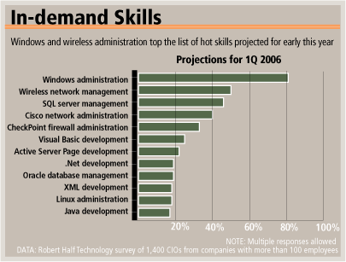
The skills sought for in regards to IT employees can vary greatly between industries, companies, and as discussed, are dependent upon current trends. With regard to the most sought skills, as can be seen to the graph to the left, the following are the top 5 most in demand skills: Windows administration, Wireless network management, SQL server management, Cisco network administration, and CheckPoint firewall administration (Spencer Lee). With the growth of wireless networking has grown in popularity, the installation of such networks and assuring that they have the tightest security possible has caused companies the need of hiring for trained individuals in this area. Also, Windows is the most common operating platform within companies, and with constant releases, upgrades and fixes needed for their software, companies are in constant need of Windows administration professionals. However, just applications knowledge is only one small part of needed skills in regards to IT workers.
Identifying the other skills needed for a job and possessed by a candidate are more challenging than just applications/hardware knowledge. There is also a strong need for softer skills such as team skills, communication skills, critical thinking skills, personal motivation, and creative thinking skills (Xiang). These types of skills are much harder to interview and test upon, which makes it hard to be certain applicants possess them when hiring. But they are imperative for lead IT workers to be able

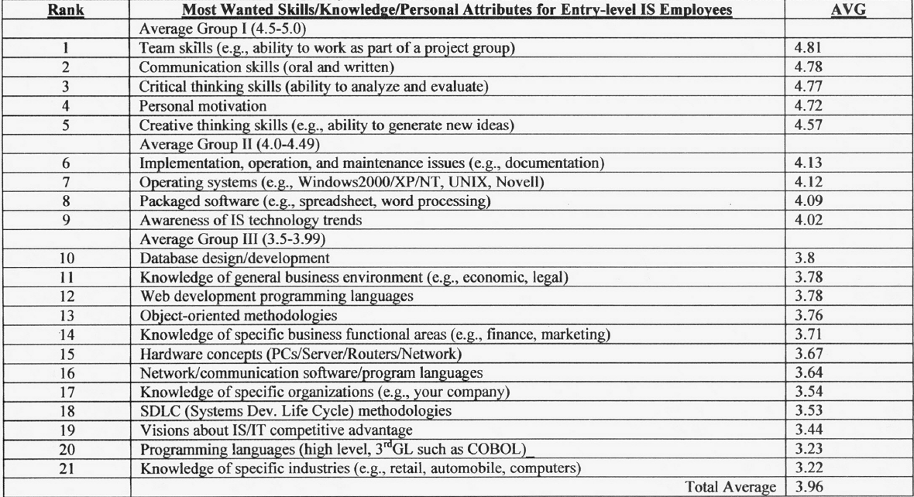

to work with business representatives and to run their IT worker teams. These skills can sometimes be taught, but the best situation presents itself when a company can hire experience in these areas.

How does a company find well-qualified IT employees?
When it comes to hiring for IT, many things must be considered before an open job is posted internally and/or externally. First, as discussed, the company must identify the business need for the hiring. Once the business need is identified, the company should identify the actual job tasks, duties, and skills needed to fill the open positions. Perhaps this will allow the company to identify that a new position is not needed – the new responsibilities can perhaps be fulfilled by the employees already on staff. Flushing out the job tasks, duties and skills will lead the company into writing job descriptions, definition of salary ranges, and will help identify the type of applicants need to be recruited.

When attracting IT professionals, these are good tips to follow:
- Use a variety of recruiting methods when possible to bring in a variety of applicants.
- Prepare well-thought out, thorough interview questions prior to all candidates interviews, so you have a consistent comparison base of question answers after all interviews.
- Emphasize the pedigree or reputation of people they will get to work with or under.
- Look for soft skills such as flexibility and adaptability.
- Find candidates who have the capacity to grow quickly.
- Check references thoroughly
- Do not wait too long to make a decision and do not delay the start date – IT workers are in high demand and they WILL find work elsewhere if they are not hired in a prompt manner (Mill).

Finding an IT job sitting in your pajamas
With today’s amazingly powerful internet job searches, looking for an IT job has truly become something you can do while sitting in your pajamas. Online job search sites have become a huge IT worker pool source for many companies. Online job searches can be found directly on many companies’ home web pages in the recruiting section of their site. Edward Jones is known for requiring everyone to use their own home recruiting site to filter through the thousands of applications they receive weekly. Requiring applicants to submit their applications/resumes through this type of standardized format can allow companies such as Edward Jones to use key words or certain question/answer criteria to automatically (via software) filter out those applicants that are not a good fit for the job position advertised. This can be quite important as sometimes applicants applying online will apply for jobs they really are not fully qualified for in hopes that they may get a chance at a new job – and this can clog the system, making it harder for employer to find those employees that truly are qualified.
Other job recruitment sites have gained much fame. Monster.com and Hotjobs.com are extremely well-known and much used sites in the US by job seekers. They were two of the first job search sites created with user friendly search engines and lots of good articles and suggestions available to all job seekers that use the sites. Applicants can search for employment opportunities and often submit their resume online. Also, companies can search the applicant pool for good fits and contact the applicants at their own discretion to offer jobs. This is the typical format of most job internet search sites.
Other job recruitment methods can also be fruitful. A very common source of recruits is via simply, word of mouth. IT professionals tend to change jobs every few years, and at every IT job they have usually worked with other professionals that have a variety of qualifications and skills. Therefore, companies can take advantage of these networked connections by offering referral bonuses to employees. Allowing employees the opportunity to refer other employees helps them feel a sense of empowerment, and the monetary incentive (often only paid after the referral is hired and has worked for a certain stated period of time) as well as reputation at stake can encourage the employees to only refer others that are of the highest quality. Also, the more traditional method of doing internal job inquiries (transfers between departments within a company) or advertising for positions in a news paper are other ways for which to search for applicants.
A trend that is growing rapidly in regards to IT hiring is the use of IT consulting firms to quickly find well-qualified, well-skilled candidates. IT consulting firms are companies that hire a pool of highly skilled professionals for which they charge a premium rate for other companies to use those professionals’ services. Therefore, if AG Edwards has an IT project in which they will need a staff of 5 all-ready-trained Quality Assurance Analysts next month, they will contact a consulting firm to see if they have 5 readily available resources that fit the job applicant requirements needed for the positions. The consulting firm then charges a high per hour amount to cover the finding, testing, and hiring (compensation and benefits) costs from the company for every hour the consultant works for that company. And often the consulting firm will allow the company to hire the employee as their own after a certain stated period of time, for which the consulting company also often receives commission upon hiring. This takes the hassle of hiring an IT employee out of the company’s hands (who may not be extremely IT oriented), and allows professionals in the IT business to make the best hiring decisions for them.

The real question is, how much can I make as an IT worker?
Salaries for information technology workers vary depending on industry, region, job, and several other factors. First let us compare 2005 and 2006 salary data looking at five different jobs. According to data from Information Week, jobs that increased in annual pay were both Enterprise Application Integration and Web Security jobs. The study was conduced in spring of 2006. Data was obtained from 10,425 individuals, 5,456 IT staffers in 2006 and 6,150 IT staffers in 2005. Annual pay for Enterprise Application Integration went up 10,000 dollars from 2005 to 2006. Salary for Web security positions increased by roughly 8,000 between the years of 2005 and 2006 (Information Week).
Enterprise Resource Planning (ERP) salaries are flattening out as ERP systems mostly were created in the 1990’s, now just maintenance is needed until the next wave of technology (Information Week). A plausible reason why there is an increase in Web Security salaries is because there is an increasing need for more security with all the sophisticated technology and continuous problems with hackers. Wireless Jobs remains about the same, popularity continues. Business Intelligence, Customer Relationship Management, and Supply Chain Management = Enterprise Application Integration. This is very popular right now, and that is a reason salaries continue to increase.
What managers make – is it the ‘big bucks’?
IT managers tend to make quite nice salaries. Additionally, as the IT work force depletes and knowledge increases per worker, salaries continue to grow. Many top layers of management in large corporations make hundreds of thousands of dollars in the US. A study conducted by Informationweek.com consists of (n=4,969) IT managers in 2006 and (n= 6,008) in 2005. The study was conducted in spring of 2006. It looks at the changes in manager salaries between 2005 and 2006. Human Resources for Information Systems increased due to an increased demand for Information Technology workers. Data Mining/warehousing is really important now that many companies have implemented Electronic Resource Planning (ERP) systems and Customer Relationship Management systems (Information Week). This data has to be stored carefully, securely, and kept private. There is a need for experienced architects to help design and structure and warehousing of data. Any way you look at the data, salaries for each of these positions has increased in 2006 from salaries of the same jobs in 2005 (Business Week).
The figures below were obtained from Dice, Inc., an online job listing service for technical professionals. The highest salaries are in Silicon Valley. Also, in New York, Washington D.C., and Lost Angeles there has been an increase in salary each year since 2003 (Business Week).

US Regional Salaries
Metro Area | 2003 | 2004 | 2005*
Silicon Valley | $87,700 | $84,200 | $85,958
New York | $78,600 | $76,500 | $80,286
Washington D.C. | $71,400 | $74,000 | $77,403
Los Angeles | $70,800 | $71,200 | $77,116
Denver | $73,000 | $69,700 | $77,073
Boston | $76,300 | $75,300 | $80,112
Atlanta | $73,600 | $75,500 | $73,213
Chicago | $71,100 | $69,200 | $73,023
Philadelphia | $69,500 | $69,500 | $69,750
San Diego | $69,000 | $71,600 | $77,129
Seattle | $71,000 | $69,600 | $66,940
Dallas/ Ft. Worth | $73,000 | $71,900 | $71,040
Detroit | $62,300 | $61,900 | $64,127
Overall | $69,400 | $66,300 | $69,700
Employment Type
Consultant | $90,200 | $82,000 | $87,107
full-time work at company | $66,900 | $64,300 | $65,479
(Business Week)

Below is a list of benchmarks geared to help better understand ranges in salaries within and between various positions. The information was collected from all industries and all regions of the United States in 2003. Data was collected from a variety of sources. The data should only be used to get estimations on salaries, the site cautions (itmWeb). For a more in depth look at salaries consider ordering “2006 National IT Study” from (Information Week).
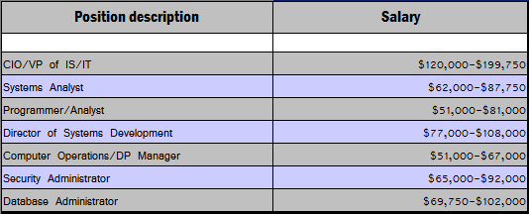
(itmWeb)

As can be seen, salary ranges can highly vary dependent upon the job role’s duties as well as the experience of the employee fulfilling the job. The more job applicable experience an employee has available, the employee is more able to negotiate higher compensation wages.
IT employees are sometimes known to “job hop”. The reason many IT workers do this is to seek higher compensation. Companies must offer competitive starting wages to attract new, fresh skills. This attractive starting wage is often more than current employees are making, as merit increases typically are not as large as the competitive wage increases. The nature of IT work lends to switching jobs easily. Software is software is software, no matter at which company it is being worked upon. Therefore, IT workers will hop jobs to receive the attractive wages and will stay long enough to receive more experience which will also make them more desirable to other companies. That why it is important for companies to consider paying training incentives to help encourage employees monetary compensation is matching their experience (and hopefully dissuade them to job hop).

IT Worker Development

Employees - Well worth the investment

"Training is a key retention tool. It is part of the employee's psychological contract of employment ensuring that they get the opportunity to develop and improve their skills.”
- Nick Russell, associate director, consultancy, at The Work Foundation (Vowler)

"I think you develop people through the development of a team...key word is team...we maximize strengths and minimize weakness of the individuals on the team.”
- Jim Tremaine, Project Manager for an IT department in an insurance firm (Tremaine)

Development for IT workers is extremely important for those firms wishing to retain their personnel and assure their IT systems and processes are up-to-date. Because the field of needed skills is so large and skill set needs change so rapidly with regards to information technology, workers and employers should incorporate constant learning into their work environment. Also employers should plan ahead when it comes to the IT training needs for their IT workers as well as their non-IT workers. This constant learning should be business needs based, and should compliment and build upon the workers’ already attained skill knowledge base.
Training can be very costly to an organization, and the costs only seem to increase each year. Often training can easily cost hundreds to thousands of dollars when all various training costs are cumulated in a large company. However, not training can be much more costly as good development can encourage retention, help reduce recruitment costs and even reduce sickness absence (Vowler). Development can also encourage increased employee loyalty and dedication while increasing staff confidence. (Vowler)

What should be taught…and how?
There are many types of development for IT workers. At Compuware for example, e-learning is available for all staff, whose personal development plans include a blend of formal training, self-study, exam certification, coaching, study leave and on-the-job training (Vowel). Different modes of training can be used to better train employees. To save money, many companies choose to use e-learning as it is easy to create a power point once, and then require all employees to review the documentation and take a follow up survey test or work sample to solidify their learning. However, some training topics may require instructor training, web meetings, conference calls, etc. just due to the need for personal non-verbal behavior tips. If budget is tight, companies sometimes choose to only train one main employee, and will empower that employee to train the rest of the team. The method of training delivery and receipt should be determined based upon the subject matter of training, budget allocated, and the needs/characteristics of the trainees.
There is technical/software skill needs based training and general organizational/business needs training. Technical/software skill training would focus on specific pieces of hardware (ex., training on how to use the new VOIP phones installed) or specific software applications (ex., how to use the newly purchased Crystal Objects application purchased for reporting purposes) the employee needs to learn. Organization/business training can also be important for IT individuals. Organizational training may just orientate the employee so they feel more comfortable working in their position for the company by better understanding the organization. Business needs training can include any soft skills, such as personal communications training for your developers that have to frequently interact with the business users in regards to effectively giving a presentation/hosting a meeting. An example of this is Avon offering its IT staff non-IT training opportunities like courses organized by the company's HR department, which would include strategy essentials and assertive skills (Vowler). Providing training in these softer skills areas can provide more than just IT staff better ability to support the business strategy. The training topics will depend upon the type of job and the job need for the training.

What’s the point?
When designing training programs it is imperative that the company does not just train people to just train people. Training can be incredibly valuable, but it can also be costly when not planned well. A survey performed by Chartered Institute of Personnel & Development in 2004 reported that 95% of employers felt training improves retention and helps avoid recruitment costs (Vowler). Additionally, developing employees while empowering them the ability to perform more job duties, with appropriate compensation to be paid with the extra effort expended, reinforces positive behavior encouraging the employees to go above and beyond. Companies should have department heads help formulate a target goal of training (either monetary or hourly goal) and make certain every employee adheres to those goals. An example of this is given by Paddy Maguire, a service delivery manager at Classroom 2000 employing 102 IT workers, who has said "Our target for staff training is 500 days a year - this is usually exceeded. We have a target to have 10% of staff on self-initiated courses: we support these by paying fees and allowing time for lectures, studying and examinations (Vowler).” Setting training goals with good incentives helps encourage and remind the employees how valued increased knowledge can be.
However, many companies neglect to truly realize the absolute value in well planned and effective training. A survey provided by Computer Weekly reports that 55% of all companies interviewed (n=800 IT employers) did not have formal training plans for their employees (Goodwin). Any value created by trying to provide training may be eradicated by the extra costs tied to loose, badly planned training programs. This is especially true of companies that do not reward training through either compensation or empowerment and companies that neglect to evaluate training results to refine or change training until successful.
Development is key for a company to gain and maintain a competitive hold within an industry market. Continuous innovation is needed to survive, and innovation is definitely more possible with added knowledge, skills, and abilities. Development is well worth the investment and should be methodically planned to assure that the investment is returned sufficiently.

Retaining IT Workers

“Retention can be a complex subject; different people are motivated by different things. A lot of managers make the mistake of using money as the ONLY motivator for retention. I have found that the most important thing to do is to understand your employee, know what motivates them. For some people, benefits, a stable environment, time off, work life balance, etc. can all be contributing factors.”
-Manager of a software development team, Larry Schaeffer

“Most of all, I have found that making the work day enjoyable does more for retention then any other single factor. We spend the majority of our adult life at work and if it is a fractious or stressful situation, the money and benefits do not matter, the employee usually finds a way to move on.”
- Manager of a software development team, Larry Schaeffer

How to keep the elusive high skilled IT worker
There are various ways in which to encourage retention. It is important for companies to consider how expensive losing a valuable employee really can be, especially if it is a frequent occurrence. Once a company can understand why employees choose to leave, it can help them understand what to do to help retain good employees.
Training can be very encouraging for employee retention. According to a survey, sixty-three percent of CIO’s said that “providing training or professional development” to IT workers was the number one method their firm was currently using to retain them (“Training is Key”).

Providing training or professional development..... 63%
Offering flexible schedules.................................... 47%
Increasing base compensation.............................. 41%
Offering bonuses....................................................31%
Offering equity incentives.........................................9%
Other....................................................................... 4%
None/no steps taken...............................................23%
(“Training is Key”)

Forty-seven percent of CIO’s surveyed said that “offering flexible schedules” was their current method in trying to retain IT talent. Forty one percent of CIO’s surveyed said that increasing compensation was how their company attempts to retain CIO’s (“Training is Key”). It is interesting that while the majority of CIOs agree that providing training and development is the best way to retain workers, the majority percentage of CIOs in the same breath say that increasing compensation is the true tactic they use to retain employees. This is due to the fact that handing out money is quick and easy for companies; rolling out valuable training programs is not. However, the lasting effects of investing in training versus the short term value of compensation on employee retention make compensation seem like a bad choice. There is an obvious gap in what best encourages retention versus what is actually used by companies in hopes of better retention.

What does pay have to do with Retention?
A study conducted in 2000 suggests that higher pay positively correlates with turnover. One would think that pay would be an incentive to keep IT workers around, but apparently this is not the case. The 2000 IT Market Compensation Study survey discusses some key findings. One of these findings is the loss of career development opportunities for employees (Vault). According to the survey many employees leave because their company does not offer them any career development opportunities. Fewer than fifty percent of companies offer development opportunities to their employees according to the survey. The survey does not mention the opportunities that are offered those that do have development opportunities but rather states that they have some type of career development system in place (Vault). It is likely that many of the companies with career development opportunities have problems themselves, but this is another issue in itself. Further research that could be performed includes surveying employees and employers in companies with career development opportunities and/or focus on some criteria in which they can compare their training program to (Vault).
The survey indicates that individuals who are 46 years and older are the employees who are most likely going to leave. Also, employees who have been with a company for fewer than 24 months have been proven to leave more often than other employees as well. The reason for this is not clearly stated but it is obvious that as we get older we retire or look for jobs that are less complex. Information Technology is getting more complex and is constantly changing. Workers must be able to adapt to these changes quickly which is stressful and demanding, especially for workers who are older. If companies want to retain older employees then they need to exactly why they are leaving. After establishing a reason they are leaving some pilot programs could be adopted focusing on issues that may help retain older workers (Vault).
It is estimated that it takes 3-4.4 months to fill the top 14 IT job titles according to this survey. This could end up costing companies a great deal of money, especially those companies that have a hard time holding on to employees. Companies need to be extremely careful when they are recruiting, selecting, and training individuals. A wide range of selection tools that are highly valid and reliable and both objective and subjective should be used when hiring individuals. These tools can make a huge difference when it comes to which employees stay and which employees leave. Also, prospective employees should be given a realistic job description and a realistic job preview to ensure that they have a good idea of what they will be doing on a daily basis. Employees should be given initial and ongoing training so they are up to date with the latest technology. Also, giving employees individual feedback and letting them know their opinions do matter can help make employees feel important.

Motivating IT workers
Stephen Mill discusses some issues that companies need to focus on to ensure their IT workers are happy and motivated which are “praise,” “recognition” and “continuous learning.” He goes on to say that although money is important research has shown that a company’s culture is something job candidates are frequently interested and ask about during the interview (Mill). Mill believes that listening to your employees is important and that those managers that actually learn to listen can make a huge difference in the way employees view their company. There are ways to sharpen your listening skills according to Mill. By having an open-door policy an employer can create a culture that allows for employees to feel at ease and also help them feel like their opinions actually do matter. Also, holding regular meetings will help keep everyone on the same page (Mill).
“Praise” and “recognition” no matter how big or how little can be rewarding to employees. Something as little as a kind remark, such as “Joe, I wanted to personally come down to your office to commend you on your hard work” or “Alice, I wanted to let you know how wonderful you did on the project, it was a huge success.” Money can only go so far, however, praise and recognition can give you a personal sense of satisfaction especially when it is personally given. A recent survey of company executives was cited in Mill’s article that found that “rewarding accomplishments” can help retain employees.
Since the IT field is constantly evolving IT professionals need to always be on the forefront of technology. Most IT professionals would agree that being able to use the latest software and other technology is something they really get a sense of satisfaction out of doing. Allowing workers to adopt new technology can be both beneficial for the company and the employee according to Mill can be a win-win situation (Mill).
Another way companies can motivate employees is by providing them with training that is “intellectually challenging” (Mill). Training that is challenging is an excellent way to keep workers satisfied and up to date on the newest technology (Mill).
Now that we have discussed some ways to motivate workers let us turn our attention to another important issue that is vital when it comes to retaining IT workers. Before companies can successfully motivate their employees they must seek to understand them (Mill).

Don’t Just Assume, Seek to understand
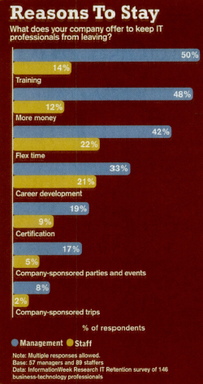
In the article Retention Tension a survey from informationweek.com is featured. Fifty-seven managers and eighty nine staffers are surveyed on what incentives help motivate employees to stick around (McGee). Although multiple responses were allowed information here gives remarkable insight into what the different perspectives workers and managers have into what they believe is helpful in retaining workers. For management (50%) of managers believed that training was the top reason why It professionals stayed compared to only (14%) of IT professionals. For management (48%) believed that more money is a reason for IT professionals stayed around compared to only (12%) of IT professionals who felt money was why they don’t leave (McGee). This suggests that managers and IT professionals do not understand each other well enough and must make a concerted effort to reconcile these different beliefs and assumptions of one another. The above survey discusses other pertinent issues that clearly reflect managers’ misunderstanding of motivators that drive IT professionals and help to retain them.
In the article “Retention Tension”, Tom Gagne chief technology officer at HCS shares what his vision of what has come true at his company in trying to retain IT professionals. Every Friday he lets his workers “explore pet projects” that could have a chance of benefiting the company (McGee). Also, at HCS letting IT workers come to meetings with executives and other managers helps the technology and business divisions collaborate and understand the holistic view of the company, both the IT and business sides (McGee).
A survey conducted by informationWeek.com of 146 IT professionals discusses why so many technology workers are seeking or considering new jobs. Of the 146 IT professionals surveyed 69% of them were currently shopping around for a new job. It is surprising that (64%) of these employees revealed they were looking for another job because of their current company’s “management” or “culture” (Information Week). This should be a wake up call for companies to immediately begin addressing these issues such as job satisfaction, and reevaluating current hiring, training, reward systems already in place. The cost for companies to retrain workers can be extremely expensive; therefore, it is wise to address these issues before they occur (McGee).
Fifty-three percent of those surveyed say that their companies are in need of IT professionals. The top reason is Turnover according to (46%). The number two reason is having a hard time finding workers with a “specific skill set according to (33%)” (McGee). This shows the importance of companies needing to invest in methods to successfully attract, train, and retain IT workers, as all these are pivotal factors and positively correlate with job satisfaction and negatively correlate with turnover (McGee).
The survey above conducted by Computerworld looks at issues pertaining to job satisfaction. Many employees that responded to the survey do not feel that their “performance” is related to their “earnings” “Job Satisfaction Survey.” (Watson) Employer need to make a concerted effort to give bonuses to employees at the right time. Waiting a half a year to reward an employee for something they did well on is too long. Failing to connect the event and reward together will be disconcerting to employees. It would be like receiving a first place trophy two years after winning. Workers should be given bonuses shortly after doing something the company and worker feel is an outstanding accomplishment so the worker can derive a sense of satisfaction for what they did. Other important issues that can help increase workers satisfaction are “Good benefits packages,” “telecommuting,” “flextime,” “casual dress policies,” “free lunches,” comfortable office equipment, and “staff outings.” (Watson)
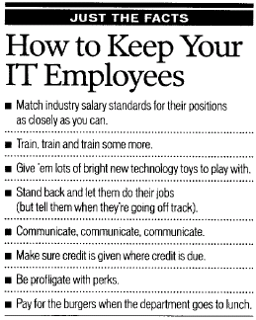
In this article Watson discusses ways employers can attempt to hold on to their IT workers. She believes that many managers continue to “miss the message.” She goes on to say that if managers would take some time to offer employees what they want and provide that to them then turnover will be dramatically reduced. Some of these include: “Match industry salary standards for their positions as closely as you can,” “train, train, and train some more,” “Give’em lots of bright new technology toys to play with,” “Stand back and let them do their jobs,” “communicate, communicate, communicate” (Watson). These are just a few ways, however, the chart above includes several other ideas that companies should take into consideration; that is if they want to keep their top talent around. Before attempting to take any of these ideas into consideration employers’ first need to acknowledge that their employees are important. Let employees know that they are important and valued by the company. (Watson)
Employees were asked what employers could do to keep them satisfied, below is exactly what employees had to say:
- Employees want to know the status how they are doing
- Provide consistent and regular feedback that not only guides my day-to-day performance but also assists me in developing those skills and characteristics that will allow me to advance my career opportunities within our organization
- Most of all they want to be noticed and flattered (Watson)
Working to retain valuable employees is an important function of every IT department. Invaluable best practices knowledge is often hard to document and is always lost when a good, long time employee leaves. If an employee is good for a company, the company should really be good back to that employee to ensure they retain their good workers. It truly benefits the company to retain great employees, and is well worth the investment. (Watson)

Case Study

Quicken, Doing Things Right

“Great companies create a culture where everyone believes we’re all in this together and together we can accomplish anything.”
- Bill Emerson, Quicken CEO (Pratt )

Attracting, hiring, developing, and evaluating IT employees is not a strong point for a lot of companies. Often this is due to companies’ lack of recognizing how valuable an investment a well-trained, motivated, empowered employee can truly be. Those companies with innovation, determination, and strength in this arena of employee satisfaction often become well known. One such company is Quicken. They provide attractive benefits, employee perks, and wonderful training opportunities to all of their employees and have really stood out among other companies for those investments.
Quicken Loans, Inc. is a consumer-focused, direct-to-consumer online mortgage site that is well organized and attractive to deal with as a customer and/or as a member of their staff. Their management includes Daniel Gilbert, chairman; Bill Emerson, CEO; Patrick McInnis, president and COO, Todd Lunsford, CIO who reports to the CEO (Quicken “Fast Facts”). They provide residential loans which include Conventional, Home Equity/HELOC, Jumbo, and Alternative loans (Quicken “Fast Facts”). They provide all of the loans online; therefore, web design is one very important component of their product. To accommodate the needs of mortgage website design and financial processing and administration, they employ over 3,600 people, who all contributed to closing $16 billion in home loans in 2005 (Quicken “Fast Facts”).
Information about Quicken can be very easily found. Their site can be reached via their web address, www.quickenloans.com. The website can also be reached via third party portals including: Yahoo! Real Estate, Yahoo! Finance, Realtor.com, Homestore.com, MSN, America Online, Bankrate.com, Netscape, and CompuServe (Quicken “Fast Facts”). The Quicken site is extremely user-friendly due to the innovative web design of the site.
At an initial glance, Quicken seems to have an ordinary structure in regards to recruiting, good pay, and benefits. A primary recruiting tool is their own job search areas on their website (https://www.quickenloanscareers.com/web/AllCareers.aspx or https://www.quickenloanscareers.com/web/recruiting-events.aspx), which of course were designed by Quicken employees. Employees have a nice benefits package which includes: medical/dental/vision insurance, 401k with 75% company match, tuition assistance, adoption assistance, paid parental leave (Quicken “Benefits”). Adoption assistance is a perk not often found in benefits packages, so it is quite interesting that they choose to offer this item. Quicken also has Refer & Earn programs which is where employees can earn extra money for referring friends and/or family for home financing and/or job opportunities (Quicken “Benefits”). This helps spread the good word about Quicken throughout the community, both local and abroad. Some other perks Quicken also offers include assistance to its employees for discounts on housing and home improvements, technology and cell phone providers, retail offers, concert tickets/shows, they provide internet connection reimbursement, and interest free home computer purchase loans (Quicken “Benefits”). Other perks include an on-site Toast Masters Club and employee gym (Quicken “Benefits”). All of these contribute to employee satisfaction and are quite valuable.
Employees are valuable assets
Quicken has a strong goal of making every employee feel valuable, and they exemplify this through their creative perks they provide. To make certain every employee has a consistent company vision, Chairman Dan Gilbert and CEO Bill Emerson spend an entire day discussing the company’s culture and philosophies with new employees during the intensive two-day orientation (Pratt ). This exemplifies to the workers that the executives at Quicken feel every employee is valuable and fortifies the open door policy they wish to encourage. Quicken places much emphasis on professional and personal development programs. They devote more than 200 hours of training per year for each employee, a personal empowerment coach, leadership training programs, and tuition assistance (Pratt ). Quicken truly encourages their workers to attend training and think outside of the box as they feel creativity is what makes their product cutting edge.
Additionally, Quicken has produced a culture that acknowledges and rewards impressive accomplishments. This includes performance-based pay and an annual bonus plan. Also, team leaders are empowered to give out “spot bonuses” for outstanding performance they observe and/or sometimes team members can even win trips for different incentive reasons (Pratt). Recently Quicken supplied a trip to the Bahamas for 400 people as an appreciation award (Pratt). These rewards help motivate employees to go above and beyond their stated job description. These types of extras really make individuals want to get a job and keep it at Quicken.
Quicken also encourages employees to have fun through leading by example. There is free popcorn, slushies, and cappuccino available all day and an in-house rock band named “The Loaners” which plays at every company meeting (Pratt). They also celebrated Quicken’s 20th anniversary by paying to send 5,300 employees and family members to Cleveland for a weekend concert celebration. They hired the group The Black Eyed Peas and musician Kid Rock to perform at the concert amongst others (Pratt). Quicken also likes to add a personal touch to show the employees how valued they are. CEO Emerson sends hand-signed birthday cards and get well cards to all employees as well as gift certificates to employees’ children on their birthdays (Pratt). All of these efforts make the employees feel their job is an amazingly valuable job.
Quicken’s attempts to create a pleasant and encouraging environment in which employees truly enjoy to work has paid off. In a survey of over 20,000 in medium or larger companies sampled by Computer World, Quicken was voted the number 1 place to work, ranked number 4 for retention, ranked number 3 for benefits. Also, 32% of their managers are women (Pratt). They were also recognized by FORTUNE Magazine as one of the "100 Best Companies to Work For" in America for three consecutive years (Pratt). These statistics are very favorable, and seem to echo the sense of a healthy work environment.

Developing All-Stars
Of particular training importance at Quicken are IT skills learning and development. They allocate a training budget of $2,500 per employee per year (Pratt). This is a large investment, considering they have over 3,600 employees (sum of approximately $9 million). CIO Magazine Named Quicken Loans to "CIO 100" List of the Most Innovative Technology Companies in August 2006 (Quicken “Company Fast Facts”). Investing in this IT learning has helped Quicken become a cutting edge loan company. Much to their advantage, they were the first mortgage company to put electronic signatures into production in 2002 (Quicken “Company Fast Facts”). This completely sped up their processing times, allowing them to aggressively gain market share for a large market presence in online loans.
CIO Todd Lunsford has understood the need to hire skilled and motivated individuals and encourage, train, and empower them to do amazing feats. He said it best with this quote:

"Our Technology Team represents the best in the business. We're proud of this team for supporting the organization's growth. Our Technology Team provides seamless support to all areas. This includes building processes that support hiring and licensing, providing technology support and equipment for all 3,600 employees, improving our award-winning Web site and supporting all the systems associated with the mortgage process.
I'm also proud of their continued focus on enhancing our business applications to the tune of making more than 25 changes per day to the many production systems we support, which help make the company more efficient and the mortgage process simpler and more convenient for our clients. In doing so, they are improving our production systems one inch at a time, but changing the entire mortgage industry in the process”(Quicken “CIO 100”).

This was vital to Quicken’s success in the past decade. They were able to gain much attention by being one of the first well designed online mortgage companies. They were the innovators of smooth mortgage web design. Lunsford continued in a different interview:

"Our business simply could not have grown as fast as it has without applications that were highly tailored to our specific business needs. Manual loan processing methods would not allow us to capitalize on the opportunity generated by the massive volume of demand due to low interest rates. Our sales team was already very large and we were adding new reps constantly. We were evolving our product mix so fast, it was next to impossible to keep a large sales team informed without building our own applications that we could adapt instantly" (“Progress”).

IT web development and applications training is not the only focus, however. Quicken also provides on-site computer training classes for MS Outlook, Word, Excel, PowerPoint, and Palm Pilot (Quicken “Benefits”). They also offer mortgage industry training and external training opportunities for all team members (Quicken “Benefits”). They feel it is important for all employees to understand the portion of the business which supplies a large portion of the company’s income.
Quicken is a great example of a company that treats its employees how it wishes to be treated. They give a lot of value to their employees via compensation, benefits, and many perks. And their employees pay back that value through dedication, strong direction, innovation, and motivation. This has lead to cutting edge mortgage technology which has helped to provide much consumer and market attention as well as financial stability for the company and its employees. They truly have made the company a team, working together to attain high quality and satisfaction for everyone involved.
Works Cited

Business Week. “Tech Pay.” BusinessWeek.com. Oct 10, 2005. http://www.businessweek.com/technology/tech_stats/regional051014.htm

DM Review Editorial Staff. “TechStats: Business Growth Fueling Demand for IT Professionals.” DM Review Magazine. September 2006. http://www.dmreview.com/article_sub.cfm?articleId=1062022

Ellis, Richard. ”Assessing the Demand for Information Technology Workers.” IT Workforce Data Project. November 1999. http://www.cpst.org/IT-4.pdf

Goodwin, Bill. “Companies Failing to Address Training Gaps.” Computer Weekly. Jun 28, 2005. Pg. 42.

Information Week. “National IT Salary Survey.” Spring, 2006. http://www.informationweek.com/showArticle.jhtml;jsessionid=WRUYYMFJ51W12QSNDLQCKH0CJUNN2JVN?articleID=186700251

itmWeb. “Information Technology Benchmarks for the United States.” itmWeb.com. March 2003. http://www.itmweb.com/blbenchsal.htm

Pratt, Mary K. “Inside the Top Five Best Places to Work: No. 1: Quicken Loans.” ComputerWorld. June 19, 2006.

McGee, Marianne Kolbasuk. “Retention Tension”. InformationWeek; Nov 7, 2005; 1063; ABI/INFORM Global. http://www.informationweek.com/showArticle.jhtml;jsessionid=L0UFAT4LTL5YWQSNDLRSKHSCJUNN2JVN?articleID=173403018&queryText=retention+tension

McNamara, Carter. “Employee Job Descriptions.” Field Guide to Leadership and Supervision. 2006. http://www.managementhelp.org/staffing/specify/job_desc/job_desc.htm

Mill, Stephen. “Don’t be unreasonable when hiring IT staff.” Computing Canada. Willowdale: Jan 4, 2002.Vol.28, Issue. 1; ABI/INFORM Global. pg. 25. http://proquest.umi.com/pqdweb?did=103212394&sid=1&Fmt=4&clientId=45249&RQT=309&VName=PQD

Murphy, Chris. “The survey says: Lots of IT jobs, not enough workers.” InformationWeek. Manhasset: Apr 17, 2000., Issue 782; ABI/INFORM Global. pg. 152.

“Progress Open Edge Platform Gets Rapid Approval from Quicken Loans.” Progress Software Press Release. June, 16, 2004. http://newsroom.progress.com/phoenix.zhtml?c=202961&p=irol-newsArticle&ID=582102&highlight , viewed Nov 5, 2006

Quicken website. “Benefits.” https://www.quickenloanscareers.com/web/benefits.aspx , viewed Nov 5, 2006.

Quicken website. “Company Fast Facts.” http://www.quickenloans.com/about/press_room/company_fast_facts.html , viewed Nov 5, 2006

Quicken website. “CIO 100.” http://www.quickenloans.com/about/press_room/news_releases/CIO_100.html , viewed Nov 5, 2006

Schaeffer, Larry. Technical Manager at RGA Technology Partners, Inc., interviewed in person by Tammy Hawkins, Oct 28, 2006

Spencer Lee, Katherine. Optimize. Feb 1, 2006. http://www.informationweek.com/industries/showArticle.jhtml?articleID=180201680&pgno=1&queryText=I.T.+Hiring+Heats+Up

“Technology Staffing.” The Controller's Report. New York: Sep 2004., Issue. 9; pg. 14 http://proquest.umi.com/pqdweb?did=681299871&sid=3&Fmt=4&clientId=45249&RQT=309&VName=PQD

Tremaine, Jim. Project Manager at RGA Technology Partners, Inc., interviewed in person by Tammy Hawkins, Oct 28, 2006.

Vowler, Julia. “How Effective Training Aids Staff Retention.” Computer Weekly. Nov 15, 2005. Pg. 40.

Watson, Sharon. Computerworld. Framingham: Vol.34, Issue 21; pg. 56.

Xiang Fang; Sooun Lee; Seokha Koh “Transition of Knowledge/Skills Requirement for Entry-Level IS Professionals” The Journal of Computer Information Systems; Fall 2005; Volume 1; ABI/INFORM Global. pg. 58. http://proquest.umi.com/pqdweb?index=4&did=914802201&SrchMode=1&sid=3&Fmt=4&VInst=PROD&VType=PQD&RQT=309&VName=PQD&TS=1159235287&clientId=45249

“Training is Key to Retaining Good Employees.” Robert Half Technology. April 2006. http://www.insideindianabusiness.com/newsitem.asp?id=17433, viewed Nov 14, 2006.

“Training is Key to Retaining Good Employees.” Robert Half Technology. April 2006) http://www.insideindianabusiness.com/newsitem.asp?id=17433

Tyco Health Care. “Systems Support Specialist I.” Tyco Health Care Website. Viewed Nov 15, 2006. http://jobsearch.monster.com/getjob.asp?JobID=51006862&AVSDM=2006%2D11%2D30+22%3A14%3A12&Logo=1&JobTitle=SYSTEMS+SUPPORT+S%2E%2E%2E&pg=4&fn=9005&cy=us&JSNONREG=1&JSNONREGN=1&dcjvlid=892

US Bureau of Labor Statistics. “Fastest Growing Industries.” US Department of Labor Bureau of Labor Statistics. Dec 7, 2005. http://www.bls.gov/emp/empfastestind.htm

Vault. “Think High Pay Improves IT Retention Rates? Guess Again.” Business and Legal Reports. http://www.vault.com/nr/newsmain.jsp?nr_page=3&ch_id=402&article_id=52097&cat_id=1123 viewed Nov 14, 2006.

Watson, Sharon. “Why Staffers Stay”. Computerworld. Framingham: May 22, 2000. Vol 34, Iss 21; pg. 56.

