Executive Summary

Enterprise Resource Planning (ERP)

By: Scott Burchette
Joseph Mario Masong
Doug Frye

What is ERP?

Enterprise Resource Planning (ERP) is a packaged business software system that allows a company to automate and integrate the majority of its business processes, to share common data and practices across the entire enterprise, and to produce and access information in a real-time environment.⁽¹⁾ It enables decision-makers to have an enterprise-wide view of the information they need in a timely, reliable and consistent fashion.

ERP provides the backbone for an enterprise-wide information system. At the core of this enterprise software is a central database which draws data from and feeds data into modular applications that operate on a common computing platform, thus standardizing business processes and data definitions into a unified environment. With an ERP system, data need to be entered only once. Moreover, the system provides consistency and visibility or transparency across the entire enterprise.

Benefits of ERP

- Single point of data entry – Company needs to enter data only once, and then ERP software will share the data throughout the company. Thus, with real-time information all over the company, productivity could be improved.
- Accurate inventory management – ERP software manages inventory control with real time information. Thus, manufacturing efficiencies could be improved.
- Available vendor information – Allows user to see “preferred” vendors with the most competitive prices and lead times.
- Pending purchasing information – Displays “in-process” orders to help avoid over ordering of materials.
- Automatic data transfer and reconciliation – With automatic data transfer and real-time information, teamwork could be improved.
- Accurate financial information – Faster financial information means faster decision making.

Risks of ERP

Implementing ERP does not mean risk free. The result of a survey from 600 companies that implement ERP showed that 57% finished with 10%-30% over budget. Only 3% of the companies finished with 10%-30% under budget. 45% of the companies need 10%-30% more time to completely finish implementing ERP.⁽²⁾ Below are some examples of how a poor implementation of ERP could harm a company’s business:

- WW Grainger Inc. experienced losses of about $ .24/share because of substantial systems and transaction processing disruptions. Moreover, the loss caused the company’s stock to drop by 2% which is equal to a $100M loss in market value on the earning announcement.⁽³⁾
- Hewlett-Packard Inc. experienced a $400M loss in the third-quarter of 2004 because of poorly executed migration of ERP.⁽⁴⁾
- Hershey Foods Corp. lost its customers during Halloween because of a delay processing in customer orders.⁽³⁾
- Whirlpool Corp. experienced a series of shipment delays to customers because of poor implementation of ERP.⁽³⁾.

Critical Success Factors of Implementing ERP
- Top management support.
- Implies active backing by senior management
- Project team competence.
- Intelligence of team
- Experience with company processes
- Interdepartmental co-operation.
- ERP by definition integrates multiple functions
- Clear goals and objectives.
- Phase I - conceptualization of goals
- Manage “scope creep”
- Project Management.
- Methodical planning
- Ability to be flexible and improvise
- Interdepartmental communication.
- Communication across functional boundaries
- Management of expectations
- Careful not to “oversell” end-users
- Alignment of expectations
- Project champion.
- Ability to make substantial organizational changes happen
- Authority to “Market” to end-users
- Vendor support.
- Success is associated with compatibility of IT vendors employed
- Careful package selection.
- Package fits business processes and strategy
ENTERPRISE RESOURCE PLANNING (ERP)

Implementing ERP is not an easy job and is not a process that can be repeated easily. Installing ERP is a large project that can cost a lot of money and consume a lot of time. Therefore, companies must have a basic knowledge of ERP, background of ERP and understand how ERP works before they decide to implement ERP into their organization. Failing to do so can result in company losses due to poor implementation.

Introduction of ERP

Enterprise Resource planning software (ERP) does not live up to its acronym. Forget about planning and forget about resources because the software will not do that. ERP is a true ambition. It attempts to integrate all departments and functions across a company on a single computer system that can serve particular needs of different departments.⁽⁵⁾

1. Example of an Enterprise

In order to make it clear, we will use the example of a small enterprise, a lemonade stand, which could represent a professional enterprise in the real world. In terms of business processes, the lemonade stand is shown below in Figure 1.

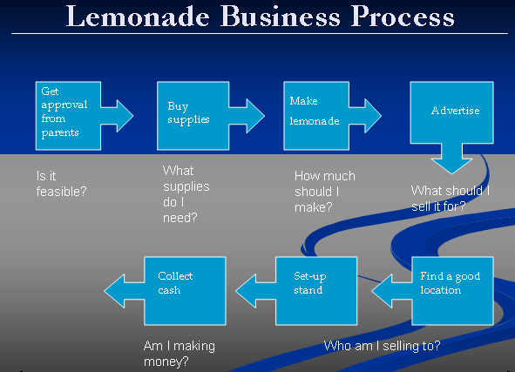

(Figure 1) - Lemonade Stand Business Process

Every process needs decisions, which involve all the partners in the business enterprise.
- Get approval from parents – This decision comes from one of our business partners. We can make our lemonade stand only if we get permission from our parents.
- Buy supplies – In this case, the decisions will involve our decisions and our enterprise partner’s decision. The kind of supplies we need, the number glasses that we need, etc. are all our decisions. However, the supplier will make the decision about price of supplies and when he/she can deliver. Failing to cooperate with the supplier could result in production delays.
- Make lemonade – Decisions in this process will involve people that help us make the lemonade. Moreover, the decisions will be the number of glasses of lemonade that we should make and what the sweetness of the lemonade will be.
- Advertising – This decision will relate to the signage, such as, how big and what color it should be.
- Find a good location – This decision will relate to the location of our stand, such as, near basketball court, school or park.
- Set-up stand – This decision will relate to the style of the stand and the color we should use for the tablecloth.
- Collect cash – From the money we collect, we will make the decision whether or not to continue with the lemonade stand.

As we can see, all of the processes include a lot of decisions that need to be made. However, the decisions here are related to all the business enterprise partners of a company. From the example of lemonade stand, customers, friends, grocery stores and parents are the 4 categories of enterprise business partners that help make the decisions.

The basic process in a real enterprise might not be much different from the process of our lemonade stand example, except there could be more enterprise business partners as decision makers. Figure 2 shows the basic process of a lemonade stand with the example of decisions from a real enterprise.

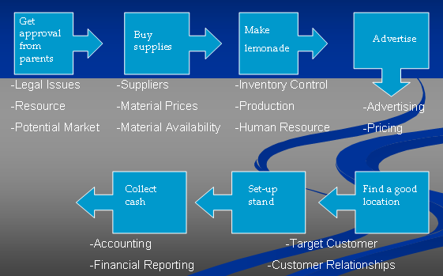

(Figure 2) - Example Of Real Enterprise Decisions
The first step of the lemonade example is “to get approval from parents,” but in a real enterprise, the decisions might not come from parents; they will come from banks, government, etc. Moreover, the decisions will be related to legal issues, loan and credit, potential market, etc. “Buy supplies” relates to the suppliers. In a real enterprise, we will talk to a lot of suppliers, and the decisions will be related to material prices, material availability, etc. “Make lemonade” represents the production floor inside an organization. The decisions involved here are related to production planning, human resources, and inventory control. “Advertising” relates to advertising and pricing which also involves advertising companies as business partners. “Find a good location” and “Set-up stand” are related to targeting customer and customer relationship management. The last step, “Collect cash,” is related to accounting and financial reporting functions.

From the example of a real enterprise, we have more decisions to make and more business partners to include. The faster the information can be reached by each of the partners, the faster decisions can be made in the organization. ERP software makes it possible for an organization and all of its partners to access each other’s information in a real time environment. Therefore, with ERP, the organization will have a single point of data entry, accurate inventory management, available vendor information, pending purchasing information, automatic data transfer and reconciliation, and accurate financial information…...each adding to the success of all business partners.

2. How Does ERP Work?

Figure 3 shows how ERP shares information across the entire enterprise and multiple modules by using a central database.

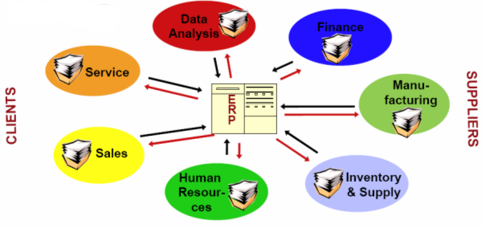

(Figure 3) - Company With ERP Implementation

This simplified illustration makes it seem that ERP is a simple process, but the fact that information must be assimilated into all parts of a business means that a lot of thought must go into an ERP software package. Moreover, an ERP software package provides all the information for every department in an organization to make a product.

3. Example of How ERP Works

In order to make it easier to understand how ERP works, Figure 4 shows an example of a sneaker company with seven departments that have already implemented ERP software.

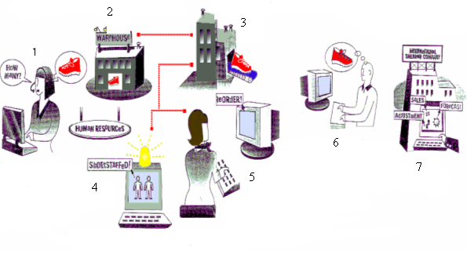
(Figure 4) - Example Of ERP In A Company

In this example, seven departments in this company are working together through an integrated system, which allows them to make faster and more accurate decisions. The steps as illustrated in Figure 4 include:

1. Ordering. A sales representative takes an order for 1000 pairs of sneakers from a Brazilian retailer. From his/her portable PC, the representative can input the data into the ERP sales module back at headquarters, which will check the price, including any discounts the retailer is eligible for, and the retailer’s credit history.

2. Availability. Simultaneously, ERP inventory software checks the stock available and notifies the sales representative that half of the order can be filled immediately from a Brazilian warehouse. The other sneakers will be delivered in five days directly from the company's factory in Taiwan.

3. Production. ERP manufacturing software schedules the production of the sneakers at the Taiwan factory. Meanwhile, the warehouse manager in Brazil is notified to ship the available stock to the retailer. An invoice gets printed in Portuguese.

4. Manpower. Human Resource module identifies a shortage of workers in Taiwan’s Factory to handle the order and notifies the personnel manager of the need for temporary workers.

5. Purchasing. ERP materials planning module notifies the purchasing manager to buy more materials for the production. Therefore, the purchasing manager can order more materials with just-in-time delivery.

6. Order Tracking. Customer Relationship and Order Tracking module permits the customer to log on directly to the sneaker company to confirm the status and arrival date of their order. Moreover, this module lets customers know if there is new stock available and lets them places the order online.

7. Planning. Based on historical data from its information warehouse and current sales data, ERP forecasting and financial modules will notify the CEO about current trends in the sneaker market.

4. History of ERP

ERP software was not feasible until the 1990’s as an integrated system to handle real-time information. Current ERP systems evolved as a result of the development of hardware and software technology needed to support the system and the development of the vision of integrated information systems.

Howard H. Aiken built the first automatic digital computer, called Harvard Mach I, in 1944. This computer was 50 feet long, 8 feet tall and weighed 5 tons. It consisted of 750,000 components that included switches, relays, shafts and clutches. There was no way these early computer systems could provide integrated, real data for business decision making.⁽⁶⁾

However, computers got smaller, cheaper and faster during the 1960’s and 1970’s. Storage and retrieval technology improved to allow direct or random access to data on magnetic disk. All programs that accessed data immediately became faster as a result of this change. Anyway, the vision of having an integrated information system began on the factory floor. Manufacturing software developed during the 1960’s and 1970’s, evolving from simple inventory tracking systems to Material Requirement Planning (MRP) software. MRP software allowed a plant manager to plan production and raw materials requirements using the sales forecast. Thus, the manager could look at the marketing and sales forecast and plan the production schedule needed to meet that demand, calculate the raw materials needed to meet production and the projected raw material purchase orders to suppliers. This kind of computation was almost impossible without a computer for a company with many products, raw materials, and shared production resources.

In the 1980’s, computer hardware became even smaller than before. The microprocessor became a serious business tool when IBM introduced the first personal computer (PC) in 1981.⁽⁶⁾ The increasing capability and decreasing cost of the personal computer eventually helped computers become standard business tools. Moreover, the release of word-processing software allowed business people to type their own documents, rather than relying on clerks. VisiCalc, the first spreadsheet package for PC, was introduced in 1979.⁽⁶⁾ This spreadsheet software allowed users to develop complex business analyses without having programming knowledge. As more business people joined the PC revolution, companies realized they needed to connect individual PC’s to integrate their data.

The basic concept of the ERP system was inherent in the development of MRP II (Manufacturing Resource Planning). The term “MRP II” was coined by Oliver Wight, a key figure in the development of MRP systems during the early 1980’s.⁽⁶⁾ Instead of having one set of numbers for the operating system in manufacturing and another set kept by the financial people, MRP II software shared both of the data in order to get faster results to calculations. Manufacturing Resource Planning became the company base software for manufacturing, marketing, engineering and finance. In other words, MRP II software shares and integrates data between the production floor and the finance department.

In the 1990’s, a competitive business environment forced every company to deal with the quality of their product, faster services and cost reduction. Therefore, the key to gain competitive advantages was to have efficient and integrated information systems. Mass production technology made computer hardware even cheaper than before. The development of computer and networking allowed a company to share its data and information in real-time. Based on the technological foundations of MRP and MRP II, Enterprise Resource Planning (ERP) software systems integrate business processes management, project management, inventory management, service and maintenance, and transportation. Moreover, ERP provides accessibility, visibility and consistency across all parts of the enterprise. Figure 5 gives a quick explanation about the evolution of ERP.

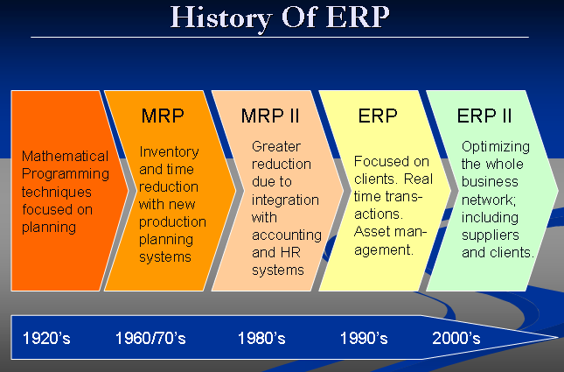

(Figure 5) - The Evolution Of ERP

5. Future of ERP

The development of the Internet has had tremendous impact on every aspect of the IT sector. ERP, which is one of the IT systems, is becoming more and more “Internet-enabled”. This environment of accessing system resources from anywhere and anytime has helped ERP vendors extend their contemporary ERP systems to integrate with newer external business modules such as supply chain management, customer relationship management, sales force automation (SFA), advanced planning and scheduling (APS), business intelligence (BI), and e-business capabilities. The extension to SCM and CRM can increase the effectiveness of business relationships among the organization, suppliers and the customers. Successful implementation of supply chain management allows an enterprise to anticipate demand and deliver the right product to the right place at the right time at the lowest possible cost to satisfy the customers. Therefore, savings can be achieved in inventory reduction, transportation costs and reduced spoilage by matching supply with actual demand. With the deployment of CRM, organizations are able to gather more knowledge about their customers. Therefore, a company can gain more satisfied customer, while increasing customer loyalty.

In the future, we will hear more about ERP II (the expanded ERP system), also known as Enterprise Application Integration (EAI). Even though the software is different, ERP systems remain in the forefront of EAI software development. Some people think that EAI is the future of computing systems and a necessary foundation for full integration of enterprise-wide applications. For instance, ERP II is the opening of internal systems to customers and suppliers so that e-business can be enabled through the Internet.⁽⁷⁾ How the ERP II revolution will take place is still a large question.

Improvements to conventional ERP to be addressed with ERP II include role, domain, function, process, architecture, and data improvement.

- Role – There will be a shifting from enterprise optimization to value chain participation or e-commerce enablement.
- Domain – Integrates manufacturing and distribution to all sectors or segments of an Industry.
- Function – Integrates manufacturing, sales and distribution, and finance processes to cross-industry, industry sector and specific industry processes.
- Process – Shifting from internal and hidden process to externally connected process
- Architecture – Shifting from web-aware to web-based.
- Data – Improvement from internally generated and consumed data to internally and externally published and subscribed data.

Enterprise Resource Planning Suppliers and Customers

1. ERP Suppliers

There are primarily four ERP service providers that we researched: SAP, Oracle, PeopleSoft, and JD Edwards. Each of these four has created its own small niche in a very competitive marketplace, where not only quality and range of service is evaluated, but increasingly cost of service is becoming a decisive factor. To that end, and like the technology marketplace in general, the last three to four years has brought tremendous change and evolution to the ERP environment. PeopleSoft has since bought and merged with JD Edwards, and during this research specifically, Oracle was given DOJ (Department of Justice) approval to purchase Peoplesoft. What once was a market flourishing with a multitude of individual companies, each with their own specialty, has increasingly become a market dominated by economies of scale. Larger companies like SAP and Oracle will continue to survive and thrive in the market, but our research shows that the future will likely continue to evolve, bringing smaller more agile competitors to a continuously changing technology landscape.

The largest “Pure play” ERP provider in the marketplace is SAP; they were founded in Waldorf, Germany in 1972. Today, SAP employs 30,000 people in more than fifty countries and with revenues reaching nearly nine billion dollars, they will continue to be a dominant force in the future. SAP’s most notable achievement in the ERP revolution has been creating “mySAP Business Suite” - one of the most integrated and flexible operating systems in the industry. They have successfully positioned their ERP package at the center of the operating platform, supplemented by “mySAP CRM,” “mySAP SRM,” and other SAP solution packages. (Figure 6)

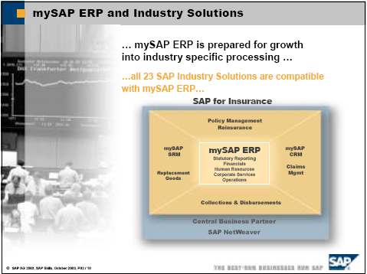

(Figure 6) – mySAP ERP

Additionally, we found that of the more prevalent ERP providers, SAP provides the most complete ERP functionality, allowing companies to achieve their strategies in a fully integrated, open software architecture. (Figure 7) SAP offers a wide array of industry solutions covering strategic management to people management and integration. The core of these products includes analytical modeling, financial integration, operational management, human capital management and SAP NetWeaver. Each of these software packages is designed to accentuate SAP’s flexibility in the market and drive it to future growth in the industry.

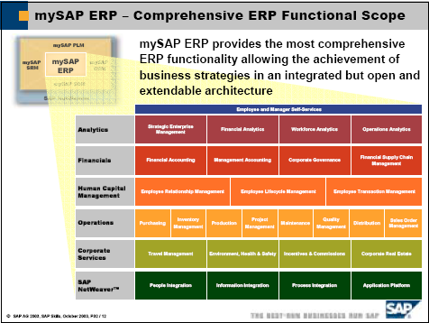

(Figure 7) – SAP ERP Functionality

The second largest of the ERP providers is Oracle. Oracle was founded in 1979 in California, and has over 40,000 employees worldwide. Although not a traditional ERP company, such as SAP, Oracle has made its mark on the industry by acquiring smaller rivals… most recently PeopleSoft. Rather than system flexibility or ability, Oracle has positioned itself in the marketplace as the lowest cost provider of ERP services in the industry. With the recent addition of PeopleSoft’s flexible software package, which I’ll describe shortly, Oracle has positioned itself as an immediate rival to SAP in an industry that is quickly becoming consolidated.

PeopleSoft is the last company that we researched; they are also the smallest of the three with only three billion in annual revenues. PeopleSoft was founded in 1987 and is headquartered in California, as well.

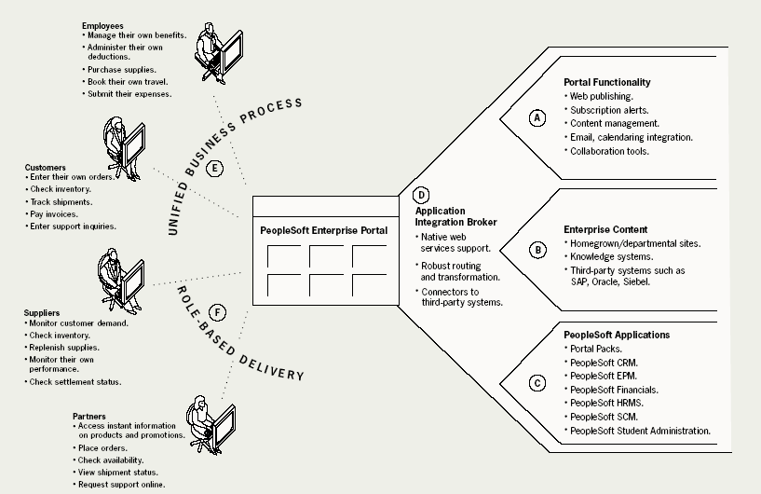

(Figure 8) – PeopleSoft ERP Structure

PeopleSoft has over 12,000 employees across the world, and of the three, we found that they have carved out a niche in the market as the most flexible of all ERP providers. PeopleSoft has the ability to combine multiple software solutions provided by multiple different companies into one coherent, fully integrated ERP platform. (Figure 8) SAP, on the other hand, has primarily made its mark by supplying its own software solutions. It’s no wonder then that Oracle has sought to expand its position in the market by bidding for PeopleSoft. The combination of the two becomes a very large company with the ability to provide low cost services across multiple software packages.

Our research did not focus on what the market will look like in the future, but rather what it looks like today. However, based on what we see with the mergers and changes in the industry, it would seem likely that Oracle may have gained a significant advantage over SAP. This particular situation is very reminiscent of Apple vs. IBM in the 80’s/90’s. If you bought an Apple, you had to run Apple software etc. If you bought IBM, you were able to choose between multiple brands of PC’s, as well as multiple brands of software. Additionally, new ERP providers are making a launch at the industry, and there is some research that tells us SAP is no longer the choice among current (Figure 9) and future consumers. (Figure 10)

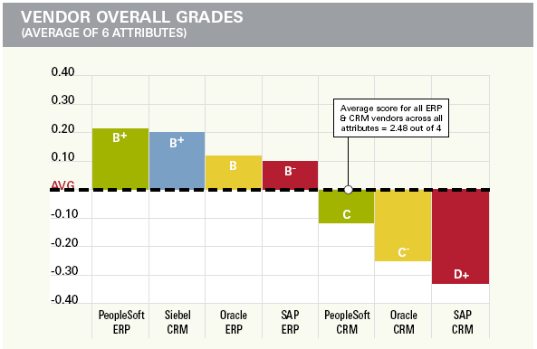

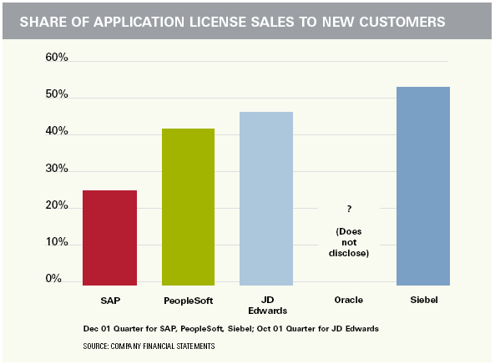

(Figure 9 and 10) – Customer Ratings/New Licenses

2. ERP Customers

In doing research on ERP providers, we also found some very interesting information on the customers. Of most interest to us was whom the customer chose for their integration, both by size and industry sector. Also we wanted to find out what functionality those respondents integrate during the first wave of implementation and what functionality they were evaluating for the future. In all, Peerstone research surveyed 534 recent implementers of an enterprise resource system. They separated the accounts out first by size of the company and then by industry sector. The second survey that Peerstone did was to compare current functionality vs. future functionality and tie each of them to the vendor of choice.

The first comparison that we will look at is the comparison of company size and industry sector vs. the chosen ERP provider. In figure 11, a total 534 customers were surveyed about their size and which ERP provider they chose for their implementation. Of all respondents, SAP was chosen 24% of the time, while Oracle, PeopleSoft, and JD Edwards were chosen 24%, 20%, and 11% of the time respectively. In all, almost 180 of the 534 companies surveyed had 10,000 employees or more.
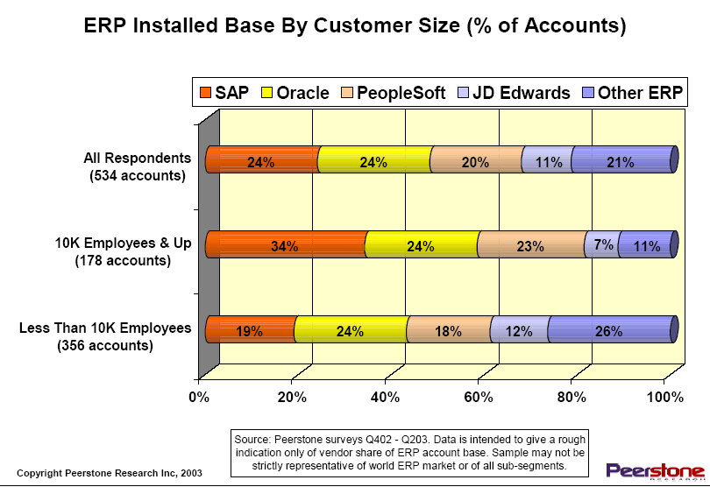

(Figure 11) – Customer Size

Of those companies, SAP was the vendor of choice. 34% of the time, the larger companies relied on SAP to integrate their ERP system. Oracle was second with 24%, while PeopleSoft and JD Edwards had 23% and 7% respectively. Contrastingly, almost 360 of the 534 respondents were companies with fewer than 10,000 employees. Of these smaller companies, there was no specific vendor of choice. Interestingly enough, 26% of the time the smaller companies chose less well-known ERP providers to implement their enterprise system. SAP, incidentally, dropped from 34% of the larger companies to 19% of the smaller companies, while the remaining three remained relatively flat vs. the entire sample.

While there is no specific information as to why these companies chose the way they did, we drew some conclusions based on what we know about each ERP provider. It seems to make sense that larger companies would choose SAP to implement their enterprise system. First, SAP is the largest enterprise resource provider in the world and they have a much more established history than their industry peers. Based on some additional research that we did for the Monsanto case, we concluded that one of the key reasons why a company chooses any particular ERP provider is stability. An ERP investment for a large company can run into the hundreds of millions of dollars; therefore it is critically important to choose a vendor that can provide a stable and consistent service platform. Second, SAP offers a far more extensive and integrated ERP solution than its competitors. A company with 10,000 employees generally would have the need to integrate across multiple functions, countries, and services all within the same company. SAP would offer that large company a “one-stop shop” of sorts, rather than trying to integrate multiple solutions from multiple vendors. Lastly, larger companies have a larger fund from which to implement an ERP package. SAP most likely would be more expensive because of the name recognition and abilities; therefore larger companies would be much more willing and more able, than their smaller peers, to pay higher implementation expenses. Conversely, it also makes sense that smaller companies would likely choose an ERP provider who is less well known and offers fewer accouterments. Smaller companies, generally, require fewer, less complicated integrations and quite simply do not need what SAP, Oracle, or PeopleSoft have to offer.

In Figure 12, Peerstone further breaks out the 534 respondents by industry. Of the 534 respondents, approximately 415 represented the manufacturing/service industries, 125 represented the regulated/financial service industries, and 40 represented the “traditional” utilities industry.
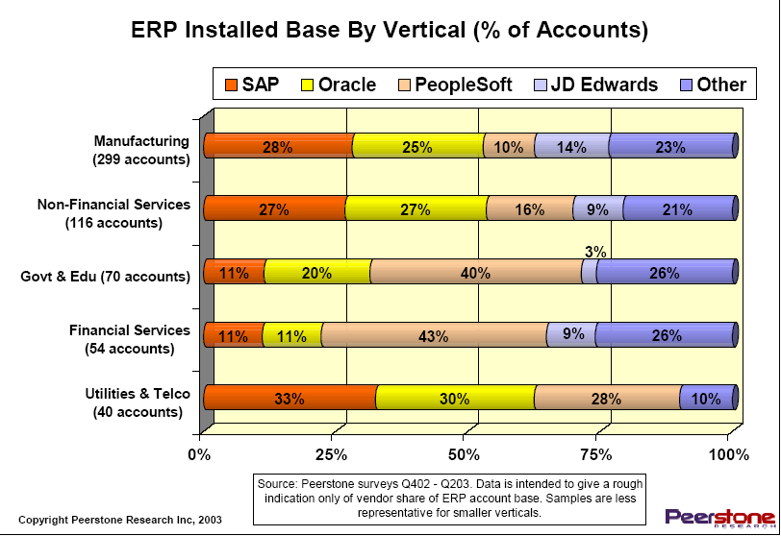

(Figure 12) – Customer By Industry

Overwhelmingly, the utilities industry chose SAP, Oracle, and PeopleSoft over their smaller, lesser-known rivals. Similarly, the government and financial industries overwhelmingly chose PeopleSoft over its industry rivals. The manufacturing/service industries chose more equally across the board of competitors, and more in line with the survey as a whole. Again, even though there were no specific addresses made to these points, we can arrive at certain conclusions based on what we know about the industries. Utility companies tend to be very decentralized in their operations, meaning that a small number of employees would be required to run multiple power generating stations. With SAP’s integrated functionality, it is much easier to operate multiple generating sites from more central locations. Additionally, utility companies generally operate in a heavily regulated industry due to environmental concerns. Because of this, this industry has traditionally been identified as being risk averse. The decision, in this instance, is especially critical because of the extremely high price of failure. The possible outside impact to the environment and proceeding financial impact to the company could be staggering. Utility companies do not have the luxury of experimenting, so they choose partners with experienced, stable backgrounds.

On the other hand, government and financial organizations tend to be organized in fragments according districts, regions, and functions. For instance, one school district may use a different operating system than the one in the next county. The IRS probably uses different operating software than the FBI or the CIA. Similarly, multiple mergers within the banking industry require banking locations to integrate multiple different types of software and operating systems. PeopleSoft has clearly positioned itself in the marketplace as “The enterprise solution provider” to join this type of fragmented business environment.

3. ERP Present vs. Future

The second study Peerstone did was to identify current and highest priority functionality vs. future and value added functionality. In figure 13, it is clear that companies tended to implement the most critical, in terms of everyday operations, functionality first.

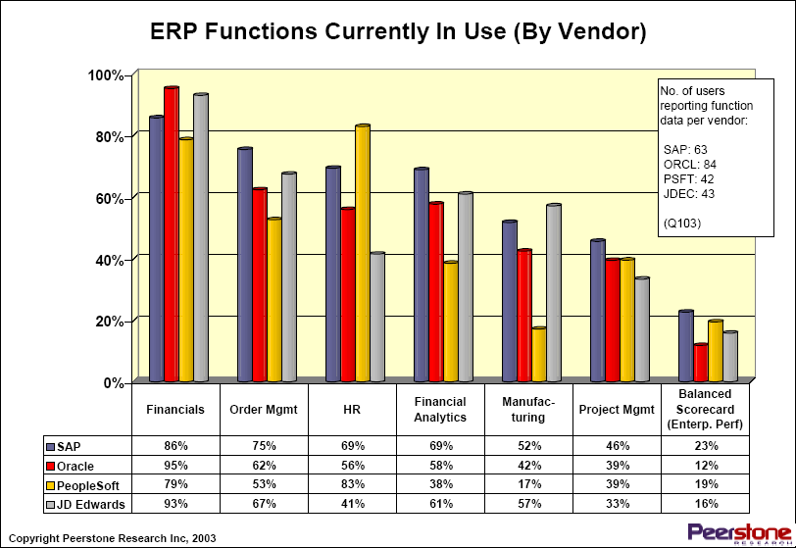
(Figure 13) – Current ERP Functionality

For example, financial integration generally came before project management functions, manufacturing functions came before balanced scorecards, and order management came before analytical modeling. Generally speaking these are functions that a company must do in order to keep up with competition and often don give them a significant competitive advantage, nor a positive return on investment. However, the reverse isn’t true; by not improving their basic systems, a company could be leaving efficiencies, customer solutions, etc. “on the table.”

Figure 14 identifies the more value added functionality that will surely come in the future, as more valued added functionality becomes the expectation for an enterprise system.
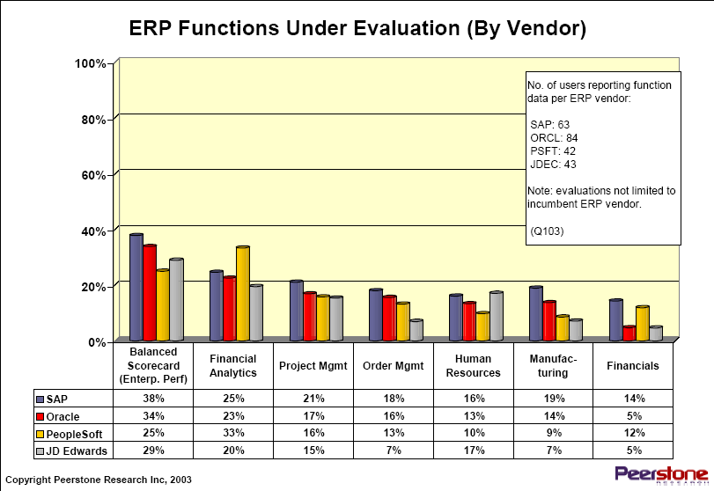
(Figure 14) – ERP Functionality Under Evaluation

Balanced scorecards are being evaluated to measure a company’s effectiveness against completing goals, analytical modeling is being considered as the power of an integrated enterprise system becomes fully realized, and project management will be used to track deadlines and milestones of projects. Each of these functions, although not critical to success of a business, can directly add value to an organization.

Critical Success and Failure Factors

ERP implementations can be very problematic for a lot of companies. They can
be large, expensive, and complex. It is no surprise that many become less successful than anticipated. Toni Somers and Klara Kelson have provided a list of 21 critical success factors (CSFs) in their study, "The Impact of Critical Success Factors across the stages of Enterprise Resource Planning Implementations". The most important factor that they have found is gaining top management support. If top management is not actively backing an all-pervasive project like an ERP implementation, there is little hope for it. Middle management and other staff are also important, but if top management permanently delegates its responsibilities to technical experts, the chances for project failure are high. The implementation must also have a project champion. The project must be able to make substantial organizational changes happen. Project team competence also plays an important role. The team must not only have experience in dealing with the companies processes, but also in how ERP should be implemented. This was something that executives found to be very important. Because companies usually only get one chance at implementing an ERP system, it is important the company allocates its best people for the project.
When selecting an ERP package, it is important that it fits the business processes and strategies. It is important to understand the size and significance of the project. Some packages are better suited for large firms, while others are more suited for smaller firms. Also, this is probably the last time that the company will replace its major business systems. Any future changes will likely be upgrades or enhancements to the chosen platform. A company should not underestimate the scale and impact of the project. Also, benchmarks should be set. There must be clearly defined measures of success, not simply a budget and a project deadline.

A company must also have interdepartmental cooperation between business functions. ERP by definition integrates multiple functions. Therefore, it is essential that departments are communicating with each other. Management also found that there must be clear goals and objectives. The project should begin with a clear conceptualization of goals. Goals should be updated as the process goes on, but not added on. A company cannot lose focus on what the necessary benefits are. Project management must create a clear plan, but also must be flexible and able to improvise. Product management must also be wary of "overselling" end-users. The expectations of the implementation need to be made clear. It must keep all of the divisions involved up to date. Management must ensure that the organization and personnel are ready, willing, and able to embrace the new processes and systems. As changes take place, interdepartmental communication has to occur.

NESTLE USA CASE STUDY:




1. Nestlé USA Background

When looking at implementing ERP, one very important case study to take note of is the Nestlé case. Nestlé’s odyssey began in 1997, when Nestlé USA signed a contract with SAP to install an ERP system. The implementation was intended to more integrate the company nationwide and worldwide. The six-year process ended up costing the company over $200 million.

At the time, Nestlé USA, whose parent company is headquartered in Zurich, Switzerland, brought in $8.1 billion in annual revenue. It is also the world’s biggest food manufacturer, with popular brands such as Baby Ruth, Carnation Instant Breakfast, Coffee-Mate, Nescafé, Nestlé Carnation Baby Formulas, Alpo, PowerBar, Stouffer’s Lean Cuisine, SweeTarts, and Taster’s Choice. It employs over 16,000 men and women, including an IT staff of 250.

2. Need for ERP

Nestlé USA’s problem was that its divisions were not very well integrated. Before 1991, Nestlé was simply a collection of independently operating brands, such as Stouffer’s and Carnation, owned by the Swiss-based parent. In 1991, the brands were organized into one company, Nestlé USA. However, Nestlé USA never really did anything to bring each division together. These divisions still had geographically dispersed headquarters and were free to make their own business decisions.

In 1997, a startling revelation was found. Nestlé USA’s different divisions were paying 29 different prices for vanilla – to the same vendor. "Every plant would buy vanilla from the vendor, and the vendor would just get whatever it thought it could get," said Jeri Dunn, vice president and CIO of Nestlé USA. "And the reason we couldn’t even check is because every division and every factory got to name vanilla whatever they wanted to. So you could call it 1234, and it might have a whole specification behind it, and I might call it 7778. We had no way of comparing."⁽⁸⁾

In 1991, Dunn, who was then associate director for application systems of Stouffer’s Hotels, a Nestlé brand, went to Switzerland to try to implement common procedures for Nestlé worldwide. In 1995, she was promoted to assistant vice president of technology and standards for Nestlé, and introduced technology standards for future Nestlé companies. Dunn believed these practices and policies would save the company millions and would make each division more effective. Dunn soon found out that many of her policies and recommendations had not been acted on when she returned to the US as CIO at Nestlé USA in 1997. "My team could name the standards, but the implementation rollout was at the whim of the businesses,"⁽⁸⁾ she said. She knew that serious changes needed to be made.

3. Implementation Phase

Dunn decided to join forces with executives in charge of finance, supply chain, distribution and purchasing to form a key stakeholder’s team and find out what was right and wrong with the company. "I don’t think they knew how ugly it was," said Dunn. "We had nine different general ledgers and 28 points of customer entry. We had multiple purchasing systems. We had no clue how much volume we were doing with a particular vendor because every factory set up their own vendor masters and purchased on their own."⁽⁸⁾ The company agreed that major changes should be made. They also agreed on an ERP implementation through SAP, which they believed should be completed in three to five years. The project was to be code named BEST (Business Excellence through Systems Technology). The implementation team was consisted of 50 top business executives and 10 senior IT professionals. Its goal was to create common work procedures that would be followed by each Nestlé division. Nestlé USA's key stakeholders decided to implement five SAP modules - purchasing, financials, sales and distribution, accounts payable and accounts receivable - plus an additional supply chain module through Manugistics, an SAP partner. The deadline for four of the modules was set for 2000. Each Nestlé USA division would follow the same best practices, guidelines, and data. However, in its haste to reach the deadline, Nestlé USA created many more problems for the company.

What Nestlé had not fully taken into account was the effect this implementation would have on its workers. One of the main reasons for this problem is simply that none of the employees who would be directly affected by the ERP implementation had been included on the implementation team. Dunn said, "We were always surprising [the heads of sales and the divisions] because we would bring something up to the executive steering committee that they weren’t privy to."⁽⁸⁾ Workers were not only unaware of how to use the new system, but also the new processes. Dunn says her help desk calls reached 300 a day. "We were really naive in the respect that these changes had to be managed,”⁽⁸⁾ she now admits. Nobody wanted to learn the new way of doing things. Morale tumbled. Turnover among the employees who forecast demand for Nestlé products reached 77 per
cent. The integration team was struggling with this and introducing two more SAP modules - sales and distribution and accounts receivable. The implementation was quickly turning into a disaster.

Nestlé USA also soon experienced a technical problem. Each individual division may have been fully integrated, but the divisions were not integrated together. This caused problems throughout the company. For example, the sales department may have sold items at a discounted rate; however the accounts receivable department would be completely unaware.

In June 2000, Nestlé removed Marc Richenderfer as project co-leader and gave Dunn full responsibility. She met with 19 Nestlé USA key stakeholders and business executives in order to figure out how the various components could work together. They agreed that they should not try to reach a set deadline, but start with the business requirements and then reach an end date. They also agreed that they would have to gain support from key divisional heads and that all the employees knew exactly what changes were taking place, when, why and how. The ERP implementation was ultimately completed late and over-budget in 2003. However, Dunn insists that the BEST project has saved the company over $325 million. It created a more trustworthy demand forecast which in turn led to reduced inventory. Its common databases and business processes also led to greater communication throughout the company.

4. Lessons Learned

This case is very intriguing because it contains elements of success and failure. Dunn and Nestlé USA not only have learned some very valuable lessons, but have given lessons to other Fortune 500 companies and even Nestlé USA's own parent company, Nestlé SA, which later implemented its own ERP system. "I took eight or nine autonomous divisions and said we are going to use common processes, systems and organization structures," said Dunn. However, the company never focused on achieving universal buy-in from its employees. "If you try to do it with a system first, you will have an installation, not an implementation,” she says. “And there is a big difference between installing software and implementing a solution."⁽⁸⁾ The biggest lesson learned is that ERP is not only about the software. It also involves the people using the software. Employees must be involved in the entire process. Also, a company cannot constantly worry about deadlines, because many implementations arrive late. It is much better for the company to set benchmarks for project requirements. Also, the budget will need to be frequently updated. Since changes may occur, it is better to update the budget than to leave yourself vulnerable.

Since Nestlé USA was able to see the problem, they were finally able to fix it. As Dunn worked with the different divisions and was able to get the employees to listen, the process was completed. Also, even though Nestlé USA spent more money than it wanted, it believes it saved the company even more. This case shows that not all ERP implementations will go as planned, but that they still may be useful to the company. Nestlé is the world’s largest company in the food industry. Changes were necessary in order to have each division communicating with each other. Nestlé USA knew that an ERP implementation would provide the most effective changes.

OREGON HEALTH & SCIENCES UNIVERSITY CASE STUDY


Oregon Health & Sciences University, a Portland-based health and research university, knew that it needed some help with integrating its administrative applications when it separated from the Oregon State System of Higher Education. The university, which employs over 11,000 people and enrolls 3500 students, needed a better way to manage its $2.3 billion in annual economic activity. “We were looking for a way to have financial information systems that were independent from the state,” said Bridget Haggerty, senior manager, enterprise administrative applications management. “We just needed to start using our own technology.”⁽⁹⁾

The implementation through Oracle took place with no major glitches and in 1998 the university conducted a review of the software. They discovered that they had saved $2 million a year by automating purchase ordering and receiving, and other processes using the integrated general ledger, accounts payable, and procurement applications. The university, for example, was able to save thousands through volume purchase ordering, something that was not an option before the applications were installed. This led to OHSU installing several other ERP applications including cash management, human resources, payroll, fixed assets, and grants software. It also began installing browser-based front ends on some applications. “We feel like we are finally through the pain of transition and to the point where we’re getting a lot of value from the ERP system,”⁽⁹⁾ said Haggerty.
This case is looked at as a success because the university felt that new applications were necessary and is now able to see the benefits of the implementation. Changes needed to take place in order for the university to separate from the Oregon State System of Higher Learning. These changes were made through the help of the ERP system and the university is now able to see results. The company has saved $2 million annually and even introduced additional ERP applications. This case shows how ERP, when used effectively and appropriately, can help an organization to grow. It also shows that ERP is not only becoming necessary in the private sector, but in the public sector as well.

Monsanto Case Study:


1. Company Overview

Monsanto was originally founded in the beginning of the 20th century as a chemical producer of Anhydrous Ammonia. Since that time, many mergers and spin-offs have taken place to form the company that we know today. The current Monsanto is a global provider of agricultural products and integrated technology solutions. It is headquartered here in St Louis, but with more than 14,000 employees in 46 countries, it is truly a multi-national corporation. Some of its more familiar products include Dekalb and Asgrow brand seed, Posilac dairy hormones, and Roundup, which is the largest selling herbicide in the world. Additionally, Monsanto is the largest supplier of genetically modified agricultural traits in the world, including Roundy Ready technology. Ending fiscal year 2004, Monsanto had revenues of $5.5 billion, net income of $267 million, free cash flow of $1 billion, and as of September 2004, a market capitalization of $11.5 billion.

2. Identifying Need For ERP

The need for an ERP system was first identified in 1996 for two reasons. The first was the considerable efficiencies that would be gained by integrating the purchasing, payables, finance, and manufacturing organizations. It was thought that by integrating purchasing and payable functions, we could leverage material and service savings across functions. Likewise, by integrating manufacturing sites across the world, we could leverage inventory levels and productions schedules to become as close to “just-in-time” as possible. The second reason was that Monsanto was pursuing a “Life Sciences” business platform that required the integration of functions of the business. At the time, Monsanto owned a pharmaceutical company, a nutrition company, and an agricultural company. The life sciences concept combined the three companies into an idea that medicine could be grown in plants and then marketed through the consumer portion of the business.

There were other perceived benefits that helped get the project approved. In addition to integration savings and the Life Sciences concept, there was a Y2K problem in Europe, as well as the need to faster integrate the newly acquired seeds companies. Y2K seems like distant history now, but in 1996, it was a very real threat to business operations. Part of the sell to senior management was that a Y2K solution for Europe would be very costly to implement. An ERP system would allow Monsanto to both solve the Y2K problem, as well as create an integrated business platform in that region. Moreover, during the late 90’s Monsanto was acquiring many small companies, namely Dekalb and Asgrow, which had already implemented SAP. These reasons, more than any, helped cement the case for implementing an organization wide enterprise business solution within Monsanto.

3. Implementation Phase

Once the project was approved and SAP was selected as the vendor, there were several steps that needed to be completed to start the process. The most important of the tasks was to select a staff that would be in charge of implementing the SAP software. There were four phases in which the staff would be selected. First, full-time Monsanto employees who were identified as experts in their filed would help design the business processes for each of the business functions. Second, higher caliber IT employees would be selected to help with the programming and language aspects. After all available positions were identified and filled with internal Monsanto employees, outside SAP experts and implementation personal were hired. According to Chris, this more than any other factor helped Monsanto’s SAP project become a success.

The second step was to identify an Implementation process and timeline. Monsanto took a phased approach that lasted from before 2000 to 2006 that implemented limited parts of the business at different times. In doing this, the project team could learn from mistakes and gain efficiencies before they started implementing a new function. The implementation plan can be seen below.

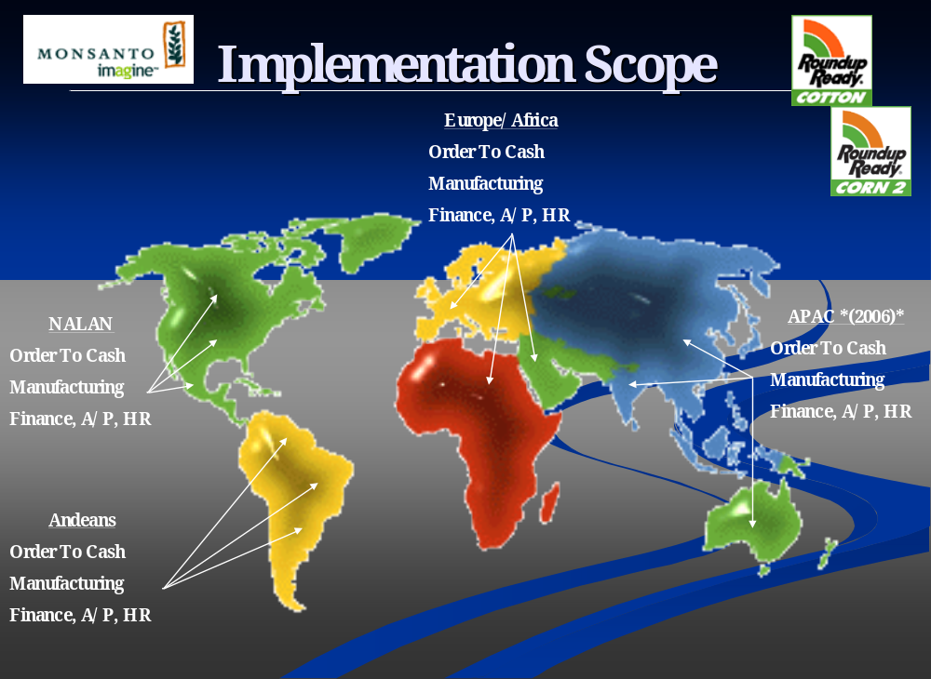
According to Chris, Monsanto’s implementation of SAP was extremely successful. Some of the noted achievements include $50M in annual IT savings and material savings, total company-wide integration, enhanced reporting capabilities, real-time data, sharing across functions, and the project was completed on-time and on-budget. For future growth, Monsanto has a successful, stable ERP platform on which it can build its business and upgrade its functions.

There were 6 critical lessons that can be taken away from the Monsanto implementation.

- Good organization and planning is essential to a successful implementation.

- Hire quality people to manage the implementation process.

- Understand the scope and manage be able to manage change.

- Communicate changing roles and expectations.

- Teach the importance and effect of integrated systems.

Each of these lessons has the ability to applied across companies as a best practice.

Citation/Bibliography

Citation

- http://www.datainstincts.com/glossary.htm

- The Controller’s Report. New York: May 2004., Iss. 5; pg. 7, 1 pgs

- James P. Miller. Wall Street Journal. (Eastern Edition). New York, N.Y.: Jan 10, 2000. pg. C.12

- Patrick Thibodeau, Don Tennant. Computerworld. Framingham: Sep 27, 2004. Vol.38, Iss. 39; pg. 14, 1pgs

- http://guide.darwinmag.com/technology/enterprise/erp/

- Brady, Monk & Wagner. The Development of Enterprise Resource Planning, pg. 17-35.

- http://semiramis.com/archiv_2004_de.html

- Ben Worthen. “Crunch Time At Nestle”. http://proquest.umi.com/pqdweb?index5&did=00000012099. Sept. 27, 2004.

- Beckie Kelly Schuerenberg. “ERP ROI not PDQ but A-OK”. http://proquest.umi.com/pqdweb?index27&sid=2. Sept. 28,2004.

Bibliography

Beckie Kelly Schuerenberg. Health Data Management. New York: Jun 2004. Vol.12, Iss 6; pg. 56, 4 pgs

Ben Worthen. CIO. Framingham: May 15, 2002. Vol.15, Iss. 15; pg. 1

Chris Dufner, Director NALAN IT, Monsanto Company – St Louis, Interviewed in person by Scott Burchette, September 20, 2004.

H Akkermans and K van Heldon. European Journal of Information systems. Vicious and virtuous cycles in ERP implementation. 2002 pg 35-46

http://finance.yahoo.com/q/pr?s=MON

http://ida_group.com/downloads/excerpts/19307836XEcerp.pdf
http://isaca-washdc.org/presentations/sep2003-monthly_slides.pdf

http://webprofesores.iese.edu/valor/Docs/EMBA/intro%20ERPS.pdf

http://www.cio.com/research/erp/edit/erpbasics.html

http://www.e-innovation.org/presentations/kick-off/mrp-erp.ppt

http://www.freequality.org/beta%20freequal/fq%20web%20site/training/EnterpriseResourcePlanning2%5B1%5D.ppt

http://www.monsanto.com/monsanto/layout/investor/financial/annual_reports.asp

http://www.nestleusa.com/

http://www.ohsu.edu/about/facts/simply_ohsu.pdf

http://www.oracle.com/corporate/index.html

http://www.palgrave-journals.com/ejis

http://www.peerstone.com/

http://www.peoplesoft.com/corp/en/about/invest/index.jsp

http://www.sap.com/company/investor/index.aspx

http://www91.homepage.villanova.edu/william.wagner/MBA8556/erplec1.ppt

Somers TM and Nelson K. The Impact of Critical Success Factors Across the Stages of Enterprise Resource Planning Implementations. Proceedings of the 34th Hawaii International Conference on Systems Sciences, January 3-6 Maui, Hawaii. 2001.

